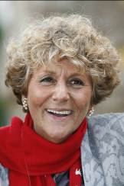 | Barande-Barbe, Corine | Cup – Cirrus Des Aigles
 | Age 56, Corine Barande-Barbe took out her licence in 1991 and is based at Chantilly. Until recent seasons the best horse she had trained remained Carling, winner of the G1 French Oaks and G1 Prix Vermeille in 1995, but others of note have been Red Roses Story, Perfect Vintage and Jeopardy. Cirrus Des Aigles has been her ambassador in recent years and was rated the world’s best horse in training at the end of 2012 after pushing Frankel in the latter’s final race, the G1 Champion Stakes at Ascot. Cirrus Des Aigles had won that contest in 2011 and in early 2012 he added the G1 Dubai Sheema Classic, G1 Prix Ganay. She saddled her stable star to finish 5th in the 2009 HK Vase, and 7th (2010) then 5th (2011) and 3rd (2013) in the HK Cup. The gelding was a withdrawal on the eve of the 2012 HK Cup due to injury and Barande-Barbe patiently guided him back to form for a second successive win in the G2 Prix Dollar and runner-up finish in the G1 Champion Stakes in 2013, and early this year he won the Ganay again, the G1 Prix d’Ispahan and G1 Coronation Cup.

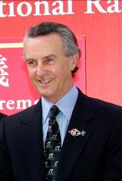 | Bolger, Jim | Vase – Parish Hall
 | Age 72, Jim Bolger is one of Ireland’s great trainers. The Coolcullen handler’s major achievements include saddling New Approach (2008) to win the G1 Derby in England, and Jet Ski Lady’s win in the G1 Oaks (1991), also at Epsom. Bolger also sent out St Jovite to win the G1 Irish Derby and G1 King George VI & Queen Elizabeth Stakes in 1992 (Trading Leather gave him a second Irish Derby win in 2013). New Approach went on to win the G1 Irish Champion Stakes and dominated the G1 Champion Stakes at Newmarket. Now a successful stallion, he is one of five winners of the G1 Dewhurst Stakes for Bolger, who dominated the UK’s premier two-year-old race in a 7-year spell with Teofilo (2006), New Approach (2007), Intense Focus (2008), Parish Hall (2011) and Dawn Approach (2012). The last-named won the 2013 G1 2,000 Guineas in England and the G1 St James’s Palace Stakes. In 2007, Bolger remarkably sent out his crack filly Finsceal Beo to win the English 1,000 Guineas and Irish 1,000 Guineas, and between times finish a head 2nd in the French equivalent, all in the space of 21 days. His many G1 winners also include Saoirse Abu, Park Express, Lush Lashes, Polonia and Alexander Goldrun. The last-named won five G1s including the 2004 Hong Kong Cup.

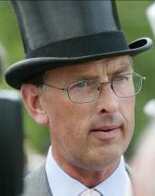 | Charlton, Roger | Mile – Captain Cat
 | Age 64, Charlton has been one the most respected and successful trainers in the UK for over 20 years. After assisting the famous Jeremy Tree for several years he took over Tree’s Beckhampton stables in 1990 and achieved extraordinary success almost immediately with Sanglamore winning the 1990 G1 Prix du Jockey Club and three days later Quest For Fame winning the G1 Derby at Epsom. Since then he has enjoyed steady rather than spectacular success mainly, but not exclusively, with sprinters. His G1 sprint wins include the G1 Haydock Sprint Cup with Tamarisk (1998) and Tante Rose (2004), and the G1 Prix de l’Abbaye twice with the half-brothers Patavellian (2003) and Avonbridge (2005). More recently, in 2012 Cityscape was the runaway winner of the G1 Dubai Duty Free and the following year Al Kazeem lit up the 2000m division with wins in the G1 Tattersalls Gold Cup, G1 Prince of Wales’s Stakes and G1 Eclipse Stakes. This year Charlton sent out Thistle Bird to win the G1 Pretty Polly Stakes.

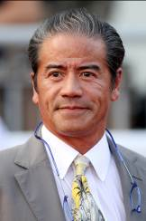 | Cruz, Tony | Cup – Blazing Speed, California Memory, Helene Super Star  Vase – Willie Cazals; Sprint – Peniaphobia
 | Age 57, Tony Cruz was six times Hong Kong's champion jockey and rode 946 winners. Achieved his first HK trainers' title in 1999/2000 and regained it in 2005, setting a then record for a season's winners (91) and earnings (HK$113m). His most famous horses have been Silent Witness, the dual HK Sprint and nine-time G1 winner, Bullish Luck, a five-time G1 winner and winner of the G1 Yasuda Kinen in Japan and California Memory, winner of back-to-back Hong Kong Cups in 2011 and 2012. California Memory also took the HKG1 Champions & Chater Cup in 2013 to claim the Champion Stayer crown. Lucky Owners' double in the HK Mile and HK Derby and Helene Mascot's Derby victory, as well as Blazing Speed's Stewards' Cup and Champions & Chater Cup wins in 2014, also stand out. In 2010/11 in which he won two HKG1s and the G1 HK Mile with Beauty Flash, he was pipped late for the trainer's title by John Moore's late burst. In 2012/13 Cruz closed in to lead the trainers' title race with a double at the last meeting of the season, only to be overtaken again in the final race and finish the campaign in 2nd. He has 16 wins this term for a career total of 991 wins.

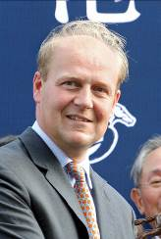 | Dunlop, Ed | Vase – Red Cadeaux
 | Age 46, Old Etonian Ed Dunlop is a son of retired champion British trainer John Dunlop and took out his trainer's licence in 1994. In 1996, Ta Rib was his first Classic winner in the French 1,000 Guineas and Iktamal his first G1 scorer in Britain. He won the Irish Oaks in 2001 with Lailani and in 2004 with Ouija Board (after she won The Oaks at Epsom and before she won the Breeders' Cup Filly & Mare Turf). Ouija Board was European Horse of the Year in 2004 and captured the HK Vase in decisive fashion in 2005. In 2010, Snow Fairy won four G1s for him: The Oaks, the Irish Oaks and in Japan the Queen Elizabeth II Commemorative Cup, before crowning her season with victory in the G1 HK Cup. Snow Fairy scored a repeat victory in the QEII Commemorative Cup in 2011 and added the G1 Irish Champion Stakes in 2012. Red Cadeaux has been his standard-bearer recently, winning the G1 HK Vase in 2012 and running 2nd in the 2013 G1 Dubai World Cup. The tough gelding failed by the narrowest of noses to win the 2011 G1 Melbourne Cup and was 2nd again in the 2013 and 2014. He saddled Joshua Tree to win the G1 Canadian International in October, 2013, the trainer’s 24th G1 win spread across eight countries.

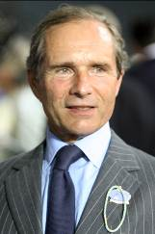 | Fabre, Andre | Vase – Flintshire
 | Age 69, Andre Fabre is one of the greatest trainers in racing history, and not just in his native France. The law graduate son of a diplomat, this unusual racing character, one of whose greatest pleasures in life are the works of Marcel Proust, became one of France’s leading jump jockeys, riding more than 250 winners including France’s premier steeplechase, the Grand Steeplechase de Paris. As a trainer he won the national trainers’ title 21 years in succession. Having relinquished his crown in 2008 and 2009, he has won the title four years straight since regaining it in 2010 for a total of 25 championships, and heads the race this year (as of 27 Nov). He has trained the winners of all his country’s greatest races including the Prix de l’Arc de Triomphe seven times and has prepared many European and World Champions, including Trempolino, In The Wings, Zafonic, Peintre Celebre, Hurricane Run and Manduro. In 2011, after many attempts, he finally completed a lifelong ambition when Pour Moi triumphed in the G1 Derby at Epsom. His previous LONGINES HKIR success came with Borgia in the 1999 Vase.

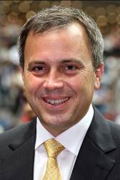 | Fownes, Caspar | Cup – Military Attack; Vase – Rainbow Chic; Sprint – Lucky Nine
 | Age 47, Caspar Fownes assisted his trainer father Lawrie for several seasons before taking over the mantle in 2003/04. He eclipsed his father's best season stats in his rookie year with 44 wins. In 2006/07 he won his first trainers' premiership and added his second premiership in 2008/09. His third championship came in 2013/14 when his strong late charge brought three wins on the closing day to tie with John Size on 62 wins, and with one more second place than his rival he sealed the title on count-back. His most famous victories include The Duke's win in the G1 HK Mile (2006), Green Birdie's win in the G1 KrisFlyer International Sprint (2010) and Lucky Nine's wins in the G1 HK Sprint (2011), the G1 KrisFlyer International Sprint (2013 & 2014), the HKG1 Chairman's Sprint Prize (2013 & 2014) and the G2 Jockey Club Sprint (2012). On 20 June 2010 he sent out six winners in a single day, equalling the record in Hong Kong's professional racing era. He leads the championship this season with 20 wins, for a HK career total of 619.

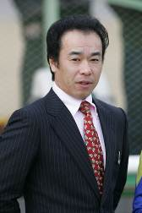 | Fujiwara, Hideaki | Cup – Archimedes; Mile – Fiero; Sprint – Straight Girl
 | Age 49, Hideaki Fujiwara obtained his JRA trainer license in 2000. Three-time JRA Award winner due to achieving highest winning percentage of runners in 2007, 2008 and 2013. He has saddled no fewer than 489 winners (as of 23 November) so far in his career, including 42 wins this season to sit 6th in the JRA premiership. He has had no less than seven G1/JPN G1 successes to date. His stable’s top performers included Asian Winds (2008 Victoria Mile), Success Brocken (2009 February Stakes), Eishin Flash (2010 Japanese Derby & 2012 Tenno Sho Autumn) and Tosen Ra (2013 Mile Championship).

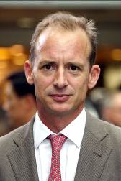 | Gibson, Richard | Mile – Gold-Fun; Vase – Wayfoong Express
 | Age 45, formerly French-based Englishman Richard Gibson arrived in HK for the 2011/12 season with a strong training record to his credit. After getting his grounding in the art with Frenchmen Pascal Bary and Henri-Alex Pantall, as well as Americans Bill Mott and Gary Jones, he took out his first licence at Chantilly in 1996 and struck gold as early as 1999 when Lady of Chad won the G1 Prix Marcel Boussac en route to becoming European Champion Juvenile Filly. He has trained the winners of seven G1s altogether, notably Akeed Mofeed, winner of the 2013 Hong Kong Cup, and Doctor Dino, winner of successive runnings of the G1 HK Vase (2007 & 2008) as well as of the G1 Man O'War Stakes at Belmont, USA. He also has three HKG1s on the board thanks to Akeed Mofeed (2013 Hong Kong Derby), and Gold-Fun (2013 Hong Kong Classic Mile; 2014 Queen's Silver Jubilee Cup). Gold-Fun also won the G2 Jockey Club Mile in the 2013/14 season to be crowned Champion miler. His other high-class trainees prior to moving to HK include Marotta, Lune D'Or, Cut Quartz, Mores Wells, Swedish Shave, and for a short spell Dunaden. He has 6 wins this season for a HK total of 108.

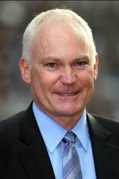 | Hall, David | Vase – Bubble Chic
 | Age 51, David Hall was born in Adelaide the son of trainer Joe Hall. He began training at Morphettville in 1988 and moved to Melbourne five years later. Best known at home for winning the Melbourne Cup (2003) with the brilliant Makybe Diva, he also trained Silent Witness before the champion sprinter switched to Hong Kong. Hall began his training career in Hong Kong in 2004/05. Absolute Champion's victories in the G1 Hong Kong Sprint (2006) and the HKG1 Centenary Sprint Cup (2008) have provided his finest moments locally. In 2013/14 Bubble Chic who won the HKG3 Premier Plate and HKG3 Queen Mother Memorial Cup, while Bundle Of Joy won this season’s HKG3 National Day Cup. He has accrued 6 wins this term for a HK total of 298.

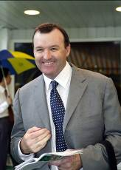 | Hayes, David | Cup – Criterion
 | Age 52, Hayes is the son of Australian training legend Colin Hayes. He took out his own licence in 1990 and won every training title in Melbourne and Adelaide before moving to Hong Kong in 1995 where he stayed nine seasons, winning 458 races, principally the Hong Kong Derby with Elegant Fashion and the 2002 Hong Kong Sprint with All Thrills Too. Returned home in 2005 and became the youngest trainer inductee to Australian racing’s Hall of Fame. Hayes has won the Melbourne Cup (1994 Jeune), as well as the Cox Plate twice (1990 Better Loosen Up; 2006 Fields Of Omagh) and two Caulfield Cups (Fraar 1993; Tawqeet 2006). He also saddled Better Loosen Up to win the 1990 Japan Cup, while Miss Finland’s clutch of G1 wins included the Golden Slipper.

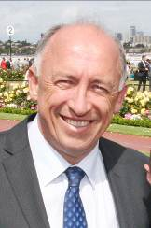 | Heathcote, Robert | Sprint – Buffering
 | Age 55, Robert Heathcote spent 15 years travelling the world from the age of 19, so the former photo engraver and tour guide came into racing relatively late in life as racing manager to his brother. He took out his own licence to train in 1997, armed with a horse physiology book, and has since notched over 1000 wins and has last season’s Queensland Premiership to go with his five metro premiership titles. Based out of Eagle Farm, his first G1 strike came in the 2012 Oakleigh Plate with Woorim. Solzhenitsyn annexed the Toorak Handicap in 2012 and retained it in 2013, but it is another bargain buy that is his stable standard-bearer, the sprinter Buffering. Heathcote has saddled Buffering to four G1 wins, the Manikato Stakes, VRC Sprint Classic and Winterbottom Stakes in October and November 2013, and the Moir Stakes this past September.

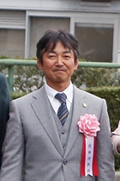 | Hirata, Osamu | Vase – Curren Mirotic
 | Age 54, Hirata obtained his JRA training license in 2005 and has since notched 234 wins (as of 23 November), including 21 this year. Curren Black Hill remains the best horse he has trained to date. The horse provided him with the only G1 of his training career so far, the NHK Mile Cup in May 2012.

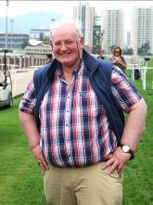 | Hogan, Tom | Sprint – Gordon Lord Byron
 | Age 61 and based in Nenagh, Co. Tipperary, Hogan is a dual-purpose trainer, preparing jumps horses alongside flat racers. He first enjoyed Group race success with the durable Common World, winner of the G3 Grosser Preis Der West LB at Dusseldorf in 2005 and the G3 Gladness Stakes in 2006. His best horse to date by some margin is Gordon Lord Byron, rated 72 when winning an all-weather maiden (his 7th start) at Dundalk in October 2011 but up to 115 after victory in the G1 Prix de la Foret at Longchamp in October 2012 – he is now rated 118 - and won the 2013 G1 Haydock Sprint Cup and 2014 G1 George Ryder Stakes in Australia for the trainer. Hogan has also saddled Gordon Lord Byron to 4th in the 2012 and 2013 editions of the G1 LONGINES HK Mile and 7th in 2014 G1 Champions Mile at Sha Tin.

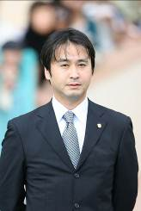 | Ikee, Yasutoshi | Mile – World Ace
 | Age 45, Yasutoshi Ikee is the son of Yasuo Ikee, the former JRA trainer who prepped two-time Japanese Horse of the Year Deep Impact and 2001 Hong Kong Vase winner Stay Gold. Yasutoshi briefly worked in his father’s stable before going to the UK to work for Michael Stoute in 1995. A year later he went to California to work for leading US trainer Neil Drysdale and he stayed there until 2003. He returned to Japan to take out his trainer's licence that same year and is now established as one of his country's most successful trainers. He has saddled no less than 434 wins, including 44 this season (as of 23 November) with 10 at G1 level. He has been the JRA Award winner on five occasions (2006, 2008, 2010, 2011 & 2012), including in 2008 when he led his peers in number of races won. Among the best he has trained are 2011 Japanese Horse of the Year and two-time Prix de l’Arc de Triomphe runner-up Orfevre, three-time G1 winner Dream Journey and 2011 Tenno Sho Autumn winner Tosen Jordan.

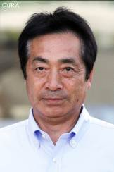 | Kato, Kazuhiro | Mile – Hana’s Goal
 | Age 58, Kazuhiro Kato rode more than 600 JRA winners and notched no less than seven G1 wins in his 30-year career as a jockey. He hung up his boots in 2005 and obtained his training license the same year. He has since saddled a total of 62 wins including five this year (as of 23 November). Kato’s three wins at pattern level so far have all come via Hana’s Goal, including his first G1 and overseas win in the All Aged Stakes at Randwick, Australia, in April 2014.

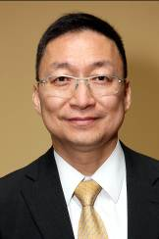 | Lui, Francis | Sprint – Smart Volatility
 | Age 55, Francis Lui rode 36 winners as a licensed jockey between 1975 and 1982 and later became an assistant trainer. He received his own licence to train in 1996/97. Group race winners have included Shanxi Fortune and Sunny Power (both at HKG3 level) and Hello Pretty (HKG2 Hong Kong Derby Trial). He trained 37 winners in 2013/14, 24 more than the previous season, and has 10 so far this season for an overall total of 455.

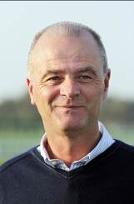 | Lynam, Edward | Sprint – Sole Power
 | Age 52, Edward Lynam first took out a trainer’s licence in Ireland in 1984 but for some time has divided his energies between running a building business and preparing winners. He learnt many of his training skills from the great Jim Bolger. The first major winner he trained was Tantum Ergo who won a G3 at the now defunct Phoenix Park. He is no stranger to Hong Kong having sent his G2 Park Stakes winner Duff to contest the HK Mile in 2009 and his top sprinter Sole Power to contest the HK Sprint in 2011 (9th) and 2013 (2nd) . The latter has given him his greatest victories the G1 Nunthorpe Stakes in 2010 and 2014 and the G1 King’s Stand Stakes at Royal Ascot in 2013 and 2014. This year he saddled Slade Power to win the G1 Diamond Jubilee Stakes at Royal Ascot and the G1 July Cup, and Anthem Alexander to G2 Queen Mary Stakes success at Royal Ascot.

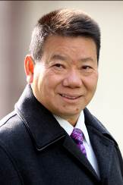 | Man, Manfred | Cup – Pleasure Gains
 | Age 57, Manfred Man rode competitively in Hong Kong between 1976/77 and 1982/83 with his triumph in the Queen Elizabeth II Cup on Go-Getter most memorable. He then worked through the training ranks, most notably with John Moore, and received a full trainer's licence in 2001. He prepared Great Achievement to win the 2003 Hong Kong International Sale bonus and has improved his winner tally steadily in recent years achieving his best total of 43 winners in 2009/10, the season in which he won five races apiece with the griffins London China Town and Tai Sing Yeh. The former horse also won the 2009 Hong Kong International Sale bonus, as did Pleasure Gains in 2013/2014. Man enjoyed a first HKG1 triumph with Eagle Regiment in the Kent & Curwen Centenary Sprint Cup in 2012 and brought the horse back from injury to win the same race in 2013. He has 12 wins this season for a total of 359 HK wins.

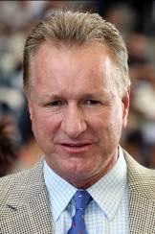 | Millard, Tony | Mile – Ambitious Dragon; Sprint – Golden Harvest
 | Age 53, Tony Millard was a multiple champion trainer in South Africa. He trained three Horses of the Year there in Empress Club, Jet Master and Surfing Home as well as numerous other champions, and he has won every major race in South Africa. He sent out 39 G1 winners in his first nine years of training before relocating to Hong Kong. He made an immediate impact locally, winning the 2000 Hong Kong Derby in his first season, with Keen Winner. But his most spectacular successes in Hong Kong have come with two-time Horse of the Year Ambitious Dragon. The stable star won the HKG1 Hong Kong Derby and G1 QEII Cup in 2010/11, and his 2011/12 campaign brought stunning wins in the HKG1 Stewards' Cup and Citibank HK Gold Cup. In the 2012/13 season he landed the G1 LONGINES Hong Kong Mile and HKG1 Queen's Silver Jubilee Cup. Millard also took Hong Kong's star mare Sweet Sanette to Royal Ascot in 2011 where she finished third in the G1 King's Stand Stakes. Last season Super Lifeline took the HKG3 Hong Kong Macau Trophy. He has 9 wins this term for an HK total of 454.

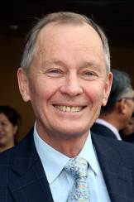 | Moore, John | Cup – Designs On Rome, Same World; Mile – Able Friend, Secret Sham  Vase – Dominant; Sprint – Sterling City, Flagship Shine
 | Age 64, Moore has been involved in Hong Kong racing since the professional era commenced in 1971 and is Hong Kong's winning-most trainer with 1397 career wins. He began training in 1985, before which he held the position of assistant trainer to his late famous father, George. In 2007 he prepared an international G1 double thanks to Viva Pataca in the QEII Cup and Able One in the Champions Mile and, in a feat perhaps unprecedented in the sport, won the same two races with the same two horses three years later. Moore is the first trainer to send out 1,000 winners in Hong Kong and has been the leader in prize-money won for the past nine seasons. His total prize money of over HK$136.7 million won in 2013/14 smashed Tony Cruz's HK prize-money record of HK$114 million and raised his career total to over HK$1.3 billion. After a 17-year gap, he clinched a sixth Trainers' Championship with a strong finish to the 2010/11 season. He finished third in the table in the 2013/14 season with 55 winners. His big-race triumphs also include further successes in the Champions Mile (2011 & 2012 Xtension, 2013 Dan Excel), Hong Kong Mile (2011 Able One) and QEII Cup (2013 Military Attack, 2014 Designs On Rome). His first overseas G1 came with Military Attack in the 2013 SIA Cup and he saddled Dan Excel to win that prize in 2014. Between times, Sterling City won the 2014 G1 Dubai Golden Shaheen and Dominant landed the 2013 G1 HK Vase. 2013/2014 also saw Moore dominate the four-year-old series with Able Friend (HK Classic Mile) and Designs On Rome (HK Classic Cup & HK Derby).

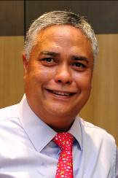 | O’Hara, John | Sprint – Spalato
 | Singapore trainer John O’Hara, 51, started out as assistant to his cousin, Ivan Allan, and was first granted a trainer’s licence in Singapore in 1992. He then moved to Penang, Malaysia, in 1997, before relinquishing his trainer’s licence in January 2000. O’Hara then worked as an assistant to Malcolm Thwaites and then Charles Leck, before he obtained a new license and returned for a second stint as a trainer in Singapore in 2009. Having saddled more than 200 winners in his training career, including 34 wins so far this year (as of 27 Nov), Spalato is by far his most successful horse to date. The gelding won him his first G1 in Singapore in the Patron's Bowl (SIN G1) in June 2014, and then captured the prestigious Singapore Derby (SIN G1) three weeks later. Ghozi also brought him key victories in the Stewards' Cup (SIN G2) in 2010, and the Kranji Sprint (SIN G3) in 2011. O’Hara saddled Spalato to run 13th in the G2 Jockey Club Sprint at Sha Tin in November.

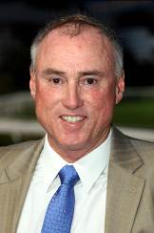 | O’Sullivan, Paul | Sprint – Aerovelocity
 | Age 55, Paul O'Sullivan was Champion Trainer in New Zealand on 11 occasions, acting in partnership with his father Dave for 17 years. He won the G1 Japan Cup in 1989 with Horlicks and added scores of other majors on both sides of the Tasman Sea, including the G1 Cox Plate with Surfers Paradise in 1991. He arrived in Hong Kong to train in 2004 and his most memorable win came in the 2007 HKG1 HK Derby with Vital King. Fellowship took the HKG1 Stewards' Cup in 2010 and Aashiq was a standard-bearer in the 2011/12 season, winning a pair of HKG3 races. In the 2013/14 season Aerovelocity was the star, notching five straight wins including the HKG3 Sha Tin Vase, and the gelding has won the HKG2 Premier Bowl this term. O'Sullivan has 8 wins this season for a HK total of 263.

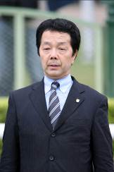 | Sameshima, Ippo | Sprint – Little Gerda
 | Age 60, Ippo Sameshima first took out a licence in 1999 and recorded his first winner in May 2000. He now has a career total of 408 victories of which 28 have come this year (as of 24 Nov). His 2014 wins include the G2 Centaur Stakes and G3 Kitakyushu Kinen. His best horses so far have been three-time group winner Silk Famous, as well as two JRA Summer Sprint Series champions – 2011 HK Sprint runner Pas de Trois, and Little Gerda, his LONGINES HK Sprint representative this year.

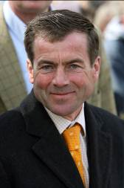 | Schiergen, Peter | Vase – Empoli
 | After a successful youth career in showjumping, Peter Schiergen, age 49, went on to become Germany’s champion jockey five times, including in 1995 when he notched a European record 273 wins. He retired from the saddle in 1997 with 1,471 wins and took over the stable of his old boss Heinz Jentsch in 1998. That year, Tiger Hill won the German 2,000 Guineas, Grosser Preis von Baden (a victory he would repeat in 1999) and was third in the Prix de l’Arc de Triomphe. Schiergen has won the G1 Deutsches Derby four times with Boreal (2001), Schiaparelli (2006), Kamsin (2008) and Lucky Speed (2013). Neatico and Nymphea gave him two further top level successes in 2013 and Empoli has given him a G1 win this year in the Preis von Europa. His major triumphs also include Boreal’s 2002 G1 Coronation Cup victory and his handling of the brilliant Danedream. The latter scored five G1 wins including Europe’s two greatest middle-distance prizes, the King George VI & Queen Elizabeth Stakes (2012) and the Prix de l’Arc de Triomphe (2011), as well as two wins back-to-back in the Grosser Preis von Baden (2011 & 2012).

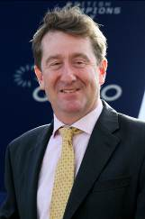 | Simcock, David | Mile – Trade Storm
 | Age 42, Newmarket trainer David Simcock learned his trade with top rank trainers Ian Balding, Major Dick Hern and Luca Cumani before heading out on his own in 2004. He has enjoyed notable successes since then. Dream Ahead would be the pick of his achievements to date; the strapping sprinter was rated higher than the great Frankel as a two-year-old in 2010 after winning the G1 Prix Morny and G1 Middle Park Stakes. Simcock sent out the colt to win the G1 July Cup, G1 Haydock Sprint Cup and G1 Prix de la Foret as he was crowned Europe’s Champion Sprinter. Further G1 success came in 2012 with I’m A Dreamer in the Beverley D Stakes: this year he has saddled three G1 winners in Sheikhzayedroad (Northern Dancer Turf Stakes), Trade Storm (Woodbine Mile) and Madame Chiang (British Champions Fillies and Mares Stakes).

 | Size, John | Cup – Endowing; Mile – Glorious Days; Vase – Khaya
 | Age 60, John Size was a top trainer in Sydney before his arrival in Hong Kong in 2001 with a reputation for improving and rekindling the spark in his horses. He broke the mould by winning the trainers' premiership in his very first season, adding six more titles in 2003, 2004, 2006, 2008, 2010 and 2012. He was level with Caspar Fownes at the end of 2013/14 with 62 wins apiece but Fownes won the title on count-back with one more second-place finisher. He has trained the winners of two Horse of the Year titles, the multiple HKG1 scorers Electronic Unicorn and Grand Delight. He also won the QEII Cup in 2004 with longshot River Dancer, the same year he secured two Triple Crown legs via Super Kid. In 2009/10 he trained Brave Kid to equal the then record of six wins in a season, and Entrapment who finally broke that record with seven victories in just five months. He enjoyed a first HKG1 HK Derby win in 2012 thanks to Fay Fay and in the 2012/13 season Glorious Days landed both the G2 Jockey Club Mile and HKG1 Stewards' Cup before going on to take the G1 HK Mile in 2013. His 10 wins this season take his HK career total to 831.

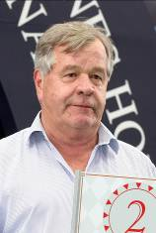 | Stoute, Sir Michael | Vase – Snow Sky
 | Age 69, Sir Michael Stoute moved to England from Barbados aged 20 and was licensed to train in 1972. He has been crowned Britain's champion trainer on 10 occasions - the first on 1981 and the latest in 2009. His G1 wins include four in the Breeders' Cup Turf, 15 English Classics including five Derbies at Epsom, two Japan Cups, a Dubai World Cup and even a Champion Hurdle. The most famous of his stars remains the ill-fated Shergar, but he has trained numerous international champions, notably Dubai World Cup and Japan Cup winner Singspiel and Breeders’ Cup Turf winner Pilsudski, as well as 2,000 Guineas and King George VI and Queen Elizabeth Stakes winner Golan. In Hong Kong he won the Vase in 2000 with Daliapour and the International Bowl in 1994 with Soviet Line. In 2008 he finally completed his set of all five English Classics when subsequent dual Breeders' Cup Turf winner, Conduit, landed the St Leger. In 2010, Harbinger won the G1 King George at Ascot by 11 lengths and Workforce won both the Derby and the Arc. In 2013 he saddled the Queen’s Estimate to give the British monarch her first G1 Ascot Gold Cup win. This year Integral notched G1 wins in the Falmouth Stakes and the Sun Chariot Stakes, and Hillstar captured the G1 Canadian International.

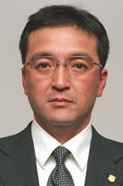 | Takagi, Noboru | Sprint – Snow Dragon
 | Age 49, Noboru Takagi received his JRA training license in 2006 and has since saddled 129 winners including 15 this season (as of 23 November). The current 2014 season is the most successful for him to date, as he has notched the first three graded race wins of his career, most prominently his maiden G1 victory with Snow Dragon in the G1 Sprinters Stakes in October.

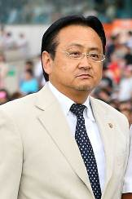 | Uehara, Hiroyuki | Cup – Meiner Lacrima
 | Age 57, Hiroyuki Uehara obtained his JRA training license in 1993 and has since trained no less than 352 winners (as of 23 November), including 12 this season. His best known horse to date is the top-class Daiwa Major whose five G1 wins included the Tenno Sho Autumn in 2006 and Yasuda Kinen in 2007.

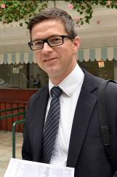 | Varian, Roger | Cup – Farraaj
 | Age 35, Roger Varian is one of the UK’s brightest young trainers. After spending six months riding out at Hollywood Park at age 15, he rode a handful of winners as an amateur and conditional jockey over jumps in Britain, as well as three during a spell in Maryland, USA. He was the late Michael Jarvis’s assistant at Kremlin House Stables in Newmarket from 2001 until he took the reins in March, 2011. He saddled his first G1 winner that October when Nahrain took the G1 Prix de l’Opera and the filly also provided his second in 2012, winning the Flower Bowl Invitational in the US. Another filly, Ambivalent, won the G1 Pretty Polly Stakes in 2013, the same year that his best horse to date emerged. Kingston Hill won that season’s G1 Racing Post Trophy and this year, after running 2nd in the G1 Derby at Epsom, gave Varian a first Classic win in the G1 St Leger in September. Three more G1s followed in a golden autumn as Cursory Glance won the Moyglare Stud Stakes, Belardo the Dewhurst and Vert De Grece the Criterium International.

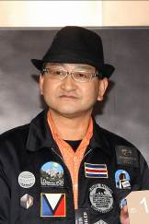 | Yahagi, Yoshito | Mile – Grand Prix Boss
 | Age 53, Yoshito Yahagi received his JRA trainers' licence in 2004 and has since risen to rank as one of the top JRA trainers. He has sent out no less than 374 winners (as of 23 November) including 49 this season, which sees him sit 2nd in the JRA trainer’s premiership. So far he has won 20 Group races in Japan. Grand Prix Boss has given him two G1 wins in the 2010 Asahi Hai Futurity and 2011 NHK Mile Cup, but his greatest success came with Deep Brillante in the 2012 Japanese Derby.

