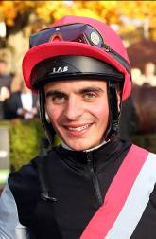 | Atzeni, Andrea
 | Age 23 and a graduate of the British Racing School, Atzeni is one of Europe's emerging talents. He began his career as an apprentice to Newmarket trainer Marco Botti in 2007. His first season on the track in 2008 brought 30 winners and he has progressed since - 2014 yielded a career peak 125 winners in Britain. He notched the first of six G1 wins atop Sortilege in the 2012 Premio Lydia Tesio and last year he added the G2 Italian Derby to his resume and followed-up with G1 wins on Seismos in the Grosser Preis Von Bayern and aboard leading two-year-old Kingston Hill in the Racing Post Trophy. He partnered the last-named to finish 2nd in the G1 Derby at Epsom in June and landed a first classic on the colt in September’s G1 St Leger. Since then he has enjoyed a golden autumn with G1 wins in the Moyglare Stud Stakes (Cursory Glance), Dewhurst Stakes (Belardo) and again in the Racing Post Trophy (Elm Park). Announced as first rider to Qatar Racing from January, he is currently enjoying a three-month contract in Hong Kong and has notched two wins (as of 1 December).

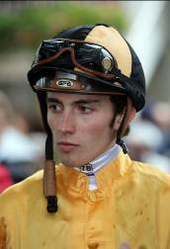 | Boudot, Pierre-Charles
 | Age 21, Boudot’s father, the late Marc Boudot, was a trainer in central France. He attended the jockeys’ school at Govieux before joining the inimitable Andre Fabre as an apprentice. He notched his first win in April 2009 and had 12 Pattern race successes on the board before clicking a maiden G1 triumph atop Gallante in this year’s Grand Prix de Paris in July. He soon followed up as he took a tactical running of the G1 Prix Rothschild in August on Esoterique. He was licensed to ride in Japan from the end of October until the end of December, based at Ritto with trainer Yatsutoshi Ikee, primarily to ride for owner Katsumi Yoshida. So far he has nine wins on the board (as of 1 December).

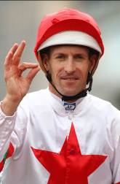 | Bowman, Hugh
 | Age 34, Bowman boasts an outstanding career record with more than 1500 wins including many of the major races on the Australian racing calendar. He has claimed the Sydney Jockeys' Championship on two occasions, taking the title for the 2007/2008 racing season with 150 wins at a winning percentage of 20%, and again in 2011/2012 with 140 wins at 19%. Over 30 wins at G1 level include the 2010, 2011 and 2013 renewals of the AAMI Victoria Derby on Lion Tamer, Sangster and Polanski respectively. He is also known to Hong Kong racing participants having competed in the 2009 IJC and completed a three-month contract in Hong Kong at the end of the 2013/14 season, during which time he notched 13 wins. He has already notched four G1 wins in Australia this season (as of 1 December), the latest being Terravista in the G1 Darley Classic. In April he partnered Criterion to win the G1 Australian Derby.

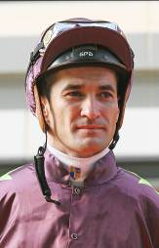 | Brown, Corey
 | Age 38, Australian rider Corey Brown is currently based in Singapore and sits third in the premiership with 64 wins. He gained his first Singapore G1 win in November when Quechua took the Singapore Gold Cup. Brown enjoyed his biggest career victory in 2009 when he rode Shocking to G1 Melbourne Cup success, one of no less than 35 wins in the highest grade. His grandfather, Jack, and father, Trevor, were jockeys before him. He was apprenticed to Eric Andersen at Kempsey at age 15 and rode his first winner there in 1991. His first G1 win came in 1998 on Camino Rose and in 2001/02 he won his first Sydney Premiership with 106 wins. On Epsom Day at Randwick in 2003 he rode four winners including a G1 hat-trick on Clangalang (Epsom Handicap), Niello (Spring Champion Stakes) and Unearthly (Flight Stakes). In 2005 Brown left Australia for the first of two stints in Hong Kong. After returning to Australia, between February and May 2008 he partnered Apache Cat to five uninterrupted G1 wins (Lightning Stakes, Australia Stakes, T J Smith Stakes, BTC Cup and Doomben 10,000) as well as a close third in that year’s G1 Hong Kong Sprint.

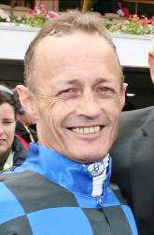 | Browne, Damian
 | Age 41, Browne has partnered Queensland’s crack sprinter Buffering in the majority of his starts, including to four G1 wins in the 2013 Manikato Stakes, VRC Sprint Classic and Winterbottom Stakes and this season’s Moir Stakes. He broke both legs in a fall in 2006 and spent a prolonged period on the sidelines. Since returning to action he has established himself as one of Australia’s top riders, with an impressive strike-rate, and enjoys a profitable association with Queensland’s champion trainer Robert Heathcote. Other major wins include the G1 Queensland Oaks (2012 Quintessential), the Oakleigh Plate (2012 Woorim) and the BTC Cup (2010 Albert The Fat).

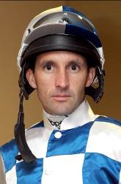 | Callan, Neil
 | Age 36, Neil Callan has, over the past several seasons, been ranked in the top echelon of riders in the UK and finished runner-up in the championship there in 2005 (151 wins) and 2007 (170 wins). He has ridden the winners of 8 international Group 1 races: the Middle Park Stakes (2005 Amadeus Wolf, 2013 Astaire), Racing Post Trophy (2005 Palace Episode), Nunthorpe Stakes (2009 Borderlescott), Fillies' Mile (2009 Hibaayeb), two atop Pressing (2007 Premio Roma & 2009 Grosser Dallmayr-Preis Bayerisches Zuchtrennen) and the Gran Premnio del Jockey Club (2010 Rainbow Peak). He also partnered Pressing to win Turkey's International Topkapi Trophy (G2) in three successive years culminating with the 2010 renewal. In May 2014 he notched his first HKG1 on Blazing Speed in the Standard Chartered Champions & Chater Cup and added the 2014 G2 LONGINES Jockey Club Cup on the gelding. He first rode in HK in the 2010/11 season and rode five winners. He notched 12 in 2011/12, a further nine in 2012/13, and in an extended stay in 2013/14 he rode 27. He has 17 wins this season for a HK total of 70 (as of 1 December).

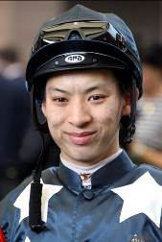 | Chadwick, Matthew
 | Age 24, Matthew Chadwick had ridden 273 Hong Kong winners by the end of the 2013/14 season, 38 of them in that injury-interrupted campaign. He was champion apprentice in 2008/09, and finished fourth in the jockeys' premiership in 2009/10, even though he only became a fully-fledged jockey in the middle of that season. He was indentured to the stable of Tony Cruz before earning a full jockey's licence in January 2010. He rode his first Group race winner on Egyptian Ra in the HKG3 National Day Cup in October 2009 and is most famous for his partnership with California Memory. The pair took the 2011 HKG1 Hong Kong Gold Cup before Chadwick became the first homegrown rider to win an HKIR when clinching the G1 Hong Kong Cup on the grey in December, 2011 - a victory they repeated in 2012. As well as that second Hong Kong Cup triumph, the 2012/13 season saw Chadwick and California Memory land the G2 Jockey Club Cup and the HKG1 Champions & Chater Cup. He earned international acclaim in August 2012 when winning the prestigious Silver Saddle as the top rider at Ascot's Shergar Cup, a feat that helped his Rest of the World team clinch the coveted cup. Chadwick notched his 250th win in Hong Kong with Majestic Anthem on 26 December 2013 and rode his first Hong Kong four-timer at Sha Tin on 22 June, 2014. He has 11 wins in HK this term for a total of 284 (as of 1 December).

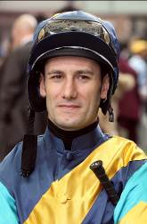 | Demuro, Mirco
 | Age 35, Italy's five-time champion jockey hails from a family of jockeys and is a familiar face on the JRA circuit in Japan alongside his brother, Cristian. Of his 23 career G1 wins, nine have been achieved in Japan. Among those major wins are the 2003 Japanese Derby, the 2008 Japan Cup, the 2010 Arima Kinen, the 2012 Tenno Sho Autumn and the 2014 Takamatsunomiya Kinen. This summer he added a German Classic to his haul thanks to Feodora in the G1 Preis der Diana. In all, he has won four Japanese classics and seven Italian classics, as well as further top level races in France and Dubai. Perhaps his most famous victory came atop the Japanese raider Victoire Pisa in the 2011 Dubai World Cup. He has won over 2,700 races in no less than 10 countries. He notched 12 wins during his first short-term Hong Kong contract in the 2013/14 season, including the HKG1 Stewards' Cup on Blazing Speed and has 6 wins in his current spell.

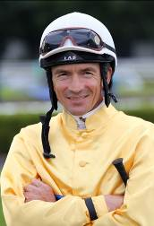 | De Vries, Adrie
 | Age 45, Dutchman Adrie de Vries won his homeland’s Derby five times between 1991 and 1999. He has since made his name as an accomplished race rider across Europe, particularly in Germany, and in the Middle East where his skills aboard Purebred Arabians are particularly sought after. He enjoyed a G1 breakthrough when notching his first European Classic atop Gyreka in the 2005 Oaks d’Italia. His five career G1s also feature the Grosser Preis von Baden (2009 Getaway), Rheinland-Pokal (2010 Campanologist) and Preis von Europa (2013 Meandre, 2014 Empoli). He has also won Pattern races on German stars such as Ivanhowe, Pastorius, and Precious Boy on whom he won the 2008 G2 German 2,000 Guineas.

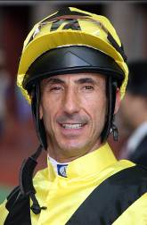 | Doleuze, Olivier
 | Former champion apprentice in France, Olivier Doleuze, 42, rode mostly for Criquette Head-Maarek in his homeland where he enjoyed Classic wins on Green Tune and Egyptband. He also won the 2001 Singapore Airlines KrisFlyer Sprint (Singapore G1) for the same stable on Iron Mask. He enjoyed his best Hong Kong season in 2006/07 when he rode 67 winners, the highlight being his victory on The Duke in the G1 Hong Kong Mile, a race he won again in 2007 and 2009 on the great Good Ba Ba. Other major HK wins include the HKG1 Chairman's Sprint Prize (2011 Dim Sum), the Hong Kong Classic Cup (2012 Zaidan), the Centenary Sprint Cup (2012 & 2013 Eagle Regiment), and in the 2013/14 season the G2 Jockey Club Mile, HKG2 Sha Tin Trophy and HKG3 National Day Cup on Gold-Fun. He also won the 2014 G3 Mahab Al Shimaal in Dubai on Rich Tapestry whom he partnered to win the G1 Santa Anita Sprint Championship in the USA in October. He ranked sixth in the jockeys' standings with 40 wins in 2013/14, bringing his Hong Kong career total to 506. He has a further 4 HK wins this season (as of 1 December).

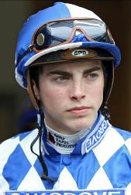 | Doyle, James
 | Age 26, James Doyle is one of British racing’s brightest talents and has emerged in recent seasons as an accomplished big-race jockey with his 12 career G1 wins achieved in the past three seasons. He was recently appointed as one of Godolphin’s two retained riders. His G1 breakthrough came in the 2012 Dubai Duty Free in which he made the running on wide-margin winner Cityscape for trainer Roger Charlton. The following year he partnered Charlton’s Al Kazeem for G1 wins in the Tattersalls Gold Cup, Prince of Wales’s Stakes and Eclipse Stakes, and was aboard Rizeena in the G1 Moyglare Stud Stakes. He was first-choice rider for Prince Khalid Abdullah for the 2014 season and partnered Europe’s champion miler Kingman to four G1 wins in the Irish 2,000 Guineas, St James’s Palace Stakes, Sussex Stakes and Prix Jacques le Marois. He also forged a great partnership with the Prince’s Noble Mission, the great Frankel’s brother, winning three more G1s in the Tattersalls Gold Cup, Grand Prix de Saint-Cloud and Champion Stakes at Ascot.

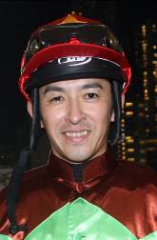 | Fukunaga, Yuichi
 | Age 37 and one of the stars of Japanese racing, former Rookie of the Year Yuichi Fukunaga has 1767 career wins (as of 1 December) and has twice been Japan’s champion jockey (2011 & 2013). He first made his mark at the top level with victory in the 1999 Oka Sho atop Primo Ordine. His five overseas G1 triumphs include this year’s Dubai Duty Free on Just A Way, the 2005 American Oaks on his Yushun Himba heroine Cesario and Eishin Preston’s wins in the Hong Kong Mile (2001) and QEII Cup (2002 & 2003), and he has no less than 23 G1 wins to his name. Further G1 wins in his homeland include the Tenno Sho Autumn, Yasuda Kinen and Kikuka Sho. His father was the famous jockey Yoichi Fukunaga.

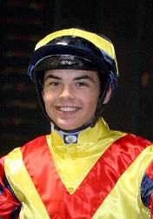 | Guyon, Maxime
 | Age 25, Maxime Guyon started his riding career with Andre Fabre in 2005 and has been stable jockey to the mighty French stable since 2009. Fabre once said he believed his protégé had the innate talent to become one of the best jockeys of all time. After gaining his senior licence in January 2008, Guyon's career blossomed with G1 victories in quick succession on Cavalryman (Grand Prix de Paris), Shalanaya (Prix de l'Opera), Cutlass Bay (Prix Ganay), Lope De Vega (French Derby & French 2000 Guineas) and Byword (Prince of Wales’s Stakes). His haul of over 1000 wins includes 22 at G1 level, among them four European classics. He has two top level wins on the board so far this year with Miss France in the 1,000 Guineas at Newmarket and Baltic Baroness in the Prix Vermeille. He enjoyed a good stint in Hong Kong during the 2010/11 season, during which he partnered Horse of the Year Ambitious Dragon to victories in the HKG1 Hong Kong Derby and HKG1 Hong Kong Classic Cup.

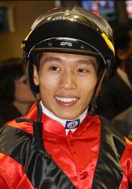 | Ho, Vincent
 | Age 24 and a graduate of the Hong Kong Jockeys’ School, Vincent Ho racked up 44 wins as a young rider in New Zealand under the tutelage of leading trainer Lance O'Sullivan. He made an impressive start to his Hong Kong riding career with 10 wins in his first season in 2009/10, including a hat-trick he achieved in May 2010, on only his fourth raceday in Hong Kong. His skill as well as his claim saw him in strong demand as he scored 39 times in 2010/11 to seal the Champion Apprentice title. Supported by his former boss, Caspar Fownes, Ho has continued to progress and this season he sits fifth in the premiership with 14 wins (as of 1 December), including victory in the HKG3 National Day Cup on Bundle Of Joy.

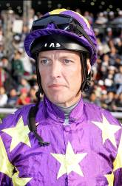 | Hughes, Richard
 | Age 41, Richard Hughes is one of the sport’s most stylish and accomplished riders, and with 161 wins this past season, he recently clinched a third consecutive UK jockeys’ title. His career so far has yielded more than 2550 wins in Britain and Ireland and many more worldwide, as well as 42 G1 successes. In 2013 he notched nine G1 wins, including a first British Classic win with Sky Lantern in the English 1,000 Guineas. This year he has notched a further four top-flight wins with Toronado (Queen Anne Stakes), Sole Power (King’s Stand Stakes & Nunthorpe Stakes) and the flying juvenile Tiggy Wiggy (Cheveley Park Stakes). Hughes is first jockey to his brother-in-law Richard Hannon, and like his late father before him, has also tasted top level success as a rider over hurdles.

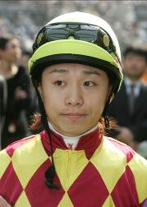 | Ikezoe, Kenichi
 | Age 35, Ikezoe, son of a steeplechase jockey and trainer, obtained his JRA jockey license in 1998 and was crowned the Champion Apprentice Jockey in Japan with 38 wins the same year. He has ridden no less than 912 winners, including 43 of them this season (as of 1 December). At least 21 of his career victories are at G1/ JPN G1 level. He enjoyed a very successful partnership with Orfevre, winning six G1s atop the 2011 Japanese Horse of the Year, including all three legs of the Japanese Triple Crown the same year. He has also teamed up with Curren Chan, Sweep Tosho, Dream Journey and Durandal for G1 successes in Japan.

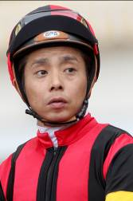 | Iwata, Yasunari
 | Age 40, Iwata made a hugely successful transition from the regional NAR circuit to the major league of the JRA in Japan in 2006, and has already ridden more than 1,300 winners to date, taking his career total wins to over 4,300. With 130 wins (as of 1 December) he ranks second in the JRA’s jockey premiership this season. He also won the World Super Jockeys Series as a NAR jockey in 2005 and was crowned JRA Champion Jockey twice, in 2011 and 2012 (number of races won and money earned). An established big-race rider in his homeland these days, he has won all Japanese classic races at least once and has no less than 32 G1/JPN G1 victories, including the Japan Cup three times. He also earned overseas G1 successes when partnering Delta Blues to win the Melbourne Cup in 2006, and back-to-back LONGINES Hong Kong Sprint wins in 2012 and 2013 with last year’s Japanese Horse of the Year Lord Kanaloa. This year he has added two more G1s atop Nuovo Record in the Japanese Oaks, and most recently with Danon Shark in G1 Mile Championship.

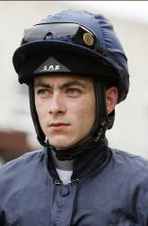 | Lordan, Wayne
 | Age 32, Lordan, the son of amateur rider Pat Lordan, started out as an apprentice to Thomond O’Mara and was runner-up in Ireland’s 2001 apprentice championship. He notched a major milestone with a first G1 win atop Sole Power in the 2010 Nunthorpe Stakes. He had to wait three years for a follow-up and that came thanks to Sudirman in the 2013 Phoenix Stakes. His top-flight tally now stands at four as a result of Slade Power’s two G1 wins this year in the Diamond Jubilee Stakes and July Cup. All his G1 wins have come on sprinters and he has forged a good partnership with Gordon Lord Byron in recent months, winning the G2 British Champions Sprint on the gelding in October.

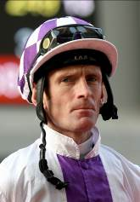 | Manning, Kevin
 | Age 47, Manning started out with Jim Bolger in 1982 and is married to the trainer’s daughter. He was twice Ireland’s champion apprentice (1984 & 1987) and became the stable’s number one rider in 1993. His first classic success came in 2002 when he guided Margarula to G1 Irish Oaks success. He has no less than 30 G1 wins on the board including the English Derby in 2008 atop New Approach, on whom he also won the Irish and the English Champion Stakes. That colt was one of five Dewhurst Stakes winners in seven years for Manning and Bolger. The most recent of the quintet, Dawn Approach, went on to win the 2,000 Guineas at Newmarket in 2013. He clinched a first G1 Irish Derby win with Trading Leather that year, too. He has also ridden star runners Finsceal Beo, Teofilo, Lush Lashes, Saoirse Abu and Eva Luna. The most prolific of all was the mare Alexander Goldrun, on whom Manning won five G1s in four countries, including a short-head victory over Bullish Luck in the 2004 Hong Kong Cup.

Maruta, Kyosuke
Age 28, Kyosuke Maruta received his JRA riding license in 2007. He has ridden 280 wins in his career, including 25 this term (as of 1 December). He has three career wins at graded race level, including two this year with his JRA Summer Sprint Series winner and LONGINES HK Sprint contender, Little Gerda, in the G2 Centaur Stakes in September and G3 Kitakyushu Kinen in August.

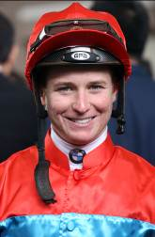 | McDonald, James
 | Age 22, James McDonald made a big impression in Hong Kong when he debuted in the 2011 LONGINES IJC, with the precocious Kiwi finishing runner-up to Frankie Dettori. Champion Apprentice in his homeland, he went on to claim the Premiership there twice, latterly with a New Zealand record tally of 207 for the 2010/2011 season. In 2012 he won a first New Zealand Derby and gained wider international exposure that May when winning the G1 Champions Mile at Sha Tin on Xtension. Now based in Australia, he clinched his first Sydney Premiership in July, 2014, with 72 wins on the board, riding two winners on the final day of the season to draw that number clear of Nash Rawiller. He currently leads the NSW Premiership with 35.5 wins (as of 1 December). The first of his 22 career G1 wins came in the 2008 New Zealand Bloodstock Breeders Stakes and his most recent was October’s Caulfield Guineas aboard Shooting To Win. His career total already stands at just over 1000 wins.

Miura, Kosei
Age 24, Kosei Miura shot to fame after receiving his JRA jockey license in 2008. With a total of 91 winners that season, he earned the Champion Apprentice Jockey title and in doing so eclipsed the 69-win record set by Yutaka Take in 1987 for the number of wins ridden by an apprentice. He also rode his 100th win in February 2009, 11 months after his debut, two months faster than Take’s record. He has ridden 496 wins in his career, including 69 this season. So far he has eight graded race wins, most recently with Robe Tissage in the G3 Keeneland Cup this August.

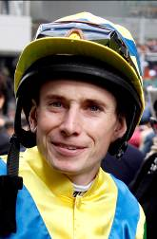 | Moore, Ryan
 | Age 31, combative, driven, tactically astute and naturally gifted, three-time UK champion jockey Ryan Moore is one of the finest riders in the world and is the winner of this year’s inaugural World’s Best Jockey Award. His 53 career G1 wins include the 2009 AP QEII Cup on Presvis and the 2010 Hong Kong Cup atop Snow Fairy - a filly he partnered to five G1 wins in four countries, including two classics and back-to-back wins in Japan’s QEII Commemorative Cup. Other highlights include Workforce’s wins in the 2010 Derby and Prix de l’Arc de Triomphe, Breeders’ Cup Turf victories on Conduit and Magician, the 2013 Derby success of Ruler Of The World, Gentildonna’s Japan Cup win and this year’s Melbourne Cup victory on Protectionist. That last-named is one of 15 G1 wins in seven countries so far this year including the Cox Plate, Canadian International, Irish Champion Stakes, Yorkshire Oaks, Prix du Jockey Club, Irish 1,000 Guineas and Dubai Sheema Classic. He has twice won the LONGINES IJC (2009 [dead-heat] & 2010) in Hong Kong.

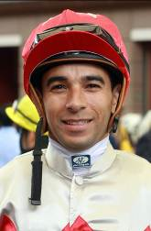 | Moreira, Joao
 | Age 30, Joao “Magic Man” Moreira leads the Premiership in Hong Kong this season. Champion Jockey in Singapore in 2010, 2011, 2012 and 2013, he relocated to Hong Kong in October 2013 and rode 97 wins to finish 2nd in the premiership . He achieved a second career eight-timer when winning on all eight of his mounts at Kranji in September, 2013. Moreira’s early career achievements in South America brought over 1,000 wins and two Brazilian Eclipse Awards as well as a notable victory in the G1 Derby Argentino in 2006 on Eu Tambem. His major highlights in Hong Kong include the HKG1 Hong Kong Classic Mile on Able Friend and the HKG1 Citibank Hong Kong Gold Cup on Military Attack. He also partnered Amber Sky and Sterling City to a famous G1 double at the 2014 Dubai World Cup meeting and has grabbed G1 wins this year in Australia in the Coolmore Stud Stakes and Epsom Handicap. Moreira spectacularly landed the LONGINES IJC spoils in 2012 with a last race victory. He has 36 HK wins this season for a total of 136 (as of 1 December).

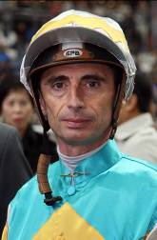 | Mosse, Gerald
 | A former champion apprentice in France, Mosse, 47, has ridden more than 50 G1 wins in Europe and holds the record of most wins at the LONGINES HKIR with eight victories. His career highlight remains his Arc triumph on Saumarez in 1990 although his famous victory in the 150th Melbourne Cup on board Americain in November 2010 has to run it close. He has also won all the French Classics and all classic races in Hong Kong. He has won three Hong Kong Derbies, a Champions Mile with Bullish Luck in 2005 and he notched three Group 1 successes on Beauty Flash in the HK Mile, the Stewards' Cup, and the Queen's Silver Jubilee Cup in 2010/11. In December 2012 he partnered Red Cadeaux to a memorable win in the G1 Hong Kong Vase. This year he added another G1 win to his tally as he partnered Garswood to victory in the G1 Prix Maurice de Gheest. He ended the 2013/14 HK season with 24 wins and he already has 12 this term for a HK career total of 615 (as of 1 December).

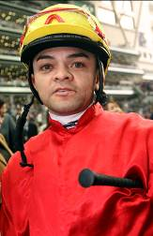 | Nunes Manoel
 | Age 39, Brazilian ride Manoel Nunes is set for a first Singapore championship this year as he leads the premiership with 102 wins (as of 1 December), 24 clear of nearest rival Danny Beasley. Now based in Singapore, Nunes made his name in Asia with six championship wins in Macau, his first in 2004/05. He partnered a record 122 wins in taking that first premiership and in 2010 he became the first jockey to partner a horse to all three legs of the Macau Triple Crown when Luen Yat Forever triumphed. In May 2011 he became the first rider to reach 700 Macau wins. Born in north-eastern Brazil, Nunes has ridden horses since an early age and was competing in local horse sports at age seven. At age 12 his family moved to Sao Paulo and at 18 he joined the Sao Paulo Apprentice Academy. His first win came in 1995 and he gained over 400 wins in Brazil, including the 1997 Triple Crown on Quari Bravo. Nunes has had two spells in Hong Kong, notching 37 wins in 2006/07 and 14 wins in 2007/08.

Ono, Takuya
Age 28, Takuya Ono is famous among Japanese racing fans for being a jockey with a knack for riding long-shot runners, as he landed at least one 100-1 winner in each of his first seven seasons after making his JRA debut in 2006. Ono has ridden a total of 286 winners to date, including 35 of them in 2014 (as of 1 December). He got his first G1 aboard 45-1 chance Snow Dragon in the Sprinters Stakes at Niigata in October. He also partnered Transwarp to win the JRA’s Summer 2000 Series in 2012.

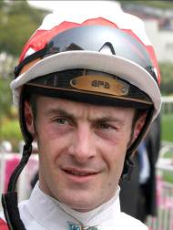 | Peslier, Olivier
 | Age 41, and four times France’s champion jockey, Olivier Peslier has seven LONGINES HKIR wins – Docksider, Hat Trick (Mile ’99, ’05), Patripal, Borgia & Doctor Dino (Vase ’95, ’99, ’07, ’08) and Vision D’Etat (Cup ’09). In October, 2012 he notched a fourth win in the Prix de l’Arc de Triomphe aboard Solemia and he has also won the Japan Cup twice in his career among over 100 G1 wins worldwide. He is associated with the great Goldikova, whom he partnered to 14 wins including three G1 Breeders’ Cup Miles, and champions such as Peintre Celebre, Zenno Rob Roy and Banks Hill. In 2012 he rode Cirrus Des Aigles to wins in the G1 Dubai Sheema Classic, G1 Prix Ganay and G2 Prix Dollar and 2013 brought a second G1 Prix du Jockey Club win, thanks to Intello, 16 years after his first on Peintre Celebre. His two G1 wins in 2014 have come on Charm Spirit in the Prix Jean Prat and Ascot’s Queen Elizabeth II Stakes.

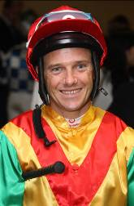 | Prebble, Brett
 | Aged 37, Prebble is a former champion apprentice and twice champion jockey in Melbourne. His Hong Kong breakthrough came aboard Precision in the HKG1 Champions & Chater Cup in 2003. In 2005 he added the G1 Australia Stakes on Cape Of Good Hope, and the Champions Mile and 2006 Yasuda Kinen on Bullish Luck. In 2009/10 he scored a G1 treble on board Sacred Kingdom in the HK Sprint, Centenary Sprint Cup, and Chairman's Sprint Prize. His 2009/10 battle with Douglas Whyte for the Jockeys' Championship, in which he eventually went down by 100-99, was one of the most thrilling in HK's racing history. Prebble's consolation for defeat being his six winning rides at Happy Valley on 20 June, itself a Hong Kong record, which was matched by Whyte in April, 2013. He ended the 2013/14 season with 29 wins and he has 12 this season for a HK total of 671 (as of 1 December). He has enjoyed an illustrious partnership with Lucky Nine, winning top prizes including the G1 HK Sprint (2011) and G1 KrisFlyer International Sprint (2013 & 2014) and the Chairman's Sprint Prize (2013 & 2014), while his career highlight came when victorious on Green Moon in the G1 Melbourne Cup of 2012.

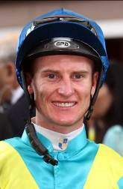 | Purton, Zac
 | Age 31, Zac Purton is Hong Kong’s current Champion Jockey. He notched the fastest 50 in Hong Kong history last term and ended the 2013/14 campaign as the jurisdiction’s second century maker with 112 wins, just two shy of Douglas Whyte’s record. Purton won the Brisbane jockeys' premiership as an apprentice in 2003 before moving to Sydney where he came second only to perennial champion Darren Beadman. His first G1 win came on Excites in the 2006 Produce Stakes at Randwick and his initial major Hong Kong win was in the 2010 HKG1 Stewards’ Cup on Fellowship. Further big-race wins have followed in Hong Kong, notably Ambitious Dragon’s G1 LONGNES Hong Kong Mile in 2012, Military Attack’s HKG1 Hong Kong Gold Cup in 2013 and Dominant’s 2014 G1 LONGINES Hong Kong Vase. His international achievements feature Little Bridge’s G1 King’s Stand Stakes success at Royal Ascot in 2012; Military Attack’s G1 SIA Cup triumph in 2013; and wins this year in the Doncaster Mile, George Main Stakes and Caulfield Cup. Purton won Japan’s World Super Jockeys Series in 2012. He has 27 wins this term for a HK career total of 464 (as of 1 December).

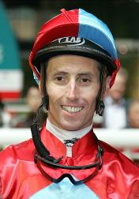 | Rawiller, Nash
 | Age 39, Nash Rawiller is widely considered to be in the top echelon of jockeys in Australia having ridden in excess of 2100 winners and has been crowned Champion Jockey in Sydney on 3 occasions. Rawiller has also achieved a great deal of success at Group level with his 58 G1 victories. Early success at the elite level came on Elvstroem, the champion race mare More Joyous and outstanding colt Pierro on which he won the 2012 Golden Slipper Stakes, 2012 Sires Produce Stakes and the 2013 George Ryder Stakes. Rawiller is currently riding in Hong Kong and has two wins on the board (as of 1 December).

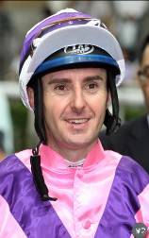 | Reith, Christian
 | Reith, 36, was 6th in the Sydney Jockeys Championship with 44 wins when he relocated to HK near the end of the 2013/14 season. The former Queensland champion apprentice scored his initial G1 success aboard Nechita in the 2012 Coolmore Stud Stakes at Flemington Racecourse before recording his second win at the top level when guiding the Peter Snowden-trained Complacent to victory in the 2013 Spring Champion Stakes at Randwick. Reith, who has also recorded 3 wins at G2 level and 9 wins at G3 level, had his first HK win on his second race day, at Happy Valley on 5 June, 2014. He remained in Hong Kong this season and has two wins on the board (as of 1 December).

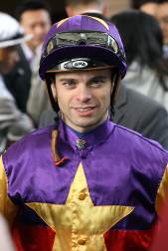 | Rispoli, Umberto
 | Age 26, Italian jockey Umberto Rispoli capped his first stint in Hong Kong with victory on Rulership in the 2012 G1 QEII Cup. He commenced his apprenticeship in his homeland in 2005 and was crowned Champion Italian Jockey in both the 2009 and 2010 racing seasons. That 2009 title came courtesy of 245 wins, a total that bettered the longstanding previous record of 229. He has achieved two G1 victories in Italy on Aoiffe Alainn in the 2010 Premio Lydia Tesio and Estejo in the 2011 Premio Presidente della Repubblica. In early 2011 he rode in Japan, winning the G1 Takamatsunomiya Kinen. He has spent the past three summers/autumns in France and secured further top level success aboard Molly Malone in the 2012 G1 Prix du Cadran and Priore Philip in the 2013 G1 Gran Criterium. This year he has a G1 score on Vert De Grece in the Criterium International. He has 32 HK wins on the board with two this season (as of 1 December).

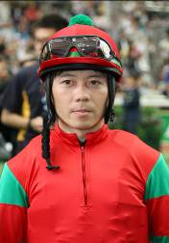 | Shibata, Daichi
 | Age 37, Daichi Shibata obtained his JRA riding license in 1996 and is one of the few Japanese jockeys to have won G1s in both flat and steeplechase races in Japan. His twin brother, Misaki Shibata, is also a JRA jockey. Shibata has won no less than 10 pattern races in his career with his first G1 success coming atop Meiner Neos in the 2011 Nakayama Grand Jump (J-G1). Shibata made it two in a row in the Nakayama Grand Jump in 2012 as he gained success in the same race atop Majesty Bio. In May 2013 he achieved his maiden G1 victory on the flat in the G1 NHK Mile Cup aboard Meiner Ho O. He has 285 career wins from flat and jump races, with 44 achieved in 2014 (as of 1 December).

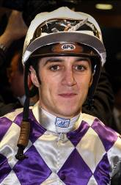 | Soumillon, Christophe
 | Age 33, Christophe Soumillon’s talent in the saddle has brought him over 2,300 wins and to the cusp of a seventh champion jockey title in France this year. Enjoying a second spell as the Aga Khan’s number one jockey, some of his greatest moments have been in the Aga’s green silks, notably two Prix de l’Arc de Triomphe wins on Dalakhani and the brilliant filly Zarkava. He has won no less than 74 G1 races across Europe, Japan, Hong Kong, Dubai, Canada and the USA, including the 2008 G1 Hong Kong Mile on Good Ba Ba. The Belgian rider has had a notable association with Cirrus Des Aigles on whom he won the G1 Prix d’Ispahan and G1 Coronation Cup this year, while Sea The Moon provided him a G1 German Derby success in July. He clinched a famous win atop Epiphaneia in the Japan Cup on 30 November. His Hong Kong experience includes a shared victory in a dead-heat for the 2004 IJC.

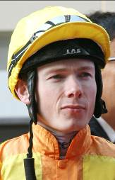 | Spencer, Jamie
 | Age 34, Jamie Spencer was apprenticed to Liam Browne in Ireland and won the G1 Irish 1,000 Guineas on Tarascon at age 17 in 1998. He moved to England after being crowned Ireland’s Champion Apprentice and won a second Irish 1,000 Guineas in 2002 on Gossamer and added a third in 2013 on Just The Judge. He was appointed stable jockey to Aidan O’Brien in 2004 but returned to England in 2005 and two years later shared the title of UK Champion Jockey. He enjoyed a good association with owners Jim & Fitri Hay and rode their Cape Blanco to three G1 successes in North America in 2011 as the horse clinched the US Eclipse Award as Turf Champion. He enjoyed further North American G1 success in 2012 atop Wigmore Hall in the Northern Dancer Stakes and in October that year signed a two-year deal to ride for the Qatar Bloodstock operation. He has notched no less than 34 G1 wins in his career, including this season on Trade Storm (Woodbine Mile) and Just The Judge (E. P. Taylor Stakes) for his main retainer Qatar Racing. He will retire at the end of the year to take up a management role with Qatar Racing.

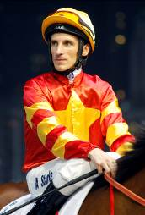 | Starke, Andrasch
 | Age 40, Andrasch Starke began riding as an amateur at age 15. He has been champion jockey in Germany six times while building an international reputation, having competed successfully in Canada, Dubai, France, Italy, Singapore, and the USA, as well as in Hong Kong, where he has twice won the IJC in 2000 & 2005. He has partnered some of Germany’s best horses including Caitano, Elle Danzig, Quijano, Samum, Schiaparelli, Ungaro and Danedream. He has won every G1 in Germany including the Grosser Preis von Baden four times, the Preis der Diana five times and the Deutsches Derby six times. Major international wins include Epalo’s 2004 SIA Cup. He hit a career high when he rode Danedream to win Europe’s two great mile and a half races, the 2011 Prix de l”Arc de Triomphe and the 2012 King George VI & Queen Elizabeth Stakes. Earlier this year he partnered World Ace to win the G2 Yomiuri Milers Cup in Japan.

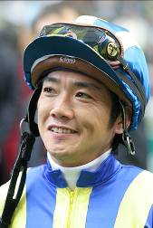 | Tanaka, Katsuharu
 | Age 43, Katsuharu Tanaka’s family operates a horse farm in Hokkaido and he obtained his JRA jockey license in 1989. Having ridden no less than 49 graded race wins, including four at the top level, Tanaka notched his first JRA G1 success in his 4th year riding, partnering top miler Yamanin Zephyr to win the Yasuda Kinen in 1992. But he had to wait another 15 years to get the next one when Victory scored in the 2007 Satsuki Sho. He also earned his first and only overseas G1 success when Shadow Gate won the G1 SIA Cup at Kranji in May that year. Tanaka has a career total of 1,689 wins, including 46 this term (as of 1 December).

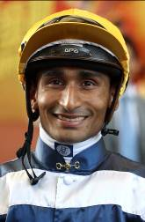 | Teetan, Karis
 | Age 24, Karis Teetan, was well ensconced in the top 10 of the South African Jockeys' Championship when he left for Hong Kong in August, 2013. After entering the South African National Jockey Academy at the age of 14 Teetan went on to be crowned Champion South African Apprentice Jockey in 2008 before graduating in 2009 with 147 winners to his credit. Teetan passed the 100 winners mark in every season as a senior jockey in South Africa. He has recorded five Group 1 wins with his inaugural success at the top level being in his native Mauritius on 24 November 2008 aboard Halo Hunter. His other G1 wins include Grisham in the 2011 Castle Tankard in Zimbabwe, and in South Africa Thunder Dance in the 2012 Paddock Stakes, and Jackson in the 2012 Investec Cape Derby and the 2012 Daily News 2000. Teetan represented South Africa in the 2012 International Jockeys' Invitational in Seoul, Korea and in the 2008 Macau Apprentice Jockeys Invitation Races. He notched 50 wins in his first HK season, including the HKG2 Chairman's Trophy on Able Friend, the HKG3 Queen Mother Memorial Cup and HKG3 Premier Plate on Bubble Chic, and the HKG3 HK Macau Trophy on Super Lifeline.

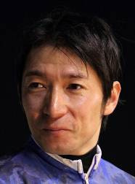 | Uchida, Hiroyuki
 | Age 44, Hiroyuki Uchida was based at the regional National Racing Association’s Ohi Racecourse in Tokyo from 1989, and rode over 3,100 winners before he obtained his JRA riding license and officially switched to the JRA ranks in March 2008. That move brought him instant and enormous success as he was crowned champion jockey in Japan in both 2009 and 2010. So far he has ridden more than 880 JRA winners, including 63 this term (as of 1 December). Uchida has won no less than 11 JRA G1 races to date, including the 2010 Japanese Derby aboard Eishin Flash, and the 2012 Satsuki Sho (Japanese 2000 Guineas) and Kikuka Sho (Japanese St. Leger) atop Gold Ship. He also partnered Gold Ship to win the 2012 Arima Kinen and 2013 Takarazuka Kinen. His latest G1 win came on Verxina as the mare won him a back-to-back G1 Victoria Mile in May.

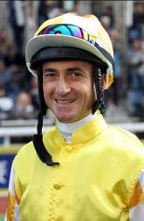 | Whyte, Douglas
 | Age 43, Whyte was born in Durban, South Africa. He was champion jockey in Hong Kong for 13 consecutive seasons from 2000/01, losing his title to Zac Purton in 2013/14. At Sha Tin on April 7, 2013 he rode six winners to equal Brett Prebble's Hong Kong record of most winners in a day. He holds the record for career wins in Hong Kong: 1,631 (as of 1 December), with 19 this season. He is the only jockey ever to reach 1,000 winners in Hong Kong, and his monstrous tally of 114 winners in 2005/06 broke his own record for a season. His several Hong Kong G1 wins have come on luminaries such as Indigenous, London News, Oriental Express, Packing Winner, Best Of The Best, Armada, Ambitious Dragon, Glorious Days and Gold-Fun, as well as the Hong Kong Derby on Super Satin (2010), Fay Fay (2012) and Akeed Mofeed (2013). At the 2013 LONGINES HKIR he rode a double on Akeed Mofeed (HK Cup) and Glorious Days (HK Mile). He was third in the 2013/14 premiership and ended the campaign as the highest prize-money earner for the eighth consecutive season with HK$106.3 million.

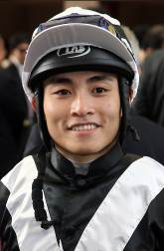 | Yeung, Keith
 | Age 26, Keith Yeung had his first ride on 3 June 2007 in Australia and showed spectacular form in 2009/10 to become Hong Kong's champion apprentice. He continued his progress with a haul of 18 winners in 2010/11 and reached the graduation benchmark after claiming his 70th win in Hong Kong with Nicku on 17 December 2011. He ended the 2011/12 season with 37 wins, placing seventh in the jockeys' table. In the 2012/13 season he rode 22 winners and in an injury interrupted 2013/14 season he scored 16 wins; this season he has 6 for an overall total of 138 HK wins (as of 1 December). His career highlight so far was a four-timer at Happy Valley on 1 November 2009.

