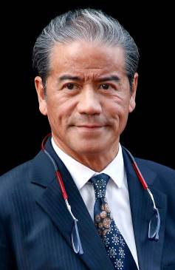 | Cruz, Tony | Mile – Beauty Only; Sprint – Peniaphobia
 | Age: 60. Tony Cruz is a son of Johnny Cruz, a renowned rider from Hong Kong’s amateur era. His brother, Derek Cruz, is also a trainer. He was among the first intake of apprentices to the HKJC Apprentice Jockeys’ School when that facility opened in 1972 and started his riding career in the 1973/74 season. He went on to be Hong Kong's champion jockey six times and rode 946 winners. Cruz also made his name at G1 level in Europe and notably partnered the great race mare Triptych. He was granted a Hong Kong trainer’s licence in 1996 and first landed the trainers’ title in 1999/2000. In 2005, he set a then record for a season's winners (91) and earnings (HK$113m). Cruz trained the great Hong Kong champion Silent Witness to win 17 consecutive races before tasting defeat. Hong Kong Champion Jockey: (1978/79, 1980/81, 1982/83, 1983/84, 1985/86, 1994/95); Hong Kong Champion Trainer (1999/00, 2004/05). Champions Mile wins (2): Bullish Luck (2005 & 2006). Chairman’s Sprint Prize wins (2): Silent Witness (2004 & 2005). APQEII Cup wins (1): 2015 Blazing Speed. HKIR wins (8): Hong Kong Mile (2003 Lucky Owners, 2010 Beauty Flash, 2016 Beauty Only), Hong Kong Cup (2011 & 2012 California Memory), Hong Kong Sprint (2003 & 2004 Silent Witness, 2015 Peniaphobia). Hong Kong Career Wins (at 24 April, 2017): 1,109 (win strike rate: 10.64%).

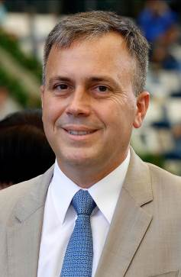 | Fownes, Caspar | Sprint – Dundonnell
 | Age: 49. Caspar Fownes assisted his late father Lawrie for several seasons before taking over the mantle in 2003/04. He eclipsed his father's best season stats in his rookie year with 44 wins. In 2006/07 he won his first trainers’ premiership and has since added two more. His third championship came in 2013/14 when his strong late charge brought three wins on the closing day to tie with John Size on 62 wins, and with one more second place than his rival he sealed the title on count-back. Fownes is particularly known for his success at Happy Valley where he has notched 392 career wins (as of 24 April), a tally second only to Hong Kong’s longest-serving trainer John Moore. Hong Kong Champion Trainer: (2006/07, 2008/09, 2013/14) Chairman’s Sprint Prize Wins (2): Lucky Nine (2013 & 2014) HKIR wins (2): Hong Kong Mile (2006 The Duke), Hong Kong Sprint (2011 Lucky Nine). Other notable wins include: KrisFlyer International Sprint (2010 Green Birdie, 2013 & 2014 Lucky Nine), Hong Kong Derby (2010 Super Satin), Queen’s Silver Jubilee Cup (2012 Lucky Nine). Hong Kong Career Wins (at 24 April, 2017): 746 (win strike rate: 9.90%).

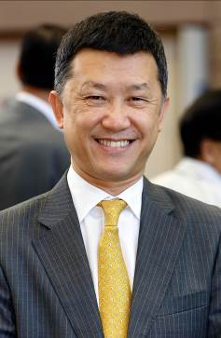 | Ho, Peter L | Sprint – Limitless
 | Age: 56. Peter Ho graduated from the ranks of assistant trainer to be licensed as a Hong Kong trainer in 1997/98. His biggest successes to date have come in the Champions & Chater Cup thanks to Packing Winner and Mr Medici. The latter was crowned Champion Stayer (2009/10) after defeating Derby runner-up Super Pistachio and the great Viva Pataca in that local G1 contest. Mr Medici went on to run with credit in both the Caulfield Cup (6th) and Melbourne Cup (10th) in 2010. Notable wins include: HKG1 Champions & Chater Cup (2008 Packing Winner, 2010 Mr Medici), HKG3 Queen Mother Memorial Cup (2009 Mr Medici), HKG3 Sha Tin Trophy (2009 Packing Winner), HKG3 Premier Plate (2010 Mr Medici), HKG3 January Cup (2016 Flame Hero). Hong Kong Career Wins (at 24 April, 2017): 507 (win strike rate: 7.00%).

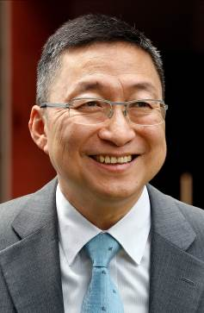 | Lui, Francis K W | Sprint – Lucky Bubbles
 | Age: 58. Francis Lui emerged from the HKJC Apprentice Jockeys’ School to ride 36 winners as a licensed jockey between 1975 and 1982, and later became an assistant trainer. He received his own licence to train in 1996/97. His biggest win to date came with his talented sprinter Lucky Bubbles in this season’s G2 Premier Bowl, having saddled the same horse to second in the 2016 G1 Chairman’s Sprint Prize. Notable Race Wins Include: G2 Premier Bowl (2016 Lucky Bubbles), HKG2 Hong Kong Derby Trial (2006 Hello Pretty), HKG3 Sha Tin Trophy (2001 Shanxi Fortune), HKG3 Sha Tin Vase (2008 Sunny Power), HKG2 Sprint Cup (2016 Lucky Bubbles) Hong Kong Career Wins (at 24 April, 2017): 532 (win strike rate: 6.97%).

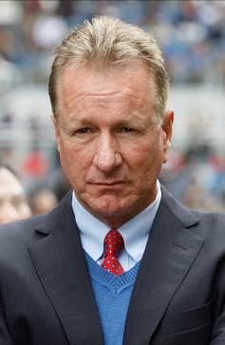 | Millard, Anthony | Sprint – Strathmore
 | Age: 55. Tony Millard’s father was the legendary multiple South African champion trainer Terrance Millard. He made an impressive start to his own training career in 1991. He was champion trainer in South Africa twice and won all of that country’s majors. He trained three Horses of the Year there in Empress Club, Jet Master and Surfing Home. Millard sent out 39 G1 winners in his first nine years of training before relocating to Hong Kong. He made an immediate impact, winning the 2000 Hong Kong Derby in his first season, with Keen Winner. His most spectacular successes in Hong Kong have come with two-time Horse of the Year Ambitious Dragon whose 13 career wins included two G1s and five local G1s. The handler took Hong Kong's star mare Sweet Sanette to Royal Ascot in 2011 where she finished third in the G1 King's Stand Stakes. Two-time South African Champion Trainer (1992, 1994 [shared with Pat Shaw]). HKIR wins (1): Hong Kong Mile (2012 Ambitious Dragon). APQEII Cup win (1): Ambitious Dragon (2011). Other notable wins include: Hong Kong Derby (2000 Keen Winner, 2011 Ambitious Dragon), Hong Kong Classic Cup (2011 Ambitious Dragon), Stewards’ Cup (2012 Ambitious Dragon), Hong Kong Gold Cup (2012 Ambitious Dragon), Queen’s Silver Jubilee Cup (2013 Ambitious Dragon), Durban July (1993 Dancing Duel), J & B Met (1993 Empress Club, 1995 Surfing Home), Queen’s Plate (1993 Empress Club, 1999 Jet Master). Hong Kong Career Wins (at 24 April, 2017): 540 (win strike rate: 8.31%).

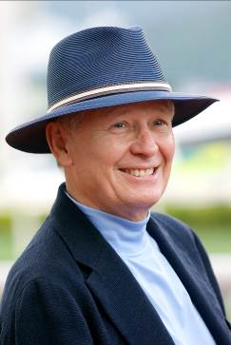 | Moore, John | Mile – Helene Paragon, Rapper Dragon;  Sprint – Dashing Fellow, Not Listenin'Tome
 | Age: 67. Background: John Moore has been involved in Hong Kong racing since the professional era commenced in 1971 and is Hong Kong's longest-serving and winning-most trainer. A former amateur jockey, he began training in 1985, before which he was assistant trainer to his late famous father, George. In 2007 he prepared an international G1 double thanks to Viva Pataca in the APQEII Cup and Able One in the Champions Mile and, in a feat perhaps unprecedented in the sport, won the same two races with the same two horses three years later. Moore was the first to reach 1000 wins in Hong Kong and has been the leading prize money earner for the past 10 seasons. Seven-time Hong Kong Champion Trainer (1985/86, 1990/91, 1991/92, 1992/93 [tied with David Hill], 1994/95, 2010/11, 2014/15); Hong Kong record holder for all-time career prize money (HK$1.73 billion) and all-time career wins; record for most prize money in a season (HK$139,938,247 in 2014/15). Champions Mile wins (6): Able One (2009 & 2011), Xtension (2011 & 2012), Dan Excel (2013), Able Friend (2015). Chairman’s Sprint Prize wins (4): Happy Money (1994), Billet Express (2006), Dim Sum (2009 & 2011). APQEII Cup wins (5): 2007 & 2010 Viva Pataca, 2013 Military Attack, 2014 Designs On Rome, 2016 Werther. HKIR wins (6): Hong Kong Mile (2011 Able One, 2014 Able Friend), Hong Kong Cup (1993 Motivation, 2014 Designs On Rome), Hong Kong Sprint (2008 Inspiration), Hong Kong Vase (2013 Dominant). Hong Kong Career Wins (at 24 April, 2017): 1561 (win strike rate: 10.69%).

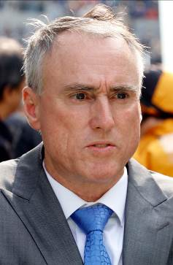 | O'Sullivan, Paul | Sprint – Aerovelocity
 | Age: 57. Paul O'Sullivan was Champion Trainer in New Zealand on 11 occasions, acting in partnership with his father Dave for 17 years. His brother, Lance, New Zealand’s all-time winning-most jockey, is also a trainer. O’Sullivan won the G1 Japan Cup in 1989 with Horlicks, ridden by his brother, and added scores of other majors on both sides of the Tasman Sea, including the G1 Cox Plate with Surfers Paradise in 1991. He arrived in Hong Kong to train in 2004. HKIR wins (2): Hong Kong Sprint (2014 & 2016 Aerovelocity). Other notable wins include: Hong Kong Derby (2007 Vital King), Stewards’ Cup (2010 Fellowship), Japan Cup (1989 Horlicks), Cox Plate (1991 Surfers Paradise), Takamatsunomiya Kinen (2015 Aerovelocity), KrisFlyer International Sprint (2015 Aerovelocity), Centenary Sprint Cup (2016 Aerovelocity), New Zealand Derby (1990 Surfers Paradise, 1993 Popsy), New Zealand Oaks (1994 Snap). Hong Kong Career Wins (at 24 April, 2017): 363 (win strike rate: 8.48%).

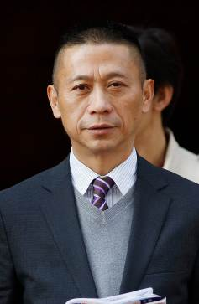 | Shum, Danny C S | Mile – Circuit Land
 | Age: 56. Danny Shum rode 24 winners in Hong Kong between 1977 and 1983. He learnt the training ropes as assistant to former multiple Hong Kong champion trainer Ivan Allan. He was granted a Hong Kong trainer’s licence ahead of the 2003/04 season and began brightly with 34 winners. He improved on that good debut season to rank third in the trainers' premiership in his second term when Scintillation emerged as his standout runner. The 2011/12 season brought a first overseas success as Little Bridge went to Royal Ascot to clinch victory in the G1 King's Stand Stakes. He ended the 2015/16 second in the premiership with 54 wins. Notable Race Wins Include: King’s Stand Stakes (2012 Little Bridge), Centenary Sprint Cup (2006 & 2007 Scintillation), Hong Kong Classic Mile (2005 Scintillation, 2009 Thumbs Up), G2 Jockey Club Sprint (2011 Little Bridge), HKG2 Sprint Cup (2012 Little Bridge), HKG3 National Day Cup (2006 Flaming Lamborgini). Hong Kong Career Wins (at 24 April, 2017): 473 (win strike rate: 8.59%).

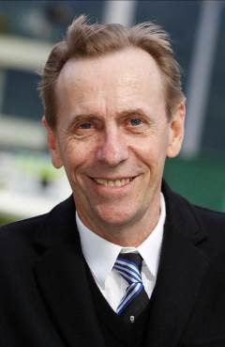 | Size, John | Mile – Contentment;  Sprint – Amazing Kids, Mr Stunning, Sun Jewellery, Thewizardofoz
 | Age: 62. John Size was a top trainer in Sydney before his arrival in Hong Kong in 2001 with a reputation for improving and rekindling the spark in his horses. He broke the mould by winning the trainers' premiership in his very first season. Size notched an eighth championship in the 2015/16 season as he finished with 68 wins, 14 clear of the pack. He has trained the winners of two Horse of the Year titles, the multiple HKG1 scorers Electronic Unicorn and Grand Delight. In 2009/10 he trained Brave Kid to equal the then record of six wins in a season and Entrapment who finally broke that record with seven victories in just five months. Hong Kong Champion Trainer (2001/02, 2002/03, 2003/04, 2005/06, 2007/08, 2009/10, 2011/12, 2015/16). Champions Mile wins (2): Electronic Unicorn (2003), Sight Winner (2009) Chairman’s Sprint Prize win (1): Grand Delight (2003) APQEII Cup win (1): River Dancer (2004) HKIR win (1): Hong Kong Mile (2013 Glorious Days). Other notable race wins include: Hong Kong Derby (2012 Fay Fay, 2015 Luger), Stewards’ Cup (2003 Electronic Unicorn, 2004 Super Kid, 2007 Armada, 2013 Glorious Days), Queen's Silver Jubilee Cup (2004 Electronic Unicorn, 2016 Contentment) Hong Kong Career Wins (at 24 April, 2017): 1023 (win strike rate: 14.20%).

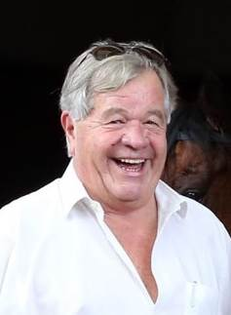 | Stoute, Sir Michael | Mile – Convey
 | Age: 71. Sir Michael Stoute moved to England from Barbados aged 19 and was licensed to train in 1972. He has been crowned Britain's champion trainer 10 times (1981, 1986, 1989, 1994, 1997, 2000, 2003, 2005, 2006, 2009). His G1 wins include four in the Breeders' Cup Turf, 15 English Classics including five in the Derby at Epsom, two Japan Cups, a Dubai World Cup and even a Champion Hurdle. The most famous of his stars remains the ill-fated Shergar, but he has trained numerous international champions, notably Dubai World Cup and Japan Cup winner Singspiel and Breeders’ Cup Turf winner Pilsudski, as well as 2,000 Guineas and King George VI and Queen Elizabeth Stakes winner Golan. In 2008 he finally completed his set of all five English Classics when subsequent dual Breeders' Cup Turf winner, Conduit, landed the St Leger. In 2010, Harbinger won the G1 King George at Ascot by 11 lengths and Workforce won both the Derby and the Arc. In 2013 he saddled the Queen’s Estimate to give the British monarch her first G1 Ascot Gold Cup win. He notched his latest G1 win with Queen’s Trust in the 2016 Breeders’ Cup Filly & Mare Turf. HKIR wins (2): Hong Kong International Bowl (1994 Soviet Line); Hong Kong Vase (2000 Daliapour).

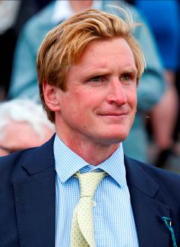 | Walker, Ed | Mile – Stormy Antarctic
 | Age: 33. After working as assistant trainer to Luca Cumani, Ed Walker set out with his own string in 2010, located in the Authorized yard at St Gatien Stables, Newmarket. His first runner was a winner - Riggins in the listed Hyde Stakes at Kempton and the handler has since earned a reputation as one of Britain’s brightest young operators, despite a somewhat nomadic start to his career. Walker moved his string to Grange House Stables in 2012 and landed a first overseas win when Ruscello took the G3 Lexus Stakes at Flemington, Australia. At the end of 2013, Walker moved again, to lease part of the late Henry Cecil’s Warren Place Stables and he enjoyed two fruitful years there with a career peak 40 wins in 2014 and 34 in 2015. After a season back across Newmarket at Eve Lodge Stables, Walker has settled into Kingsdown Stables in Upper Lambourn. He has yet to land a G1 score but Stormy Antarctic, last season’s G3 Craven Stakes winner, has placed second twice in that grade, while Mutatis Mutandis was third in the 2015 G1 Flower Bowl Stakes at Belmont, USA.

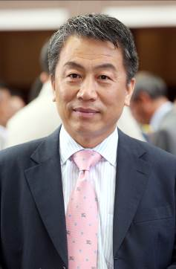 | Yiu, Ricky P F | Sprint – Blizzard
 | Age: 59. Ricky Yiu rode 11 winners between 1974 and 1980 and was first licensed as a trainer in 1995/96. One of his greatest early moments came with Fairy King Prawn’s success in the inaugural Hong Kong Sprint of 1999. Sacred Kingdom was his outstanding stable star and this two-time G1 Hong Kong Sprint winner and 2009/10 Horse of the Year won the Champion Sprinter title for the fourth year in succession in 2010/11. In the 2010/11 season he also sent out Ultra Fantasy to triumph in the G1 Sprinters Stakes at Nakayama as, with Alex Lai on board, the pair became the first Hong Kong Chinese trainer-jockey partnership to triumph in an overseas G1 event. Following Sacred Kingdom’s retirement in the spring of 2012, another blistering speedster, Amber Sky, provided Yiu with further elite success at home and abroad. Chairman’s Sprint Prize wins (3): Fairy King Prawn (1999), Sacred Kingdom (2008 & 2010). HKIR wins (3): Hong Kong Sprint (1999 Fairy King Prawn, 2007 & 2009 Sacred Kingdom). Other notable wins include: Centenary Sprint Cup (2010 & 2011 Sacred Kingdom, 2014 Amber Sky), KrisFlyer International Sprint (2009 Sacred Kingdom), Sprinters Stakes (2010 Ultra Fantasy), Al Quoz Sprint (2014 Amber Sky). Hong Kong Career Wins (at 24 April, 2017): 672 (win strike rate: 8.12%).

