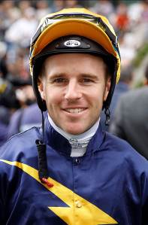 | Berry, Tommy
 | Age: 26. Tommy Berry grew up around horses at the Warwick Farm stable of his father Kevin Berry, a former jockey. Berry began his career in 2007 and was Sydney champion apprentice in 2009/10. After a spell as stable jockey to Gai Waterhouse from April, 2011, he turned freelance in early 2015. His first short-term contract with the Hong Kong Jockey Club ran from 28 April, 2013 until that season's end and yielded 22 wins. Berry became the first HKJC licensed rider to win a G1 on the first day of his contract when successful aboard Military Attack in the 2013 APQEII Cup. In 2014 he became the third rider to notch back-to-back QEII Cup wins thanks to Designs On Rome. His first G1 win came on Epaulette in the 2012 Golden Rose Stakes. Chairman’s Sprint Prize wins (1): Chautauqua (2016). APQEII Cup wins (2): Military Attack (2013), Designs On Rome (2014). Other notable wins include: Hong Kong Derby (2014 Designs On Rome), Hong Kong Classic Cup (2014 Designs On Rome), Hong Kong Gold Cup (2016 Designs On Rome), Stewards’ Cup (2017 Helene Paragon), Queen’s Silver Jubilee Cup (2017 Helene Paragon), T. J. Smith Stakes (2015, 2016, 2017 Chautauqua), Golden Slipper (2013 Overreach, 2015 Vancouver), Singapore Airlines International Cup (2014 & 2015 Dan Excel). Hong Kong Career Wins (as of 24 April, 2017): 56 (win strike rate: 12.04%).

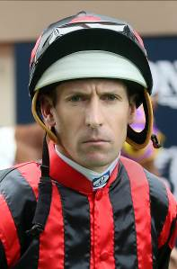 | Bowman, Hugh
 | Age: 36. Hugh Bowman has forged an outstanding career since his debut ride on Naturalised in 1999, winning many of Australia’s major races. He has won the Sydney Jockeys’ Premiership three times (2008/09, 2011/12, 2014/15) and has won no less than 66 G1 races in his career, 12 of those in the 2016/17 season. He has partnered Australia’s great mare Winx in 16 of her 21 career victories and has also steered Hong Kong champion Werther to wins in the BMW Hong Kong Derby, APQEII Cup and Hong Kong Gold Cup. APQEII Cup wins (1): Werther (2016). Other notable wins include: Cox Plate (2015 & 2016 Winx), Doncaster Mile (2016 Winx), George Ryder Stakes (2016 & 2017 Winx, 2010 Danleigh, 2005 Court In Session), Chipping Norton Stakes (2016 & 2017 Winx, 2012 & 2013 Shoot Out, 2011 Danleigh), Epsom Handicap (2015 Winx), Australian Derby (2014 Criterion), Darley Classic (2014 Terravista), Queen Elizabeth Stakes (2013 Reliable Man, 2017 Winx), T. J. Smith Stakes (2006 Red Oog). Hong Kong Career Wins (as of 24 April, 2017): 23 (win strike rate: 9.91%).

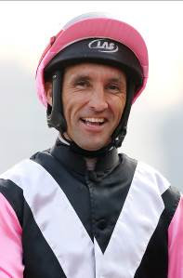 | Callan, Neil
 | Age: 38. Irishman Neil Callan finished runner-up in the UK jockeys’ championship in 2005 (151 wins) and 2007 (170 wins). After a fruitless start as an apprentice in Ireland with Kevin Prendergast he moved to Britain and was named UK champion apprentice in 1999, having forged successful partnerships with trainers Karl Burke, Kevin Ryan and Michael Jarvis. His first short-term Hong Kong contract came in the 2010/11 season and he has since established a reputation as a tough competitor. His first full Hong Kong season, 2014/15, yielded 47 wins and fifth place in the jockeys’ premiership, while he once again finished fifth in the championship with 40 wins in 2015/16. APQEII Cup wins (1): Blazing Speed (2015). Other notable wins include: Champions & Chater Cup (2014 & 2016 Blazing Speed), Hong Kong Classic Mile (2015 Beauty Only), Middle Park Stakes (2005 Amadeus Wolf, 2013 Astaire), Racing Post Trophy (2005 Palace Episode), Nunthorpe Stakes (2009 Borderlescott), Fillies' Mile (2009 Hibaayeb), Premio Roma (2007 Pressing), Grosser Dallmayr-Preis Bayerisches Zuchtrennen (2009 Pressing). Hong Kong Career Wins (as of 24 April, 2017): 175 (win strike rate: 7.65%).

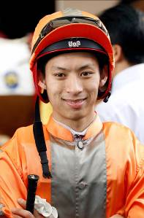 | Chadwick, Matthew
 | Age: 26. A graduate of Hong Kong's Apprentice Jockeys’ School, Chadwick went to Australia for his apprentice training and rode a four-timer at Lismore Racecourse at age 17. He was indentured to the Tony Cruz stable upon his return to Hong Kong and was champion apprentice in 2008/09. He earned a full jockey’s licence in January 2010. His first Group race winner was Egyptian Ra in the HKG3 National Day Cup (2009). He is most famous for his partnership with California Memory and became the first homegrown rider to win an HKIR contest when clinching the G1 Hong Kong Cup on the grey in December, 2011. Chadwick notched his 250th win in Hong Kong with Majestic Anthem on 26 December 2013 and rode his first Hong Kong four-timer at Sha Tin on 22 June, 2014. Shergar Cup Silver Saddle winner (2012). HKIR wins (2): LONGINES Hong Kong Cup (2011 & 2012 California Memory). Other notable race wins include: Hong Kong Gold Cup (2011 California Memory), Standard Chartered Champions & Chater Cup (2013 California Memory). Hong Kong Career Wins (24 April, 2017): 309 (win strike rate 8.50%).

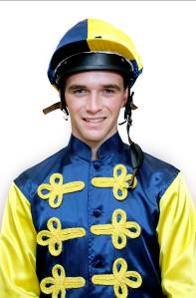 | Clipperton, Sam
 | Age: 23. Sam Clipperton is one Australia’s rising stars and has enjoyed success with the elite Godolphin operation, for which he has ridden five G2 wins. He competed in showjumping and eventing and also some rodeo in his youth before discovering horse racing as a teenager. He left school at 15 and joined the stable of eight-time Sydney champion jockey and Hall of Famer Ron Quinton. Clipperton made his race-riding debut aboard Nine Dragons at Wyong on 16 July, 2010. His breakthrough came the following season in which he notched 23 wins. In 2014 he became the first rider since Bobby El-Issa 20 years earlier to win the Sydney apprentice title twice in succession. His best season to date came in 2014/15 as he racked up 81 wins. He notched a first G1 win in March, 2016 atop Peeping in the Coolmore Classic for his old boss and mentor Quinton, who also guided Hugh Bowman’s early career. He made it two G1 wins a month later aboard English in the All-Aged Stakes. He partnered his first four-timer at Rosehill on 19 December, 2015. He is currently in his debut season as a club jockey in Hong Kong. Hong Kong Career Wins (as of 24 April, 2017): 31 (win strike rate: 8.45%).

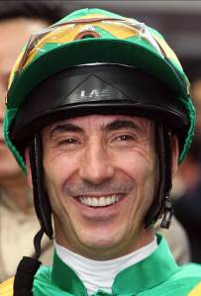 | Doleuze, Olivier
 | Age: 45. Former champion apprentice in France, Olivier Doleuze rode mostly for Criquette Head-Maarek in his homeland where he enjoyed Classic wins on Green Tune and Egyptband. He also won the 2001 SING1 Singapore Airlines KrisFlyer Sprint for the same stable on Iron Mask. He enjoyed his best Hong Kong season in 2006/07 when he rode 67 winners, the highlight being his victory on The Duke in the G1 Hong Kong Mile, a race he won again in 2007 and 2009 on the great Good Ba Ba. He enjoyed a notable year in 2014, guiding Rich Tapestry to wins in Dubai's G3 Mahab Al Shimaal and a historic triumph in the G1 Santa Anita Sprint Championship at Santa Anita, the first victory by a Hong Kong-trained horse on American soil. From June, 2015, Doleuze was sidelined with a shoulder problem that required surgery and after six months out he rode a two-month stint in Macau to prove his fitness before returning to Hong Kong action in March, 2016. Chairman’s Sprint Prize wins (1): Dim Sum (2011). Champions Mile wins (1): Good Ba Ba (2008). HKIR wins (3): Hong Kong Mile (2006 The Duke, 2007 & 2009 Good Ba Ba). Other notable wins include: Stewards' Cup (2008 Good Ba Ba), Queen's Silver Jubilee Cup (2008 Good Ba Ba), Hong Kong Classic Cup (2012 Zaidan), Centenary Sprint Cup (2012 & 2013 Eagle Regiment), SIA Cup (2012 Chinchon), Prix de la Foret (2002 Dedication), Prix de l'Abbaye (1996 Kistena). Hong Kong Career Wins (as of 24 April, 2017): 551 (win strike rate: 9.07%).

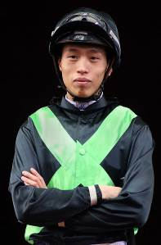 | Ho, Vincent C Y
 | Age 26. HKJC Apprentice Jockey School graduate Vincent Ho racked up 44 wins as a young rider in New Zealand under the tutelage of leading trainer Lance O'Sullivan. He made an impressive start to his Hong Kong career with 10 wins in his first season in 2009/10, including a trio of wins he achieved on only his fourth race day in Hong Kong. He sealed the 2010/11 Champion Apprentice title with 39 wins. Ho reached the graduation benchmark on 1 October, 2012, by claiming his 70th win in Hong Kong on board Castle Hero. He notched 33 wins in 2014/15 to be the season's leading homegrown rider. Hong Kong Champion Apprentice (2010/11); Best Freelance Jockey Award (2014/15). Notable Race Wins Include: HKG3 National Day Cup (2014 Bundle Of Joy). Hong Kong Career Wins (as of 24 April, 2017): 185 (win strike rate: 6.25%).

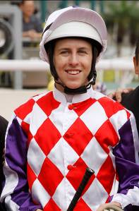 | Lane, Damian
 | Age: 23. Prodigious talent Damian Lane was apprenticed to his father Michael in 2009 and had his first race ride at age 16, notching more than 100 wins in Western Australia. He then transferred his indentures to the Melbourne-based training partnership of Matthew Ellerton and Simon Zahra during the 2010/2011 racing season, graduating to the senior riding ranks during the 2012/2013 racing season. His first Group win came at Flemington on Se Sauver in the 2013 G2 Edward Manifold Stakes, while his maiden G1 victory came atop Trust In A Gust in the 2014 Sir Rupert Clarke Stakes. He achieved his 500th career win on the eve of his 21st birthday in February, 2015. Lane undertook a first short-term contract in Hong Kong at the end of the 2014/15 season for five wins. Other notable wins include: Oakleigh Plate (2016 Flamberge), William Reid Stakes (2106 Flamberge), The Champagne Stakes (2017 The Mission), Australian Derby (2017 Jon Snow), Australian Cup (2017, Humidor), Hong Kong Career Wins (as of 24 April, 2017): 8 (win strike rate: 4.52%).

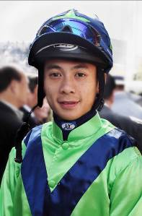 | Leung, Derek K C
 | Age: 28. A product of Hong Kong’s Apprentice Jockeys’ School, Derek Leung cut his teeth as a young rider in New Zealand under the tutelage of trainer Lance O’Sullivan. He was assigned as apprentice jockey to Paul O’Sullivan’s stable upon his return to Hong Kong. Leung was involved in a four-way battle for the 2009/10 Hong Kong apprentice jockeys' championship but came up five wins short of eventual champion Keith Yeung, although he did win a first stakes race in the HKG3 Premier Bowl on Inspiration. In 2010, he defeated some of the best apprentices in Asia to win the Asian Young Guns Challenge at Kranji. He reached the graduation benchmark after claiming his 70th win on board Star Of Fame on 1 June, 2011. In the 2015/16 season, Leung reached a personal best 33 wins for the campaign, including the HKG3 January Cup on Flame Hero. Hong Kong Career Wins (as of 24 April, 2017): 217 (win strike rate: 5.39%).

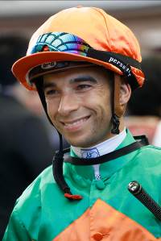 | Moreira, Joao
 | Age: 34. Brazilian sensation Joao Moreira, known as “Magic Man”, notched more than 1000 wins in South America. He relocated to Singapore in 2009 and after finishing third in the premiership in that first season he proceeded to dominate the circuit for four years. He moved to Hong Kong in October, 2013 and was runner-up in the title race that term with 97 wins. He clinched a first championship in a record smashing 2014/15 campaign that yielded an all-time high 145 wins - he demolished that record in 2015/16 with 168 wins, 88 clear of Zac Purton in second place. Champions Mile wins (2): Able Friend (2015), Maurice (2016). HKIR wins (4): Hong Kong Mile (2014 Able Friend), Hong Kong Cup (2014 Designs On Rome), Hong Kong Sprint (2015 Peniaphobia), Hong Kong Vase (2016 Satono Crown). Other notable wins include: Hong Kong Gold Cup (2014 Military Attack, 2015 Designs On Rome), Queen’s Silver Jubilee Cup (2015 Able Friend), Stewards’ Cup (2015 Able Friend), Hong Kong Derby (2017 Rapper Dragon), Newmarket Handicap (2015 Brazen Beau), Al Quoz Sprint (2014 Amber Sky), Dubai Golden Shaheen (2014 Sterling City), Gran Premio Nacional (2006 Eu Tambem). Hong Kong Career Wins (as of 24 April, 2017): 550 (win strike rate: 23.93%).

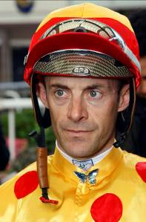 | Peslier, Olivier
 | Age 43: Four times France’s champion jockey (1996, 1997, 1999, 2000), Olivier Peslier is among the world’s best jockeys of the past 25 years, with a host of major wins around the globe, more than 100 at G1 level. He has won the Prix de l’Arc de Triomphe four times (1996 Helissio, 1997 Peintre Celebre, 1998 Sagamix, 2012, Solemia) and he has also won the Japan Cup twice (2001 Jungle Pocket, 2004 Zenno Rob Roy). He is associated with the great Goldikova, whom he partnered to 14 G1 wins including three G1 Breeders’ Cup Miles, as well as champions such as Peintre Celebre, Zenno Rob Roy and Banks Hill. In 2012 he rode Cirrus Des Aigles to wins in the G1 Dubai Sheema Classic, G1 Prix Ganay and G2 Prix Dollar. 2013 brought a second G1 Prix du Jockey Club win, thanks to Intello, 16 years after his first on Peintre Celebre. In 2015 he notched three more G1 wins on Make Believe (Poule d’Essai des Poulains and Prix de la Foret) and Amazing Maria (Prix Rothschild). HKIR wins (6): Hong Kong Mile (1999 Docksider, 2005 Hat Trick), Hong Kong Vase (1995 Patripal, 1999 Borgia, 2007 & 2008 Doctor Dino), Hong Kong Cup (2009 Vision D’Etat).

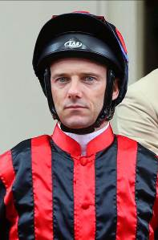 | Prebble, Brett
 | Age: 39. Brett Prebble left Australia for Hong Kong in 2002 with two Melbourne premierships to his name. He collected a first major win at Sha Tin aboard Precision in the 2003 Champions & Chater Cup. He has since partnered to victory Hong Kong stars such as Bullish Luck, Sacred Kingdom, Cape Of Good Hope and Lucky Nine. His past tussles with Douglas Whyte for the jockeys’ championship are legendary, although he has not yet lifted the crown. Prebble was runner-up six times to his rival, his 2009/10 battle with Whyte especially epic as he lost out by one, the final score being 100-99. He set a Hong Kong record, since surpassed, of most wins in a day with his six-timer at Happy Valley on 20 June, 2010. His career highlight is Green Moon’s win in the 2012 Melbourne Cup. Chairman’s Sprint Prize wins (4): 2007 Absolute Champion, 2009 Sacred Kingdom, 2013 & 2014 Lucky Nine. Champions Mile wins (2): 2006 Bullish Luck, 2009 Sight Winner. HKIR wins (3): Hong Kong Sprint (2006 Absolute Champion, 2009 Sacred Kingdom, 2011 Lucky Nine). Other notable wins include: Hong Kong Derby (2007 Vital King), Golden Slipper (2010 Crystal Lily), Yasuda Kinen (2006 Bullish Luck), KrisFlyer International Sprint (2009 Sacred Kingdom, 2013 & 2014 Lucky Nine). Hong Kong Career Wins (as of 24 April, 2017): 781 (win strike rate: 12.34%).

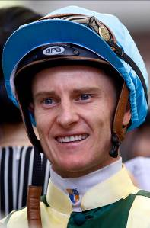 | Purton, Zac
 | Age: 34. Zac Purton ended Douglas Whyte's 13-season dominance when claiming his first and, so far, only Hong Kong jockeys' championship in 2013/14 with 112 wins. He raced to the then fastest ever 50 in Hong Kong history that season and became the second rider, after Whyte, to notch 100 wins in a season. He had finished runner-up in 2011/12 and 2012/13. Purton lost his title when second to Joao Moreira in 2014/15 with 95 wins and was runner-up again in 2015/16 with 80 wins, 88 behind Moreira and 33 clear of third place. He started his career in Brisbane where he was an apprentice sensation, winning the champion jockey title while still a claimer, and then moved on to Sydney where he was twice second in the premiership behind perennial champion Darren Beadman. His first G1 win came on Excites in the 2006 Sires Produce Stakes. Purton moved to Hong Kong in September, 2007. HKIR wins (4): Hong Kong Mile (2012 Ambitious Dragon), Hong Kong Sprint (2014 & 2016 Aerovelocity), Hong Kong Vase (2013 Dominant). Other notable wins include: Stewards’ Cup (2010 Fellowship), Hong Kong Gold Cup (2013 Military Attack), Queen’s Silver Jubilee Cup (2013 Ambitious Dragon), Hong Kong Derby (2015 Luger), King's Stand Stakes (2012 Little Bridge), Singapore Airlines International Cup (2013 Military Attack), Caulfield Cup (2014 Admire Rakti), Doncaster Mile (2014 Sacred Falls, 2017 It’s Somewhat), Takamatsunomiya Kinen (2015 Aerovelocity), KrisFlyer International Sprint (2015 Aerovelocity). Hong Kong Career Wins (as of 24 April, 2017): 685 (win strike rate: 13.44%).

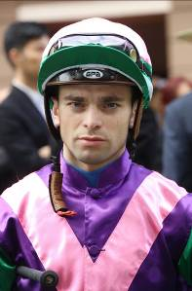 | Rispoli, Umberto
 | Age: 28. Italian jockey Umberto Rispoli commenced his apprenticeship in 2005 and graduated to the senior ranks in 2010. He is a two-time Champion Jockey in Italy. In winning his first Italian title, in 2009, he rode 245 winners and so smashed the longstanding previous record of 229. Rispoli, who has also ridden in Japan, notched six wins in his first Hong Kong season in 2011/12, crowned by APQEII Cup success on the Japanese galloper Rulership. After moving to trainer Mikel Delzangles in France, he took a further G1 atop Molly Malone in the Prix du Cadran. Rispoli has since returned to Hong Kong on short-term contracts and is currently licensed until the end of the 2016/17 season. APQEII Cup wins (1): Rulership (2012). Other notable wins include: Premio Lydia Tesio (2010 Aoife Alainn), Takamatsunomiya Kinen (2011 Kinshasa No Kiseki), Prix du Cadran (2012 Molly Malone), Premio Presidente della Repubblica (2011 Estejo, 2015 Cleo Fan), Gran Criterium (2013 Priore Philip), Criterium International (2014 Vert De Grece). Hong Kong Career Wins (as of 24 April, 2017): 49 (win strike rate: 5.92%).

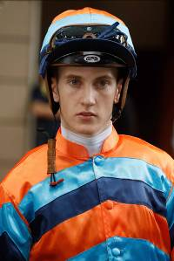 | Schofield, Chad
 | Age: 22. Chad Schofield spent four years of his youth, between 2002 and 2006, living in Hong Kong where his father, the South African jockey Glyn Schofield, was contracted to ride. His family relocated to Australia and Schofield commenced his own riding career in Sydney in the 2010/11 season and enjoyed rapid success, winning the city’s champion apprentice title in 2011/12. He moved to Melbourne in 2012 to ride for the powerful David Hayes stable and also won the champion apprentice title there. His first Group 1 win was a major, the 2013 Cox Plate on Shamus Award. He and his father made history in 2014 as the first father and son to compete against each other in the Melbourne Cup and at Sha Tin on 14 February, 2016 they became the first in Hong Kong to ride against each other. Schofield spent three months during the summer of 2015 riding in England, based out of Ed Dunlop’s yard, and scored two wins from 42 rides. His biggest Hong Kong success came in February’s G3 Centenary Vase aboard Supreme Profit. Other notable wins include: Queen Mother Memorial Cup (2016 Ambitious Champion), Newmarket Handicap (2014 Lankan Rupee), Champagne Stakes (2014 Go Indy Go), Queensland Derby (2014 Sonntag). Hong Kong Career Wins (as of 24 April, 2017): 52 (win strike rate: 6.72%).

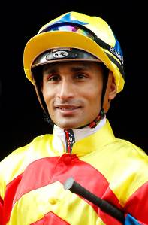 | Teetan, Karis
 | Age: 26. Mauritian rider Karis Teetan was in the top 10 of the South African Jockeys' Championship when he left for Hong Kong in August, 2013. He entered the South African National Jockey Academy at the age of 14 and was champion South African apprentice in 2008. He graduated in 2009 with 147 wins to his credit and passed the 100-win mark in every season as a senior jockey in South Africa. He has recorded five Group 1 wins, with his inaugural success at the top level being in his native Mauritius on 24 November, 2008, aboard Halo Hunter. Teetan represented South Africa in the 2012 International Jockeys' Invitational in Seoul, Korea and in the 2008 Macau Apprentice Jockeys Invitation Races. He notched an impressive 50 wins in his first Hong Kong season, finishing equal-third in his third season in 2015/16. He started the 2016/17 season with international wins on Super Jockey in the Korea Sprint and Lim’s Cruiser in the EW Barker Trophy in Singapore. Other notable wins include: Hong Kong Classic Cup (2015 Thunder Fantasy), Sha Tin Trophy (2016 Designs On Rome), Chairman’s Trophy (2014 Able Friend), Premier Bowl (2015 Able Friend), Cape Derby (2012 Jackson), Daily News 2000 (2012 Jackson), Paddock Stakes (2012 Thunder Dance), Castle Tankard (2011 Grisham). Hong Kong Career Wins (as of 24 April, 2017): 156 (win strike rate: 7.30%).

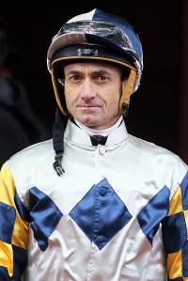 | Whyte, Douglas
 | Age: 45. Douglas Whyte was born in Durban, South Africa, hence his nickname “The Durban Demon”. He was champion jockey in Hong Kong for 13 consecutive seasons, losing his title to Zac Purton in 2013/14. Whyte first sat on a horse at age two and developed his skills riding in the countryside with his late father, himself a former jockey. He is a graduate of the South African Jockey Academy. In 1996 he rode weekends in Singapore and Malaysia and undertook a short contract in Hong Kong in the winter of the 1996/97 season. He returned that spring for a breakthrough APQEII Cup win on South African champion London News. Whyte moved to Hong Kong for the 1997/98 season and made the city his home. He is the only jockey ever to reach 1,000 wins in Hong Kong, and his tally of 114 wins in 2005/06 stood as a record until Joao Moreira surpassed it in 2014/15. Chairman’s Sprint Prize wins (1): Oriental Express (1998). AP QEII Cup wins (2): Oriental Express (1998), Ambitious Dragon (2011). HKIR wins (3): Hong Kong Cup (2013 Akeed Mofeed), Hong Kong Mile (2013 Glorious Days), Hong Kong Vase (1998 Indigenous). Other notable wins include: Hong Kong Derby (2010 Super Satin, 2012 Fay Fay, 2013 Akeed Mofeed), Queen’s Plate (1997 London News), J & B Met (1997 London News), Kingston Town Classic (2014 Moriarty). Hong Kong Career Wins (as of 24 April, 2017): 1,755 (win strike rate: 15.29%).

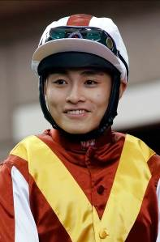 | Yeung, Keith M L
 | Age: 29. Hong Kong Apprentice Jockey’ School graduate Keith Yeung undertook his overseas placement in Australia, the later portion with trainer Leon Wells in Tasmania. He had his first race ride on 3 June, 2007. He returned to Hong Kong for the 2008/09 Hong Kong season with 11 Australian wins under his belt from 130 rides. Indentured to Sha Tin trainer Almond Lee, Yeung showed great form in 2009/10 to become Hong Kong's champion apprentice. He reached the graduation benchmark after claiming his 70th win in Hong Kong with Nicku on 17 December 2011. He rode his first four-timer at Happy Valley on 1 November, 2009. Hong Kong Career Wins (at as of 24 April, 2017): 198 (win strike rate: 5.79%).

