Biographies

Member of The Hong Kong Jockey Club Equestrian Team

PATRICK LAM (林立信)
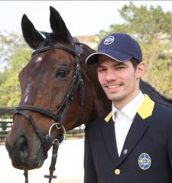

Place of birth : Austria
Equestrian Discipline : Jumping

Awards and achievements:
- Overall 3rd place at the FEI World Cup 2012 Jumping Chinese League
- Awarded the Hong Kong SAR Chief Executive's Commendation for Community Service in 2010, in recognition of his excellent performance in equestrian sports
- Hong Kong’s first-ever equestrian medal, team bronze medal at the Guangzhou 2010 Asian Games, with teammates Kenneth Cheng, Jacqueline Lai and Samantha Lam who are also Club-sponsored riders
- Individual gold and team bronze medal at the Jinan 2009 National Games, with the same teammates Kenneth Cheng, Jacqueline Lai and Samantha Lam
Background:
- Born and studied in Austria, Lam enjoyed conventional sports such as running, football and basketball. Since his first trial of riding when he was a teenager, Lam was hooked immediately. He loved to compete with an animal as a partner.
- In 2008, Lam represented Hong Kong to compete in Beijing Olympics with a superb clear round in the 1st round, the individual jumping qualifier. He was the only rider from Hong Kong and China to make it through to the third round.
- Lam was selected as a member of The Hong Kong Jockey Club Equestrian Team and received sponsorship from the Club after Olympics.
- Lam now bases in Switzerland and focuses on his riding career with the Club’s financial support.
- Lam’s current mounts include Jockey Club Tilburg and Jockey Club Millennium.
SAMANTHA LAM (林子心)
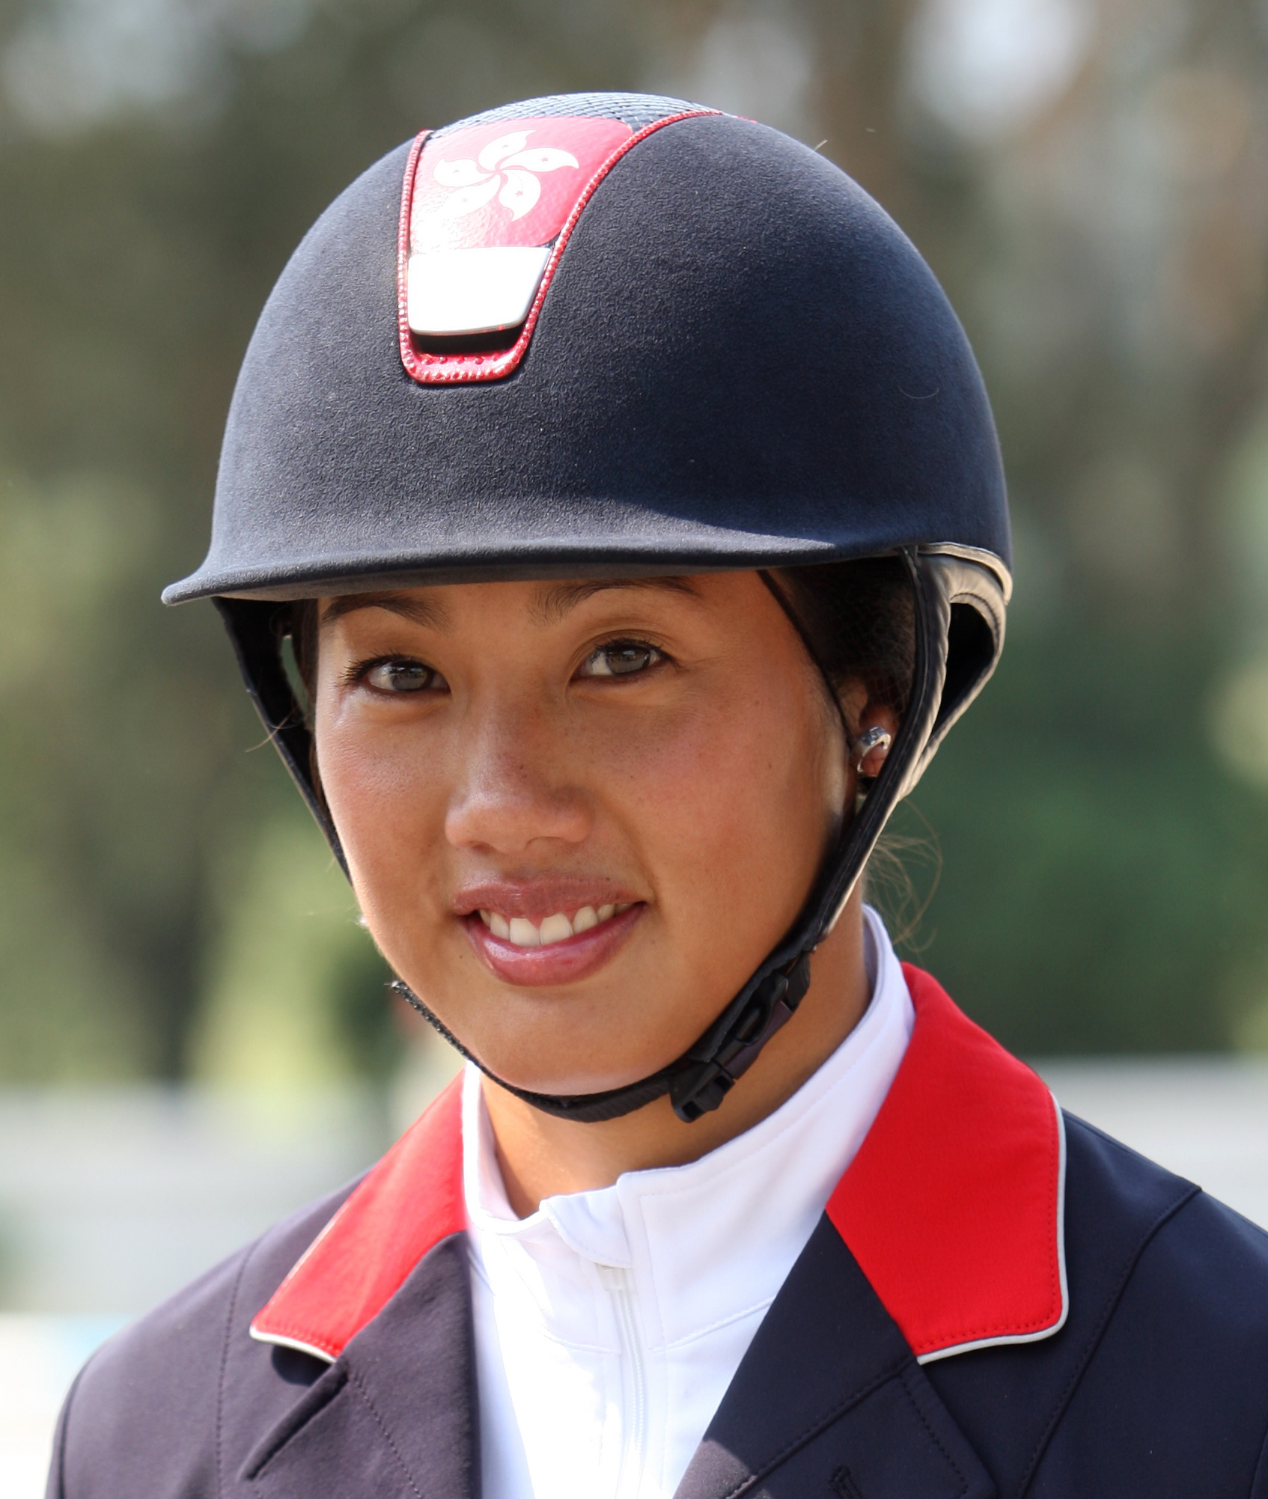
Place of birth : Vancouver, Canada
Start riding : age 7
Equestrian discipline : Jumping

Awards and achievements:
- Gold medal at the first leg of 2011 FEI World Cup Jumping Chinese League in Beijing
- Hong Kong’s first-ever equestrian medal, team bronze medal at the Guangzhou 2010 Asian Games with teammates Kenneth Cheng, Patrick Lam and Jacqueline Lai who are also Club-sponsored riders
- Team bronze medal at the Jinan 2009 National Games, with the same teammates Kenneth Cheng, Patrick Lam and Jacqueline Lai; Lam was also the winner of the Sportsmanship Award at the competition
- Champion of Grand Prix in Bernkastel-Kues of Germany in 2009
- Received “GOLD KARTE” jumping rider award from the German Equestrian Federation in 2005
Background:
- Lam began riding at the age of seven in Canada and made her debut in Grand Prix Jumping at the age of 14. Four years later, she finished third in a competition in Tampa of Florida with the prize totalled US$100,000. In 1997, at the age of 19, she became the youngest ever female rider to compete in the World Cup Finals in Gothenburg, Sweden.
- In 1998, Lam moved to Germany to focus on her riding career, she was awarded the German Golden Riding Medal by German Equestrian Federation, which was the highest honour for professional riders.
- In 2008, Lam represented Hong Kong to compete in Beijing Olympics at the home soil. Lam was selected as a member of The Hong Kong Jockey Club Equestrian Team and received sponsorship from the Club in 2008.
- Lam now bases in Belgium, actively participates in local and international competitions with the Club’s financial support.
- Lam’s current Grand Prix mounts include Jockey Club Crunship.

KENNETH CHENG (鄭文傑)
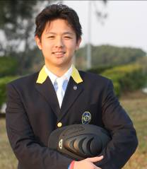

Place of birth : Hong Kong
Start riding : age 4
Equestrian discipline : Jumping

Awards and achievements:
- Hong Kong’s first-ever equestrian medal, team bronze medal at the Guangzhou 2010 Asian Games, with teammates Jacqueline Lai, Patrick Lam, and Samantha Lam who are also Club-sponsored riders
- Double bronze medals in individual and team jumping at the Jinan 2009 National Games Equestrian Events, with the same teammates Jacqueline Lai, Patrick Lam and Samantha Lam
- 2nd Place at the CSI3* Gera Hardenberg 2009
- Champion at the Asian Classic League Finals of World Cup Finals 2006

Background:
- Nurtured in an equestrian family in Hong Kong, Cheng began riding at the age of 4. His father was a former Hong Kong team member and finished fourth at the Seoul 1986 Asian Games.
- Cheng was a talent rider and got stellar results in competitions; at the age of 18, he claimed a top 20 at the Doha 2006 Asian Games.
- In 2008, Cheng was selected as one of the Olympic torch bearers, carried the Olympic torch on horseback and historically lit the cauldron at Olympic equestrian venue.
- At the age of 20, Cheng was the youngest among the three members representing Hong Kong to compete in Beijing 2008 Olympics Equestrian Events. Cheng has been selected as a member of The Hong Kong Jockey Club Equestrian Team and received sponsorship from the Club after Olympics.
- Now, Cheng is a full-time rider based in Belgium and participates in various international competitions in Europe with Club’s sponsorship.
- Cheng’s current mounts include Jockey Club Caballo, Dragon Leon and Dragon Zidane.

JACQUELINE LAI (賴楨敏)
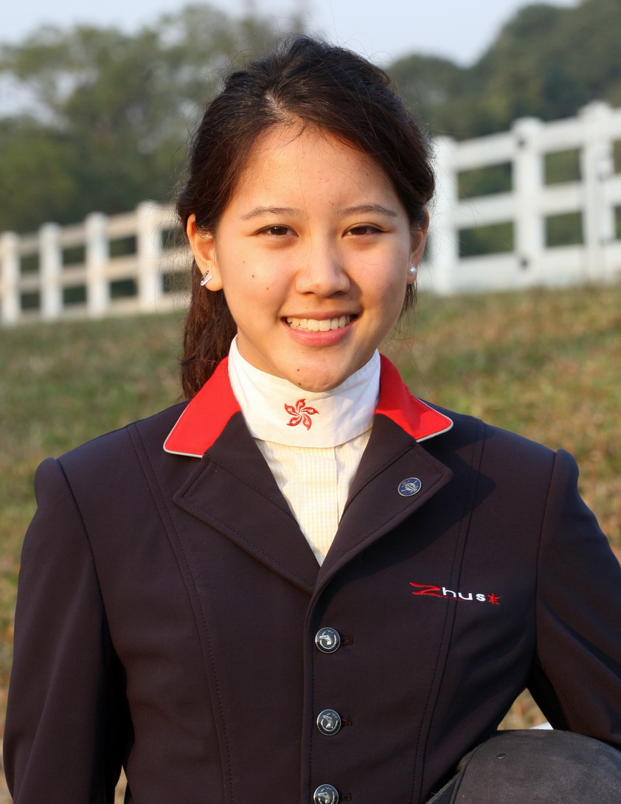

Place of birth : United States
Start riding : age 10
Equestrian Discipline : Jumping

Awards and achievements:
- 2nd place at the Denmark 2012 Herning Grand Prix
- Hong Kong’s first-ever equestrian medal, team bronze medal at the Guangzhou 2010 Asian Games with teammates Kenneth Cheng, Patrick Lam and Samantha Lam who are also Club-sponsored riders.
- Team bronze medal at the Jinan 2009 National Games, with the same teammates Kenneth Cheng, Patrick Lam and Samantha Lam
- Individual gold medal at the 2009 China National Showjumping Championships in Beijing, making her Hong Kong’s first national champion rider
- Team silver medal at the KRA Cup CSI 2* in Korea, with teammates Galle Tong and her younger sister Jasmine
Background:
- Lai is an animal lover. She quickly hooked on horse riding when her horse-loving mother brought her to stables to meet ponies and horses.
- In 2009, Lai was selected as a member of The HKJC Junior Equestrian Team and received systematic training provided by the Club.
- Lai was recruited into senior HKJC Equestrian Team in 2011, in recognition of her outstanding achievements and dedication.
- In 2011, Lai experienced serious injury and stopped riding for months. She recovered quickly, rode again and participated in international competitions with the Club’s continued support a year later.
- Now, Lai bases in Denmark, receives professional training and participates in various local and international competitions with significant achievement.

RAENA LEUNG (梁巧羚)
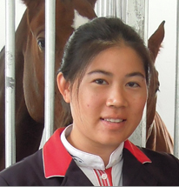
Place of birth : Hong Kong
Start riding : age 6
Equestrian discipline : Jumping

Awards and achievements:
- 3rd Place at the Six Bar of CSI2* Neustadt Dosse in Germany in 2013
- Overall champion of the FEI World Cup 2012 Jumping Chinese League
- Champion of CSI1* World Cup Beijing in 2012
- Champion of Puissance of CSN Dobrock in Germany in 2012
- 3rd Place at the Six Bar of CSN Dobrock in Germany in 2012
- 3rd Place at the Small Tour Final of CSI3* Pioltello in Italy in 2011
Background:
- Born and studied in Hong Kong, Leung decided to take her riding further by riding on European circuit alongside with her university studies in 2006.
- Training in Europe let Leung compete up to 1.40m and 1.45m classes and achieve good results in international shows up to three-star level. She was the reserve rider for the Hong Kong Jumping team at the 2010 Asian Games.
- 2012 was Leung’s breakthrough year; she attained numerous international placings up to five-star level and climbed up the world rankings. Her achievements include the champion of Puissance of Dobrock in Germany by jumping 2.05m and her first Grand Prix victory at the World Cup Beijing.
- Leung currently holds the World Cup champion of the FEI World Cup Jumping Chinese League, and participated in the 2013 Rolex World Cup Finals in Gothenburg of Sweden.
- Leung is also qualified for the 2014 World Equestrian Games with her horse Orphee du Granit.

