Previous Winners

Year | Horse /  Owner |  | Age/  Sex | Trainer /  Jockey | Rep. | Wt. | Win.  Margin | Draw | Odds | Going | Race Time | Int’l Rating | Form  (Last 5) | Best Performance Last  12 months (Runs since)
2016 | Chautauqua (AUS) |  | 5g | M Hawkes | AUS | 126 | N | 6 | 2.8F | G | 1.08.69 | 121 | 12131 | Won T J Smith S. 1200 G1 (0)
 | R & C Legh Racing Pty Ltd, G P I Racing, Gurners Bloodstock Co,  G Pulitano, S W Kay, Ms M A Keating, Wright Racing, Throsby Racing |  |  | T Berry
2015 | Gold-Fun (IRE) |  | 6g | R Gibson | HK | 126 | SH | 1 | 8 | G | 1.08.79 | 122 | 12226 | 2nd Sha Tin Trophy hcp 1600 (G2) (3)
 | Pan Sutong |  |  | C Soumillon
2014 | Lucky Nine (IRE) |  | 7g | C Fownes | HK | 126 | N | 5 | 5.9 | G | 1.09.37 | 120 | 71267 | Won Krisflyer Int’l Sprint 1200 G1 (3)
 | Dr Chang Fuk To & Maria Chang Lee Ming Shum |  |  | B Prebble
2013 | Lucky Nine (IRE) |  | 6g | C Fownes | HK | 126 | 3/4 | 5 | 2.3F | G | 1.09.28 | 118 | 05155 | Won Jockey Club Sprint 1200 G2 (2)
 | Dr Chang Fuk To & Maria Chang Lee Ming Shum |  |  | B Prebble
2012 | Joy And Fun (NZ) | 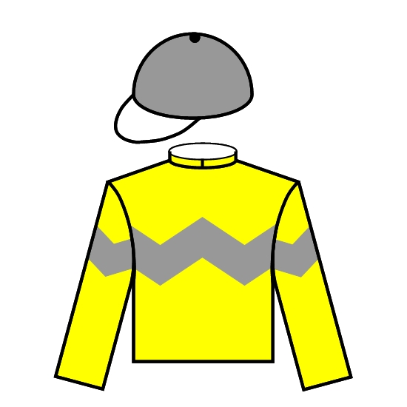 | 8g | D Cruz | HK | 126 | 3/4 | 10 | 11 | G | 1.08.98 | 110 | 14522 | 2nd Hong Kong Sprint 1200 G1 (1)
 | Mr & Mrs Johnny Wong Chun Nam |  |  | B Doyle
2011 | Dim Sum (GB) |  | 7g | J Moore | HK | 126 | N | 2 | 14 | G | 1.08.74 | 112 | 05492 | 2nd Centenary Sprint 1000 (G1) (0)
 | David Pong Chun Yee |  |  | O Doleuze
2010 | Sacred Kingdom (AUS) | 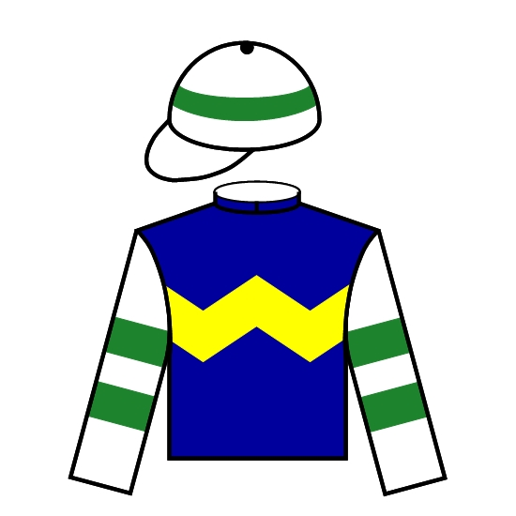 | 6g | P F Yiu | HK | 126 | 1-1/4 | 4 | 1.9F | G | 1.09.23 | 122 | 15211 | Won Hong Kong Sprint 1200 G1 (1)
 | Sin Kang Yuk |  |  | B Prebble
2009 | Dim Sum (GB) |  | 5g | J Moore | HK | 126 | HD | 4 | 51 | G | 1.09.49 | 104 | 24050 | 10th Centenary Sprint 1000 (G1) (0)
 | David Pong Chun Yee |  |  | J Winks
2008 | Sacred Kingdom (AUS) |  | 4g | P F Yiu | HK | 126 | 1-1/2 | 2 | 1.2F | G | 1.08.60 | 123 | 41112 | Won Hong Kong Sprint 1200 G1 (1)
 | Sin Kang Yuk |  |  | G Mosse
2007 | Absolute Champion (AUS) | 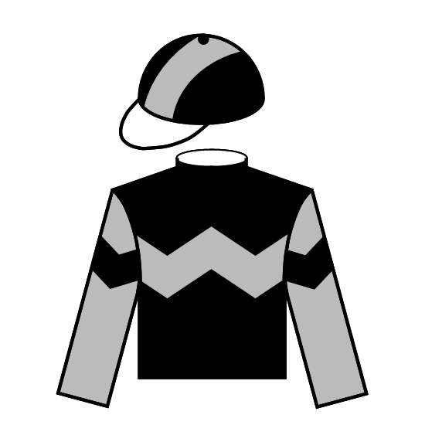 | 5g | D J Hall | HK | 126 | 1-1/2 | 4 | 1.3F | GF | 1.08.20 | 121 | 41112 | Won Hong Kong Sprint 1200 G1 (1)
 | Mr & Mrs Eddie Wong Ming Chak |  |  | B Prebble

