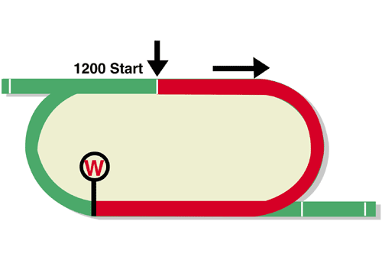
Chairman’s Sprint Prize (Group 1)
Final Leg of the Hong Kong Speed Series
Race Best Time
1.08.20 (2007)
HK$16 million (US$2.0 million)
1st HK$9,120,000, 2nd HK$3,520,000, 3rd HK$1,600,000,
4th HK$912,000, 5th HK$528,000, 6th HK$320,000

Performance Analysis

Horse Details |  |  |  |  |  | Horse Statistics |  |  |  |  |  |  | Probable Jockey | Trainer
Name |  | Rep | Age/  Sex | Wt. | Int’l Rtg# (18/19) | Lifetime | G1 | Good | Wet | RH | 1000-1200 | Trk/Dist
Santa Ana Lane |  | AUS | 6g | 126 | 124 | 33 (10-1-5) | 8 (5-0-0) | 20 (6-0-1) | 13 (4-1-4) | 10 (4-1-1) | 27 (8-0-5) | 0 (0-0-0) | H Bowman | A Freedman
Mr Stunning |  | HK | 6g | 126 | 121 | 24 (11-7-3) | 6 (2-4-0) | 23 (11-7-3) | 1 (0-0-0) | 21 (9-7-3) | 24 (11-7-3) | 19 (7-7-3) | Z Purton | F C Lor
Beat The Clock |  | HK | 5g | 126 | 120 | 20 (7-8-5) | 6 (1-3-2) | 19 (7-8-4) | 1 (0-0-1) | 20 (7-8-5) | 9 (4-2-3) | 9 (4-2-3) | J Moreira | J Size
Little Giant |  | HK | 6g | 126 | 116 | 10 (5-0-2) | 3 (0-0-0) | 6 (2-0-1) | 3 (2-0-1) | 8 (3-0-2) | 6 (3-0-1) | 5 (2-0-1) | C Y Ho | D J Hall
Rattan |  | HK | 5g | 126 | 116 | 21 (7-6-1) | 1 (0-0-0) | 19 (6-6-1) | 2 (1-0-0) | 21 (7-6-1) | 2 (1-0-0) | 2 (1-0-0) | C Schofield | R Gibson
Enzo's Lad |  | NZ | 6g | 126 | 114 | 28 (7-5-3) | 2 (2-0-0) | 17 (4-4-2) | 11 (3-1-1) | 1 (0-0-0) | 27 (7-5-3) | 0 (0-0-0) | J McDonald | M Pitman
Winner's Way |  | HK | 6g | 126 | 114 | 35 (8-6-3) | 3 (0-0-1) | 33 (7-6-3) | 2 (1-0-0) | 31 (6-5-3) | 12 (2-1-3) | 10 (2-0-3) | K Teetan | A S Cruz
Pingwu Spark |  | HK | 6g | 126 | 109 | 20 (6-3-2) | 3 (0-0-0) | 17 (4-3-1) | 3 (2-0-1) | 20 (6-3-2) | 7 (3-1-1) | 5 (2-1-0) | K C Leung | T P Yung
Viddora |  | AUS | 6m | 122 | 114 | 31 (9-7-1) | 9 (2-2-0) | 25 (7-6-1) | 6 (2-1-0) | 4 (1-2-0) | 31 (9-7-1) | 0 (0-0-0) | J Bowditch | L Kennewell
Nac Venus |  | JPN | 6m | 122 | 110 | 32 (7-10-5) | 4 (0-0-1) | 26 (6-7-5) | 1 (0-1-0) | 23 (6-7-3) | 25 (6-8-3) | 0 (0-0-0) | Y Take | H Sugiura

# 1st August – 16th April

Barrier Draw Statistics (Since 1992) Speed Chart

Draw 1st 2nd 3rd 4th  1 3 4 4 2  2 3 1 1 1  3 2 3 2 5  4 3 4 2 1  5 3 4 3 4  6 1 0 1 3  7 1 2 2 3  8 1 1 3 6  9 1 5 1 0  10 3 0 4 1  11 3 3 2 0  12 1 0 2 1  13 1 0 0 1  14 1 0 0 0  (Past 27 runnings) | 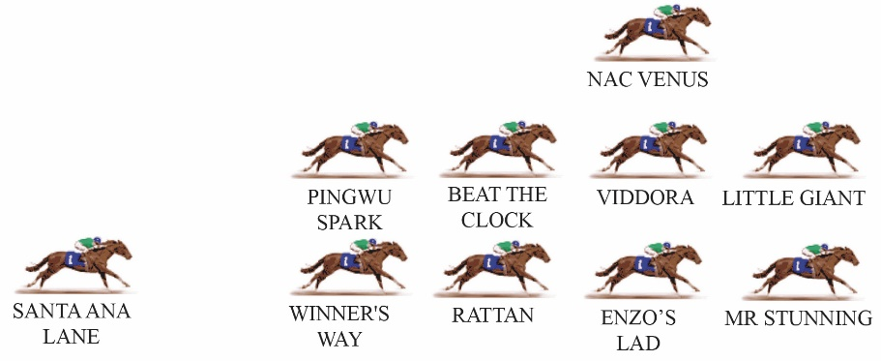  This will be slightly strange --- an international sprint race without an obvious leader. None of the invitees are at their best when left in front so it’s hard to see the pace being too strong. Top-level sprints at Sha Tin are typically won by the horses racing prominently, with the notable exception of Chautauqua, who came from a distant last when he rounded up Lucky Bubbles to win the 2016 Chairman’s Sprint Prize in the final bound. Given the lack of obvious speed this year, the ideal position should be up close with cover.

