Spotlight

Hong Kong’s sprinters face tough raiders in what promises to be the season’s most thrilling speed race.

Australia won the first international G1 edition of the Chairman’s Sprint Prize with the late-thrusting grey Chautauqua. Santa Ana Lane is another real deal Australian sprint star heading to Sha Tin. The latest of the six-year-old’s five G1 wins was achieved last time out, an impressive score in the T. J. Smith Stakes (1200m).

Viddora, meanwhile, heads to Hong Kong from Australia via a good fourth in Dubai’s G1 Al Quoz Sprint (1200m) - the six-year-old mare is a two-time G1 winner.

Mr Stunning and Beat The Clock - second and third in this race last year - have been at the top of Hong Kong’s sprint division this term. Mr Stunning landed a second G1 LONGINES Hong Kong Sprint (1200m) in December, while Beat The Clock took the G1 Centenary Sprint Cup (1200m) a month later.

That speedy duo received a shock - albeit when carrying 5lb G1 penalties - when Rattan rattled past them to win the prime lead-up to this contest, the G2 Sprint Cup (1200m).

New Zealand will cheer on Enzo’s Lad, who in January nailed back-to-back wins in the G1 Telegraph (1200m).

Japan’s Nac Venus is set to take her place in the 10-runner line-up. The G1-placed galloper won the G3 Keeneland Cup in August.

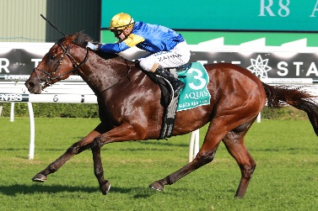 | SANTA ANA LANE (AUS)  AUSTRALIA  6g 124  A Freedman | 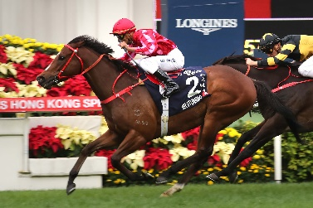 | MR STUNNING (AUS)  HONG KONG  6g 121  F C Lor
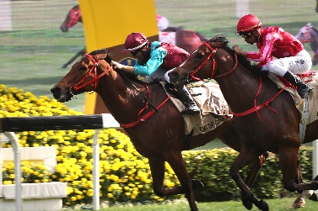 | BEAT THE CLOCK (AUS)  HONG KONG  5g 120  J Size | 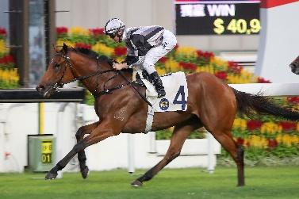 | LITTLE GIANT (NZ)  HONG KONG  6g 116  D J Hall
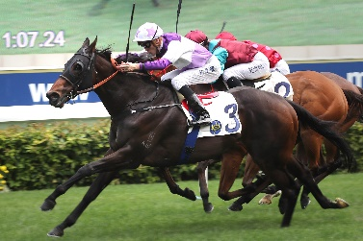 | RATTAN (NZ)  HONG KONG  5g 116  R Gibson | 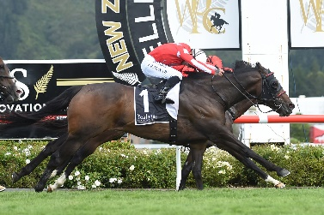 | ENZO’S LAD (AUS)  NEW ZEALAND  6g 114  M Pitman
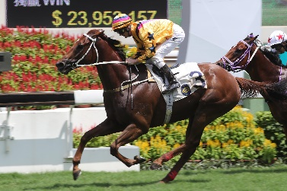 | WINNER'S WAY (AUS)  HONG KONG  6g 114  A S Cruz | 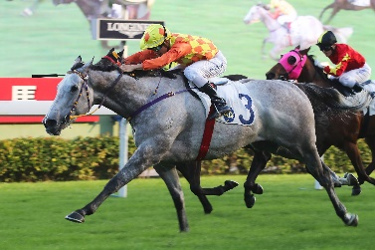 | PINGWU SPARK (NZ)  HONG KONG  6g 109  T P Yung
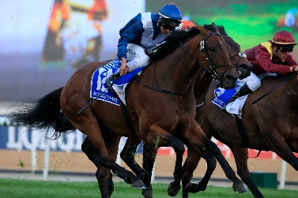 | VIDDORA (AUS)  AUSTRALIA  6m 114  L Kennewell | 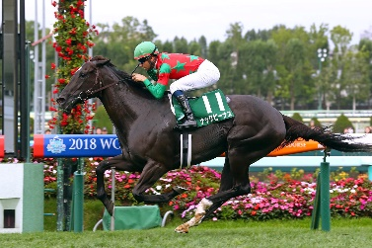 | NAC VENUS (JPN)  JAPAN  6m 110  H Sugiura

