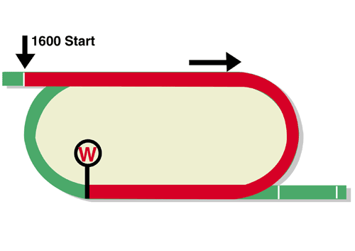
FWD Champions Mile (Group 1)
HK$18 million (US$2.3 million)
Race Best Time
1.33.42 (2013)
1st HK$10,260,000, 2nd HK$3,960,000, 3rd HK$1,800,000,
4th HK$1,026,000, 5th HK$594,000, 6th HK$360,000

Performance Analysis

Horse Details |  |  |  |  |  | Horse Statistics |  |  |  |  |  |  | Probable Jockey | Trainer
Name |  | Rep | Age/  Sex | Wt. | Int’l Rtg# (18/19) | Lifetime | G1 | Good | Wet | RH | 1400-1800 | Trk/Dist
Beauty Generation |  | HK | 6g | 126 | 127 | 29 (16-3-4) | 10 (6-1-0) | 25 (14-2-3) | 4 (2-1-1) | 29 (16-3-4) | 23 (15-1-3) | 13 (9-0-2) | Z Purton | J Moore
Conte |  | HK | 5g | 126 | 116 | 12 (7-2-2) | 2 (0-1-1) | 12 (7-2-2) | 0 (0-0-0) | 12 (7-2-2) | 11 (6-2-2) | 3 (1-1-0) | J Moreira | J Size
Seasons Bloom |  | HK | 6g | 126 | 114 | 25 (7-2-2) | 6 (1-0-1) | 21 (5-1-2) | 4 (2-1-0) | 23 (6-2-2) | 18 (5-2-1) | 12 (3-1-0) | H Bowman | C S Shum
Simply Brilliant |  | HK | 5g | 126 | 110 | 19 (7-3-2) | 1 (0-0-0) | 17 (6-3-2) | 2 (1-0-0) | 15 (6-3-2) | 14 (5-1-2) | 5 (3-0-0) | O Murphy | F C Lor
Singapore Sling |  | HK | 5g | 126 | 110 | 18 (4-3-2) | 4 (0-0-0) | 16 (3-3-2) | 2 (1-0-0) | 15 (3-3-1) | 15 (3-2-2) | 6 (0-2-0) | K Teetan | A T Millard
Rise High |  | HK | 5g | 126 | 108 | 15 (6-1-1) | 0 (0-0-0) | 12 (4-1-0) | 3 (2-0-1) | 13 (4-1-1) | 15 (6-1-1) | 10 (4-1-1) | J McDonald | C Fownes
Romantic Touch |  | HK | 8g | 126 | 105 | 68 (8-8-7) | 4 (1-0-0) | 55 (5-7-6) | 13 (3-1-1) | 66 (8-8-7) | 60 (8-8-5) | 14 (0-1-1) | M Chadwick | A S Cruz
# 1st August – 16th April

Barrier Draw Statistics (Since 2001) Speed Chart

Draw 1st 2nd 3rd 4th  1 4 3 2 1  2 3 2 3 2  3 1 1 0 3  4 1 2 4 1  5 0 0 3 1  6 1 3 1 2  7 2 2 1 0  8 3 1 0 3  9 2 1 1 1  10 0 1 1 2  11 0 0 0 1  12 1 1 1 0  13 0 0 0 0  14 0 1 1 1  (Past 18 runnings) | 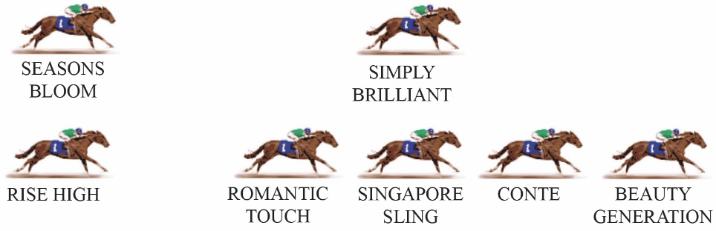  Hong Kong’s champion racehorse and reigning Horse of the Year BEAUTY GENERATION has made front-running his signature tune. He may not necessarily run quick fractions early but he increases the tempo mid-race and puts rivals under pressure before they’re ready. On face value, none of his fellow HK-based invitees can go with him and given the make-up of the field it's hard to see the race being run any different to expectation. In “normal” feature mile races at Sha Tin, the sweet spot has been behind midfield and away from the rail, but in the BEAUTY GENERATION era, those horses are barely competitive.

