Spotlight

Beauty Generation is among the world’s very best racehorses and the “Master Miler” will attempt a second G1 FWD Champions Mile success against six rivals. Trainer John Moore’s six-year-old is unbeaten in his last eight races, seven of which have been this season, matching the Hong Kong all-time record for most wins in a campaign. Victory would see him surpass Viva Pataca as the highest earner in Hong Kong history.

The field also features high-class milers Conte and Rise High and the 2018 Hong Kong Classic Cup victor Singapore Sling.

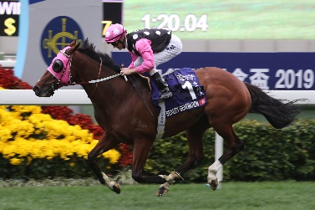 | BEAUTY GENERATION (NZ)  HONG KONG  6g 127  J Moore | 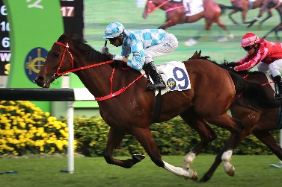 | CONTE (AUS)  HONG KONG  5g 116  J Size
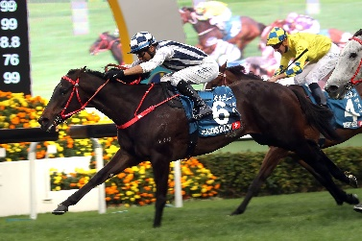 | SEASONS BLOOM (AUS)  HONG KONG  6g 114  C S Shum | 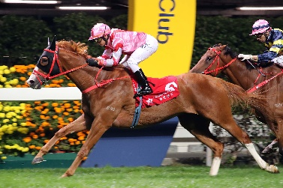 | SIMPLY BRILLIANT (GB)  HONG KONG  5g 110  F C Lor
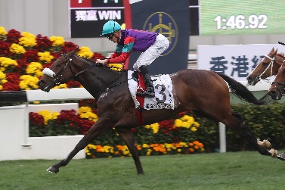 | SINGAPORE SLING (SAF)  HONG KONG  5g 110  A T Millard | 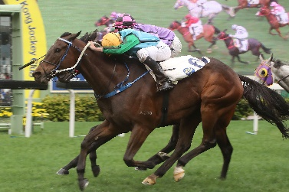 | RISE HIGH (FR)  HONG KONG  5g 108  C Fownes
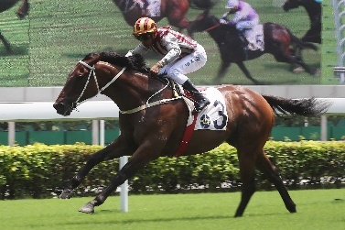 | ROMANTIC TOUCH (AUS)  HONG KONG  8g 105  A S Cruz

