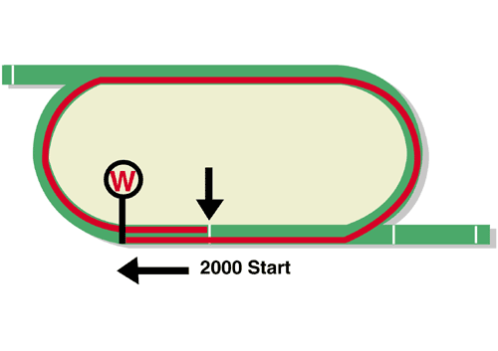
FWD QEII Cup (Group 1)
Race Best Time
2.00.10 (1999)
HK$24 million (US$3.1 million)
1st HK$13,680,000, 2nd HK$5,280,000, 3rd HK$2,400,000,
4th HK$1,368,000, 5th HK$792,000, 6th HK$480,000

Performance Analysis

Horse Details |  |  |  |  |  | Horse Statistics |  |  |  |  |  |  | Probable Jockey | Trainer
Name |  | Rep | Age/  Sex | Wt. | Int’l Rtg# (18/19) | Lifetime | G1 | Good | Wet | RH | 1800-2200 | Trk/Dist
Exultant |  | HK | 5g | 126 | 120 | 20 (8-5-2) | 4 (2-1-1) | 18 (7-5-1) | 2 (1-0-1) | 19 (7-5-2) | 10 (4-3-1) | 4 (2-1-1) | Z Purton | A S Cruz
Time Warp |  | HK | 6g | 126 | 120 | 34 (11-3-5) | 6 (2-0-1) | 23 (6-2-3) | 5 (4-0-1) | 28 (8-2-4) | 12 (4-2-1) | 7 (2-1-1) | K Teetan | A S Cruz
Glorious Forever |  | HK | 5g | 126 | 119 | 18 (6-4-1) | 2 (1-0-0) | 14 (5-3-1) | 4 (1-1-0) | 13 (6-2-1) | 13 (5-3-0) | 4 (2-0-0) | K C Leung | F C Lor
Win Bright |  | JPN | 5h | 126 | 117 | 17 (7-2-0) | 4 (0-0-0) | 17 (7-2-0) | 0 (0-0-0) | 12 (6-2-0) | 13 (7-1-0) | 0 (0-0-0) | M Matsuoka | Y Hatakeyama
Pakistan Star |  | HK | 6g | 126 | 116 | 23 (5-5-1) | 7 (2-1-0) | 22 (5-4-1) | 1 (0-1-0) | 23 (5-5-1) | 9 (1-3-0) | 6 (1-2-0) | M Chadwick | P O'Sullivan
Southern Legend |  | HK | 6g | 126 | 116 | 29 (9-3-5) | 7 (0-1-3) | 25 (8-2-5) | 4 (1-1-0) | 26 (8-3-4) | 3 (0-1-0) | 1 (0-1-0) | C Schofield | C Fownes
Eagle Way |  | HK | 6g | 126 | 115 | 38 (8-5-5) | 8 (1-0-2) | 34 (8-4-5) | 4 (0-1-0) | 38 (8-5-5) | 16 (3-3-3) | 5 (1-0-1) | U Rispoli | J Moore
Eminent |  | GB | 5h | 126 | 114 | 13 (3-1-1) | 7 (0-1-1) | 12 (3-0-1) | 1 (0-1-0) | 7 (1-1-0) | 7 (1-1-1) | 0 (0-0-0) | J McDonald | Sir M Todd
Furore |  | HK | 4g | 126 | 112 | 11 (6-0-2) | 2 (0-0-1) | 9 (5-0-1) | 2 (1-0-1) | 11 (6-0-2) | 5 (3-0-1) | 1 (1-0-0) | H Bowman | F C Lor
Dark Dream |  | HK | 4g | 126 | 110 | 16 (6-6-2) | 1 (1-0-0) | 13 (4-5-2) | 3 (2-1-0) | 16 (6-6-2) | 9 (5-2-1) | 3 (2-0-0) | T Clark | F C Lor
Dinozzo |  | HK | 6g | 126 | 110 | 37 (6-5-8) | 3 (0-0-1) | 32 (5-5-7) | 5 (1-0-1) | 36 (5-5-8) | 25 (4-5-6) | 9 (0-1-1) | C Y Ho | J Size
Waikuku |  | HK | 4g | 126 | 110 | 9 (5-2-0) | 0 (0-0-0) | 7 (5-1-0) | 2 (0-1-0) | 7 (4-2-0) | 3 (1-1-0) | 2 (0-1-0) | J Moreira | J Size
Lys Gracieux |  | JPN | 5m | 122 | 114 | 18 (4-8-3) | 9 (1-5-0) | 17 (4-7-3) | 1 (0-1-0) | 10 (2-4-3) | 7 (2-3-1) | 0 (0-0-0) | O Murphy | Y Yahagi
Deirdre |  | JPN | 5m | 122 | 113 | 22 (7-4-3) | 7 (1-1-1) | 19 (6-3-3) | 3 (1-1-0) | 14 (5-3-2) | 12 (6-1-1) | 1 (0-1-0) | Y Take | M Hashida
# 1st August – 16th April

Barrier Draw Statistics (Since 1997) Speed Chart

Draw 1st 2nd 3rd 4th  1 3 2 1 2  2 1 2 5 1  3 2 2 2 4  4 0 1 2 0  5 3 4 0 2  6 2 1 2 3  7 2 0 1 2  8 5 3 1 3  9 1 1 1 1  10 1 2 2 0  11 0 2 1 4  12 2 1 2 0  13 0 1 2 0  14 0 0 0 0  (Past 22 runnings) | 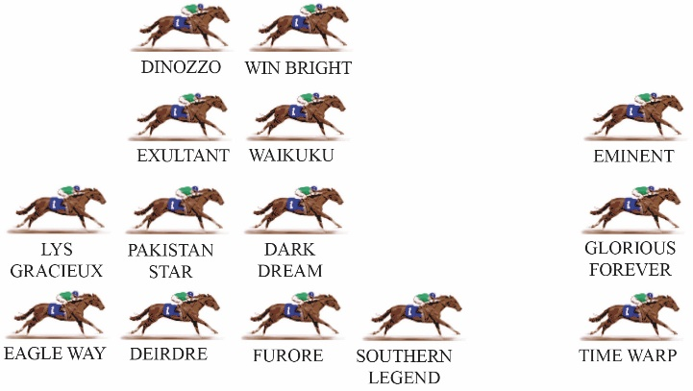  There looks to be speed aplenty in the 2019 renewal of the QEII Cup. The major question will be which horses persist for front-running honours and which steady behind the speed. There is also the possibility of a speed duel, but however it plays out the tempo should be strong enough. The barrier draw is hugely important at the Sha Tin 2000m start, which is effected right in front of the grandstand, shortly before the winning post. The short run to the first turn is especially tough on horses with a forward running style which have drawn wide. On the flip side, midfield runners who draw wide will often find themselves two or three positions further back than they might prefer.

