Spotlight

Japan has won the FWD QEII Cup four times thanks to Eishin Preston (2002 & 2003), Rulership (2012) and Neorealism (2017). This time around, Lys Gracieux and Deirdre will lead the Japanese assault, bringing their top-class ability back to Hong Kong to build on their fine efforts at the LONGINES Hong Kong International Races in December.

Four months ago, at Sha Tin, Deirdre placed second in the G1 LONGINES Hong Kong Cup (2000m), while Lys Gracieux was second to Exultant in the G1 LONGINES Hong Kong Vase (2400m). Deirdre was a solid fourth to superstar filly Almond Eye in the G1 Dubai Turf last time, while Lys Gracieux warmed up for her FWD QEII Cup test with a good second in the G2 Kinko Sho (2000m).

Japan will also send across Win Bright who is rolling off two good wins, latterly in the G2 Nakayama Kinen (1800m) which he also won in 2018.

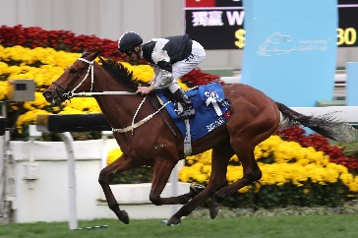 | EXULTANT (IRE)  HONG KONG  5g 120  A S Cruz | 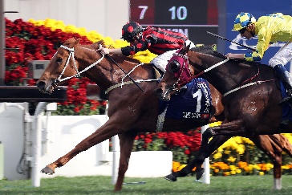 | TIME WARP (GB)  HONG KONG  6g 120  A S Cruz
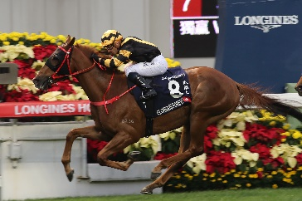 | GLORIOUS FOREVER (GB)  HONG KONG  5g 119  F C Lor | 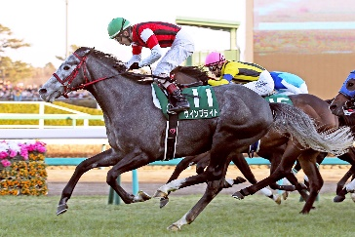 | WIN BRIGHT (JPN)  JAPAN  5h 117  Y Hatakeyama
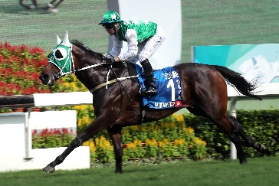 | PAKISTAN STAR (GER)  HONG KONG  6g 116  P O’Sullivan | 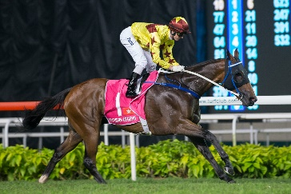 | SOUTHERN LEGEND (AUS) HONG KONG  6g 116  C Fownes
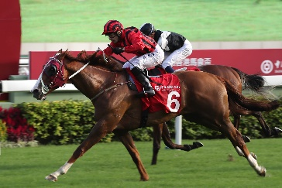 | EAGLE WAY (AUS)  HONG KONG  6g 115  J Moore | 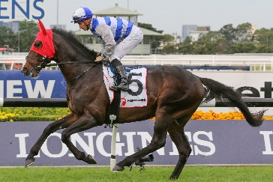 | EMINENT (IRE)  GREAT BRITAIN  5h 114  Sir M Todd
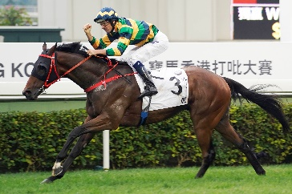 | FURORE (NZ)  HONG KONG  4g 112  F C Lor | 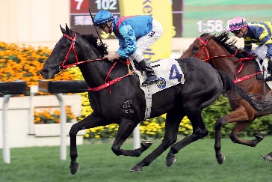 | DARK DREAM (AUS)  HONG KONG  4g 110  F C Lor
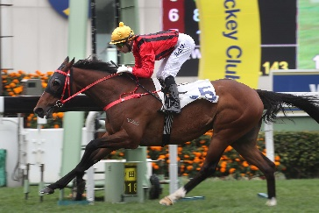 | DINOZZO (IRE)  HONG KONG  6g 110  J Size | 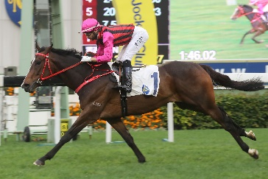 | WAIKUKU (IRE)  HONG KONG  4g 110  J Size
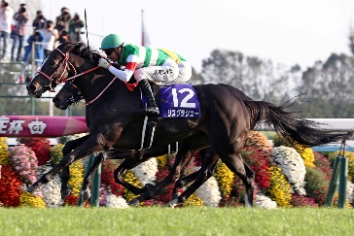 | LYS GRACIEUX (JPN)  JAPAN  5m 114  Y Yahagi | 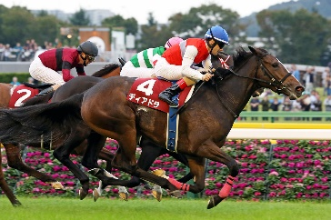 | DEIRDRE (JPN)  JAPAN  5m 113  M Hashida

