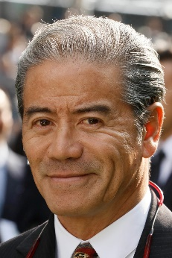 | Cruz, Tony | FWDQEII ‒ Exultant, Time Warp; CM ‒ Romantic Touch; CSP ‒ Winner's Way
 | Age: 62. Tony Cruz is a son of Johnny Cruz, a renowned rider from Hong Kong’s amateur era. His brother, Derek, was also a trainer. He was among the first intake of apprentices to the HKJC Apprentice Jockeys’ School in 1972. Cruz started his riding career in the 1973/74 season, went on to be Hong Kong’s champion jockey six times and rode 946 winners. Cruz also made his name at G1 level in Europe and partnered the great race mare Triptych. He started training in 1996 and won the trainers’ title in 1999/2000 and 2004/2005, latterly setting a then record for a season’s winners (91) and earnings (HK$113m). He trained the great Hong Kong champion Silent Witness to win 17 consecutive races. Honours: Hong Kong Champion Jockey (1978/79, 1980/81, 1982/83, 1983/84, 1985/86, 1994/95); Hong Kong Champion Trainer (1999/00, 2004/05). FWD Champions Day race wins (6): FWD Champions Mile (2005 & 2006 Bullish Luck), FWD QEII Cup (2015 Blazing Speed, 2018 Pakistan Star), Chairman's Sprint Prize (2004 & 2005 Silent Witness). Hong Kong wins: 1,217.

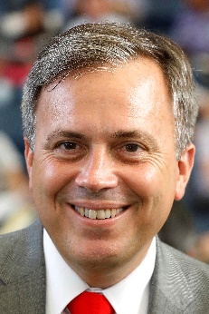 | Fownes, Caspar | FWDQEII ‒ Southern Legend; CM ‒ Rise High
 | Age: 51. Caspar Fownes assisted his late father Lawrie for several seasons before gaining his licence in 2003/04. He eclipsed his father's best season stats in his rookie year with 44 wins. In 2006/07 he won his first premiership and has since added two more. His third championship came in 2013/14 when his strong late charge brought three wins on the closing day to tie with John Size on 62 wins, and with one more second place than his rival he sealed the title on count-back. Fownes is particularly known for his fine record at Happy Valley where he has notched more than 440 career wins, a tally second only to Hong Kong's longest-serving trainer John Moore. His big race wins offshore include Lucky Nine’s double in the KrisFlyer International Sprint (2013 and 2014) and Southern Legend’s score in the 2018 Kranji Mile. Honours: Hong Kong Champion Trainer (2006/07, 2008/09, 2013/14). FWD Champions Day race wins (2): Chairman's Sprint Prize (2013 & 2014 Lucky Nine). Hong Kong wins: 822.

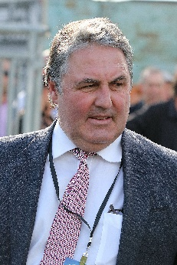 | Freedman, Anthony | CSP ‒ Santa Ana Lane
 | Age: 55. Anthony Freedman is the third eldest of racing’s famous Freedman Brothers (Lee, Michael, Anthony and Richard), who together until 2008, combined to win an astonishing 124 G1’s, including two Melbourne Cups, four Caulfield Cups, four consecutive Golden Slippers and two Cox Plates. Anthony completed year 12 at Canberra Grammar and began working with his brothers Lee and Richard at their Warwick Farm stable in 1983. He played an integral part in Freedman Racing’s move to Flemington in 1984, until Sydney called again and he was tasked with heading up their Randwick stable in 1992. He prepared Bint Marscay to win the 1993 Golden Slipper Stakes at Rosehill, the first of four consecutive Slippers the brothers would win. Anthony is well known for selecting Mummify as a yearling, who the brothers trained to win five G1’s including the 2003 Caulfield Cup and the 2005 Singapore Airlines International Cup at Kranji. Anthony has been head trainer of his own operation since the beginning of the 2011/12 season and he trained his first G1 in his own name when Mawingo won the Doomben Cup on 19 May, 2012, since then he has added a further 12 to his tally. Hong Kong wins: No previous Hong Kong runners.

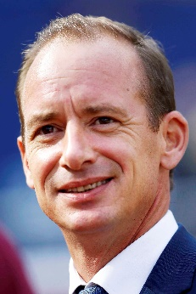 | Gibson, Richard | CSP ‒ Rattan
 | Age: 49. Englishman Richard Gibson established himself as a Group 1 trainer in France before he arrived in Hong Kong for the 2011/12 season. He gained a solid grounding in the art and science of training racehorses with Frenchmen Pascal Bary and Henri-Alex Pantall, as well as Americans Bill Mott and Gary Jones. He took out his licence at Chantilly in 1996 and struck gold as early as 1999 when Lady Of Chad won the G1 Prix Marcel Boussac en route to becoming European Champion Juvenile Filly. He has trained the winners of eight G1s altogether, the highlights being Akeed Mofeed's and Doctor Dino's exploits in Hong Kong and the USA, and Gold-Fun’s big race triumphs at Sha Tin. FWD Champions Day race wins (1): Chairman’s Sprint Prize (2015 Gold-Fun). Hong Kong wins: 216.

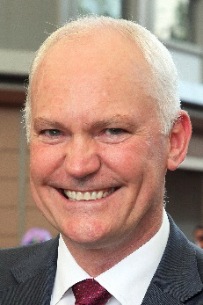 | Hall, David | CSP ‒ Little Giant
 | Age: 55. David Hall was born in Adelaide, the son of trainer Joe Hall. He began training at Morphettville in 1988 and moved to Melbourne five years later. Best known at home for winning the Melbourne Cup in 2003 with the brilliant Makybe Diva, he also trained Silent Witness before the champion sprinter switched to Hong Kong. Hall began his training career in Hong Kong in 2004/05. Absolute Champion's victory in the G1 Hong Kong Sprint is his Hong Kong highlight to date. FWD Champions Day race wins (1): Chairman's Sprint Prize (2007 Absolute Champion). Hong Kong wins: 432.

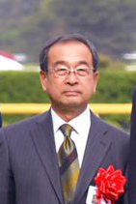 | Hashida, Mitsuru | FWDQEII ‒ Deirdre
Age: 66. Son of a former jockey and trainer, Hashida has plied his trade since 1985 and is currently the President of the Japan Trainers Association. Passing Shot brought him his first G1 success in the Mile Championship in 1990, and he has collected no less than 11 G1 wins over the years. His leading performers include HKIR runners Silence Suzuka (1998 Takarazuka Kinen), Admire Cozzene (1998 Yasuda Kinen), Admire Max (2005 Takamatsunomiya Kinen), as well as Admire Vega (1999 Tokyo Yushun), Admire Groove (2003 & 2004 Queen Elizabeth II Commemorative Cup), and his current flagbearer Deirdre (2017 Shuka Sho). He has amassed a total of 697 JRA wins in his career, including five of them this year.
Hong Kong wins: 0

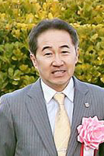 | Hatakeyama, Yoshihiro | FWDQEII ‒ Win Bright
 | Age: 56. Hatakeyama commenced his JRA career as a work rider in 1986, before obtaining his JRA training licence in 1999 and started his stable operation the following year. Meiner Dupre’s success in the G3 Kyodo News Service Hai in 2004 was Hatakeyama’s first at Group level. His top-class breakthrough and his sole G1 win to date came from Meiner Ho O’s victory in the 2013 NHK Mile Cup. His other top performers include three-time G2 winner Win Bright, and top dirt fillies Grab Your Heart and Trois Bonheur, who brought the trainer a total of nine Group wins on the regional NAR circuit. He has amassed a total of 298 JRA wins, including six this season. Hong Kong wins: No previous Hong Kong runners.

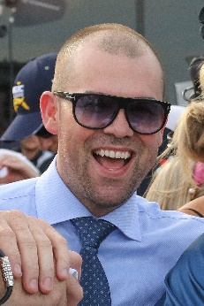 | Kennewell, Lloyd | CSP ‒ Viddora
 | Age: 37. Lloyd Kennewell grew up around horses at his father Gary’s stables and following the completion of a Business Management Course, decided to set up on his own in 2003 and applied for his training licence. Kennewell made history upon receiving his licence, becoming the youngest recipient in South Australia at just 21 years of age. His first winner was Treasure Time who won at the now closed, Cheltenham Park Racecourse in Adelaide on 14 February, 2004. He won his first G1 when Viddora took out the 2017 Winterbottom Stakes at Ascot in Perth. Kennewell trained Viddora to her second G1 win in the 2018 Moir Stakes at Moonee Valley. Hong Kong wins: No previous Hong Kong runners.

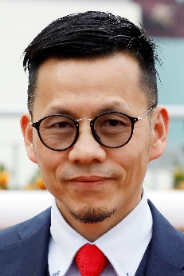 | Lor, Frankie F C | FWDQEII ‒ Dark Dream, Furore, Glorious Forever; CM ‒ Simply Brilliant;  CSP ‒ Mr Stunning
 | Age: 53. Frankie Lor began his career as a jockey in Hong Kong, notching 27 wins between 1981 and 1995. He then became a work rider before working as an assistant to a number of trainers, most notably to two of Hong Kong's greats, John Moore and John Size. Lor was granted a licence ahead of the 2017/18 Hong Kong racing season. His first win was achieved with his first runner, Yourthewonforme, in a Class 4 contest at the season opener on 3 September, 2017. Lor ended the campaign second in the premiership behind his old master John Size. His final tally of 65 wins surpassed Hong Kong's previous best first-season total, set by Size when winning his first Hong Kong trainers' championship in 2002. This term he has enjoyed G1 victories with Mr Stunning (Hong Kong Sprint) and Glorious Forever (Hong Kong Cup) and took all three legs of the 4YO Classic Series with Furore (BMW Hong Kong Derby & Hong Kong Classic Mile) and Mission Tycoon (Hong Kong Classic Cup). Hong Kong wins: 113.

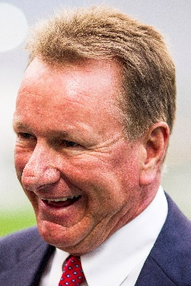 | Millard, Tony | CM ‒ Singapore Sling
 | Age: 57. Tony Millard's father was the legendary multiple South African champion trainer Terrance Millard. He made an impressive start to his own training career in 1991. He was champion trainer in South Africa twice and won all of that country's majors. He trained three Horses of the Year there in Empress Club, Jet Master and Surfing Home as well as numerous other champions. He sent out 39 G1 winners in his first nine years of training before relocating to Hong Kong. Millard made an immediate impact locally, winning the 2000 Hong Kong Derby in his first season with Keen Winner. His most spectacular successes in Hong Kong have come with two-time Horse of the Year Ambitious Dragon whose 13 career wins included two G1s and five local G1s. Honours: South African Champion Trainer (1992, 1994 [shared with Pat Shaw]). FWD Champions Day race wins (1): FWD QEII Cup (2011 Ambitious Dragon). Hong Kong wins: 612.

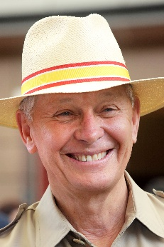 | Moore, John | FWDQEII ‒ Eagle Way; CM ‒ Beauty Generation
 | Age: 69. John Moore has been involved in Hong Kong racing since the professional era commenced in 1971 and is Hong Kong’s longest-serving and winning-most trainer. A former amateur jockey, he began training in 1985, before which he was assistant trainer to his late famous father, George. In 2007 he prepared an international G1 double thanks to Viva Pataca in the QEII Cup and Able One in the Champions Mile and, in a feat perhaps unprecedented in the sport, won the same two races with the same two horses three years later. He was the first to saddle 1000 wins in Hong Kong and was the leading prize money earner in 12 of the past 13 seasons. The stable has also produced the last six gallopers to be named Hong Kong Horse of the Year – Military Attack, Designs On Rome, Able Friend, Werther, Rapper Dragon and Beauty Generation. Honours: 7x Hong Kong Champion Trainer (1985/86, 1990/91, 1991/92, 1992/93 [tied with David Hill], 1994/95, 2010/11, 2014/15); Hong Kong record holder for all-time career prize money (HK$1.87 billion). FWD Champions Day race wins (16): FWD QEII Cup (2007 & 2010 Viva Pataca, 2013 Military Attack, 2014 Designs On Rome, 2016 Werther), FWD Champions Mile (2007 & 2010 Able One, 2011 & 2012 Xtension, 2013 Dan Excel, 2015 Able Friend, 2018 Beauty Generation), Chairman’s Sprint Prize (1994 Happy Money, 2006 Billet Express, 2009 & 2011 Dim Sum). Hong Kong wins: 1648.

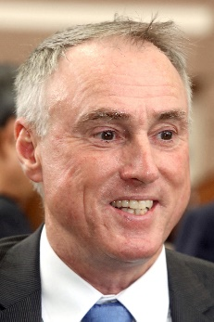 | O’Sullivan, Paul | FWDQEII ‒ Pakistan Star
 | Age: 59. Paul O'Sullivan arrived in Hong Kong in 2004 and has enjoyed major successes with Vital King (Hong Kong Derby), Fellowship (Stewards’ Cup) and champion sprinter Aerovelocity (G1 wins include Hong Kong Sprint x2), who during the 2014/15 season became the first Hong Kong horse to win three G1s in three different international jurisdictions. O'Sullivan was champion trainer in New Zealand on 11 occasions, acting in partnership with his father Dave for 17 years. His brother, Lance, New Zealand's all-time winning-most jockey, is also a trainer. O'Sullivan won the G1 Japan Cup in 1989 with Horlicks, ridden by his brother, and added scores of other majors on both sides of the Tasman Sea, including the G1 Cox Plate with Surfers Paradise in 1991. Honours: 11-time New Zealand Champion Trainer. Hong Kong wins: 425.

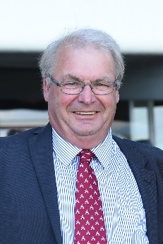 | Pitman, Michael | CSP ‒ Enzo’s Lad
 | Age: 63. Michael Pitman spent much of his youth at Riccarton Park racecourse with his parents before electing to take out his owner-trainer licence over four decades ago. Pitman has consistently been in the top five in the New Zealand trainers’ premiership and in the 2007/08 season he became the first South Island-based trainer in 36 years to win a premiership (86 wins). G1 success has followed in recent years, including Savvy Coup who claimed two G1’s in 2018, winning the New Zealand Oaks and the Livamol Classic. Pitman’s most recent G1 success came when Enzo’s Lad won his second consecutive G1 Telegraph in January 2019. Pitman is based in at Riccarton, training in partnership with his son, Matthew Pitman. Honours: New Zealand Trainers’ Premiership (2007/08). Hong Kong wins: No previous Hong Kong runners.

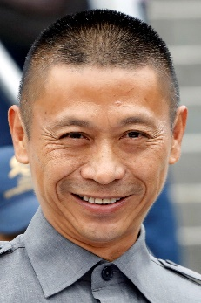 | Shum, Danny C S | CM ‒ Seasons Bloom
 | Age: 58. Danny Shum rode 24 winners in Hong Kong between 1977 and 1983. He learnt the training ropes as assistant to former multiple Hong Kong champion trainer Ivan Allan. He was granted a Hong Kong trainer’s licence ahead of the 2003/04 season and began brightly with 34 winners. He improved on that good debut season to rank third in the trainers’ premiership in his second term when Scintillation emerged as his standout runner. The 2011/12 season brought a first overseas success as Little Bridge went to Royal Ascot to clinch victory in the G1 King’s Stand Stakes. Last term, he saddled Seasons Bloom to win the G1 Stewards’ Cup. He recorded a best ever season’s tally of 54 wins to finish second in the 2015/16 trainers’ premiership. Hong Kong wins: 569.

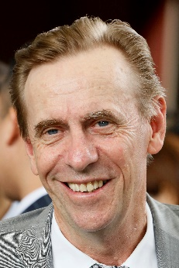 | Size, John | FWDQEII ‒ Dinozzo, Waikuku; CM ‒ Conte; CSP ‒ Beat The Clock
 | Age: 64. John Size was a top trainer in Sydney before his arrival in Hong Kong in 2001. He broke the mould by winning the trainers’ premiership in his very first season. Size notched his ninth championship in 2016/17, setting a new record for most wins in a season with 94, 27 more than nearest rival John Moore; and in 2017/18 he smashed Moore’s record for most prize money in a season by more than HK$21 million as his 87 wins accrued HK$176 million. He has trained the winners of two Horse of the Year titles, the multiple HKG1 scorers Electronic Unicorn and Grand Delight. In 2009/10 he trained Brave Kid to equal the then record of six wins in a season and Entrapment who finally broke that record with seven victories in just five months. Honours: 10x Hong Kong Champion Trainer (2001/02, 2002/03, 2003/04, 2005/06, 2007/08, 2009/10, 2011/12, 2015/16, 2016/17, 2017/18); record for most prize money in a Hong Kong season (HK$176 million); Australian Racing Hall of Fame inductee (2018). Notable G1 Wins in Australia: George Ryder Stakes (2000 Al Mansour), Queen Elizabeth Stakes (2000 Georgie Boy), The Galaxy (2001 Padstow). FWD Champions Day race wins (6): FWD QEII Cup (2004 River Dancer), FWD Champions Mile (2003 Electronic Unicorn, 2009 Sight Winner, 2017 Contentment), Chairman’s Sprint Prize (2003 Grand Delight, 2018 Ivictory). Hong Kong wins: 1191.

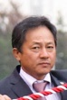 | Sugiura, Hiroaki | CSP ‒ Nac Venus
 | Age: 58. Born in Hokkaido, Hiroaki Sugiura commenced his career as a jockey in 1982. He rode a total of 209 wins until he hungup his boots and received his JRA trainer licence in 1995. His first G1 win came from Telegnosis in the 2002 NHK Mile Cup. He took the same horse to France to finish third in the G1 Prix Jacques le Marois and to Hong Kong for the Hong Kong Mile in 2003. Showa Modern brought him another important win in the G1 Yasuda Kinen in 2010. He has amassed a total of 365 JRA wins, including six this year. Hong Kong wins: 0

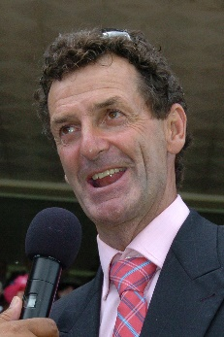 | Todd, Sir Mark | FWDQEII ‒ Eminent
Age: 53. Sir Mark Todd is New Zealand’s most decorated Olympian, having competed at a record seven Olympic Games. Todd won gold twice in Individual Eventing, first at the 1984 Los Angeles games and his second at the 1988 Seoul games. He has trained racehorses on and off throughout his career and has enjoyed G1 success on two occasions. He trained Bramble Rose to victory in the 2003 New Zealand Oaks and won the 2007 Wellington Cup with Willy Smith. Honours: Seven-time Olympian (1984, 1988, 1992, 2000, 2008, 2012, 2016); two-time Olympic Gold Medallist (Eventing)
Hong Kong wins: No previous Hong Kong runners.

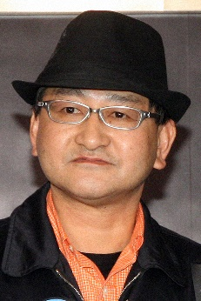 | Yahagi, Yoshito | FWDQEII ‒ Lys Gracieux
Age: 58. Yoshito Yahagi grew up in the vicinity of Oi Racecourse in Tokyo, as his father Kazuto Yahagi was a trainer and jockey in the regional NAR circuit. Fond of racing, tennis and cycling as a teenager, Yahagi travelled to Australia to learn the skills of training at Randwick, Flemington and Toowoomba Racecourses, before coming back to Japan to start his career as a stable assistant in 1984. In 1990, he spent three months working with trainer Geoff Wragg in the UK. Yahagi received his JRA training licence in 2004 and has since become one of the top JRA trainers, having won the JRA Award twice as the Best Trainer, with most races won in 2014 and 2016. He has sent out no less than 582 JRA winners including 10 this season. Grand Prix Boss gave Yahagi his first career G1 wins in the 2010 Asahi Hai Futurity Stakes and 2011 NHK Mile Cup, followed by Deep Brillante’s success in the 2012 Japanese Derby. He notched two more G1 wins last year, thanks to Mozu Ascot in the G1 Yasuda Kinen in June, and most recently Lys Gracieux in the G1 Queen Elizabeth II Cup in November.
Hong Kong wins: 0

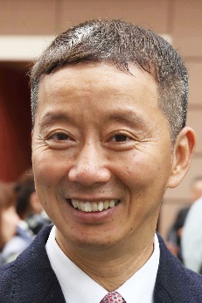 | Yung, Benno T P | CSP ‒ Pingwu Spark
 | Age: 60. Benno Yung started out at the Hong Kong Jockey Club as an apprentice jockey in 1978 and rode professionally in Hong Kong until 1986, the final four years as a senior jockey. He was first appointed assistant trainer in 1991, working under Christopher Cheung. He then spent two seasons in the same role for Tony Millard until moving to the John Size stable when the Australian first arrived in 2001. Yung remained in that role until receiving a licence to train ahead of the 2013/14 season. His first season yielded 37 winners at a strike rate of 11%. His stable standout so far has been the giant grey Pingwu Spark, a five-time winner and G2 placed. Hong Kong wins: 174.

