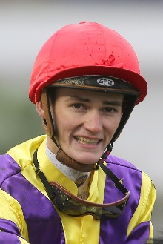 | Bayliss, Regan
 | Age: 21. Regan Bayliss is the son of former jockey and trainer Jamie Bayliss and brother to fellow rider Jake Bayliss. He was raised around horses, riding ponies after school and spending time at the Peter Moody stable from age 13. He was apprenticed to Moody before moving on to join the David Hayes, Tom Dabernig and Ben Hayes operation. 133 of his more than 350 wins in Australia have come in tandem with the Hayes/Dabernig team. His first ride was aboard Alana's Dream at Donald in July 2013 and he rode out his claim with a treble at Flemington on 17 December, 2016. He has three G1 wins on the board: Newmarket Handicap (2017 & 2018 Redkirk Warrior), Black Caviar Lightning (2018 Redkirk Warrior). Bayliss has ridden in Britain, the USA and the UAE and has been based in Hong Kong since February this year. Hong Kong wins: 3

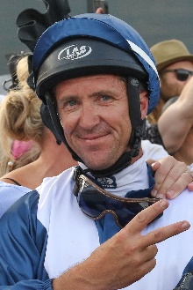 | Bowditch, Joe
 | Age: 42. Originally from Wagga, New South Wales, Joe Bowditch began his apprenticeship in Sydney with the late Ray Guy at age 15 in 1992. Bowditch rode his first winner at Randwick but soon after moved to Adelaide and rode for David Hayes. Bowditch remained in Adelaide for a number of years following the departure of Hayes who relocated to Hong Kong. Bowditch secured his first G1 aboard Hard To Get in the 2004 South Australian Derby for trainer Mark Kavanagh. He has been Lloyd Kennewell’s stable rider for over a decade and the pair have enjoyed G1 success twice together with Viddora in the 2017 Winterbottom Stakes and the Moir Stakes. Bowditch has ridden over 1200 winners across his career and notched multiple stakes wins in Queensland during the early 2000’s. Hong Kong wins: No previous rides

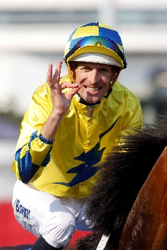 | Bowman, Hugh
 | Age: 38. The 2017 LONGINES World’s Best Jockey award recipient, Bowman boasts an outstanding career record of 88 G1 victories among more than 2,000 wins since his debut ride on Naturalised in 1999. He has been champion jockey in Sydney four times and the most prolific G1-winning jockey in Australia for each of the past three seasons. He has a record of 32 wins from 33 rides on the champion mare Winx, notably an incredible four wins in the Cox Plate. In Hong Kong, he has won the Hong Kong Derby (2016 Werther, 2019 Furore), Hong Kong Gold Cup (2016 Werther) and Champions & Chater Cup (2016 Werther). This season he has already notched 11 top-level wins. FWD Champions Day race wins (2): FWD QEII Cup (2016 Werther), Chairman’s Sprint Prize (2017 Lucky Bubbles). Honours: Sydney champion jockey (2008/09, 2011/12, 2014/15, 2016/17); LONGINES World’s Best Jockey (2017); LONGINES IJC (2016). Hong Kong wins: 29

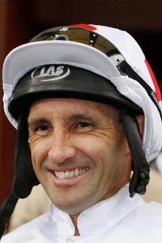 | Callan, Neil
 | Age: 40. Irishman Neil Callan finished runner-up in the British jockeys' championship in 2005 (151 wins) and 2007 (170 wins). After a fruitless start as an apprentice in Ireland with Kevin Prendergast he moved to Britain and forged successful partnerships with trainers Karl Burke, Kevin Ryan and Michael Jarvis. He first rode in Hong Kong on a short contract in the 2010/11 season and has since established a reputation as a tough competitor. His first full Hong Kong season, 2014/15, yielded 47 wins and fifth place in the jockeys' premiership and he equalled that tally when finishing third in 2016/17. His big race wins include the 2015 Hong Kong Classic Mile on Beauty Only. FWD Champions Day race wins (1): FWD QEII Cup (2015 Blazing Speed) Honours: UK Champion Apprentice (1999). Hong Kong wins: 223

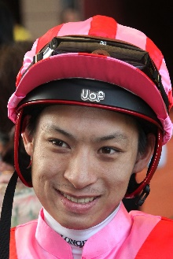 | Chadwick, Matthew
 | Age: 28. A graduate of Hong Kong's Apprentice Jockeys' School, Matthew Chadwick went to Australia for his apprentice training and rode a four-timer at Lismore Racecourse at age 17. Indentured to the Tony Cruz stable upon his return to Hong Kong, he was champion apprentice in 2008/09. He earned a full jockey's licence in January, 2010. His first Group race winner was Egyptian Ra in the HKG3 National Day Cup (2009). Chadwick became the first homegrown rider to win a HKIR contest when clinching the G1 Hong Kong Cup on California Memory in 2011 and followed up on the same horse in the same race in 2012. He rode his first Hong Kong four-timer at Sha Tin on 22 June, 2014. Honours: Hong Kong Champion Apprentice (2008/09); Shergar Cup Silver Saddle winner (2012). Hong Kong wins: 346

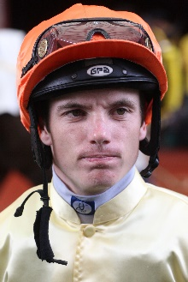 | Clark, Tim
 | Age: 32. Tim Clark was born in Leeton, New South Wales and began his career apprenticed to Peter Clancy. Clark rode his first winner aboard Tactica at Gundagai on 21 November, 2003, before moving to Sydney, where he was crowned champion apprentice in 2005/06. He landed his first G1 victory on Typhoon Zed in The Galaxy at Royal Randwick in 2008. He won the 2011 G1 Doncaster Mile on Sacred Choice and in the very next race took a second The Galaxy on Atomic Force. He also struck up a successful partnership with the mare Hot Danish, winning the G1 All Aged Stakes and the G1 Doomben 10,000. Clark has ridden over 1000 winners overall in Australia, including 11 G1’s, his most recent the G1 Flight Stakes at Randwick aboard Ooohood. He is no stranger to Hong Kong and spent almost two seasons here in 2011/12 and 2012/13, tallying 59 wins. His Hong Kong feature wins include Jacobee’s HKG3 Sa Sa Ladies’ Purse success, Destined For Glory’s G2 Jockey Club Mile victory and It Has To Be You’s Classic Cup success of 2013. Honours: Sydney champion apprentice (2006). Hong Kong wins: 59

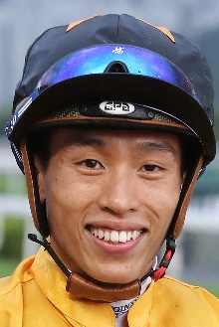 | Ho, Vincent C Y
 | Age: 28. HKJC Apprentice Jockeys' School graduate Vincent Ho racked up 44 wins as a young rider in New Zealand under the tutelage of leading trainer Lance O'Sullivan. He made a good start to his Hong Kong career with 10 victories in his first season in 2009/10, including a trio of wins he achieved on only his fourth race day in Hong Kong. He sealed the 2010/11 Champion Apprentice title with 39 wins. Ho reached the graduation benchmark on 1 October, 2012 by claiming his 70th win in Hong Kong on board Castle Hero. He notched 33 wins in 2014/15 to be the season's leading homegrown rider. He rode a short stint in Europe during the off-season in 2018 and notched a first UK win at the first attempt, partnering the Mark Johnston-trained X Rated to success at Haydock on 9 August. Honours: Hong Kong Champion Apprentice (2010/11); Best Freelance Jockey Award (2014/15). Hong Kong wins: 250

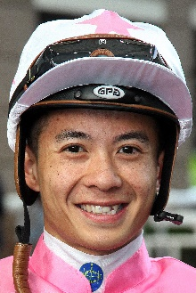 | Leung, Derek K C
 | Age: 30. Derek Leung’s career highlight is his 2017 LONGINES Hong Kong Mile victory aboard Beauty Generation. A product of Hong Kong's Apprentice Jockeys' School, he cut his teeth in New Zealand under trainer Lance O'Sullivan. He was assigned as apprentice jockey to Paul O'Sullivan's stable upon his return to Hong Kong. Leung reached the graduation benchmark after his 70th win on board Star Of Fame on 1 June, 2011. He reached a personal best total of 33 wins in the 2015/16 season and received the Tony Cruz Award in 2016/17 and 2017/18 as the leading home-grown rider. His biggest win came in the 2017 Hong Kong Mile on Beauty Generation. Honours: Asian Young Guns Challenge winner (2010); Tony Cruz Award winner (2017 & 2018). Hong Kong wins: 272

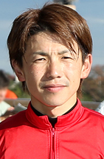 | Matsuoka, Masami
Age: 34. A baseball lover and a musician in a band, Matsuoka commenced his JRA jockey career in 2003 and he obtained the first of his 33 Pattern race wins atop Win Glanz in the 2005 G3 Diamond Stakes. Matsuoka chose to travel to Ireland in 2006, to work for trainer John Oxx for three months. He earned his first G1 win the following year, atop Koiuta in the JPN G1 Victoria Mile, before adding another important win with Meiner Kitz in the 2009 G1 Tenno Sho Spring. He also partnered Bamboo Ere to win the JPN G1 JBC Sprint in 2008. Matsuoka has amassed a total of 813 JRA wins, including seven this year.
Hong Kong wins: No previous rides

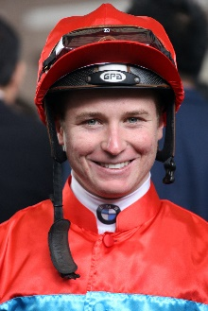 | McDonald, James
 | Age: 27. James McDonald made a big impression in Hong Kong when finishing second to Frankie Dettori on his LONGINES IJC debut when still a teenager back in 2011. He returned the following May and partnered Xtension to victory in the 2012 G1 Champions Mile at Sha Tin. Champion Apprentice in his homeland, he went on to claim the Premiership there twice, in 2008/09 and latterly with a New Zealand record tally of 207 for the 2010/11 season. In 2012 he won a first New Zealand Derby. He clinched his first Sydney Premiership in July, 2014. He was appointed Godolphin’s number one rider in Australia in March 2015 but lost that role when in December 2016 he was disqualified for 18 months due to a breach of betting rules. He returned to race-riding in May 2018 and landed his 40th and most recent G1 on Verry Elleegant in the ATC Oaks this month. FWD Champions Day race wins (1): FWD Champions Mile (2012 Xtension). Honours: Two-time Sydney champion jockey (2013/14, 2015/16); two-time New Zealand champion jockey (2008/09, 2010/11). Hong Kong wins: 5

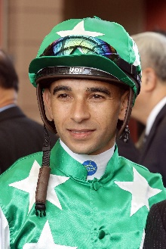 | Moreira, Joao
 | Age: 34. Brazilian Joao Moreira notched more than 1000 wins in South America. He relocated to Singapore in 2009 and dominated the Singapore circuit for four years. He moved to Hong Kong in October, 2013 and has been champion jockey three times with record-breaking win totals (145, 168 and 170). Honours: Three-time Hong Kong Champion Jockey (2014/15, 2015/16, 2016/17); LONGINES IJC winner (2012); Japan's World All-Star Jockeys winner (2015); four-time Singapore Champion Jockey (2010, 2011, 2012, 2013); two-time Brazilian Eclipse Award winner (2006/07, 2007/08); fastest 100 in a Hong Kong season (22 February, 2017); Hong Kong record for most wins in a season (170 in 2016/17); most wins in a Hong Kong race day (eight: 5 March, 2017); Singapore record for most wins in a season (206 in 2012); eight wins from eight rides at Kranji (6 September, 2013); eight wins in a day at Cidade Jardim (March, 2006). FWD Champions Day race wins (3): FWD QEII Cup (2017 Neorealism), Champions Mile (2015 Able Friend, 2016 Maurice). Hong Kong wins: 772

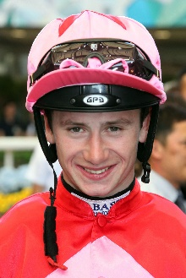 | Murphy, Oisin
 | Age: 23. Oisin Murphy is Qatar Racing's retained rider in Europe. The Killarney native is a graduate of the Irish pony racing circuit. Schooled in riding by his uncle, the Cheltenham Gold Cup-winning jockey Jim Culloty, Murphy worked summer holidays for trainers Tommy Stack and Aidan O'Brien. He was apprenticed to Andrew Balding in October 2012 and had his first race ride in May 2013 when already 18. He ended his first season (2013) with 41 wins, including a four-timer on Ayr Gold Cup day that featured the historic sprint handicap itself. Murphy impressed in winter stints in Australia and the UAE before riding on a short contract in Hong Kong in the winter of 2016/17, which brought four wins. His G1 breakthrough came in October, 2017 on Aclaim in the Prix de la Foret and two weeks later he took the G1 E P Taylor Stakes on Blond Me. He had nine G1 wins in 2018, including four on Roaring Lion. Honours: UK Champion Apprentice (2014) Hong Kong wins: 5

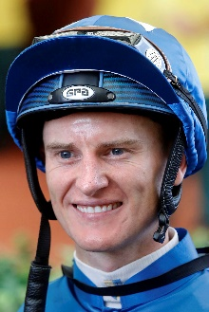 | Purton, Zac
 | Age: 36. Zac Purton is Hong Kong’s current Champion Jockey. Having ended Douglas Whyte's 13-season dominance with his first Hong Kong jockeys' championship in 2013/14 (112 wins), in 2017/18 he halted Joao Moreira’s title streak at three. His second championship was a remarkable effort as he chased down Moreira to take the lead for the first time that term on June 10, 2018. Five weeks later, at season’s end, he had outpointed Moreira 136-134 with a win strike rate of 21% to the Brazilian’s 20%. Purton started his career in Brisbane and was an apprentice sensation, winning the premiership there in 2003. Purton moved to Hong Kong in September, 2007. His many major wins include the King's Stand Stakes at Royal Ascot in 2012 on Hong Kong’s Little Bridge. Honours: Hong Kong Champion Jockey (2013/14, 2017/18); Brisbane Champion Jockey (2003 - when still an apprentice); LONGINES IJC (2017); World Super Jockeys Series (Japan) winner (2012). FWD Champions Day race wins (2): Chairman’s Sprint Prize (2018 Ivictory), FWD Champions Mile (2018 Beauty Generation) Hong Kong wins: 956

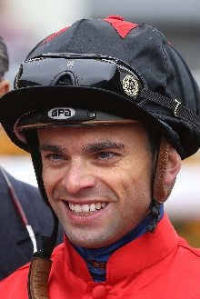 | Rispoli, Umberto
 | Age: 30. Italian jockey Umberto Rispoli commenced his apprenticeship in 2005 and graduated to the senior ranks in 2010. He is a two-time Champion Jockey in Italy. In winning his first Italian title, in 2009, he rode 245 winners and so smashed the longstanding previous record of 229. Rispoli, who has also ridden in Japan, notched six wins in his first Hong Kong season in 2011/12, crowned by G1 QEII Cup success on the Japanese galloper Rulership. After moving to trainer Mikel Delzangles in France, he took a further G1 atop Molly Malone in the Prix du Cadran. Rispoli has since returned to Hong Kong on short-term licences. He broke a leg three meetings into his 2016/17 winter contract but was back in action within two and a half months and ended the term with 15 wins. Honours: Italian Champion Jockey (2009 & 2010). FWD Champions Day race wins (1): FWD QEII Cup (2012 Rulership). Hong Kong wins: 112

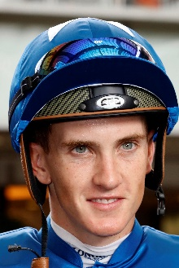 | Schofield, Chad
 | Age: 25. Chad Schofield spent four years (2002-2006) of his youth living in Hong Kong where his father, the South African jockey Glyn Schofield, was contracted to ride. His family relocated to Australia and Schofield commenced his own riding career in Sydney in the 2010/11 season. He moved to Melbourne in 2012 to ride for the powerful David Hayes stable. His first G1 win was a major, the 2013 Cox Plate on Shamus Award and he also won the 2014 G1 Newmarket Handicap on Lankan Rupee. He and his father made history in 2014 as the first father and son to compete against each other in the Melbourne Cup and at Sha Tin on 14 February, 2016 they became the first in Hong Kong to ride against each other. He rode Singapore Sling to win the Hong Kong Classic Cup in 2018. Honours: Sydney Champion Apprentice (2011/12); Melbourne Champion Apprentice (2012/13). Hong Kong wins: 126

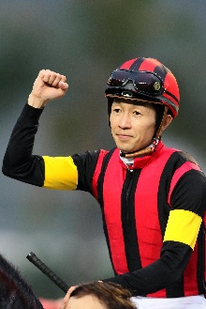 | Take, Yutaka
 | Age: 50. Background: Take is the son of famed jockey Kunihito Take and is a living legend in Japan, with more than 4,000 wins in his homeland and overseas. He has been champion jockey in Japan 18 times and was the first jockey to ride eight winners in a day in Japan, a feat achieved in December 2002. He became the first Japanese jockey to win a G1 race in Europe when Ski Paradise captured the 1994 Prix du Moulin de Longchamp . In 2000 he spent time riding in the US and in 2001 he was based with trainer John Hammond in France. His 111 G1 wins include four Japan Cups with Special Week (1999), Deep Impact (2006), Rose Kingdom (2010) and Kitasan Black (2016), and his latest atop Inti in the G1 February Stakes this year. His overseas achievements include the Hong Kong Cup (2015 A Shin Hikari) and Hong Kong Vase (2001 Stay Gold). In winning the G3 Sirius Stakes in October 2015 he became the first rider to win 300 JRA Graded races in Japan. With 38 wins, he currently sits third in the JRA’s jockey standing this year. Hong Kong wins: 4

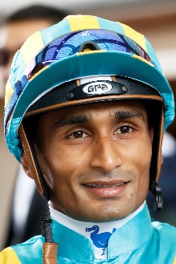 | Teetan, Karis
 | Age: 28. Mauritian rider Karis Teetan arrived in Hong Kong in August, 2013. After entering the South African Jockey Academy at the age of 14 Teetan went on to be crowned Champion South African Apprentice in 2008. He graduated in 2009 with 147 wins to his credit. Teetan passed the 100-win mark in every season as a senior jockey in South Africa. He has recorded five Group 1 wins, with his inaugural success at the top level being in his native Mauritius on 24 November, 2008, aboard Halo Hunter. Teetan notched an impressive 50 wins in his first Hong Kong season and has partnered to victory two of Hong Kong’s all-time heroes, Able Friend and Designs On Rome. He is currently second on the Hong Kong premiership. Honours: South African Champion Apprentice (2008). Hong Kong wins: 284

