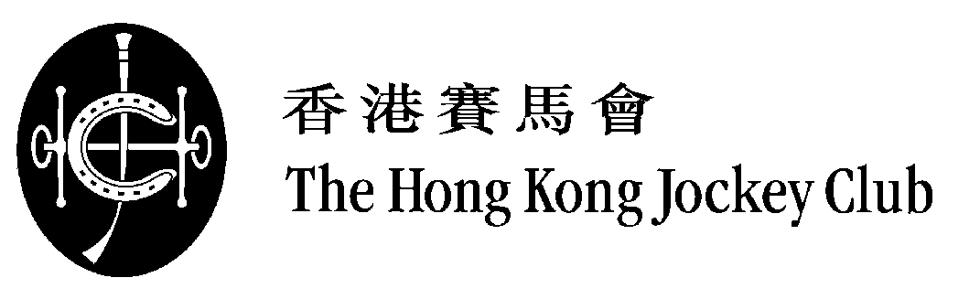

2019 LONGINES Hong Kong International Races

Selected Runners

(as at 20/11/2019)

LONGINES Hong Kong Mile (Group 1) – 1600m
HK$25 million (US$3.199 million)

Country / Region | Int'l Rating | Selected Horse |  | Age | Sex | Weight | Trainer
HK | 127 | * | BEAUTY GENERATION (NZ) | 7 | g | 126 | John Moore
JPN | 119 | * | INDY CHAMP (JPN) | 4 | c | 126 | Hidetaka Otonashi
JPN | 116 | * | PERSIAN KNIGHT (JPN) | 5 | h | 126 | Yasutoshi Ikee
HK | 115 |  | WAIKUKU (IRE) | 4 | g | 126 | John Size
GB | 113 |  | ZAAKI (GB) | 4 | g | 126 | Sir Michael Stoute
HK | 112 |  | KA YING STAR (GB) | 4 | g | 126 | Tony Cruz
HK | 111 |  | SIMPLY BRILLIANT (GB) | 5 | g | 126 | Frankie Lor
HK | 110 |  | CITRON SPIRIT (IRE) | 7 | g | 126 | Ricky Yiu
IRE | 118 | * | CIRCUS MAXIMUS (IRE) | 3 | c | 125 | Aidan O’Brien
JPN | 116 | * | ADMIRE MARS (JPN) | 3 | c | 125 | Yasuo Tomomichi
JPN | 113 | * | NORMCORE (JPN) | 4 | f | 122 | Kiyoshi Hagiwara
 |  |  | (11)
* International Group 1 winner

Nigel Gray
Head of Handicapping,
Race Planning and International Racing

