Spotlight

Exultant has proven to be one of the world’s top stayers since winning last year’s Vase, which saw subsequent Cox Plate winner Lys Gracieux in second place and Prix de l’Arc de Triomphe hero Waldgeist in fifth. Hong Kong’s champion stayer is set to face another tough line-up with Japan and Europe offering strong contenders.

Anthony Van Dyck is set to become the first Derby (English) winner to contest the LONGINES Hong Kong Vase. The Ballydoyle-trained colt is selected alongside well-regarded stablemate Mount Everest who missed most of this year but returned in the autumn to run a promising sixth in the G1 Breeders’ Cup Turf. The British raiders are Aspetar, winner of the G1 Preis von Europa, Prince Of Arran who has made the frame in the past two renewals of the G1 Melbourne Cup, and the well-regarded G3 winner Young Rascal.

Japan has some of its best fillies and mares slated to take on Exultant: Deirdre, runner-up in the Hong Kong Cup last year, has been a marvel on her travels this year and won the G1 Nassau Stakes; Lucky Lilac won the G1 Queen Elizabeth II Cup at Kyoto last time; Glory Vase is a G2-winning and G1-placed stayer.

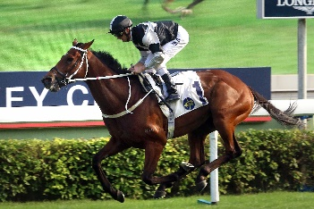 | EXULTANT  HONG KONG 5g 120  Hong Kong’s champion middle distance/stayer last term with three G1 wins. Defeated Lys Gracieux in thriller for this contest in 2018 and impressive in G2 win latest. | 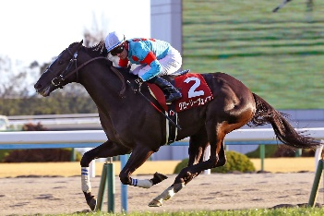 | GLORY VASE  JAPAN 4c 117  G2-winning stayer and placed second in the G1 Tenno Sho Spring over two miles in April.
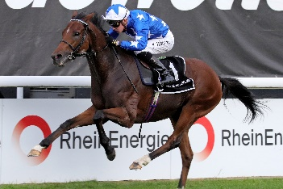 | ASPETAR  GREAT BRITAIN 4g 116  Matured into a top-class galloper this term with wins in the G2 Grand Prix de Chantilly and G1 Preis von Europa. | 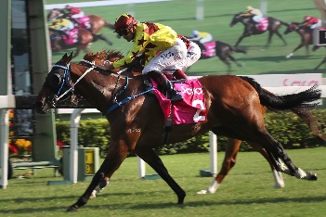 | SOUTHERN LEGEND  HONG KONG 7g 116  Two-time SIN G1 Kranji Mile winner, third in last year’s LONGINES Hong Kong Mile and in 2018 G1 FWD Champions Mile - untried beyond 2000m.
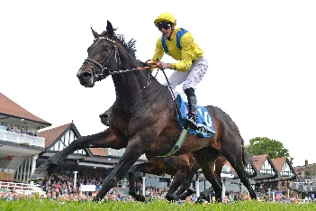 | YOUNG RASCAL  GREAT BRITAIN 4g 115  Three-time G3 winner whose only defeat as a 3yo in 2018 came when seventh in the Derby; below par two starts early this year but gelded and returned for easy Listed win earlier this month. | 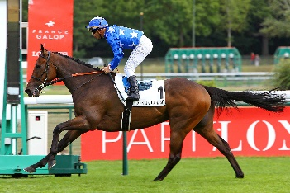 | CALLED TO THE BAR  FRANCE 5g 114  Stout G1-placed stayer with wins this term in the G2 Prix Vicomtesse Vigier and latterly the G3 Prix Gladiateur.
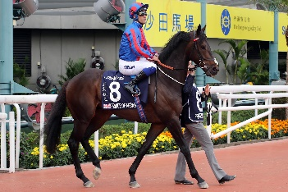 | PRINCE OF ARRAN  GREAT BRITAIN 6g 113  Classy stayer and world traveller, British-trained but two-time G3 winner in Australia and placed third and second in last two Melbourne Cups. | 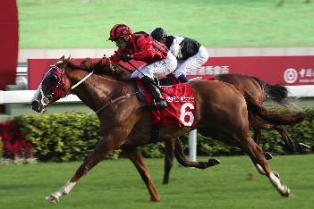 | EAGLE WAY  HONG KONG 7g 112  G1 Queensland Derby winner pre-import; G2 Jockey Club Cup win last year when also fourth in G1 LONGINES Hong Kong Vase.
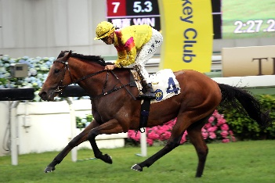 | HO HO KHAN  HONG KONG 5h 108  Progressed through the ranks to become a smart 4yo last term - fifth in BMW Hong Kong Derby - and ended the campaign with G3 handicap victory over 2400m. | 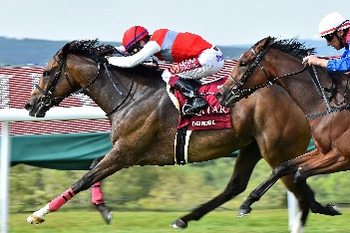 | DEIRDRE  JAPAN 5m 115  Top-class globe-trotting mare who was runner-up in the G1 Hong Kong Cup last year; raced in Europe this summer for a win in the G1 Nassau Stakes.
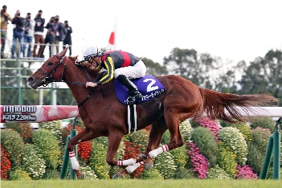 | LUCKY LILAC  JAPAN 4f 114  Won first four career starts but no match for Almond Eye when placed in first two fillies’ classics in 2018; hit new peak with last start win in G1 QEII Cup at Kyoto. | 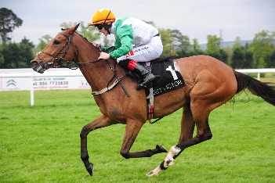 | TRUE SELF  IRELAND 6m 111  Started out as a National Hunt horse and has two wins over hurdles at home in Ireland; switched to flat and five wins since include a G3 handicap at Flemington latest.
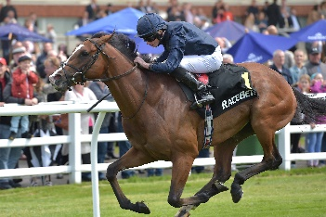 | ANTHONY VAN DYCK  IRELAND 3c 118  Won the G1 Derby at Epsom in June; no win in four runs since but followed a sound third in the G1 Irish Champion Stakes with a somewhat unlucky third in the G1 Breeders’ Cup Turf. | 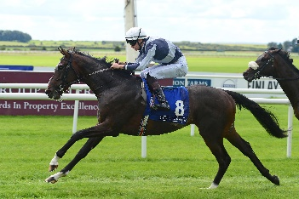 | MOUNT EVEREST  IRELAND 3c 113  High in the Ballydoyle pecking order of possible Derby candidates as a 2yo; not seen again until this autumn when won Listed race and sixth in G1 Breeders’ Cup Turf.

