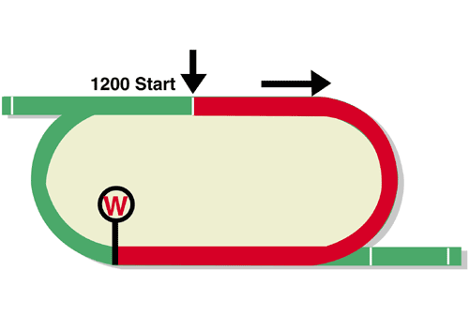
LONGINES Hong Kong Sprint (Group 1)
HK$20 million (US$2.6 million)
Race Best Time
1.07.80 (2006)
1st HK$11,400,000, 2nd HK$4,400,000, 3rd HK$2,000,000,
4th HK$1,140,000, 5th HK$660,000, 6th HK$400,000

Performance Analysis

Horse Details |  |  |  |  |  | Horse Statistics |  |  |  |  |  |  | Probable Jockey | Trainer
Name |  | Rep | Age/  Sex | Wt. | Int’l Rtg | Lifetime | G1 | Good | Wet | RH | 1000-1200 | Trk/Dist
Beat The Clock |  | HK | 6g | 126 | 120 | 22 (8-8-6) | 7 (2-3-2) | 21 (8-8-5) | 1 (0-0-1) | 22 (8-8-6) | 11 (5-2-4) | 11 (5-2-4) | J Moreira | J Size
D B Pin |  | HK | 7g | 126 | 119 | 18 (6-6-2) | 4 (1-2-0) | 16 (5-6-1) | 1 (0-0-1) | 14 (4-5-1) | 18 (6-6-2) | 11 (1-5-1) | R Moore | J Size
Mr Stunning |  | HK | 7g | 126 | 119 | 25 (11-7-3) | 6 (2-4-0) | 24 (11-7-3) | 1 (0-0-0) | 22 (9-7-3) | 25 (11-7-3) | 20 (7-7-3) | H Bowman | F C Lor
Hot King Prawn |  | HK | 5g | 126 | 118 | 12 (9-2-0) | 1 (0-0-0) | 11 (8-2-0) | 1 (1-0-0) | 6 (3-2-0) | 12 (9-2-0) | 5 (2-2-0) | K Teetan | J Size
Rattan |  | HK | 6g | 126 | 117 | 24 (7-7-1) | 2 (0-1-0) | 22 (6-7-1) | 2 (1-0-0) | 23 (7-7-1) | 5 (1-1-0) | 4 (1-1-0) | C Schofield | R Gibson
Little Giant |  | HK | 7g | 126 | 116 | 14 (6-0-3) | 4 (0-0-1) | 9 (2-0-2) | 4 (3-0-1) | 11 (4-0-3) | 10 (4-0-2) | 8 (3-0-2) | – | D J Hall
Danon Smash |  | JPN | 4c | 126 | 114 | 14 (6-2-1) | 4 (0-0-1) | 14 (6-2-1) | 0 (0-0-0) | 10 (6-1-1) | 7 (4-1-1) | 0 (0-0-0) | L Dettori | T Yasuda
Ivictory | 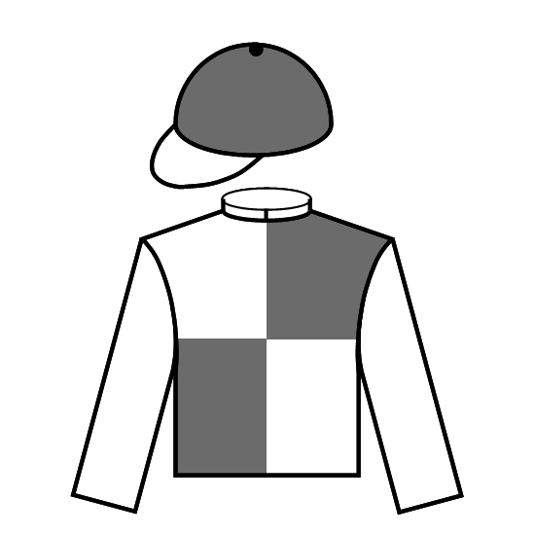 | HK | 6g | 126 | 114 | 15 (7-1-0) | 2 (1-0-0) | 14 (6-1-0) | 1 (1-0-0) | 12 (6-0-0) | 15 (7-1-0) | 10 (4-0-0) | A Sanna | J Size
Wishful Thinker |  | HK | 6g | 126 | 113 | 26 (8-1-8) | 1 (0-0-0) | 23 (7-1-7) | 3 (1-0-1) | 16 (5-1-5) | 25 (8-1-8) | 13 (3-1-5) | C Soumillon | R Gibson
Seasons Bloom |  | HK | 7g | 126 | 112 | 29 (8-4-2) | 7 (1-0-1) | 25 (6-3-2) | 4 (2-1-0) | 27 (7-4-2) | 6 (3-1-0) | 4 (2-1-0) | G van Niekerk | C S Shum
Full Of Beauty |  | HK | 5g | 126 | 106 | 11 (6-3-0) | 0 (0-0-0) | 10 (6-3-0) | 1 (0-0-0) | 10 (5-3-0) | 11 (6-3-0) | 10 (5-3-0) | C Y Ho | J Size
Regency Legend |  | HK | 4g | 126 | 104 | 8 (6-1-0) | 0 (0-0-0) | 6 (4-1-0) | 2 (2-0-0) | 6 (5-0-0) | 8 (6-1-0) | 5 (4-0-0) | – | C S Shum
In Her Time |  | AUS | 7m | 122 | 115 | 27 (9-4-4) | 12 (2-3-3) | 19 (7-4-4) | 8 (2-0-0) | 22 (8-2-3) | 21 (8-3-3) | 0 (0-0-0) | B Avdulla | K Lees
Aethero |  | HK | 3g | 117 | 119 | 6 (5-0-1) | 0 (0-0-0) | 6 (5-0-1) | 0 (0-0-0) | 4 (3-0-1) | 6 (5-0-1) | 4 (3-0-1) | Z Purton | J Moore

Barrier Draw Statistics Speed Chart

Draw 1st 2nd 3rd 4th  1 0 0 1 3  2 1 2 4 1  3 0 1 2 2  4 1 0 2 0  5 1 4 0 1  6 3 3 1 0  7 2 1 0 3  8 1 0 1 0  9 2 1 0 0  10 0 0 0 0  11 0 0 0 1  12 1 2 0 1  13 0 0 1 1  14 1 0 0 0  (Past 13 runnings) | 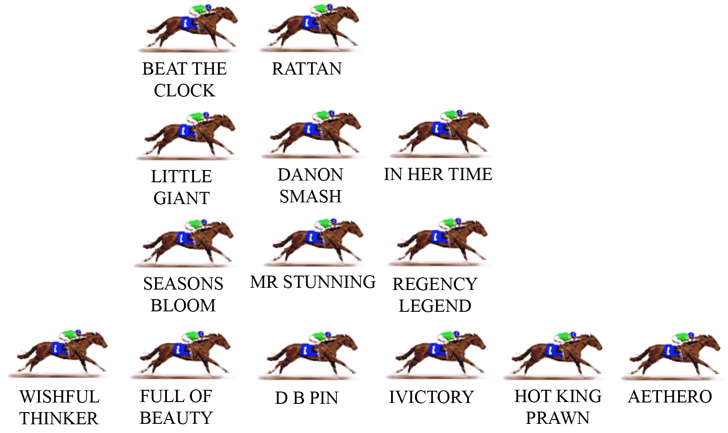  The sprint course at Sha Tin offers a run of just on 300m to the first turn and barriers are of critical importance. A horse that might be placed handy on the rail from a low draw can literally be forced to go back to last from the outside gate. The three most favoured positions from a statistical viewpoint, when the rail is in the A (true) position, are the leader, the horse following the leader and the horse outside that follower. The recent history of the race suggests that the winner will settle within the compass of the first three positions (counting back from the leader).  LIKELY PACE: GOOD

