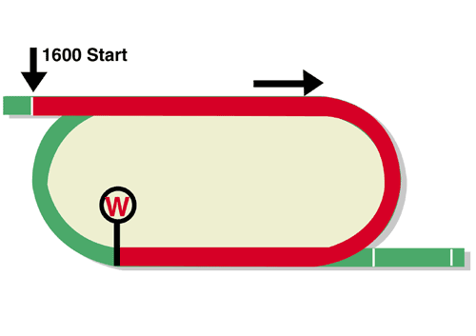
LONGINES Hong Kong Mile (Group 1)
HK$25 million (US$3.2 million)
Race Best Time
1.32.71 (2008)
1st HK$14,250,000, 2nd HK$5,500,000, 3rd HK$2,500,000,
4th HK$1,425,000, 5th HK$825,000, 6th HK$500,000

Performance Analysis

Horse Details |  |  |  |  |  | Horse Statistics |  |  |  |  |  |  | Probable Jockey | Trainer
Name |  | Rep | Age/  Sex | Wt. | Int’l Rtg | Lifetime | G1 | Good | Wet | RH | 1400-1800 | Trk/Dist
Beauty Generation |  | HK | 7g | 126 | 127 | 33 (18-3-6) | 11 (7-1-0) | 29 (16-2-5) | 4 (2-1-1) | 33 (18-3-6) | 27 (17-1-5) | 16 (10-0-4) | Z Purton | J Moore
Indy Champ |  | JPN | 4c | 126 | 119 | 12 (7-1-2) | 2 (2-0-0) | 12 (7-1-2) | 0 (0-0-0) | 8 (4-1-1) | 12 (7-1-2) | 0 (0-0-0) | D Lane | H Otonashi
Persian Knight |  | JPN | 5h | 126 | 116 | 21 (4-4-2) | 10 (1-3-1) | 19 (4-4-1) | 2 (0-0-1) | 12 (3-3-2) | 15 (4-2-2) | 1 (0-0-0) | O Murphy | Y Ikee
Waikuku |  | HK | 4g | 126 | 115 | 13 (6-3-1) | 1 (0-0-0) | 11 (6-2-1) | 2 (0-1-0) | 11 (5-3-1) | 9 (6-1-1) | 2 (1-1-0) | J Moreira | J Size
Zaaki |  | GB | 4g | 126 | 113 | 16 (4-3-4) | 0 (0-0-0) | 12 (3-3-3) | 3 (1-0-0) | 4 (0-2-1) | 11 (4-1-1) | 0 (0-0-0) | R Moore | Sir M R Stoute
Ka Ying Star | 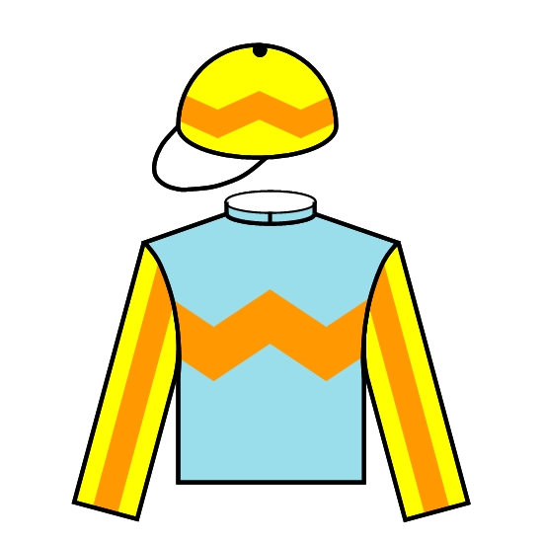 | HK | 4g | 126 | 112 | 15 (5-3-4) | 0 (0-0-0) | 14 (5-3-3) | 1 (0-0-1) | 11 (2-3-3) | 14 (5-3-4) | 7 (2-2-2) | K Teetan | A S Cruz
Simply Brilliant | 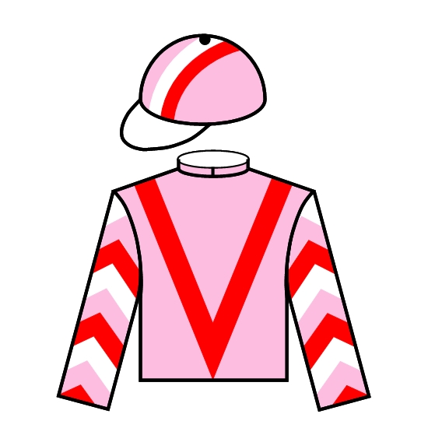 | HK | 5g | 126 | 111 | 24 (7-3-3) | 2 (0-0-1) | 22 (6-3-3) | 2 (1-0-0) | 20 (6-3-3) | 19 (5-1-3) | 9 (3-0-1) | A Badel | F C Lor
Citron Spirit | 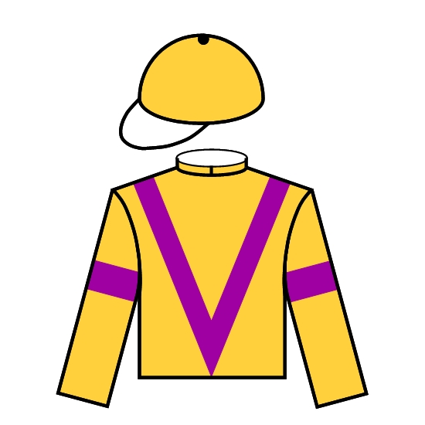 | HK | 7g | 126 | 110 | 44 (9-5-9) | 1 (0-0-0) | 41 (8-4-9) | 3 (1-1-0) | 41 (7-4-9) | 41 (8-4-9) | 16 (2-2-4) | C Y Ho | P F Yiu
Admire Mars | 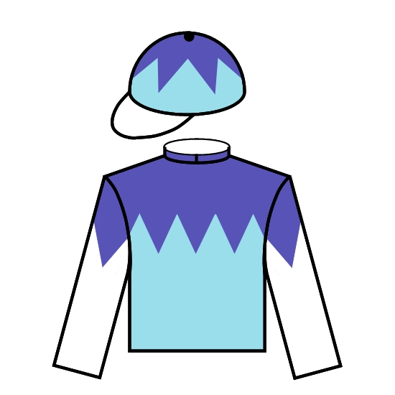 | JPN | 3c | 125 | 116 | 8 (5-1-0) | 3 (2-0-0) | 8 (5-1-0) | 0 (0-0-0) | 3 (2-0-0) | 7 (5-1-0) | 0 (0-0-0) | C Soumillon | Y Tomomichi
Normcore | 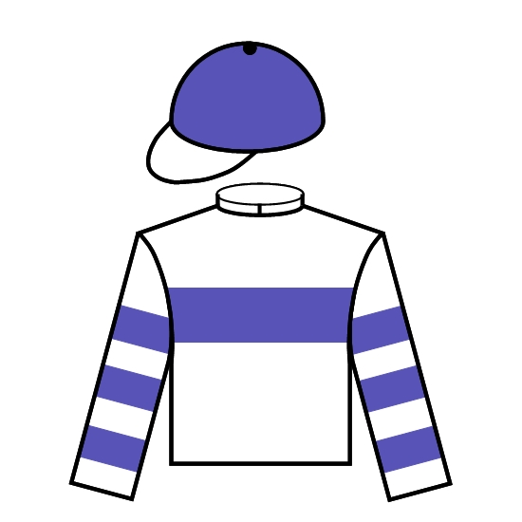 | JPN | 4f | 122 | 113 | 10 (5-1-2) | 2 (1-0-0) | 10 (5-1-2) | 0 (0-0-0) | 6 (3-0-1) | 6 (4-0-1) | 0 (0-0-0) | C Lemaire | K Hagiwara

Barrier Draw Statistics Speed Chart

Draw 1st 2nd 3rd 4th  1 0 2 2 1  2 0 0 1 1  3 1 1 0 1  4 1 1 1 2  5 0 4 2 2  6 1 1 0 4  7 3 2 0 1  8 1 0 0 1  9 3 0 6 3  10 3 2 2 0  11 2 1 1 2  12 1 4 4 0  13 3 2 1 0  14 1 0 0 3  (Past 20 runnings) | 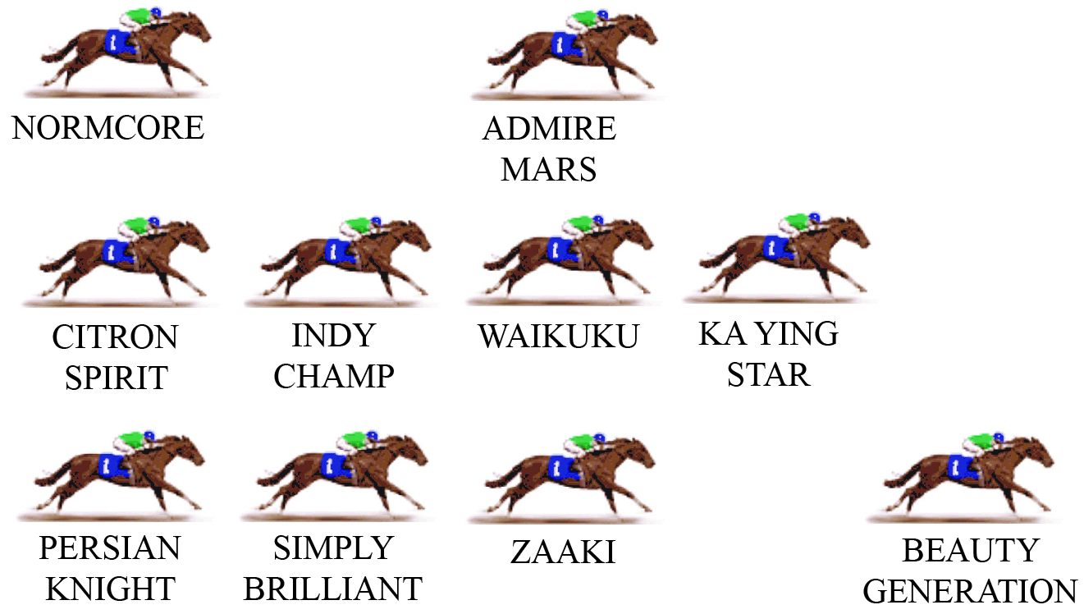  Last year, Beauty Generation led throughout and won handsomely, but this pattern of racing is not normally the key to HK Mile success. The winners can come from just about anywhere, including back and wide. Indeed, that general position has a surprising success rate, with past winners such as Glorious Days, Ambitious Dragon, Good Ba Ba, Olympic Express and Eishin Preston. With Beauty Generation back to defend his Mile crown, the tempo of the race should be assured but if the speed is only moderate, expect the tempo to increase before the home corner.  LIKELY PACE: GOOD

