Spotlight

Good Ba Ba is the only horse in HKIR history to win three times and he achieved the feat in the Hong Kong Mile in consecutive years. Beauty Generation, imperious in making it two wins in a row last year and another star of world racing, will have to bounce back from two recent defeats if he is to make the hat-trick. The world’s top-rated miler will face his latest conqueror, the improving Waikuku, as well as some brilliant overseas raiders.

Japan’s assault has a formidable look to it: Indy Champ defeated Almond Eye when taking the G1 Yasuda Kinen in June and last weekend the colt saw off the highly-regarded Danon Premium to win the second of his country’s two big mile races, the G1 Mile Championship, the same two races the powerhouse champion Maurice won before taking this prize in 2015; two-time G1 winner Admire Mars, the G1-winning filly Normcore and the top-class Persian Knight are also selected for Japan.

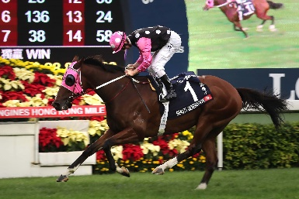 | BEAUTY GENERATION  HONG KONG 7g 127  World’s top-rated miler and two-time Hong Kong Horse of the Year with seven G1 wins including last two runnings of this race - mile track record holder at Sha Tin. | 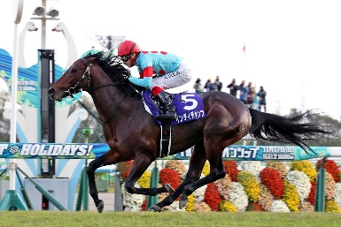 | INDY CHAMP  JAPAN 4c 119  Japan’s standout miler this year, winning the G1 Yasuda Kinen and G1 Mile Championship, just as Maurice did before winning this race in 2015.
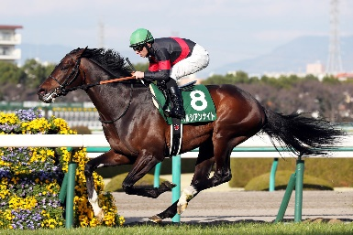 | PERSIAN KNIGHT  JAPAN 5h 116  Latest win was in 2017 G1 Mile Championship; was second in that race last year before fifth in Hong Kong Mile and ran third this year. | 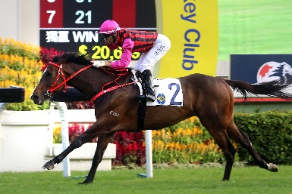 | WAIKUKU  HONG KONG 4g 115  Rapid progress last season and ran second in BMW Hong Kong Derby; improved to win G2 Jockey Club Mile latest with Beauty Generation third.
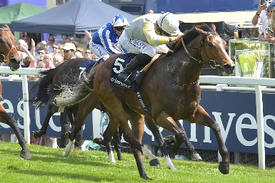 | ZAAKI  GREAT BRITAIN 4g 113  Three wins from six starts this year including two G3 successes; well behind the impressive Benbatl when third in G2 Joel Stakes latest. | 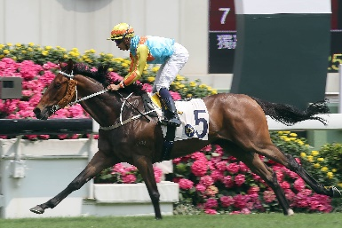 | KA YING STAR  HONG KONG 4g 112  A top Hong Kong 4yo last term and mixing it with the best this season including when second to Waikuku in G2 Jockey Club Mile.
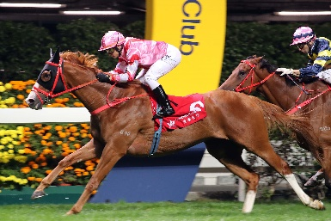 | SIMPLY BRILLIANT  HONG KONG 5g 111  G3 winner last term whose only two attempts in G1 brought 4th in Citi Hong Kong Gold Cup and 3rd in FWD Champions Mile. | 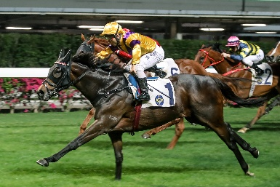 | CITRON SPIRIT  HONG KONG 7g 110  Hardy and consistent galloper on the Hong Kong circuit with six wins from 39 starts in lesser grade.
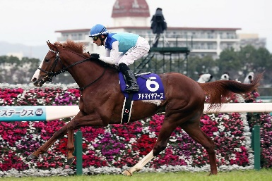 | ADMIRE MARS  JAPAN 3c 116  Winner of five from eight races including the G1 Futurity Stakes as a 2yo last year and this year’s G1 NHK Mile Cup for 3yo. | 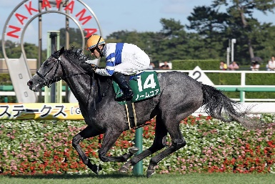 | NORMCORE  JAPAN 4f 113  G1 breakthrough in May in the G1 Victoria Mile for fillies and mares, returned from summer break with a warm-up win in October’s G3 Fuji Stakes.

