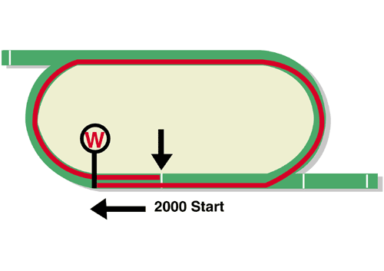
LONGINES Hong Kong Cup (Group 1)
Race Best Time
2.00.60 (2015)
HK$28 million (US$3.6 million)
1st HK$15,960,000, 2nd HK$6,160,000, 3rd HK$2,800,000
4th HK$1,596,000, 5th $924,000, 6th HK$560,000

Performance Analysis

Horse Details |  |  |  |  |  | Horse Statistics |  |  |  |  |  |  | Probable Jockey | Trainer
Name |  | Rep | Age/  Sex | Wt. | Int’l Rtg | Lifetime | G1 | Good | Wet | RH | 1800-2200 | Trk/Dist
Win Bright |  | JPN | 5h | 126 | 120 | 20 (8-2-0) | 6 (1-0-0) | 20 (8-2-0) | 0 (0-0-0) | 14 (7-2-0) | 16 (8-1-0) | 1 (1-0-0) | M Matsuoka | Y Hatakeyama
Rise High |  | HK | 5g | 126 | 117 | 20 (8-2-1) | 2 (0-1-0) | 16 (6-1-0) | 4 (2-1-1) | 18 (6-2-1) | 2 (1-0-0) | 1 (0-0-0) | C Y Ho | C Fownes
Time Warp |  | HK | 6g | 126 | 117 | 39 (11-4-5) | 8 (2-0-1) | 27 (6-3-3) | 6 (4-0-1) | 33 (8-3-4) | 16 (4-3-1) | 9 (2-1-1) | K Teetan | A S Cruz
Glorious Forever |  | HK | 5g | 126 | 116 | 22 (6-4-1) | 4 (1-0-0) | 17 (5-3-1) | 5 (1-1-0) | 17 (6-2-1) | 15 (5-3-0) | 6 (2-0-0) | Z Purton | F C Lor
Dark Dream |  | HK | 5g | 126 | 115 | 20 (6-6-3) | 3 (1-0-1) | 16 (4-5-2) | 4 (2-1-1) | 20 (6-6-3) | 12 (5-2-1) | 5 (2-0-0) | D Lane | F C Lor
Furore |  | HK | 5g | 126 | 112 | 15 (6-1-2) | 3 (0-0-1) | 13 (5-1-1) | 2 (1-0-1) | 15 (6-1-2) | 8 (3-1-1) | 3 (1-1-0) | H Bowman | F C Lor
Almond Eye |  | JPN | 4f | 122 | 124 | 10 (8-1-1) | 7 (6-0-1) | 10 (8-1-1) | 0 (0-0-0) | 3 (3-0-0) | 3 (3-0-0) | 0 (0-0-0) | C Lemaire | S Kunieda
Magic Wand |  | IRE | 4f | 122 | 114 | 21 (3-7-2) | 16 (1-6-1) | 14 (3-5-1) | 7 (0-2-1) | 8 (1-4-0) | 11 (1-6-2) | 0 (0-0-0) | R Moore | A P O'Brien
Edisa |  | FR | 3f | 119 | 107 | 8 (3-3-1) | 0 (0-0-0) | 3 (2-0-0) | 5 (1-3-1) | 4 (1-2-0) | 5 (3-2-0) | 0 (0-0-0) | S Pasquier | A de Royer Dupre

Barrier Draw Statistics Speed Chart

Draw 1st 2nd 3rd 4th  1 4 1 1 3  2 0 2 2 3  3 1 6 1 0  4 2 2 2 3  5 3 1 3 2  6 0 0 1 3  7 2 0 4 2  8 2 2 1 3  9 1 1 2 1  10 1 3 1 0  11 1 1 0 0  12 3 0 1 0  13 0 1 1 0  14 0 0 0 0  (Past 20 runnings) | 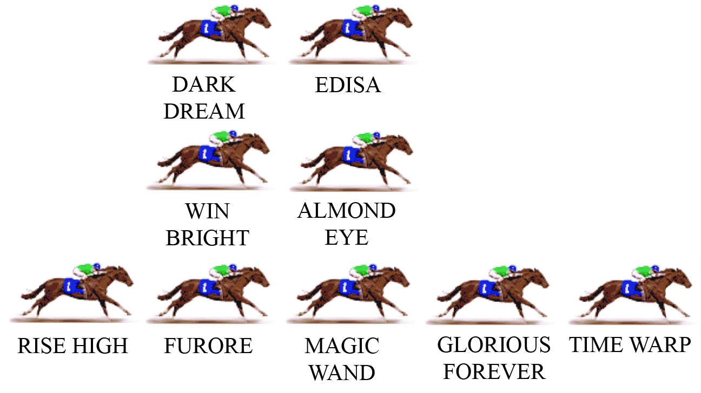  As it has been the last two years, the Hong Kong Cup is fortunate to have the presence of at least two free-running gallopers who will ensure there is speed on. This requires some tactical adjustment from all the other jockeys, because leaving the leaders with a soft time of things on a flat course like Sha Tin gives them too much advantage. On the other hand, taking off early to put pressure on can ruin the chance of the horse that makes that early move. Statistically, the position with the best winning strike-rate in 2000m races is the horse settling midfield, one horse off the fence.  LIKELY PACE: GOOD TO SLOW

