Spotlight

World superstar Almond Eye heads to Sha Tin with a record of eight wins from 10 starts, with six G1 victories to her name. After winning last year’s Fillies’ Triple Crown in Japan, the four-year-old smashed her rivals in the G1 Dubai Turf at Meydan and ran with merit at a mile when third in the G1 Yasuda Kinen. The daughter of two-time LONGINES Hong Kong Sprint winner Lord Kanaloa returned from a long summer break with an impressive success in the G1 Tenno Sho Autumn (2000m) in October. Compatriot Win Bright is one from one at the course and distance thanks to his G1 FWD QEII Cup win in April.

Among those out to prevent a sixth Japanese win in the race is the Aidan O’Brien-trained recent G1 Mackinnon Stakes winner Magic Wand. Last year’s winner Glorious Forever is engaged again, as is his full-brother and 2017 victor Time Warp but the biggest home contenders could be the improving G1-placed Rise High and last season’s BMW Hong Kong Derby hero Furore.

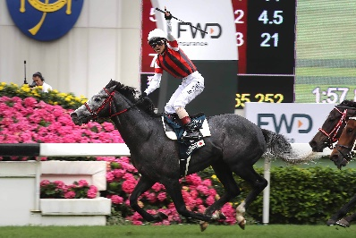 | WIN BRIGHT  JAPAN 5h 120  Career peak win at course and distance in G1 FWD QEII Cup last April when displayed a strong turn-of-foot. | 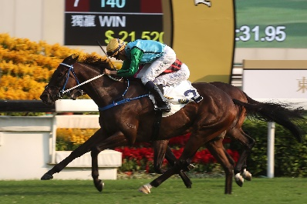 | RISE HIGH  HONG KONG 5g 117  Second to Exultant in G1 Champions & Chater Cup last season; ended Beauty Generation’s win streak in G2 handicap first-up this term and fourth to Exultant in G2 Jockey Club Cup latest.
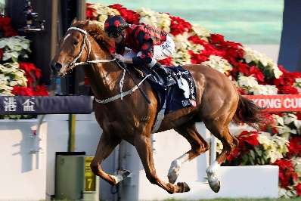 | TIME WARP  HONG KONG 6g 117  In and out performer but capable when things fall right; won 2017 G1 LONGINES Hong Kong Cup and 2018 G1 Citi Hong Kong Gold Cup. | 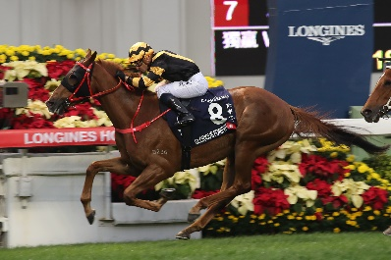 | GLORIOUS FOREVER  HONG KONG 5g 116  Front-running winner of G1 LONGINES Hong Kong Cup last year and fourth to Win Bright in April’s G1 FWD QEII Cup.
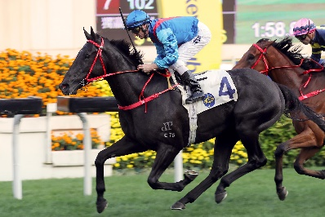 | DARK DREAM  HONG KONG 5g 115  G1 Queensland Derby winner pre-import; course and distance winner and thereabouts in Hong Kong’s 4yo Classic Series last term. | 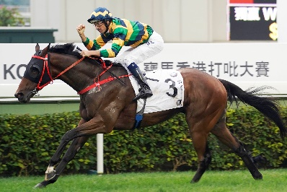 | FURORE  HONG KONG 5g 112  Hong Kong’s top four-year-old last year with wins in Hong Kong Classic Mile and BMW Hong Kong Derby; 2nd to Exultant in G2 Jockey Club Cup latest.
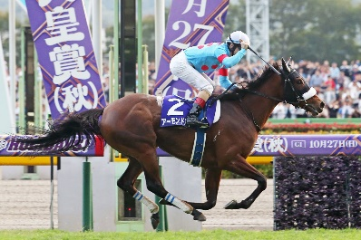 | ALMOND EYE  JAPAN 4f 124  Japan’s Fillies’ Triple Crown winner in 2018 and standout champion with eight wins from 10 career starts; brilliant G1 Tenno Sho Autumn win latest. | 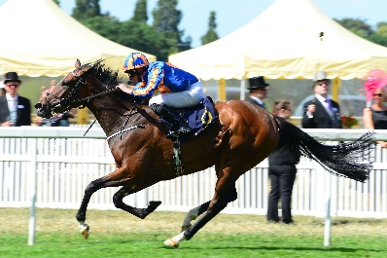 | MAGIC WAND  IRELAND 4f 114  16 G1 starts in six countries for 11 top-four finishes including a last start win in the Mackinnon Stakes at Flemington, Australia.
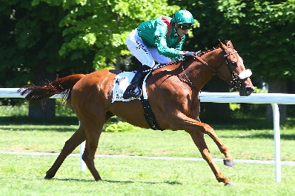 | EDISA  FRANCE 3f 107  Progressive 3yo filly who followed a win in the Jockey Club Oaks Invitational at Belmont, USA with second in G2 Prix du Conseil de Paris.

