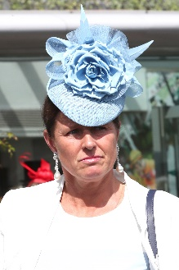 | Brandt, Pia | Vase ‒ Called To The Bar
 | Age: 52. Pia Brandt notched more than 80 wins as a professional jockey in Sweden before turning to training in Stockholm with her husband Joakim, also a former jockey. She moved her operation to Chantilly, France in late 2015 and has since established a string of about 75 horses. Her first of two G1 wins came in the 2016 Grand Prix de Paris with Mont Ormel, afterwards sold to Hong Kong to become Helene Charisma. Her second top-flight win was achieved in 2019 when Mkfancy landed the G1 Criterium de Saint-Cloud. Brandt is no stranger to international forays: L’Amour de Ma Vie won the 2014 G2 Balanchine at Meydan and the trainer won the 2019 UAE 1,000 Guineas there with Silva; L’Amour de Ma Vie was her first runner in Britain when second in the G2 Duke Of Cambridge Stakes at Royal Ascot. Called To The Bar was second in the 2017 G1 Belmont Derby Invitational in the USA and has continued as a flag-bearer for the stable with wins in G2 and G3 races this year. Hong Kong Wins: No previous runner

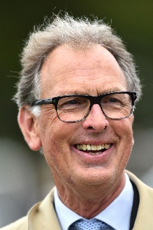 | Charlton, Roger | Vase ‒ Aspetar
 | Age: 69. Roger Charlton is one the most respected and successful trainers in Britain over the past 30 years. He assisted the famous Jeremy Tree for several years and took over Tree’s Beckhampton stables in 1990. He achieved extraordinary success almost immediately when Sanglamore won the 1990 G1 Prix du Jockey Club and three days later Quest For Fame won the G1 Derby at Epsom. Since then he has enjoyed steady rather than spectacular success. His G1 sprint wins include the G1 Haydock Sprint Cup with Tamarisk (1998) and Tante Rose (2004), and the G1 Prix de l’Abbaye de Longchamp twice with the half-brothers Patavellian (2003) and Avonbridge (2005). More recently, in 2012 Cityscape was the runaway winner of the G1 Dubai Duty Free and the following year Al Kazeem lit up the 2000m division with wins in the G1 Tattersalls Gold Cup, G1 Prince of Wales’s Stakes and Eclipse Stakes, and in 2015 returned to win a second Tattersalls Gold Cup: in 2017 it was Decorated Knight’s turn with G1 wins in the Jebel Hatta, Tattersalls Gold Cup and Irish Champion Stakes. His G1 tally stands at 18 following the wins this year of Quadrilateral in the Fillies’ Mile and Aspetar in the Preis von Europa. Hong Kong wins: 0

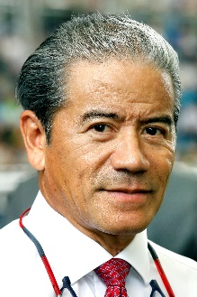 | Cruz, Tony | Cup ‒ Time Warp; Mile ‒ Ka Ying Star; Vase ‒ Exultant
 | Age: 62. Tony Cruz is a son of Johnny Cruz, a renowned rider from Hong Kong's amateur era. He was among the first intake of apprentices to the HKJC Apprentice Jockeys’ School when that facility opened in 1972. Cruz started his riding career in the 1973/74 season. He went on to be Hong Kong's champion jockey six times and rode 946 winners. Cruz also made his name at G1 level in Europe and notably partnered the great race mare Triptych. He was granted a Hong Kong trainer's licence in 1996 and first landed the trainers' title in 1999/2000. He regained the crown in 2005, setting a then record for a season's winners (91) and earnings (HK$113m) in the process. He most famously trained the great Hong Kong champion Silent Witness to win 17 consecutive races before the galloper tasted defeat at the hands of stablemate Bullish Luck in the 2005 Champions Mile. Honours: Hong Kong Champion Jockey (1978/79, 1980/81, 1982/83, 1983/84, 1985/86, 1994/95); Hong Kong Champion Trainer (1999/00, 2004/05). HKIR wins (10): Hong Kong Mile (2003 Lucky Owners, 2010 Beauty Flash, 2016 Beauty Only), Hong Kong Cup (2011 & 2012 California Memory, 2017 Time Warp), Hong Kong Sprint (2003 & 2004 Silent Witness, 2015 Peniaphobia), Hong Kong Vase (2018 Exultant). Hong Kong Wins (as of 25 November): 1,239

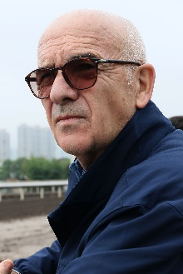 | de Royer Dupre, Alain | Cup ‒ Edisa
 | Age 75. Alain de Royer Dupre trains at Chantilly and is one of France’s most respected and successful trainers. He trained his first winner, in a steeplechase, in 1972. He started out in Normandy but in 1981 moved to Chantilly as principal trainer to the Aga Khan. In 2008 he ended Andre Fabre's 21-year reign as France's champion trainer, thanks largely to the Aga Khan’s outstanding Zarkava, the European Horse of the Year who took the Arc in an unbeaten career that yielded five G1 wins. His first Prix de l'Arc de Triomphe came in 2003 with another Aga Khan-owned luminary, Dalakhani. Royer Dupre has won the Prix du Jockey Club six times, the Prix de Diane six times, the Poule d’Essai des Poulains three times and the Poule d’Essai des Pouliches four times. He numbers the Breeders' Cup Turf (1984 Lashkari) and the Hong Kong Cup (Pride in 2006) among his international triumphs. A regular visitor to Hong Kong, he also won the 2009 Hong Kong Vase with Daryakana. In November 2010 he sent out Americain to become the first French-trained winner of the G1 Melbourne Cup. This year he has saddled Siyarafina to win the G1 Prix Saint Alary, while Edisa gave him another overseas win in the Jockey Club Oaks Invitational at Belmont Park. Honours: France’s champion trainer (2008). HKIR wins (2): Hong Kong Cup (2006 Pride), Hong Kong Vase (2009 Daryakana). Hong Kong Wins (as of 25 November): 2

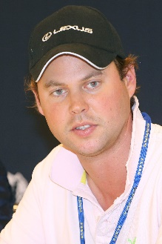 | Fellowes, Charlie | Vase ‒ Prince Of Arran
 | Age: 33. Charlie Fellowes has made a positive start to his training career since setting up in 2014, improving his win tally to a career best 31 this year. He trains from the historic Bedford House Stables in Newmarket, having bought the yard from Luca Cumani in the spring of 2019. Fellowes’ flag-bearer is the globe-trotting Hong Kong Vase entrant Prince Of Arran. He has shown a great willingness to travel having had runners in America, Canada, New York, Dubai, France, Ireland, Australia and Hong Kong. His first stakes win came with Moonlit Snow in the 2016 Blenheim Stakes but Australia is where he has seen his most notable achievements: Prince Of Arran won the G3 Lexus Stakes there in 2018 ahead of a fine third in the G1 Melbourne Cup and the same horse won the G3 Geelong Cup before running second in the 2019 running of Australia’s greatest race. Hong Kong wins: 0.

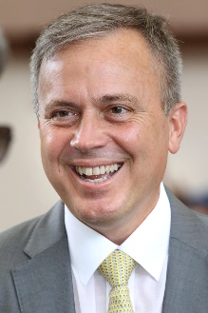 | Fownes, Caspar | Cup ‒ Rise High; Vase ‒ Southern Legend
 | Age: 52. Caspar Fownes assisted his late father Lawrie for several seasons before gaining his licence in 2003/04. He eclipsed his father's best season stats in his rookie year with 44 wins. In 2006/07 he won his first premiership and has since added two more. His third championship came in 2013/14 when his strong late charge brought three wins on the closing day to tie with John Size on 62 wins, and with one more second place than his rival he sealed the title on count-back. Fownes is particularly known for his fine record at Happy Valley where he has notched 460 career wins, a tally second only to Hong Kong's longest-serving trainer John Moore. He has enjoyed overseas success with Lucky Nine and Green Birdie in the G1 Krisflyer International Sprint, and Southern Legend, who won the first two international editions of the Kranji Mile. Honours: Hong Kong Champion Trainer (2006/07, 2008/09, 2013/14). HKIR wins (2): Hong Kong Mile (2006 The Duke), Hong Kong Sprint (2011 Lucky Nine). Hong Kong Wins (as of 25 November): 852

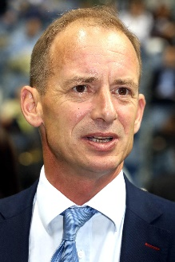 | Gibson, Richard | Sprint ‒ Rattan, Wishful Thinker
 | Age: 50. Englishman Richard Gibson established himself as a Group 1 trainer in France before he arrived in Hong Kong ahead of the 2011/12 season. He gained a solid grounding in the art and science of training racehorses with Frenchmen Pascal Bary and Henri-Alex Pantall, as well as Americans Bill Mott and Gary Jones. He took out his first licence at Chantilly in 1996 and struck gold as early as 1999 when Lady Of Chad won the G1 Prix Marcel Boussac en route to becoming European Champion Juvenile Filly. He has trained the winners of eight G1s altogether, the highlights being Akeed Mofeed's and Doctor Dino's exploits in Hong Kong and the USA. His other high-class trainees prior to moving to Hong Kong include Marotta, Lune D'Or, Cut Quartz, Mores Wells, Swedish Shave, and for a short spell Dunaden. He won the Hong Kong Derby with Akeed Mofeed and saddled the top-class galloper Gold-Fun to run a close second in the 2016 G1 Diamond Jubilee Stakes at Royal Ascot. HKIR wins (3): Hong Kong Vase (2007 & 2008 Doctor Dino), Hong Kong Cup (2013 Akeed Mofeed). Hong Kong Wins (as of 25 November): 226

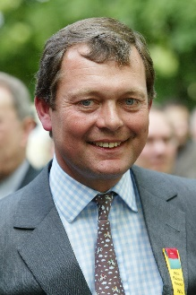 | Haggas, William | Vase ‒ Young Rascal
 | Age: 59. Newmarket trainer William Haggas is best known for his Epsom Derby success with Shaamit in 1996, having prepared the horse to win the Classic on his first start of the campaign. In 2011 the trainer prepared Dancing Rain to win the G1 Oaks at Epsom and the filly added the German Oaks and the inaugural G2 Champion Fillies & Mares Stakes. In recent season he has enjoyed further G1 successes with star fillies Sea Of Class and One Master. Sea Of Class won the 2018 Irish Oaks and Yorkshire Oaks and rattled late to challenge Enable when second in the Prix de l’Arc de Triomphe; One Master won the Prix de la Foret in 2018 and 2019. Other G1 winners include Rosdhu Queen (Cheveley Park Stakes), Chorist (Pretty Polly Stakes), Aqlaam (Prix du Moulin), King’s Apostle (Prix Maurice de Gheest) and Rivet (Racing Post Trophy). He has passed a century of winners in Britain for the past seven seasons, notching a career best 158 in 2017, and this year’s earnings of over £3.062 million is his best return yet. Hong Kong wins: 0

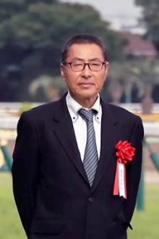 | Hagiwara, Kiyoshi | Mile ‒ Normcore
 | Age: 60. Kiyoshi Hagiwara commenced his racing career as a groom in 1982, before obtaining his JRA trainer licence in 1996. Logi Universe brought him a first top-class and Japanese Classic success when taking the JPN G1 Tokyo Yushun in 2009. Other notable gallopers he has prepared include the G1 Champions Cup winner and JRA’s Best Dirt Horse in 2018 Le Vent Se Leve, top dirt performer Obruchev (2011 Zen Nippon Nisai Yushun), and his current flagbearer Normcore (2019 Victoria Mile). He has amassed 605 JRA wins in his career including 22 this term (as of 18 November). Hong Kong wins: No previous runner

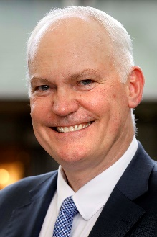 | Hall, David | Sprint ‒ Little Giant; Vase ‒ Ho Ho Khan
 | Age: 56. David Hall was born in Adelaide, the son of trainer Joe Hall. He began training at Morphettville in 1988 and moved to Melbourne five years later. Best known at home for winning the Melbourne Cup in 2003 with the brilliant Makybe Diva, he also trained Silent Witness before the champion sprinter switched to Hong Kong. Hall began his training career in Hong Kong in 2004/05. Absolute Champion's victory in the G1 Hong Kong Sprint is his Hong Kong highlight to date. In the 2018/19 season he saddled two G3 winners, Ho Ho Khan (Queen Mother Memorial Cup) and Little Giant (Sha Tin Vase). HKIR wins (1): Hong Kong Sprint (2006 Absolute Champion). Hong Kong Wins (as of 25 November): 456

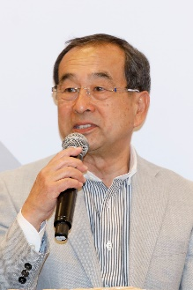 | Hashida, Mitsuru | Vase ‒ Deirdre
 | Age: 67. Hashida’s father was a jockey and trainer. He has been a trainer since 1985 and is currently the President of the Japan Trainers Association. Passing Shot brought him his first G1 success in the 1990 Mile Championship and he has collected no less than 12 G1 wins over the years. His leading performers include Admire Vega (1999 Tokyo Yushun) and Admire Groove (2003 & 2004 Queen Elizabeth II Commemorative Cup), as well as past HKIR runners Silence Suzuka (1998 Takarazuka Kinen), Admire Cozzene (1998 Yasuda Kinen) and Admire Max (2005 Takamatsunomiya Kinen). His current flagbearer Deirdre won the 2017 G1 Shuka Sho and gave him his first overseas success in the G1 Nassau Stakes at the Goodwood Festival in August. He has amassed a total of 705 JRA wins in his career, including 13 this year (as of 18 November). Hong Kong wins: 0

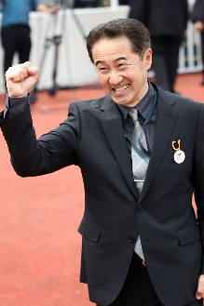 | Hatakeyama, Yoshihiro | Cup ‒ Win Bright
 | Age: 57. Yoshihiro Hatakeyama commenced his JRA career as a work rider in 1986, before obtaining his JRA training licence in 1999 and started his stable operation the following year. Meiner Dupre’s success in the G3 Kyodo News Service Hai in 2004 was Hatakeyama’s first at Group level. His top-class breakthrough came with Meiner Ho O’s victory in the 2013 NHK Mile Cup. His other top performers include top dirt fillies Grab Your Heart and Trois Bonheur, who brought the trainer a total of nine Group wins on the regional NAR circuit. He achieved a career high when three-time G2 winner Win Bright took the G1 FWD QEII Cup at Sha Tin in April. He has amassed a total of 307 JRA wins, including 15 this season (as of 18 November). Hong Kong wins: 1.

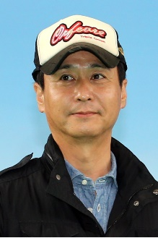 | Ikee, Yasutoshi | Mile ‒ Persian Knight
 | Age: 50. Yasutoshi Ikee is the son of Yasuo Ikee, the former JRA trainer who prepped two-time Japanese Horse of the Year Deep Impact and 2001 Hong Kong Vase winner Stay Gold. Ikee worked in his father’s stable for a brief time before going to the UK to work for Michael Stoute in 1995 and to California in 1996 to work for Neil Drysdale. He returned to Japan in 2003 to take out his trainer's licence and has notched 676 JRA wins, including 41 this season (as of 18 November). He has no less than 19 G1/JPN G1 wins. Among the best horses he has prepared are 2011 Japanese Horse of the Year and two-time Prix de l’Arc de Triomphe runner-up Orfevre, three-time G1 winner Dream Journey, and Japanese classic winners Mikki Queen and Satono Diamond. The 2017 G1 Japanese 2,000 Guineas one-two Al Ain and Persian Knight have been his flagbearers in recent times with the former taking the G1 Osaka Hai and the latter the G1 Mile Championship. Honours: Ikee is a seven-time JRA Award winner; twice as the trainer with the most wins (2008 and 2017), four times with the most prize money (2011, 2012, 2015 & 2017), and twice as the trainer with highest winning percentage (2006 & 2010). Hong Kong wins: 0

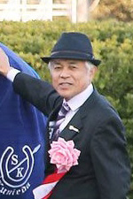 | Kunieda, Sakae | Cup ‒ Almond Eye
 | Age: 64. Sakae Kunieda studied to be a vet at university where he was also a member of the Equestrian Team. He joined racing as a work rider in 1978 and obtained his JRA training license in 1989. He has 886 JRA wins in his training career, including 42 this season (as at 18 November). He has 17 wins at G1/JPN G1 level and is responsible for two Fillies’ Triple Crown winners in Japan – the 2010 winner Apapane and also his current flagbearer, the exceptional 2018 Japanese Horse of the Year, Almond Eye. The latter brought him a first major overseas success in the G1 Dubai Turf in March 2018. His other top horses include Matsurida Gogh (2007 Arima Kinen), Black Hawk (2001 Yasuda Kinen) and Danon Platina (2014 Asahi Futurity Stakes) also stand out. Hong Kong wins: 0

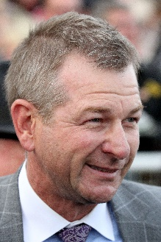 | Lees, Kris | Sprint ‒ In Her Time
 | Age: 48. Kris Lees trains at Broadmeadow, Newcastle and learned the ropes alongside his father, the late Max Lees, who sent out 20 G1 winners including the outstanding two-year-old Luskin Star. He took out a licence in 2003 and notched a first G1 win in his first season, County Tyrone in the 2004 Metropolitan Handicap. In 2013/14 he broke into the top 10 in the Australian Trainers’ Premiership with 113 wins. He topped that total in 2014/15 with 120 wins. The multiple G1-winning filly Samantha Miss was a notable stable standard-bearer and the mare Lucia Valentina took on the G1 flag, winning the Vinery Stud stakes and Queen Elizabeth Stakes. She also ran 5th in the 2015 Hong Kong Cup. His latest stable star is another mare, the speedy In Her Time who has won the G1 Galaxy and G1 Black Caviar Lightning. Hong Kong wins: 0

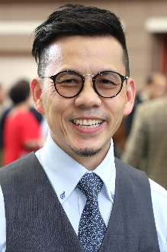 | Lor, Frankie | Cup ‒ Dark Dream, Furore, Glorious Forever; Mile ‒ Simply Brilliant; Sprint ‒ Mr Stunning
 | Age: 53. Frankie Lor began his career as a rider in Hong Kong, notching 27 wins between 1981 and 1995. He became a work rider and then an assistant to a number of trainers, most notably to two of Hong Kong's greats, John Moore and John Size. Lor was granted a full licence ahead of the 2017/18 Hong Kong racing season. His first win was achieved with his first runner, Yourthewonforme, in a Class 4 contest at the season opener on 3 September, 2017. Lor ended that campaign second in the premiership behind his old master John Size. His final tally of 65 wins surpassed Hong Kong's previous best first-season total, set by Size when winning his first Hong Kong trainers’ championship in 2002. Lor landed his first G1 wins in only his second season, scooping a double at the 2018 LONGINES HKIR with Mr Stunning (Hong Kong Sprint) and Glorious Forever (Hong Kong Cup). That season also saw him sweep the 2019 Four-Year-Old Classic Series with Furore and Mission Tycoon. HKIR wins (2): Hong Kong Sprint (2018 Mr Stunning), Hong Kong Cup (2018 Glorious Forever). Hong Kong wins (as of 25 November): 138

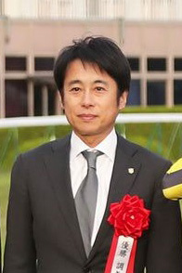 | Matsunaga, Mikio | Vase ‒ Lucky Lilac
 | Age: 52. Mikio Matsunaga developed an interest in racing when his father, a provincial livestock experimental station worker, took his son to attend races at a nearby racecourse. He joined the JRA Riding School for jockey training in 1983 and made his professional debut in 1986 and was crowned the best rookie jockey with 40 wins that same year. Matsunaga enjoyed immense success in his riding career, with more than 1400 wins and 11 at G1/JPN G1 level between 1986 and 2006. He obtained his JRA trainer licence in 2006 and started his stable operations the following year. Red Desire brought him a first G1 success in the Shuka Sho in 2009, while Red Kingdom also won him a first G1 in jump races in the 2014 Nakayama Daishogai. His current flagbearer is 2017 JRA Champion 2YO filly and 2019 G1 Queen Elizabeth II Cup winner Lucky Lilac. Matsunaga has a career total of 353 JRA wins as a trainer, including 39 this term (as at 18 Nov). Hong Kong wins: No previous runner

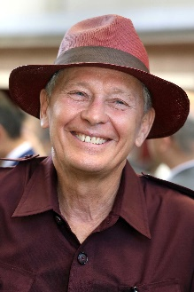 | Moore, John | Mile ‒ Beauty Generation; Sprint ‒ Aethero; Vase ‒ Eagle Way
 | Age: 69. John Moore has been involved in Hong Kong racing since the professional era commenced in 1971 and is Hong Kong's longest-serving and winning-most trainer. A former amateur jockey, he began training in 1985, before which he held the position of assistant trainer to his late famous father, George. In 2007 he prepared an international G1 double thanks to Viva Pataca in the QEII Cup and Able One in the Champions Mile and, in a feat perhaps unprecedented in the sport, won the same two races with the same two horses three years later. The seven-time Hong Kong champion trainer was the first to saddle 1000 wins in Hong Kong and was the leading prize money earner for 12 seasons straight until John Size topped the earnings table in 2017/18. The stable has also produced the last six gallopers to be named Hong Kong Horse of the Year - Military Attack (2013), Designs On Rome (2014), Able Friend (2015), Werther (2016), Rapper Dragon (2017) and Beauty Generation (2018 & 2019). Honours: Hong Kong Champion Trainer (1985/86, 1990/91, 1991/92, 1992/93 [tied with David Hill], 1994/95, 2010/11, 2014/15); Hong Kong record holder for all-time career prize money (HK$1.85 billion). HKIR wins (8): Hong Kong Mile (2011 Able One, 2014 Able Friend, 2017 & 2018 Beauty Generation), Hong Kong Cup (1993 Motivation, 2014 Designs On Rome), Hong Kong Sprint (2008 Inspiration), Hong Kong Vase (2013 Dominant). Hong Kong wins (as of 25 November): 1,689

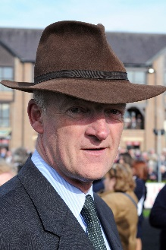 | Mullins, Willie | Vase ‒ True Self
 | Age: 63. Willie Mullins hails from a successful racing dynasty and is a titan of the jump racing scene. Being an 11-time champion trainer in that sphere in Ireland, he has an extensive list of big-race wins to his credit including the 2019 Cheltenham Gold Cup with Al Boum Photo. He has won the Champion Hurdle at Cheltenham four times with Hurricane Fly (2011 & 2013), Faugheen (2015) and Annie Power (2016), and the 2005 Grand National with Hedgehunter. He has also prepared the likes of Vautour, Quevega and Florida Pearl, while he won the 2013 G1 Nakayama Grand Jump with Blackstairmountain. He was a six-time champion amateur jockey in Ireland and won the 1983 Foxhunters Chase over the Grand National course before taking out his training licence in 1988. Mullins has enjoyed success in Flat racing too and saddled Simenon to win two races at Royal Ascot within five days in 2012, the Ascot Stakes and the Queen Alexandra Stakes. The same horse was runner-up in the G1 Gold Cup at Royal Ascot in 2013, as well as 4th in the G1 Melbourne Cup, before finishing 5th in the G1 LONGINES Hong Kong Vase that year. More recently, Max Dynamite placed in two Melbourne Cups and was sixth in the 2017 Hong Kong Vase. Honours: Ireland’s 13-time champion National Hunt trainer. Hong Kong wins: (0)

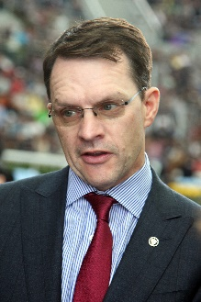 | O’Brien, Aidan | Cup ‒ Magic Wand; Vase ‒ Anthony Van Dyck, Mount Everest
 | Age: 50. Aidan O’Brien has a phenomenal list of big race victories to his name and has notched 329 G1 wins (plus a further 22 G1 National Hunt wins). In 2017, he eclipsed American training legend Bobby Frankel’s record for the most G1 wins in a season with 28 for the year, three more than Frankel’s mark. A champion amateur jump jockey in Ireland, he was assistant trainer to Jim Bolger before taking out a trainers’ licence in 1993 – he has sealed Ireland’s champion trainer title for the 22nd time in 2019 (21st consecutively). He enjoyed remarkable success with jumpers before teaming up with John Magnier’s Coolmore operation at the legendary Ballydoyle training base in 1996; a year later, he became Ireland’s youngest ever champion trainer on the Flat. He has won 77 British and Irish Classic races. O’Brien has trained a host of champions including super sire Galileo, High Chaparral, Giant’s Causeway, Rock Of Gibraltar, Yeats, Cape Blanco and Minding, as well as the great hurdler Istabraq. He broke new ground in 2014 with his first winner in Australia, Adelaide, in the G1 Cox Plate, and in December 2015 Highland Reel gave him his first Hong Kong win. HKIR wins (2): Hong Kong Vase (2015 and 2017 Highland Reel). Hong Kong wins: 2

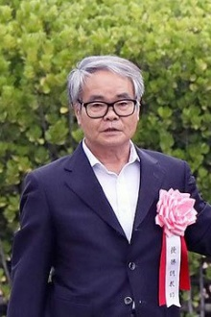 | Otonashi, Hidetaka | Mile ‒ Indy Champ
 | Age: 65. Hidetaka Otonashi rode 84 winners as a JRA jockey between 1979 and 1993, including his sole top-class success aboard Noah No Hakobune in the 1985 Yushun Himba (Japanese Oaks). He obtained his JRA trainer license in 1995. He has earned two other JRA Awards as the leading trainer in western Japan in 2004, and as the trainer with most total prize money in 2009. So far he has saddled a total of 829 JRA wins in his training career, including 39 this season (as at 18 Nov). Having no less than 13 wins at G1/JPN G1 level, his leading performers include Company (2009 Tenno Sho Autumn), Mikki Isle (2014 NHK Mile Cup, 2016 Mile Championship), Mikki Rocket (2018 Takarazuka Kinen) and his current flagbearer, this year’s G1 Yasuda Kinen and G1 Mile Championship winner Indy Champ. Honours: JRA champion trainer (2010). Hong Kong wins: 0

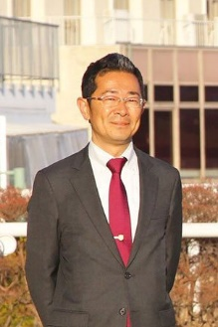 | Ozeki, Tomohito | Vase ‒ Glory Vase
 | Age: 47: Tomohito Ozeki started out as a groom in 1999. He obtained his JRA trainer licence in 2008 and established his own stable the following year. He has notched 264 JRA wins so far in his career, including 19 this term (as of 18 November). Red Falx gave him his first G1 success in the Sprinters Stakes at Nakayama in 2016 and followed up in 2017. Sakura Gospel, winner of the 2015 G2 Keio Hai Spring Cup, and Glory Vase, winner of the G2 Nikkei Shinshun Hai in January, are the other notable horses he has trained. Hong Kong wins: 0

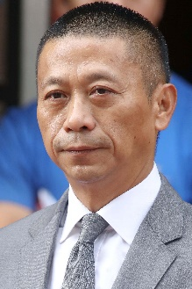 | Shum, Danny | Sprint ‒ Regency Legend, Seasons Bloom
 | Age: 59. Danny Shum rode 24 winners in Hong Kong between 1977 and 1983. He learnt the training ropes as assistant to former multiple Hong Kong champion trainer Ivan Allan. He was granted a Hong Kong trainer's licence ahead of the 2003/04 season and began brightly with 34 winners. The handler improved on that good debut season to rank third in the trainers’ premiership in his second term when Scintillation emerged as his standout runner. The 2011/12 season brought a first overseas success as Little Bridge went to Royal Ascot to clinch victory in the G1 King's Stand Stakes. Shum recorded a best ever season's tally of 54 wins to finish second in the 2015/16 trainers' premiership. Hong Kong wins (as of 25 November): 601

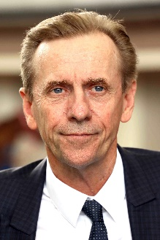 | Size, John | Mile ‒ Waikuku; Sprint ‒ Beat The Clock, D B Pin, Full Of Beauty, Hot King Prawn, Ivictory
 | Age: 65. John Size was a top trainer in Sydney before his arrival in Hong Kong in 2001 with a reputation for improving and rekindling the spark in his horses. He broke the mould by winning the trainers' premiership in his very first season. Size’s ninth championship in 2016/17 saw him set a new record for most winners in a season with 94, 27 more than nearest rival John Moore. In winning his 10th title in 2017/18, Size set a new benchmark for earnings in a season, accruing total prize money of HK$176,441,240. His 11th title in 2018/19 was sealed after a tussle with rival John Moore that went to the season’s final day. He has trained the winners of two Horse of the Year titles, the multiple HKG1 scorers Electronic Unicorn and Grand Delight. In 2009/10 he trained Brave Kid to equal the then record of six wins in a season and Entrapment who finally broke that record with seven victories in just five months. Honours: Hong Kong Champion Trainer (2001/02, 2002/03, 2003/04, 2005/06, 2007/08, 2009/10, 2011/12, 2015/16, 2016/17, 2017/18, 2018/19); Australian Racing Hall of Fame inductee (2018). HKIR wins (2): Hong Kong Mile (2013 Glorious Days), Hong Kong Sprint (2017 Mr Stunning). Hong Kong Career Wins (as of 25 November): 1,220

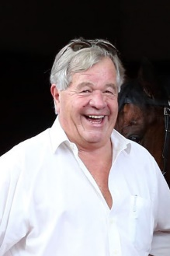 | Stoute, Sir Michael | Mile ‒ Zaaki
 | Age: 74. Sir Michael Stoute moved to England from Barbados at age 19 and was licensed to train in 1972. He has been crowned Britain's champion trainer 10 times (1981, 1986, 1989, 1994, 1997, 2000, 2003, 2005, 2006, 2009). His G1 wins include four in the Breeders' Cup Turf, 15 English Classics including five in the Derby, two Japan Cups, a Dubai World Cup and even a Champion Hurdle. The most famous of his stars remains the ill-fated Shergar, but he has trained numerous international champions, including Dubai World Cup and Japan Cup winner Singspiel and Breeders’ Cup Turf winner Pilsudski. In 2008 he finally completed his set of all five English Classics when subsequent dual Breeders' Cup Turf winner Conduit landed the St Leger. In 2013 he saddled the Queen’s Estimate to give the British monarch her first G1 Gold Cup win at Royal Ascot. Ulysses won two G1s in 2017 to earn the title of Europe’s Champion Older Horse and in 2018 Expert Eye took his overall Breeders’ Cup tally to eight. This year he has had three G1 wins with Mustashry (Lockinge Stakes), Crystal Ocean (Prince of Wales’s Stakes) and Veracious (Falmouth Stakes). HKIR wins (2): Hong Kong International Bowl (1994 Soviet Line); Hong Kong Vase (2000 Daliapour). Hong Kong wins: 2

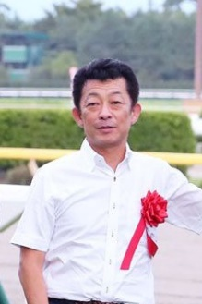 | Tomomichi, Yasuo | Mile ‒ Admire Mars
 | Age: 56. Yasuo Tomomichi was a vet student and joined the Equestrian Team shortly after his admission to university. With his Equestrian Team’s training located close to the racecourse, he took up a part-time job there, working as an assistant to horse vets during race days. Tomomichi started his own racing career as a work rider and stable assistant in 1989, and obtained his trainer’s licence in 2001. Tomomichi has no less than 13 G1/JPN G1 wins. Admire Jupiter helped him open his account in the 2008 Tenno Sho Spring, while Unrivalled gave him his first classic in the 2009 G1 Satsuki Sho (Japanese 2,000 Guineas). His other top performers include Makahiki (2015 Tokyo Yushun), Cheval Grand (2017 Japan Cup), Wagnerian (2018 Tokyo Yushun), Admire Mars (2019 NHK Mile Cup), and World Premiere (2019 Kikuka Sho). Makahiki gave him an overseas win in the 2016 G2 Prix Niel, while Vivlos landed the G1 Dubai Turf in 2017. He has amassed a total of 521 JRA wins in his career, including 30 this term (as of 18 November). Hong Kong wins: 0

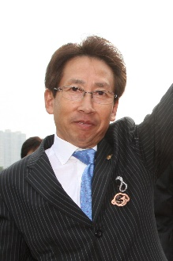 | Yasuda, Takayuki | Sprint ‒ Danon Smash
 | Age: 66. Born in Kyoto, Takayuki Yasuda had 680 wins as a jockey between 1972 and 1994. In 1991 he rode a personal best 80 wins and partnered the legendary horse Tokai Teio to take two Japanese classics, the Satsuki Sho and Tokyo Yushun. Yasuda obtained his training licence in 1994 and registered his first victory in March 1995. He has saddled 798 JRA career wins, including 14 at G1/JPN G1 level. With 59 wins (as of 18 November) he is currently leading the JRA trainers’ premiership this year, eight ahead of Noriyuki Hori in second, as he attempts to win his first champion trainer title. Yasuda handled brilliant mare and 2011 G1 Sprinters Stakes winner Curren Chan, but the great Lord Kanaloa remains the best horse he has handled. The Hall of Famer and 2013 Japanese Horse of the Year notched six G1 wins, including back-to-back successes in the G1 Sprinters Stakes and G1 LONGINES Hong Kong Sprint in 2012 & 2013. Transcend (2010 & 2011 Japan Cup Dirt) and Grape Brandy (2013 February Stakes) are his other top performers. HKIR wins (2): Hong Kong Sprint (2012 & 2013 Lord Kanaloa). Hong Kong wins: 2

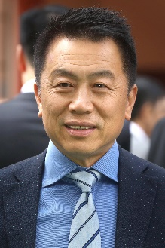 | Yiu, Ricky | Mile ‒ Citron Spirit
 | Age: 62. Ricky Yiu rode 11 winners between 1974 and 1980 and was first licensed as a trainer in 1995/96. One of his greatest early moments came with Fairy King Prawn's success in the inaugural Hong Kong Sprint of 1999. Sacred Kingdom, one of Hong Kong's all-time greats, was his outstanding stable star and the two-time G1 Hong Kong Sprint winner and 2009/10 Horse of the Year won the Champion Sprinter title for the fourth year in succession in 2010/11. In the 2010/11 season he also sent out Ultra Fantasy to triumph in the G1 Sprinters Stakes at Nakayama as, with Alex Lai on board, the pair became the first Hong Kong Chinese trainer-jockey partnership to triumph in an overseas G1 event. Following Sacred Kingdom's retirement in the spring of 2012, another blistering speedster, Amber Sky, provided Yiu with further elite success at home and abroad. His son, Eric Yiu, was appointed the stable's assistant trainer ahead of the 2018/19 season. HKIR wins (3): Hong Kong Sprint (1999 Fairy King Prawn, 2007 & 2009 Sacred Kingdom). Hong Kong wins (as of 25 November): 766

