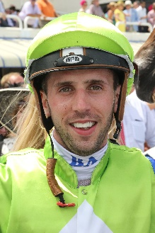 | Avdulla, Brenton
 | Age: 28. Brenton Avdulla was a leading apprentice in Melbourne before a ‘chance’ phone call from Gai Waterhouse saw him relocate to Sydney to be indentured to her. He has remained in Sydney since and was crowned 2017/18 champion jockey. Avdulla has ridden over 100 winners in his last five seasons in Sydney striking at no less than 14.5%, contributing to his total win tally of 1,124 (as of 25 November). His first G1 win came aboard the Grahame Begg-trained Secret Admirer in the 2010 Flight Stakes at Randwick and his first Australian ‘major’ came aboard Estijaab in the G1 Golden Slipper at Rosehill. Honours: Sydney champion jockey (2017/18). Hong Kong wins (as of 25 November): 0

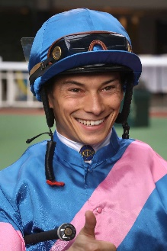 | Badel, Alexis
 | Age: 28. Alexis Badel hails from a racing tradition, his mother being trainer Myriam Bollack-Badel and his father, former jockey Alain Badel. He was France's Champion Apprentice in 2007 and broke into the top 10 in the premiership in just his second year riding, with 60 winners. Badel's first Group race win came aboard Norse King in the October 2013 Prix du Conseil de Paris. He was appointed as the second retained rider for The Aga Khan behind Christophe Soumillon at the beginning of the 2015 racing season and went on to record his most successful season to date with 104 wins. That saw him obtain seventh position in the French Championship. He debuted at Sha Tin with two mounts on 11 December, 2016. His first Hong Kong winner was Supreme Profit on 27 December, 2016 and he ended that maiden two-month stint with seven wins. He returned in the 2017/18 season, landing 14 wins. He secured a first G1 win aboard Nonza in the August 2018 Prix Jean Romanet at Deauville. Honours: France's Champion Apprentice (2007). Hong Kong wins (as of 25 November): 34

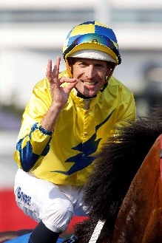 | Bowman, Hugh
 | Age: 39. The 2017 LONGINES World’s Best Jockey award recipient, Bowman boasts an outstanding career record of 88 G1 victories among more than 2,000 wins since his debut ride on Naturalised in 1999. He has been champion jockey in Sydney four times and the most prolific G1-winning jockey in Australia in recent times. He has a record of 32 wins from 33 rides on the champion mare Winx, notably an incredible four wins in the Cox Plate. In Hong Kong, he has won the Hong Kong Derby (2016 Werther, 2019 Furore), Hong Kong Gold Cup (2016 Werther), Champions & Chater Cup (2016 Werther) and Chairman’s Sprint Prize (2017 Lucky Bubbles). Honours: Sydney champion jockey (2008/09, 2011/12, 2014/15, 2016/17); LONGINES World’s Best Jockey (2017); LONGINES IJC (2016). Hong Kong wins (as of 25 November): 29

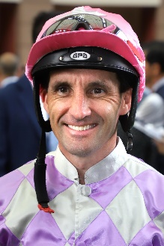 | Callan, Neil
 | Age: 41. Irishman Neil Callan finished runner-up in the British jockeys' championship in 2005 (151 wins) and 2007 (170 wins). After a fruitless start as an apprentice in Ireland with Kevin Prendergast he moved to Britain and forged successful partnerships with trainers Karl Burke, Kevin Ryan and Michael Jarvis. He first rode in Hong Kong on a short contract in the 2010/11 season and has since established a reputation as a tough competitor. His first full Hong Kong season, 2014/15, yielded 47 wins and fifth place in the jockeys' premiership and he equalled that tally when finishing third in 2016/17. His big race wins include the 2015 Hong Kong Classic Mile on Beauty Only and three G1s on Blazing Speed (2015 QEII Cup; 2014 & 2016 Champions & Chater Cup). Honours: British Champion Apprentice (1999). Hong Kong wins (as of 25 November): 233

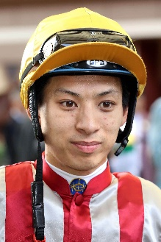 | Chadwick, Matthew
 | Age: 29. A graduate of Hong Kong's Apprentice Jockeys' School, Matthew Chadwick went to Australia for his apprentice training and rode a four-timer at Lismore Racecourse at age 17. Indentured to the Tony Cruz stable upon his return to Hong Kong, he was champion apprentice in 2008/09. He earned a full jockey's licence in January 2010. His first Group race winner was Egyptian Ra in the HKG3 National Day Cup (2009). Chadwick became the first homegrown rider to win a HKIR contest when clinching the G1 Hong Kong Cup on California Memory in 2011 and followed up on the same horse in the same race in 2012. He rode his first Hong Kong four-timer at Sha Tin on 22 June, 2014. Honours: Hong Kong Champion Apprentice (2008/09); Shergar Cup Silver Saddle winner (2012). LONGINES HKIR wins (2): Hong Kong Cup (2011 & 2012 California Memory). Hong Kong wins (as of 25 November): 357

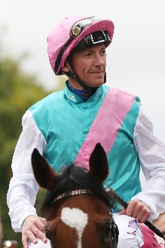 | Dettori, Frankie
 | Age: 48. One of racing’s global icons, Frankie Dettori has been champion jockey in Britain three times and was, for many years, the big-race maestro for the Godolphin operation. Dettori’s phenomenal achievements include 250 G1 wins around the world spanning 30 years. Among those are 19 British Classics, six HKIR wins, 67 Royal Ascot triumphs and 14 Breeders’ Cup scores, as well as famous victories in the Japan Cup, Dubai World Cup and Prix de l’Arc de Triomphe. This year has brought a phenomenal 19 G1 wins, including the King George VI & Queen Elizabeth Stakes, Eclipse Stakes and Yorkshire Oaks on the brilliant Enable. He famously rode all seven winners on the card at Ascot in 1996, including the G1 QEII Stakes on Mark Of Esteem. He brought the house down when winning the IJC at Happy valley for a third time in 2011 following wins in 1999 and 2001. Honours include: British Champion Jockey (1994, 1995, 2004); LONGINES IJC (1999, 2001, 2011); LONGINES World’s Best Jockey (2015 & 2019). LONGINES HKIR wins (6): Hong Kong Vase (1996 Luso, 2010 Mastery), Hong Kong Cup (2000 Fantastic Light, 2003 Falbrav, 2007 Ramonti), Hong Kong Mile (2004 Firebreak). Hong Kong wins (as of 25 November): 23

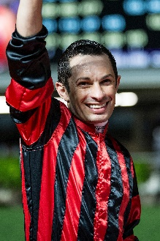 | de Sousa, Silvestre
 | Age: 38. Brazilian ace Silvestre de Sousa lit up Happy Valley with victory in the 2018 LONGINES IJC and followed up four days later with a first LONGINES HKIR win aboard Glorious Forever in the G1 LONGINES Hong Kong Cup. One of 10 children, he first sat on a horse on the family farm at age six, became an apprentice jockey at age 18 and within two years was champion apprentice in Sao Paulo. He moved to Europe at age 22 and was employed as a work rider for Dermot Weld. In 2004, dispirited after two years without a ride in public, De Sousa moved to England and teamed up with North Yorkshire trainer Dandy Nicholls. His first win in Britain was achieved aboard Sonic Anthem at Southwell on 1 January, 2006. With trainer Mark Johnston's support he finished runner-up in the 2011 British champion jockey race. He was retained by Godolphin from 2012 to 2014, during which time his haul included the G1 Dubai World Cup on African Story. Riding freelance in 2015, he achieved 132 wins to claim the British champion jockey title and repeated in 2017 (155 wins) and again in 2018 (148 wins). Injury knocked him out of the title race in 2019 but he returned in October to claim the G1 British Champions Sprint Stakes aboard Donjuan Triumphant. De Sousa notched 16 winners in each of his first two short winter stints in Hong Kong (2015/16 and 2016/17) and earned a fine 44 during a longer spell in 2018/19. Honours include: British Champion Jockey (2015, 2017 & 2018). LONGINES HKIR Wins (1): Hong Kong Cup (2018 Glorious Forever). Hong Kong wins (as of 25 November): 78

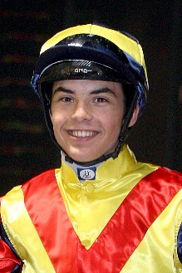 | Guyon, Maxime
 | Age: 30. Maxime Guyon rode on the pony circuit in France and attended Le Moulin a Vent jockey school in Gouvieux, after which he started his career with Andre Fabre in 2005. Fabre once said he believed his protege had the innate talent to become one of the best jockeys of all time. After gaining his senior licence in January 2008, Guyon's career blossomed quickly and he achieved his first G1 win on Cavalryman in the 2009 Grand Prix de Paris. His haul of wins includes no less than 32 at G1 level, among them four European classics. He enjoyed a good first stint in Hong Kong during the 2010/11 season when he successfully partnered Horse of the Year Ambitious Dragon to win the Hong Kong Classic Cup and Hong Kong Derby. Guyon currently (as of 25 November) leads the championship race in France as he seeks a first title. HKIR wins (1): Hong Kong Vase (2014 Flintshire). Hong Kong wins (as of 25 November): 29

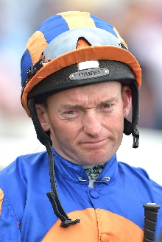 | Heffernan, Seamus
 | Age: 47. Seamie Heffernan worked for Jim Bolger and was crowned joint champion apprentice in 1994 alongside Daragh O’Donoghue, prior to joining Aidan O’Brien in 1996. He has been an important cog in the Ballydoyle machine down the years, filling the understudy role to Mick Kinane, Kieren Fallon, Jamie Spencer, Johnny Murtagh and Ryan Moore. He has partnered some big names to G1 wins, including Minding, Cape Blanco, So You Think, Imagine and Highland Reel. Among his nine European classics are three Irish Derbys. He took his tally to 31 G1 scores with his Epsom Derby win aboard Anthony Van Dyck earlier this year. He rode at the 2017 HKIR after an 11-year absence. Honours: Ireland’s champion apprentice (1994). Hong Kong wins (as of 25 November): 0

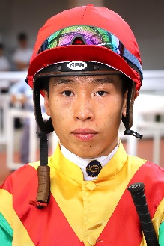 | Ho, Vincent
 | Age: 29. HKJC Apprentice Jockeys' School graduate Vincent Ho is maturing into a serious talent on the Hong Kong scene and won the 2018/19 Tony Cruz Award as the season’s leading homegrown rider, with a career-high 56 wins. He racked up 44 wins as a young rider in New Zealand under the tutelage of leading trainer Lance O'Sullivan and made a good start to his Hong Kong career with 10 victories in his first season in 2009/10, including a trio of wins he achieved on only his fourth race day in Hong Kong. He sealed the 2010/11 Champion Apprentice title with 39 wins. Ho reached the graduation benchmark on 1 October, 2012 by claiming his 70th win in Hong Kong on board Castle Hero. He notched 33 wins in 2014/15 to be the season's leading homegrown rider. Ho rode a short stint in Europe during the off-season in 2018 and notched a first win in Britain at the first attempt, partnering the Mark Johnston-trained X Rated to success at Haydock in August that year. He returned to Britain during the 2019 off-season and competed at the Shergar Cup at Ascot where he won the Shergar Cup Mile aboard the Marcus Tregoning-trained Power Of Darkness, helping the Rest of the World team secure the Shergar Cup. Honours: Hong Kong Champion Apprentice (2010/11); Best Freelance Jockey Award (2014/15); Tony Cruz Award (2018/19). Hong Kong wins (as of 25 November): 284

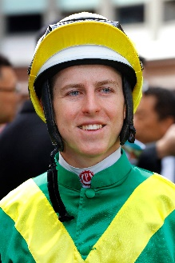 | Lane, Damian
 | Age: 25. One of the brightest young talents in Australian racing, Damian Lane achieved his 500th career win on the eve of his 21st birthday in February 2015. Apprenticed to his father Michael in 2009, he had his first race ride at age 16 and notched more than 100 wins in Western Australia before transferring his indentures to the Melbourne-based training partnership of Matthew Ellerton and Simon Zahra during the 2010/11 season. He graduated to the senior riding ranks during the 2012/13 season when he broke through the 100 wins in a season barrier for the first time (106 wins) at a strike rate of 16%. He repeated that achievement in the 2013/14 season with 105 wins and finished 3rd in the Victorian Jockeys’ Championship. His maiden G1 victory came atop Trust In A Gust in the 2014 Sir Rupert Clarke. Lane undertook a short-term contract in Hong Kong at the end of the 2014/15 season for five wins and rode with success in Japan in the summer of 2019. Also in 2019, Lane won three out of four of Australian racing’s 'Grand Slam', securing the Golden Slipper aboard Kiamichi, the Caulfield Cup aboard Mer De Glace and the Cox Plate with Lys Gracieux. Hong Kong Career Wins (as of 25 November): 5

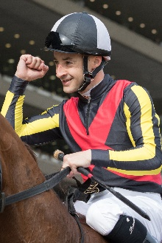 | Lemaire, Christophe
 | Age: 40. Christophe Lemaire has enjoyed stellar success with wonder filly Almond Eye. The pair won Japan’s Fillies’ Triple Crown and the G1 Japan Cup together in 2018 and this year enjoyed success in the G1 Dubai Turf at Meydan before returning to Japan to win the Tenno Sho Autumn. He leapt to prominence in 2004 thanks to his partnership with the brilliant French champion filly Divine Proportions and two years later he rode the crack mare Pride to win the G1 Champion Stakes and G1 Hong Kong Cup. Other top class winners in those days include Stacelita, Makfi, Flotilla and Elusive Wave, while Dunaden carried him to a Melbourne Cup win in 2011. His first Japanese major came a few years earlier aboard Heart’s Cry in the 2005 Arima Kinen and the duo took the 2006 Dubai Sheema Classic. Star mare Vodka’s Japan Cup is also among his G1 wins to date. In early 2015 he and Mirco Demuro became the first overseas riders to be granted full-time jockey licences in Japan. In November 2016, he equalled the record of Yutaka Take for most wins at a single Japanese meeting with eight victories. Honours: JRA champion jockey (2017); LONGINES IJC winner (2009 [DH]). LONGINES HKIR wins (1): Hong Kong Cup (2006 Pride). Hong Kong wins (as of 25 November): 5

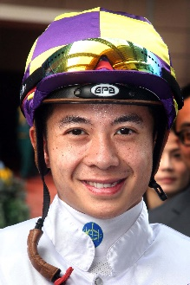 | Leung, Derek
 | Age: 31. Derek Leung’s career highlight is his 2017 LONGINES Hong Kong Mile victory aboard Beauty Generation. A product of Hong Kong's Apprentice Jockeys' School, he cut his teeth in New Zealand under trainer Lance O'Sullivan. He was assigned as apprentice jockey to Paul O'Sullivan's stable upon his return to Hong Kong. Leung reached the graduation benchmark after his 70th win on board Star Of Fame on 1 June, 2011. He reached a personal best total of 33 wins in the 2015/16 season and received the Tony Cruz Award in 2016/17 and 2017/18 as the leading home-grown rider. His biggest win came in the 2017 Hong Kong Mile on Beauty Generation. Honours: Asian Young Guns Challenge winner (2010); Tony Cruz Award winner (2017 & 2018). LONGINES HKIR wins (1): Hong Kong Mile (2017 Beauty Generation) Hong Kong wins (as of 25 November): 289

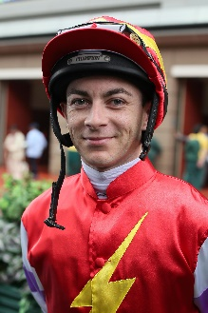 | Lordan, Wayne
 | Age: 37. Wayne Lordan, the son of amateur rider Pat Lordan, started out as an apprentice to Thomond O’Mara and was runner-up in Ireland’s 2001 apprentice championship. He notched a major milestone with a first G1 win atop Sole Power in the 2010 Nunthorpe Stakes. He had to wait three years for a follow-up and that came thanks to Sudirman in the 2013 Phoenix Stakes. In 2014 he partnered Europe’s champion sprinter Slade Power to G1 wins in the Diamond Jubilee Stakes and July Cup and the following season he was in the irons for the Coolmore-owned Legatissimo’s wins in the G1 Nassau Stakes and G1 Matron Stakes. Lordan scored his first Classic win in 2017 on the Aidan O’Brien-trained Winter in the 1,000 Guineas and won the race again in 2019 on Hermosa for the Ballydoyle team. Lordan has enjoyed a top-class association with the Joseph O’Brien-trained Iridessa: the pair won the 2018 Fillies’ Mile and scored further G1 wins in the 2019 Pretty Polly, Matron and Breeders’ Cup Filly & Mare Turf. He teamed with the Gai Waterhouse and Adrian Bott-trained Vinicunca to win the G3 Maribyrnong Plate at Flemington during that year’s Spring Carnival. Hong Kong wins (as of 25 November): 0

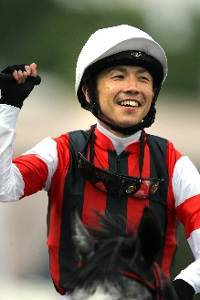 | Matsuoka, Masami
 | Age: 35. A baseball lover and a musician in a band, Matsuoka commenced his JRA jockey career in 2003 and won the first of his 33 Pattern race wins atop Win Glanz in the 2005 G3 Diamond Stakes. Matsuoka chose to travel to Ireland in 2006 and worked for trainer John Oxx for three months. He earned his first G1 win the following year, atop Koiuta in the G1 Victoria Mile, before adding another important win with Meiner Kitz in the 2009 G1 Tenno Sho Spring. He had to wait 10 years for his next top-level win: in 2019 he guided Win Bright to victory in the G1 FWD QEII Cup, setting a 2000m Sha Tin course record in the process. He also partnered Bamboo Ere to win the JPN G1 JBC Sprint in 2008. Matsuoka has amassed a total of 827 JRA wins, including 21 (as of 25 november) this year. Hong Kong wins (as of 25 November): 1

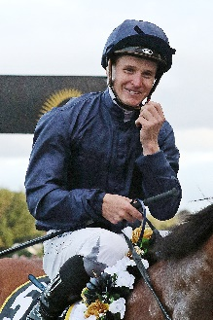 | McDonald, James
 | Age: 27. James McDonald made a big impression in Hong Kong on his LONGINES IJC debut when still a teenager back in 2011, finishing runner-up to Frankie Dettori. He returned the following May and partnered Xtension to victory in the 2012 G1 Champions Mile at Sha Tin. Champion Apprentice in his homeland, he went on to claim the Premiership there twice, in 2008/09 and latterly with a New Zealand record tally of 207 for the 2010/11 season. In 2012 he won a first New Zealand Derby. He clinched his first Sydney Premiership in July 2014, bagged a second in 2015/16 and won a third last season with 104 wins. He was appointed Godolphin’s number one rider in Australia in March 2015 but lost that role when in December 2016 he was disqualified for 18 months due to a breach of betting rules. He returned to race-riding in May 2018 and now has 43 G1 wins including five aboard It’s A Dundeel and more than 1400 wins all told. Honours: Three-time Sydney champion jockey (2013/14, 2015/16, 2018/19); two-time New Zealand champion jockey (2008/09, 2010/11). Hong Kong wins (as of 25 November): 7

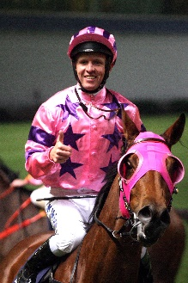 | McEvoy, Kerrin
 | Age: 39. Kerrin McEvoy made his name as a fresh-faced 20-year-old when he became the second-youngest jockey to win the G1 Melbourne Cup (2000 Brew) - he has won it three times in all thanks to Almandin (2016) and Godolphin’s Cross Counter (2018). Sheikh Mohammed’s Godolphin team recognised his talent and in 2004 appointed him second rider behind Frankie Dettori in Europe. During that spell he won a British Classic thanks to Rule Of Law in the G1 St Leger and notably partnered Shamardal to G1 success at Royal Ascot. Since returning to Australia in 2008 he has established himself among the elite in his homeland. To date he has ridden more than 1,900 career wins, with no less than 76 G1 wins to his name. In recent times he has also been associated with Australian champion colt The Autumn Sun and won the first two editions of the Everest on Redzel. Honours: LONGINES IJC champion (2013). Hong Kong wins (as of 25 November): 2

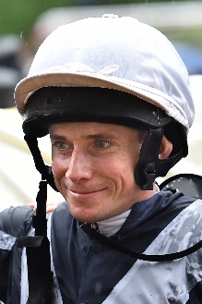 | Moore, Ryan
 | Age: 36. Ryan Moore is a two-time winner of the LONGINES IJC. He is the outstanding international rider of recent years and was the first recipient of the LONGINES World’s Best Jockey Award as a result of 15 G1 wins in 2014. He won that accolade again in 2016. Moore hails from a racing family. His first win came for his trainer father, Gary Moore, on Mersey Beat over hurdles at Towcester in May 2000. His first professional Flat win came on Marwell’s Kiss at Lingfield in January 2002. He notched a first G1 aboard Notnowcato in the 2006 Juddmonte International Stakes at York and has won 11 English Classics. His 11 G1 wins in 2019 have taken his overall tally to 127 at the elite level in 11 different countries. Moore has won some of the world’s foremost races including the LONGINES Hong Kong Cup (2016 Maurice), LONGINES Hong Kong Mile (2015 Maurice), LONGINES Hong Kong Vase (2015 & 2017 Highland Reel), Prix de l’Arc de Triomphe, English Derby, Japan Cup, Breeders’ Cup Turf and Melbourne Cup. Honours: British Champion Jockey (2006, 2008, 2009); British Champion Apprentice (2003); LONGINES IJC winner (2009 [shared] & 2010); LONGINES World’s Best Jockey Award winner (2014 & 2016). LONGINES HKIR wins (5): Hong Kong Vase (2015 & 2017 Highland Reel), Hong Kong Cup (2010 Snow Fairy, 2016 Maurice), Hong Kong Mile (2015 Maurice). Hong Kong wins (as of 25 November): 32

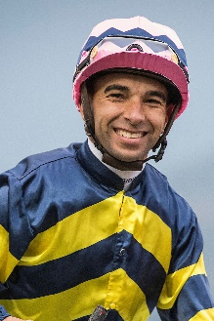 | Moreira, Joao
 | Age: 36. Known as “Magic Man”, Joao Moreira notched more than 1000 wins in South America before moving to Asia. He relocated to Singapore in 2009, and, after finishing third in the premiership in that first season, he proceeded to dominate the Singapore circuit for four years. He moved to Hong Kong in October 2013 and was champion jockey for three straight seasons, with record-breaking win totals (145, 168 and 170). He is currently leading this season’s premiership. Honours: LONGINES IJC winner (2012); Hong Kong Champion Jockey (2014/15, 2015/16, 2016/17); Singapore Champion Jockey (2010, 2011, 2012, 2013); two-time Brazilian Eclipse Award winner (2006/07, 2007/08); fastest 100 in a Hong Kong season (22 February, 2017); Hong Kong record for most wins in a season (170 in 2016/17); most wins in a Hong Kong race day (eight: 5 March, 2017); Singapore record for most wins in a season (206 in 2012); eight wins from eight rides at Kranji (6 September, 2013); eight wins in a day at Cidade Jardim (March 2006). World All-Star Series (Japan) winner (2015). LONGINES HKIR wins (4): Hong Kong Vase (2016 Satono Crown), Hong Kong Cup (2014 Designs On Rome), Hong Kong Mile (2014 Able Friend), Hong Kong Sprint (2015 Peniaphobia). Hong Kong wins (as of 25 November): 844

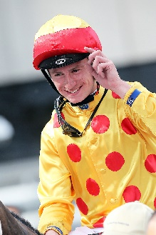 | Murphy, Oisin
 | Age: 24. Oisin Murphy won the British jockeys’ championship for the first time in 2019 with 220 wins and bagged an international major aboard Suave Richard in the G1 Japan Cup. He has 15 career G1 wins among more than 900 total. The Killarney native is a graduate of the Irish pony racing circuit. Schooled in riding by his uncle, the Cheltenham Gold Cup-winning jockey Jim Culloty, Murphy worked summer holidays for trainers Tommy Stack and Aidan O'Brien. He was apprenticed to Andrew Balding in England in October 2012 and had his first race ride in May 2013 when already 18. He ended his first season (2013) with 41 wins, including a four-timer on Ayr Gold Cup day that featured the historic sprint handicap itself. Murphy impressed in winter stints in Australia and the UAE before riding his first short contract in Hong Kong in the winter of 2016/17, which brought four wins. His G1 breakthrough came in October 2017 on Acclaim in the Prix de la Foret and two weeks later he took the G1 E P Taylor Stakes on Blond Me. He famously partnered Roaring Lion to four G1 wins under his retainer with Qatar Racing. Honours: Britain’s Champion Jockey (2019); Britain’s Champion Apprentice (2014). Hong Kong wins (as of 25 November): 5

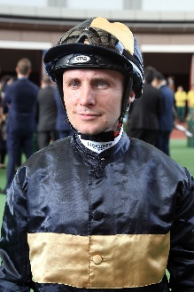 | Pasquier, Stephane
 | Age: 41. Stephane Pasquier was apprenticed to Robert Collet, winning on his second ride for the trainer at Amiens in September, 1995. He became second jockey to the Wildenstein family in July 2004 and won his first G1 in those silks atop Westerner in the Prix Royal-Oak that October. He was appointed Wildenstein first jockey in 2005. In 2007 he was contracted to ride for Khalid Abdullah and won his first French champion jockey title. He also partnered the outstanding Manduro (owned by Baron von Ullmann) to a sequence of five major wins in 2007 that included the Prix d’Ispahan, Prince of Wales’s Stakes and Prix Jacques le Marois. In 2010 he became the retained rider for the Niarchos Family and he has enjoyed G1 successes in those silks atop Maxios (2013 Prix d’Ispahan and Prix du Moulin), Karakontie (2013 Prix Jean-Luc Lagardere, 2014 Poule d’Essai des Poulains and Breeders’ Cup Mile), Erupt (2015 Grand Prix de Paris, 2016 Canadian International) and Study Of Man (2018 Prix du Jockey Club). His G1 wins also include Rail Link’s Prix de l’Arc de Triomphe in 2006. Hong Kong wins (as of 25 November): 1

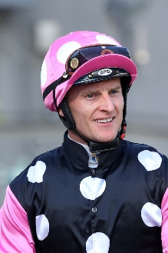 | Purton, Zac
 | Age: 36. Zac Purton sealed a third Hong Kong jockeys’ championship last season with a dominant 168 wins, just two shy of Joao Moreira’s all-time record, and stakes money of almost HK$235 million. Having ended Douglas Whyte's 13-season dominance with his first Hong Kong jockeys' championship in 2013/14 (112 wins), in 2017/18 he halted Moreira’s own title streak at three. His second championship was a remarkable effort as he chased down Moreira to take the lead for the first time that term on June 10, 2018. Five weeks later, at season’s end, he had outpointed Moreira 136-134 with a win strike rate of 21% to the Brazilian’s 20%. Purton started his career in Brisbane and was an apprentice sensation, winning the premiership there in 2003. He then moved on to Sydney where he was twice second in the premiership. Purton moved to Hong Kong in September 2007. His many major wins include the King's Stand Stakes at Royal Ascot in 2012 and a record-matching eight victories at the LONGINES HKIR including in each of the four features. He is the regular partner of current Hong Kong champion Beauty Generation. Honours: Hong Kong Champion Jockey (2013/14, 2017/18, 2018/19); Brisbane Champion Jockey (2003 - when still an apprentice); LONGINES IJC (2017); World Super Jockeys Series (Japan) winner (2012). LONGINES HKIR wins (8): Hong Kong Vase (2013 Dominant, 2018 Exultant), Hong Kong Cup (2017 Time Warp), Hong Kong Mile (2012 Ambitious Dragon, 2016 Beauty Only, 2018 Beauty Generation), Hong Kong Sprint (2014 & 2016 Aerovelocity). Hong Kong wins (as of 25 November): 1,057

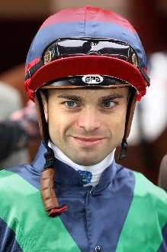 | Rispoli, Umberto
 | Age: 31. Italian jockey Umberto Rispoli commenced his apprenticeship in 2005 and graduated to the senior ranks in 2010. He is a two-time Champion Jockey in Italy. In winning his first Italian title, in 2009, he rode 245 winners and so smashed the longstanding previous record of 229. Rispoli, who has also ridden in Japan, notched six wins in his first Hong Kong season in 2011/12, crowned by G1 QEII Cup success on the Japanese galloper Rulership. After moving to trainer Mikel Delzangles in France, he took a further G1 atop Molly Malone in the Prix du Cadran. Rispoli has since returned to Hong Kong on short-term licences. He broke a leg three meetings into his 2016/17 winter contract but was back in action within two and a half months and ended the term with 15 wins. Honours: Italian Champion Jockey (2009 & 2010). Hong Kong wins (as of 25 November): 121

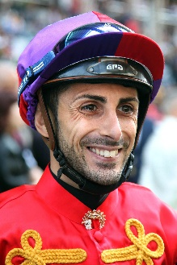 | Sanna, Alberto
 | Age: 34. Alberto Sanna has more than 800 career wins including the Premio Parioli in his native Italy and has enjoyed success in France, Germany, Dubai, Austria, Belgium, Hungary, Poland and Serbia, as well as Hong Kong where his biggest win to date is the 2019 Sa Sa Ladies’ Purse (G3) on Southern Legend. Sanna had long held an ambition to compete full-time in Hong Kong and so spent five seasons riding in Bahrain and Qatar in an attempt to prove himself as a champion jockey. In the 2016/17 season he achieved five domestic Group 1 wins including the 2017 Qatar Emir's Trophy International (US$1 Million). He was crowned Bahrain's champion jockey with a winning strike rate of more than 25% and was runner-up in the Qatar championship. He rode two wins from 19 rides during a brief Hong Kong stint at the end of the 2016/17 season and returned in 2017/18. His second term proved successful and his short-term winter contract was extended until the end of the season. He ended the campaign with 17 wins. He was limited to only six wins in 2018/19 due to two spells on the side-lines with a fractured hip and a fractured ankle. Honours: Bahrain Champion Jockey (2016/17). Hong Kong wins (as of 25 November): 32

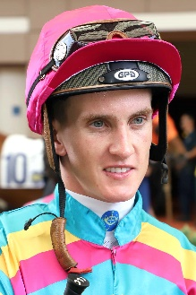 | Schofield, Chad
 | Age: 25. Chad Schofield spent four years (2002-2006) of his youth living in Hong Kong where his father, the South African jockey Glyn Schofield, was contracted to ride. His family relocated to Australia and Schofield commenced his own riding career in Sydney in the 2010/11 season. He moved to Melbourne in 2012 to ride for the powerful David Hayes stable. His first G1 win was a major, the 2013 Cox Plate on Shamus Award and he also won the 2014 G1 Newmarket Handicap on Lankan Rupee. He and his father made history in 2014 as the first father and son to compete against each other in the Melbourne Cup and at Sha Tin on 14 February, 2016 they became the first in Hong Kong to ride against each other. He rode Singapore Sling to win the Hong Kong Classic Cup in 2018. Honours: Sydney Champion Apprentice (2011/12); Melbourne Champion Apprentice (2012/13). Hong Kong wins (as of 25 November): 146

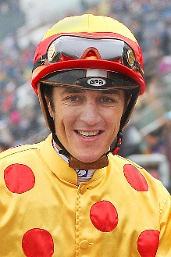 | Soumillon, Christophe
 | Age: 38. Belgian ace Christophe Soumillon is a son of jump jockey Jean-Marc Soumillon. He was apprenticed to Cedric Boutin at Chantilly and rode his first winner in November 1997. He was champion apprentice in 1999. His outstanding talent in the saddle has brought him 10 champion jockey titles in France (2003, 2005, 2006, 2011, 2012, 2013, 2014, 2015 (shared with Pierre-Charles Boudot), 2017 and 2018. In 2018 he set a European record of 305 wins in year. He has had two spells as the Aga Khan’s number one jockey and some of his greatest moments have been in the famous green and red silks, notably two Prix de l’Arc de Triomphe wins, on Dalakhani and the brilliant filly Zarkava. He has won G1 races across Europe, Japan, Hong Kong, Dubai, Canada and the USA. Soumillon had a notable association with Cirrus Des Aigles on whom he won five G1 races. In 2016 he partnered Almanzor to wins in the Irish Champion Stakes and the Champion Stakes. He had back-to-back Dubai World Cup scores aboard the Godolphin-owned Thunder Snow in 2018 and 2019. Honours: x10 France’s champion jockey. LONGINES HKIR wins (1): Hong Kong Mile (2008 Good Ba Ba). Hong Kong wins (as of 25 November): 109

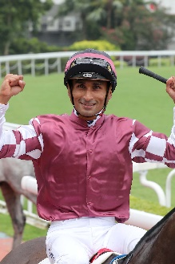 | Teetan, Karis
Age: 29. Mauritian rider Karis Teetan was well ensconced in the top 10 of the South African Jockeys' Championship when he left for Hong Kong in August 2013. He entered the South African Jockey Academy at the age of 14 and went on to be crowned South African Champion Apprentice in 2008. He graduated in 2009 with 147 wins to his credit. Teetan passed the 100-win mark in every season as a senior jockey in South Africa. His first top level win was in his native Mauritius on 24 November, 2008, aboard Halo Hunter. Teetan represented South Africa in the 2012 International Jockeys’ Invitational in Seoul, Korea and in the 2008 Macau Apprentice Jockeys Invitation Races. He notched an impressive 50 wins in his first Hong Kong season and has continued to build on that good start. He finished third in the 2017/18 premiership race with 52 wins, which included a trio of Group 3 triumphs. He topped that in 2018/19 as he secured his first Hong Kong G1 win aboard Mr Stunning in the LONGINES Hong Kong Sprint and notched a best ever 84 wins for the term.
Honours include: South African Champion Apprentice (2008). LONGINES HKIR wins (1): Hong Kong Sprint (2018 Mr Stunning). Hong Kong career wins (as of 25 November): 321

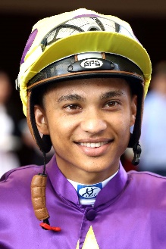 | Van Niekerk, Grant
 | Age: 28. Grant van Niekerk had never sat on a horse, nor had he followed horseracing, before he entered the South African Jockey Academy in January 2007. Based at the Academy's Milnerton campus in Cape Town, his first race ride was aboard Combat Leader at Clairwood on 11 June, 2008 and the same horse became his first winner at the same track two weeks later. The emerging talent was the Western Cape Champion Apprentice in 2010/11 and became a fully-fledged jockey on 11 February, 2012. When he opted to accept a short-term contract to ride in Hong Kong from the start of the 2018/19 season he was the leading jockey in South Africa for the term, based on prize money won. Van Niekerk has 10 G1 wins to his credit including a memorable trio in 2018 on the crack filly Oh Susanna. His first elite success was achieved aboard Inara in the 2015 Paddock Stakes, one of five G1 wins for that partnership. He has accrued more than 700 wins in his career so far. Van Niekerk, a lightweight jockey who can ride at 114lb, represented his country at the 2016 South African International Jockeys' Challenge. His first Hong Kong pattern success was aboard Flying Thunder in the 2019 G3 Premier Cup. Honours: Western Cape Champion Apprentice (2010/11). Hong Kong wins (as of 25 November): 45

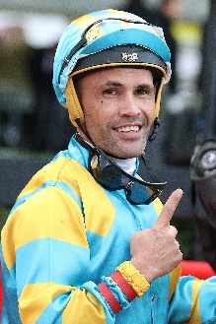 | Walker, Michael
 | Age: 34. Kiwi Michael Walker began working for trainer Allan Sharrock in New Zealand at age 11 and had his first race ride, aboard the Gifted Shifta, in 1999 at age 15. His 131 wins in his debut season saw him capture the apprentice and outright champion jockey titles. He was New Zealand’s champion three times before a brief move to Melbourne, Australia in 2004, but he has admitted to a wild lifestyle in those early years. In May 2008 he was injured badly in a pig-hunting accident - he fell 70m off a cliff while carrying a pig on his back. He returned to Australia in 2010 and has enjoyed success in tandem with trainer David Hayes. Walker has 22 G1 wins among more than 1,800 career wins. He won the G1 Doomben Cup in 2018 aboard Comin’ Through and has ridden Prince Of Arran in two Melbourne Cup placings. His major wins also include the New Zealand Derby and the Caulfield Guineas. Hong Kong wins (as of 25 November): 2

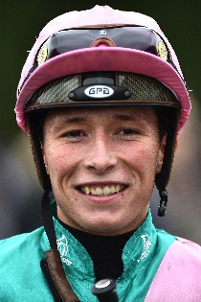 | Watson, Jason
 | Age: 19. England’s latest young jockey sensation Jason Watson began riding at a riding school in Lewes at age 6 under the tutelage of ex-jump jockey Ray Goldstein. He had his first race ride in February 2017 aboard Breakheart at Kempton for trainer Gary Moore and his first win came on 18 May that year aboard Moore’s Many Dreams at Salisbury. Like Oisin Murphy, William Buick and David Probert before him, Watson was apprenticed to Andrew Balding. He was crowned champion apprentice in 2018 with 111 wins and his first G1 success came aboard God Given in the 2018 Premio Lydia Tesio at Capannelle Racecourse in Rome, Italy. He was appointed first jockey to Roger Charlton and added another top-line success when guiding the stables Aspetar in the G1 Preis von Europa at Cologne. He secured his first G1 in Britain aboard Charlton’s Quadrilateral in the Fillies’ Mile at Newmarket. Honours: Britain’s champion apprentice (2018). Hong Kong wins (as of 25 November): 0

