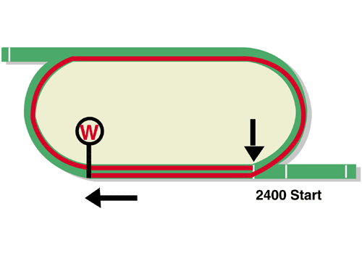
LONGINES Hong Kong Vase (Group 1)
HK$20 million (US$2.6 million)
Race Best Time
2.24.77 (2019)
1st HK$11,400,000, 2nd HK$4,400,000, 3rd HK$2,000,000,
4th HK$1,140,000, 5th HK$660,000, 6th HK$400,000

Performance Analysis

Horse Details |  |  |  |  |  | Horse Statistics |  |  |  |  |  |  | Probable Jockey | Trainer
Name |  | Rep | Age/  Sex | Wt. | Int’l Rtg | Lifetime | G1 | Good | Wet | RH | 2200-2800 | Trk/Dist
Exultant |  | HK | 6g | 126 | 120 | 31 (13-9-4) | 10 (5-3-2) | 28 (11-9-3) | 3 (2-0-1) | 30 (12-9-4) | 7 (4-2-1) | 6 (4-1-1) | Z Purton | A S Cruz
Chefano |  | HK | 6g | 126 | 114 | 27 (4-5-2) | 1 (0-1-0) | 24 (3-5-1) | 3 (1-0-1) | 26 (4-5-2) | 2 (1-1-0) | 2 (1-1-0) | P-C Boudot | D A Hayes
Ho Ho Khan |  | HK | 6h | 126 | 112 | 24 (5-0-4) | 2 (0-0-0) | 19 (3-0-2) | 5 (2-0-2) | 22 (4-0-3) | 2 (1-0-0) | 2 (1-0-0) | C Soumillon | D J Hall
Columbus County |  | HK | 5g | 126 | 111 | 12 (3-4-2) | 0 (0-0-0) | 12 (3-4-2) | 0 (0-0-0) | 10 (3-3-1) | 0 (0-0-0) | 0 (0-0-0) | J Moreira | C Fownes
Royal Julius |  | FR | 7h | 126 | 110 | 39 (6-10-4) | 4 (0-0-0) | 19 (3-7-3) | 17 (3-3-0) | 32 (5-7-3) | 7 (0-2-1) | 0 (0-0-0) | M Barzalona | J Reynier
Playa del Puente |  | HK | 4g | 126 | 109 | 15 (4-1-1) | 1 (0-0-0) | 10 (1-1-0) | 1 (0-0-1) | 11 (1-1-0) | 0 (0-0-0) | 0 (0-0-0) | W Buick | C S Shum
Mogul |  | IRE | 3c | 121 | 121 | 10 (4-1-1) | 4 (1-0-0) | 6 (3-0-1) | 3 (1-1-0) | 5 (3-1-0) | 6 (2-0-1) | 0 (0-0-0) | R Moore | A P O'Brien

Barrier Draw Statistics Speed Chart

Draw 1st 2nd 3rd 4th  1 0 6 1 3  2 2 1 3 3  3 3 3 1 1  4 4 1 2 3  5 1 2 1 3  6 1 1 2 3  7 4 3 4 1  8 1 1 3 0  9 4 1 1 2  10 2 3 3 3  11 0 1 3 1  12 3 2 0 1  13 0 0 2 0  14 1 1 1 1  (Past 26 runnings) | 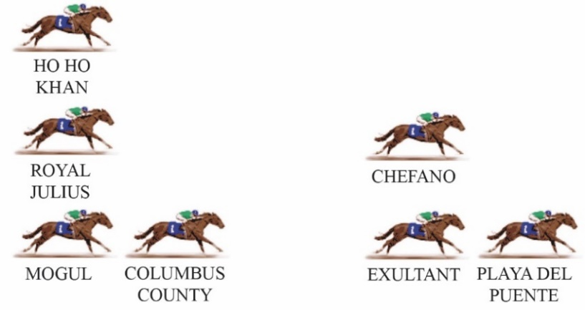  This year’s Hong Kong Vase lacks a clear or obvious leader, so it’s hard to imagine the pace being strong. The Sha Tin 2400m circuit is quite fast by European standards and requires a sharp stayer to get the best results. The Tony Cruz-trained Exultant won the race in 2018 and ran third last year and he appears to be holding his form, ready for a peak on the big day. Although the race is over 2400m, horses getting too far back in the field have a poor record.  LIKELY PACE: SLOW

