Spotlight

Five-time G1 winner Exultant will look to recapture his Hong Kong Vase crown after letting it slip last year to Japan’s Glory Vase. Hong Kong’s Horse of the Year snared a further two G1 last term, and after proving himself as one of the world’s top stayers he will face a compact but tough line-up in his bid to reign supreme once again in this staying contest.

The Aidan O’Brien-trained Mogul was a dominant G1 Grand Prix de Paris winner two starts ago beating In Swoop, who subsequently franked the form by finishing second in the Prix de l’Arc de Triomphe.

French raider Royal Julius has proven himself a solid globetrotter with a win in last year’s Bahrain International Trophy and is also a winner of Italy’s G2 Premio Presidente della Repubblica the year prior.

Ho Ho Khan, Chefano and the highly progressive Columbus County add to the home challenge, while Playa Del Puente, the 2020 BMW Hong Kong Derby runner-up to Golden Sixty, will race beyond 2000m for the first time.

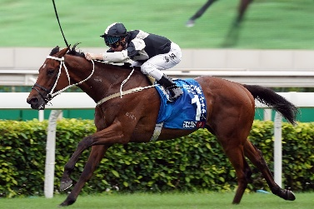 | EXULTANT  HONG KONG 6g 120  Hong Kong Horse of the Year (2019/20) with five G1 to his name including this race two years ago. | 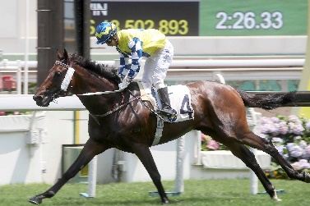 | CHEFANO  HONG KONG 6g 114  G3 Queen Mother Memorial Cup winner over this distance; likes to roll forward but has struggled in three runs this campaign.
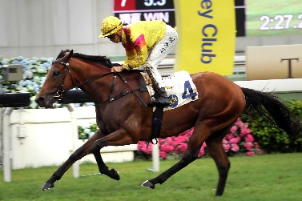 | HO HO KHAN  HONG KONG 6h 112  Fair stayer with four HK wins to his name including G3 Queen Mother Memorial Cup in 2019. | 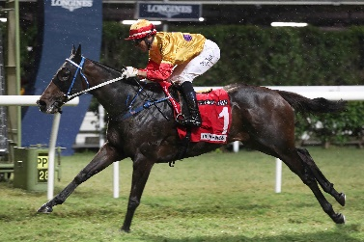 | COLUMBUS COUNTY  HONG KONG 5g 111  One-time BMW Hong Kong Derby hope who has since won twice; last-start third in G2 Jockey Club Cup.
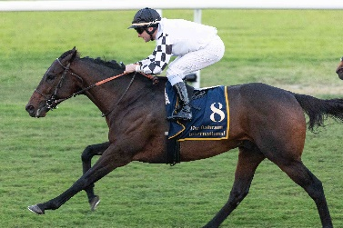 | ROYAL JULIUS  FRANCE 7h 110  G2 winner in Italy who claimed the 2019 Bahrain International Trophy. | 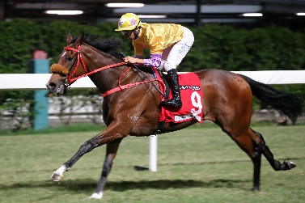 | PLAYA DEL PUENTE  HONG KONG 4g 109  2020 BMW Hong Kong Derby runner-up who races beyond 2000m for the first time.
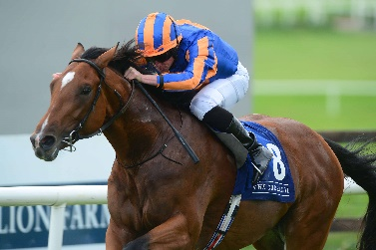 | MOGUL  IRELAND 3c 121  G1 Grand Prix de Paris winner ahead of subsequent Arc second In Swoop; tough Aidan O’Brien-trained stayer.

