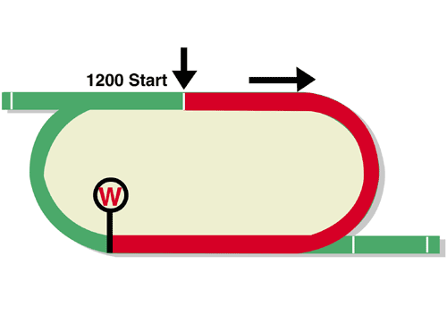
LONGINES Hong Kong Sprint (Group 1)
HK$22 million (US$2.8 million)
Race Best Time
1.07.80 (2006)
1st HK$12,540,000, 2nd HK$4,840,000, 3rd HK$2,200,000,
4th HK$1,254,000, 5th HK$726,000, 6th HK$440,000

Performance Analysis

Horse Details |  |  |  |  |  | Horse Statistics |  |  |  |  |  |  | Probable Jockey | Trainer
Name |  | Rep | Age/  Sex | Wt. | Int’l Rtg | Lifetime | G1 | Good | Wet | RH | 1000-1200 | Trk/Dist
Classique Legend |  | HK | 5g | 126 | 125 | 12 (6-2-2) | 0 (0-0-0) | 6 (3-1-0) | 6 (3-1-2) | 12 (6-2-2) | 11 (6-2-2) | 0 (0-0-0) | K McEvoy | C Fownes
Hot King Prawn |  | HK | 6g | 126 | 120 | 21 (11-5-2) | 5 (0-1-2) | 20 (10-5-2) | 1 (1-0-0) | 15 (5-5-2) | 20 (11-5-1) | 13 (4-5-1) | J Moreira | J Size
Big Time Baby |  | HK | 6g | 126 | 115 | 34 (8-4-3) | 1 (0-1-0) | 18 (3-3-1) | 2 (0-0-0) | 23 (5-2-3) | 33 (8-4-3) | 5 (0-1-0) | N Callan | K L Man
Voyage Warrior |  | HK | 5g | 126 | 115 | 13 (5-1-0) | 1 (0-0-0) | 12 (5-0-0) | 1 (0-1-0) | 7 (1-0-0) | 13 (5-1-0) | 7 (1-0-0) | K Teetan | P F Yiu
Danon Smash |  | JPN | 5h | 126 | 114 | 21 (9-3-1) | 8 (0-1-1) | 20 (9-3-1) | 1 (0-0-0) | 13 (7-2-1) | 12 (6-2-1) | 1 (0-0-0) | R Moore | T Yasuda
Tower Of London |  | JPN | 5h | 126 | 114 | 17 (7-3-3) | 4 (1-0-1) | 16 (7-3-3) | 1 (0-0-0) | 10 (5-2-3) | 6 (2-1-2) | 0 (0-0-0) | W Buick | K Fujisawa
Wishful Thinker |  | HK | 7g | 126 | 114 | 35 (9-1-8) | 5 (0-0-0) | 32 (8-1-7) | 3 (1-0-1) | 24 (6-1-5) | 33 (9-1-8) | 20 (4-1-5) | K C Leung | C H Yip
Computer Patch |  | HK | 4r | 126 | 112 | 14 (5-4-1) | 0 (0-0-0) | 14 (5-4-1) | 0 (0-0-0) | 12 (3-4-1) | 14 (5-4-1) | 9 (2-4-1) | C Soumillon | A S Cruz
Rattan |  | HK | 7g | 126 | 112 | 33 (7-7-3) | 6 (0-1-0) | 31 (6-7-3) | 2 (1-0-0) | 32 (7-7-3) | 9 (1-1-2) | 8 (1-1-2) | C Schofield | R Gibson
Big Party |  | HK | 5g | 126 | 110 | 16 (5-0-1) | 1 (0-0-0) | 14 (4-0-1) | 1 (0-0-0) | 13 (4-0-1) | 16 (5-0-1) | 11 (2-0-1) | M Chadwick | F C Lor
Jolly Banner | 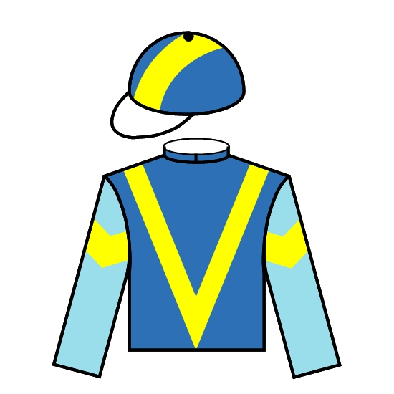 | HK | 9g | 126 | 110 | 45 (8-7-10) | 1 (0-0-0) | 40 (7-7-8) | 3 (1-0-1) | 40 (6-5-10) | 14 (2-3-4) | 7 (0-1-3) | M Barzalona | P F Yiu
Fat Turtle |  | HK | 6g | 126 | 109 | 25 (6-7-2) | 1 (0-0-0) | 23 (5-6-2) | 2 (1-1-0) | 25 (6-7-2) | 15 (5-6-1) | 8 (2-2-1) | A Hamelin | F C Lor
Inferno |  | SIN | 4g | 126 | 109 | 9 (8-1-0) | 0 (0-0-0) | 9 (8-1-0) | 0 (0-0-0) | 0 (0-0-0) | 7 (6-1-0) | 0 (0-0-0) | Z Purton | C Brown
Perfect Match |  | HK | 5g | 126 | 109 | 17 (8-2-2) | 0 (0-0-0) | 16 (7-2-2) | 1 (1-0-0) | 16 (8-2-1) | 6 (2-0-2) | 5 (2-0-1) | A Badel | C S Shum

Reserves
Amazing Star |  | HK | 6g | 126 | 109 | 17 (6-2-1) | 0 (0-0-0) | 15 (6-2-1) | 0 (0-0-0) | 15 (6-2-0) | 17 (6-2-1) | 5 (1-2-0) | – | K H Ting
Stronger |  | HK | 4c | 126 | 109 | 18 (5-2-2) | 0 (0-0-0) | 13 (3-2-1) | 5 (2-0-1) | 14 (4-0-2) | 17 (4-2-2) | 3 (0-0-0) | – | D J Whyte

Barrier Draw Statistics Speed Chart

Draw 1st 2nd 3rd 4th  1 0 1 1 3  2 1 2 4 2  3 1 1 2 2  4 1 0 2 0  5 1 4 0 1  6 3 3 1 0  7 2 1 0 3  8 1 0 2 0  9 2 1 0 0  10 0 0 0 0  11 0 0 0 1  12 1 2 0 1  13 0 0 1 1  14 1 0 0 0  (Past 14 runnings) | 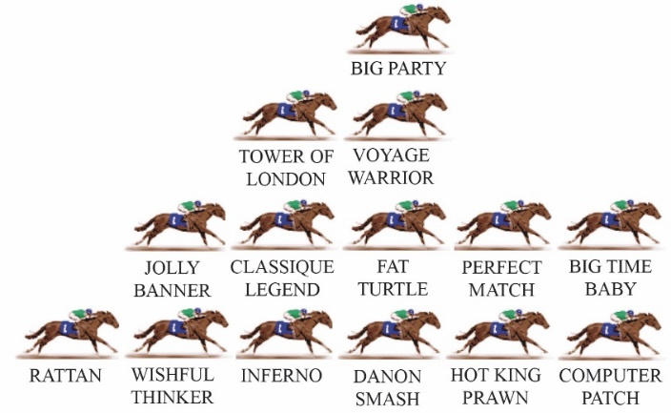  The sprint course at Sha Tin offers a run of just on 300m to the first turn and barriers are of critical importance. A horse that might be placed handy on the rail from a low draw can literally be forced to go back to last from the outside gate. The three most favoured positions from a statistical viewpoint, when the rail is in the A (true) position, are the leader, the horse following the leader and the horse outside that follower. The recent history of the race suggests that the winner will settle within the compass of the first three positions (counting back from the leader) but very rarely does the winner come from beyond midfield.  LIKELY PACE: GOOD

