Spotlight

A victory at Group 1 level has so far eluded Hot King Prawn, who claimed his second G2 Jockey Club Sprint last month to stamp himself as the local brigade’s leading hope. But, he will face off with another grey, Classique Legend, who has arrived in Hong Kong to join the yard of championship leader Caspar Fownes with an exceptional career outlined.

One of the most intriguing international challengers is Singapore speedster Inferno, who has lit up Kranji Racecourse with eight wins from nine starts, including two at SIN G1 level. The Holy Roman Emperor gelding travels to Hong Kong as the international sprinter with the least racing experience.

Also among the international trio of entries is Godolphin’s Tower Of London, who travels from Japan as the winner of last year’s G1 Sprinters Stakes at Nakayama. Japan is also represented by Danon Smash, who snared second to Gran Alegria in this year’s Sprinters Stakes at Nakayama.

Among the local brigade is young gun Computer Patch, a G3 winner for trainer Tony Cruz, as well as 2019 G2 Sprint Cup victor Rattan, who finished a fast-closing third to Hot King Prawn in the Jockey Club Sprint.

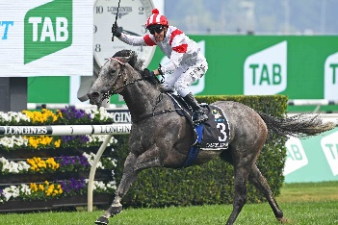 | CLASSIQUE LEGEND  HONG KONG 5g 125  The Everest victor who beat seven individual G1 winners; a dual G2 winner in Australia who will race first-up for Caspar Fownes. | 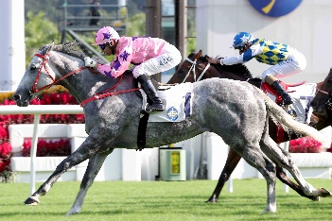 | HOT KING PRAWN  HONG KONG 6g 120  Dual G2 Jockey Club Sprint winner who has placed three times at G1 level, including a neck defeat in this race last year.
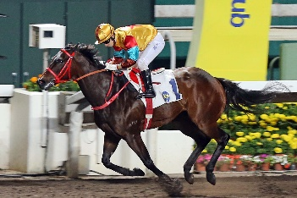 | BIG TIME BABY  HONG KONG 6g 115  Runner-up to Mr Stunning in last season’s G1 Chairman’s Sprint Prize; he has proven a solid performer on both the dirt and the turf with high-class runs on both. | 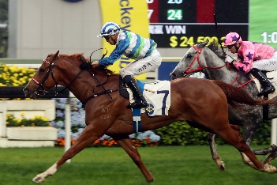 | VOYAGE WARRIOR  HONG KONG 5g 115  Five-time winner; including G2 Sprint Cup last season when beating Hot King Prawn.
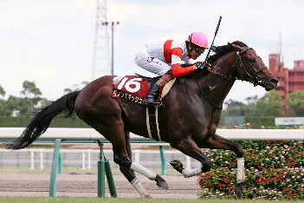 | DANON SMASH  JAPAN 5h 114  Finished second to Gran Alegria last start in the G1 Sprinters Stakes; dual G2 winner and four-time G3 winner prior to that. | 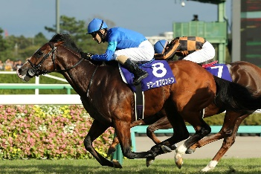 | TOWER OF LONDON  JAPAN 5h 114  2019 G1 Sprinters Stakes winner; three-time G2 winner before that top-level success last year.
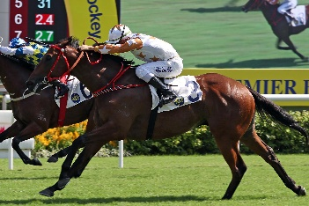 | WISHFUL THINKER  HONG KONG 7g 114  Seven-time HK winner including G2 Premier Bowl two starts ago. | 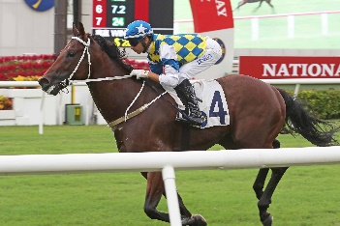 | COMPUTER PATCH  HONG KONG 4r 112  Young gun who captured the G3 National Day Cup three starts ago before twice finishing runner-up at G2 level.
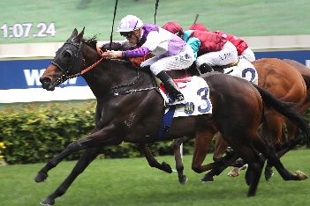 | RATTAN  HONG KONG 7g 112  Seven-time winner including 2019 G2 Sprint Cup; last two runs have produced fast-closing third place-efforts at G2 level. | 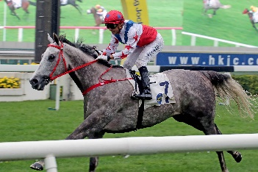 | BIG PARTY  HONG KONG 5g 110  2019 G3 Bauhinia Sprint Trophy winner who can display a strong turn-of-foot on his day.
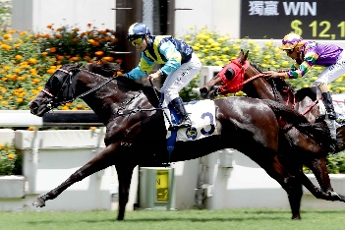 | JOLLY BANNER  HONG KONG 9g 110  Dual G3 winner having captured the Premier Cup last season and before that the 2019 G3 Bauhinia Sprint Trophy. | 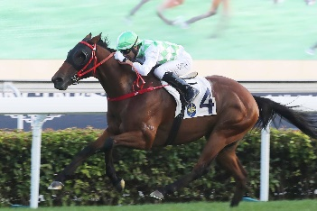 | FAT TURTLE  HONG KONG 6g 109  Two-time winner over 1200m at Sha Tin; twice-placed at G3 level, latest finished sixth in G2 Jockey Club Sprint.
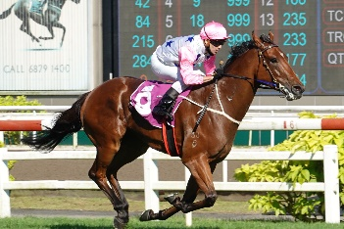 | INFERNO  SINGAPORE 4g 109  Singapore speedster who is a dual SIN G1 winner, latest took the Lion City Cup easily and prior, stretched to a mile to win the Singapore Guineas; won eight of nine starts. | 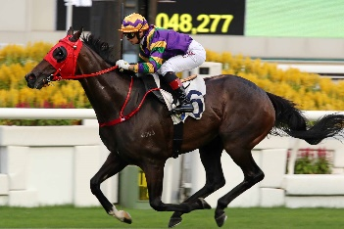 | PERFECT MATCH  HONG KONG 5g 109  Eight-time winner from 17 starts; runner-up in G3 Premier Cup last season over 1400m; won first-up this term before fading to seventh in G2 Premier Bowl.

