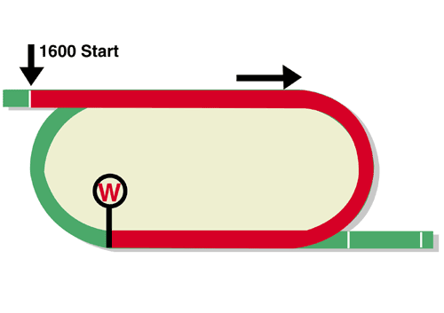
LONGINES Hong Kong Mile (Group 1)
HK$25 million (US$3.2 million)
Race Best Time
1.32.71 (2008)
1st HK$14,250,000, 2nd HK$5,500,000, 3rd HK$2,500,000,
4th HK$1,425,000, 5th HK$825,000, 6th HK$500,000

Performance Analysis

Horse Details |  |  |  |  |  | Horse Statistics |  |  |  |  |  |  | Probable Jockey | Trainer
Name |  | Rep | Age/  Sex | Wt. | Int’l Rtg | Lifetime | G1 | Good | Wet | RH | 1400-1800 | Trk/Dist
Beauty Generation |  | HK | 8g | 126 | 123 | 40 (20-6-7) | 15 (8-3-1) | 36 (18-5-6) | 4 (2-1-1) | 40 (20-6-7) | 34 (19-4-6) | 21 (11-2-5) | Z Purton | D A Hayes
Golden Sixty |  | HK | 5g | 126 | 119 | 14 (13-0-0) | 0 (0-0-0) | 14 (13-0-0) | 0 (0-0-0) | 14 (13-0-0) | 9 (8-0-0) | 3 (3-0-0) | C Y Ho | K W Lui
Admire Mars |  | JPN | 4c | 126 | 118 | 12 (6-1-2) | 6 (3-0-1) | 12 (6-1-2) | 0 (0-0-0) | 6 (3-0-2) | 11 (6-1-2) | 1 (1-0-0) | C Soumillon | Y Tomomichi
Ka Ying Star |  | HK | 5g | 126 | 118 | 26 (6-7-5) | 4 (0-1-1) | 25 (6-7-4) | 1 (0-0-1) | 22 (3-7-4) | 25 (6-7-5) | 15 (3-5-3) | C Schofield | A S Cruz
Southern Legend |  | HK | 8g | 126 | 118 | 46 (12-4-9) | 11 (1-1-3) | 42 (11-3-9) | 4 (1-1-0) | 42 (10-4-8) | 27 (6-2-6) | 13 (2-2-6) | K Teetan | C Fownes
Waikuku |  | HK | 5g | 126 | 118 | 17 (7-4-2) | 4 (1-1-1) | 15 (7-3-2) | 2 (0-1-0) | 15 (6-4-2) | 13 (7-2-2) | 6 (2-2-1) | J Moreira | J Size
Romanised |  | IRE | 5h | 126 | 116 | 19 (5-2-1) | 11 (2-1-0) | 11 (4-1-0) | 7 (1-1-0) | 5 (1-2-0) | 16 (4-2-1) | 0 (0-0-0) | W J Lee | K J Condon
More Than This |  | HK | 4g | 126 | 111 | 15 (7-1-2) | 1 (0-0-0) | 15 (7-1-2) | 0 (0-0-0) | 13 (5-1-2) | 13 (6-1-1) | 7 (3-1-0) | W Buick | K W Lui
Simply Brilliant |  | HK | 6g | 126 | 110 | 30 (8-3-3) | 3 (0-0-1) | 28 (7-3-3) | 2 (1-0-0) | 26 (7-3-3) | 25 (6-1-3) | 12 (4-0-1) | K C Leung | F C Lor
Mighty Giant |  | HK | 5g | 126 | 109 | 10 (6-2-0) | 0 (0-0-0) | 10 (6-2-0) | 0 (0-0-0) | 10 (6-2-0) | 9 (6-2-0) | 1 (0-0-0) | A Badel | P F Yiu
Order Of Australia |  | IRE | 3c | 125 | 120 | 8 (3-0-1) | 3 (1-0-0) | 3 (1-0-1) | 4 (1-0-0) | 4 (1-0-0) | 2 (1-0-0) | 0 (0-0-0) | P-C Boudot | A P O'Brien

Barrier Draw Statistics Speed Chart

Draw 1st 2nd 3rd 4th  1 0 2 2 1  2 0 0 1 1  3 1 1 0 1  4 2 1 1 2  5 0 4 3 2  6 1 1 0 4  7 3 2 0 1  8 1 0 0 1  9 3 0 6 4  10 3 3 2 0  11 2 1 1 2  12 1 4 4 0  13 3 2 1 0  14 1 0 0 3  (Past 21 runnings) | 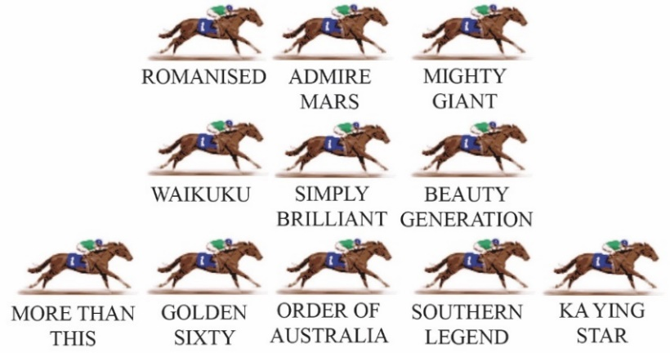  Winners of the Hong Kong Mile can come from just about anywhere in the field, including back and wide. Indeed, that general position has a surprising success rate, with past winners such as Glorious Days, Ambitious Dragon, Good Ba Ba, Olympic Express and Eishin Preston all settling back and wide. Ka Ying Star looks the obvious leader this year and he might get that position unchallenged, so the pace should only be moderate.  LIKELY PACE: GOOD TO SLOW

