Spotlight

After becoming the fourth horse in Hong Kong racing history to win 10 consecutive races, Golden Sixty will look to secure his first G1 in this year’s Hong Kong Mile, but after sweeping aside the local opposition, the son of Medaglia d’Oro faces his biggest test to date: last year’s winner, Admire Mars, who is back to defend his crown.

Beauty Generation, a two-time Hong Kong Mile winner, returns following a short freshen-up for new trainer David Hayes, while Ireland’s Aidan O’Brien fields G1 Breeders’ Cup Mile winner Order Of Australia and fellow Irishman Ken Condon is represented by French G1 winner Romanised.

In addition, the local brigade features Waikuku, who returns first-up aiming to emulate former John Size galloper Glorious Days, who recorded a famous Mile success in 2013 on his first run of the season. Southern Legend who got the better over Beauty Generation in last season’s G1 FWD Champions Mile, is also included, while solid performer and G1 placegetter Ka Ying Star features.

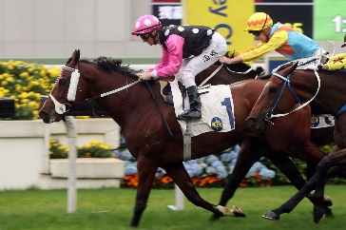 | BEAUTY GENERATION  HONG KONG 8g 123  Dual Hong Kong Mile winner who set the record for earnings in Hong Kong with HK$100 million netted; eight-time G1 winner. | 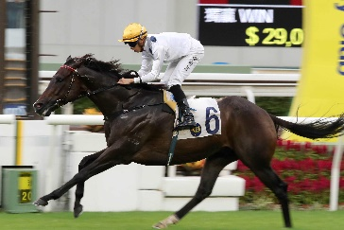 | GOLDEN SIXTY  HONG KONG 5g 119  Hong Kong’s rising star who has only tasted defeat once; swept Four-Year-Old Classic Series last season; won last 10 races including G3 Celebration Cup, G2 Sha Tin Trophy and G2 Jockey Club Mile.
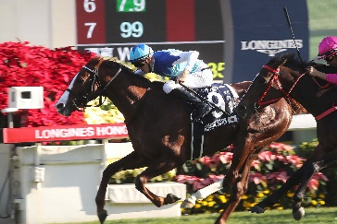 | ADMIRE MARS  JAPAN 4c 118  Three-time G1 winner who succeeded in this race last year; last out grabbed third to Gran Alegria in G1 Mile Championship. | 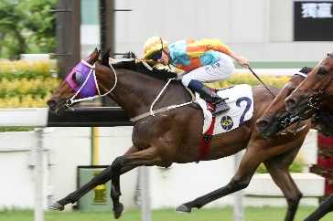 | KA YING STAR  HONG KONG 5g 118  Tough on-pace galloper who has twice placed at G1 level; last two runs twice runner-up to Golden Sixty at G2 level.
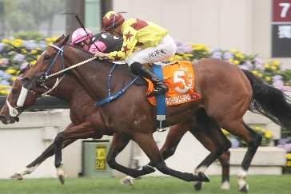 | SOUTHERN LEGEND  HONG KONG 8g 118  Dual SIN G1 Kranji Mile winner who edged Beauty Generation in a thrilling FWD Champions Mile victory last season. | 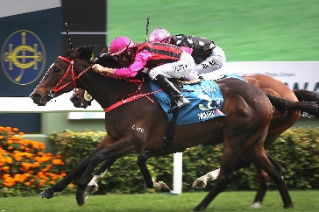 | WAIKUKU  HONG KONG 5g 118  Returns first-up after finishing third in April’s G1 FWD Champions Mile; prior won G1 Stewards’ Cup and did finish second to Admire Mars in this race last year.
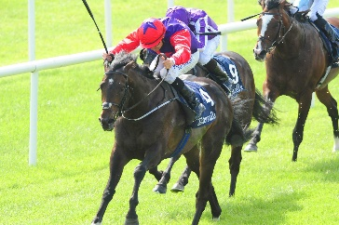 | ROMANISED  IRELAND 5h 116  G1 winner in France and Ireland; won Irish 2000 Guineas; also two-time G2 winner in Ireland at The Curragh. | 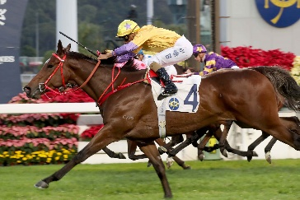 | MORE THAN THIS  HONG KONG 4g 111  One-time BMW Hong Kong Derby hopeful who on the big day managed third; four-time winner who finished fifth to Southern Legend in G1 FWD Champions Mile.
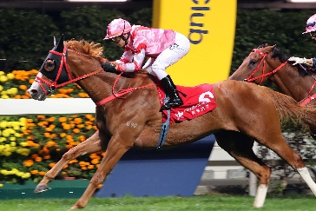 | SIMPLY BRILLIANT  HONG KONG 6g 110  Talented son of Frankel with six Hong Kong wins from 25 starts; 2019 G3 January Cup score to his name as well, finished third in 2019 FWD Champions Mile. | 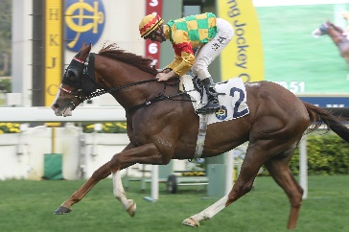 | MIGHTY GIANT  HONG KONG 5g 109  Solid galloper with six wins including five in succession before well beaten for fourth in G2 Jockey Club Mile.
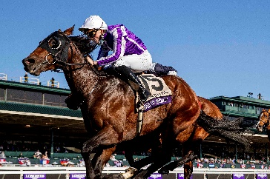 | ORDER OF AUSTRALIA  IRELAND 3c 120  Lightly raced Aidan O’Brien-trained G1 winner with three wins from eight starts; latest surprised in the G1 Breeders’ Cup Mile at 73/1.

