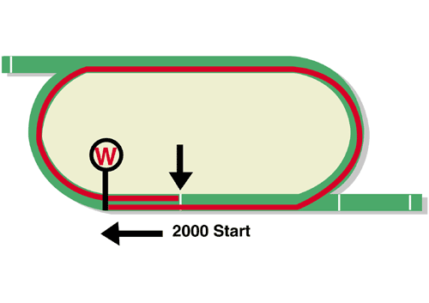
LONGINES Hong Kong Cup (Group 1)
Race Best Time
2.00.52 (2019)
HK$28 million (US$3.6 million)
1st HK$15,960,000, 2nd HK$6,160,000, 3rd HK$2,800,000
4th HK$1,596,000, 5th $924,000, 6th HK$560,000

Performance Analysis

Horse Details |  |  |  |  |  | Horse Statistics |  |  |  |  |  |  | Probable Jockey | Trainer
Name |  | Rep | Age/  Sex | Wt. | Int’l Rtg | Lifetime | G1 | Good | Wet | RH | 1800-2200 | Trk/Dist
Skalleti |  | FR | 5g | 126 | 121 | 16 (12-1-2) | 1 (0-1-0) | 1 (1-0-0) | 10 (7-1-2) | 10 (8-1-1) | 10 (8-1-0) | 0 (0-0-0) | P-C Boudot | J Reynier
Danon Premium |  | JPN | 5h | 126 | 119 | 13 (6-2-1) | 8 (1-2-1) | 12 (6-2-0) | 1 (0-0-1) | 6 (4-1-1) | 6 (3-1-1) | 0 (0-0-0) | W Buick | M Nakauchida
Win Bright |  | JPN | 6h | 126 | 119 | 23 (9-2-0) | 8 (2-0-0) | 23 (9-2-0) | 0 (0-0-0) | 16 (8-2-0) | 19 (9-1-0) | 2 (2-0-0) | M Matsuoka | Y Hatakeyama
Furore |  | HK | 6g | 126 | 117 | 25 (8-2-4) | 8 (0-1-2) | 23 (7-2-3) | 2 (1-0-1) | 25 (8-2-4) | 14 (5-2-2) | 7 (2-2-0) | J Moreira | A S Cruz
Time Warp |  | HK | 7g | 126 | 117 | 45 (12-4-5) | 12 (3-0-1) | 33 (7-3-3) | 6 (4-0-1) | 39 (9-3-4) | 21 (5-3-1) | 13 (3-1-1) | K Teetan | A S Cruz
Dances With Dragon |  | HK | 7g | 126 | 109 | 44 (11-3-3) | 2 (1-0-0) | 34 (8-1-3) | 9 (3-2-0) | 33 (8-1-2) | 10 (3-0-1) | 2 (0-0-0) | C Y Ho | C Fownes
Singapore Sling |  | HK | 7g | 126 | 104 | 25 (4-4-3) | 5 (0-1-0) | 23 (3-4-3) | 2 (1-0-0) | 21 (3-4-1) | 7 (1-1-0) | 3 (0-1-0) | C Schofield | A T Millard
Magical |  | IRE | 5m | 122 | 121 | 27 (12-8-1) | 20 (7-7-1) | 14 (5-6-0) | 13 (7-2-1) | 15 (8-2-1) | 13 (9-3-1) | 0 (0-0-0) | R Moore | A P O'Brien
Normcore |  | JPN | 5m | 122 | 114 | 16 (6-1-3) | 7 (1-0-1) | 15 (6-1-3) | 1 (0-0-0) | 9 (4-0-1) | 9 (3-1-2) | 0 (0-0-0) | C Soumillon | K Hagiwara

Barrier Draw Statistics Speed Chart

Draw 1st 2nd 3rd 4th  1 4 1 1 4  2 0 3 2 3  3 1 6 2 0  4 2 2 2 3  5 3 1 3 2  6 0 0 1 3  7 2 0 4 2  8 3 2 1 3  9 1 1 2 1  10 1 3 1 0  11 1 1 0 0  12 3 0 1 0  13 0 1 1 0  14 0 0 0 0  (Past 21 runnings) | 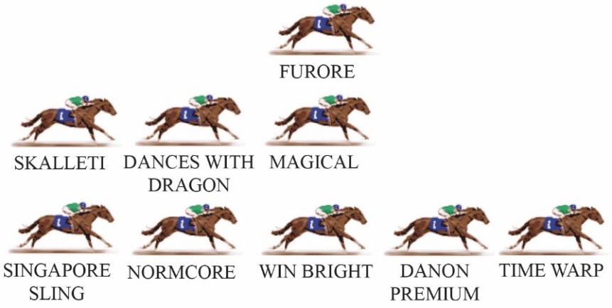  There is only one notable leader in this year’s Hong Kong Cup, Time Warp, so the tempo is unlikely to be strong. This requires some tactical adjustment from all the other jockeys, because leaving the leader with a soft time of things on a flat course like Sha Tin gives them too much advantage. On the other hand, taking off early to put pressure on can ruin the chance of the horse that makes that early move. Statistically, the position with the best winning strike-rate in 2000m races at Sha Tin is the horse settling midfield, one horse off the fence.  LIKELY PACE: GOOD TO SLOW

