Spotlight

World superstar Magical heads to Sha Tin with a record of seven G1s from 27 starts having raced in 20 Group 1 races around the world and she will look to become an eight-time Group 1 winner.

The Galileo mare heads to Hong Kong’s big track off the back of a close second in the G1 LONGINES Breeders’ Cup Turf. Two starts prior to that she tallied her most recent G1 success in the Irish Champion Stakes at Leopardstown, where she got the better of a sustained battle with current LONGINES World’s Best Racehorse Ghaiyyath.

Japan’s Win Bright returns to his favourite hunting ground as an undefeated dual G1 winner at Sha Tin after claiming Hong Kong’s Spring-Autumn G1 double: the FWD QEII Cup and 2019 LONGINES Hong Kong Cup.

Japan’s assault also features Danon Premium and Normcore. Another of Europe’s hopes comes in the form of Skalleti, who split Addeybb and Magical for second in this year’s G1 Champion Stakes at Ascot.

The local brigade is boosted by an invigorated Furore. The 2019 Hong Kong Classic Mile and BMW Hong Kong Derby hero has won his last two races at G3 and G2 level, both times beating reigning Hong Kong Horse of the Year Exultant.

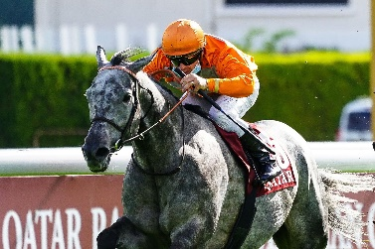 | SKALLETI  FRANCE 5g 121  Top-class French performer who beat subsequent Prix de l’Arc de Triomphe winner Sottsass in G3 at Deauville; last out second in G1 British Champion Stakes. | 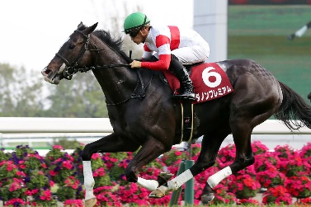 | DANON PREMIUM  JAPAN 5h 119  G1 winner at two; runner-up to Almond Eye in last year’s G1 Tenno Sho Autumn; also campaign to Australia for third in G1 Queen Elizabeth Stakes.
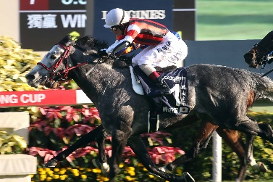 | WIN BRIGHT  JAPAN 6h 119  Claimed Spring-Autumn G1 double to remain unbeaten at Sha Tin with FWD QEII Cup and this race last year; returns for one last crack before possible retirement. | 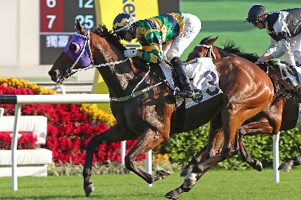 | FURORE  HONG KONG 6g 117  2019 BMW Hong Kong Derby hero who has returned to best with two Pattern race wins this season, G3 Sa Sa Ladies’ Purse and G2 Jockey Club Cup, twice beating Exultant.
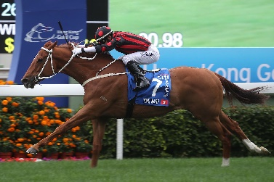 | TIME WARP  HONG KONG 7g 117  Inconsistent but tough on his day galloper; three-time G1 winner including this race in 2017, and 2018 and 2020 Citi Hong Kong Gold Cup. | 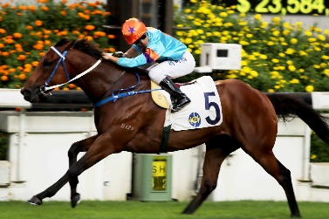 | DANCES WITH DRAGON  HONG KONG 7g 109  G1 winner in New Zealand pre-import; proven a solid performer since switching to Caspar Fownes’ yard adding four wins including G3 Premier Plate romp.
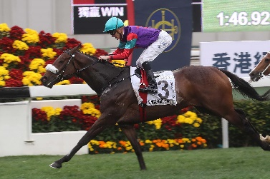 | SINGAPORE SLING  HONG KONG 7g 104  Three unplaced runs in return from a near 12 month layoff with injury; 2018 Hong Kong Classic Cup winner who has placed at G1 level to Beauty Generation. | 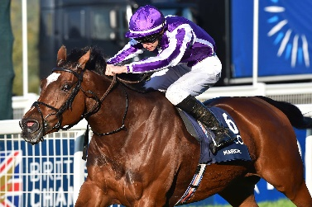 | MAGICAL  IRELAND 5m 121  Aidan O’Brien’s brilliant seven-time G1 winner who holds a win over the current World’s Best Racehorse Ghaiyyath three starts ago in Irish Champion Stakes.
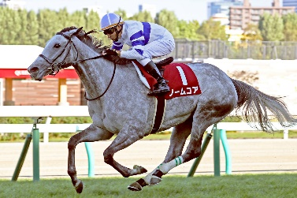 | NORMCORE  JAPAN 5m 114  2019 G1 Victoria Mile winner; third to Almond Eye in that race this year; last out faded to third last in Queen Elizabeth II Cup.

