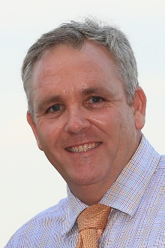 | Brown, Cliff | Sprint ‒ Inferno
 | Age: 51. Cliff Brown is the youngest trainer in the history of Australian racing to have trained three Derby winners at Group 1 level. He has trained 13 G1 and 2 winners in Australia including the 1997 Rosehill Guineas, 2002 Adelaide Cup and the South Australia Derby in 1996, 1997 and 2000, along with numerous other black-type races. Brown started his Singapore adventure in 2008 and counts the 2011 local G1 Singapore Derby with Clint as his first highlight. While better known for his affinity with stayers, Brown gained his second local G1 success in the domestic premier sprint race, the Lion City Cup with Zac Spirit in 2014. Two years later, Brown enjoyed an amazing local G1 blitz, bagging five, the most any trainer has ever claimed in the Kranji Racecourse era, starting with a second Lion City Cup with the same Zac Spirit, followed by Debt Collector’s Singapore Guineas, Laughing Gravy’s Queen Elizabeth II Cup and Debt Collector’s Kranji Mile and Raffles Cup. Hong Kong Wins: No previous runner.

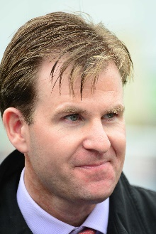 | Condon, Ken | Mile ‒ Romanised
 | Age: 44. Ken Condon grew up in Ballyhea, County Cork, Ireland, first discovering his passion for horses from his mother Mags, a daughter of a local cattle dealer and landowner, who also had a few horses in training. Condon represented Ireland at eventing and studied accountancy for two years before venturing into racehorse training. He took out his license in 2002 after stints with John Oxx, Coolmore, the Niarchos family, Lanes End Farm and Neil Howard. Condon produced his first classic winner in 2018 when Romanised won the Irish 2000 Guineas. Other notable victories include Success Days, winner of the G2 York Stakes in 2017 and G3 Ballysax Stakes, Derrinstown Derby Trial and Royal Whip Stakes. Hong Kong wins: No previous runners.

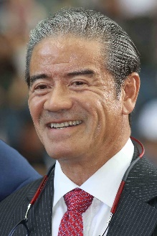 | Cruz, Tony | Cup ‒ Furore, Time Warp; Mile ‒ Ka Ying Star;  Sprint ‒ Computer Patch; Vase ‒ Exultant
 | Age: 63. Tony Cruz is a son of Johnny Cruz, a renowned rider from Hong Kong's amateur era. He was among the first intake of apprentices to the HKJC Apprentice Jockeys’ School when that facility opened in 1972. Cruz started his riding career in the 1973/74 season. He went on to be Hong Kong's champion jockey six times and rode 946 winners. Cruz also made his name at G1 level in Europe and notably partnered the great race mare Triptych. He was granted a Hong Kong trainer's licence in 1996 and first landed the trainers' title in 1999/2000. He regained the crown in 2005, setting a then record for a season's winners (91) and earnings (HK$113m) in the process. He most famously trained the great Hong Kong champion Silent Witness to win 17 consecutive races before the galloper tasted defeat at the hands of stablemate Bullish Luck in the 2005 Champions Mile. Honours: Hong Kong Champion Jockey (1978/79, 1980/81, 1982/83, 1983/84, 1985/86, 1994/95); Hong Kong Champion Trainer (1999/00, 2004/05). HKIR wins (10): Hong Kong Mile (2003 Lucky Owners, 2010 Beauty Flash, 2016 Beauty Only), Hong Kong Cup (2011 & 2012 California Memory, 2017 Time Warp), Hong Kong Sprint (2003 & 2004 Silent Witness, 2015 Peniaphobia), Hong Kong Vase (2018 Exultant). Hong Kong Wins (as of 29 November): 1,313

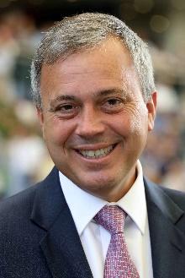 | Fownes, Caspar | Cup ‒ Dances With Dragon; Mile ‒ Southern Legend;  Sprint ‒ Classique Legend; Vase ‒ Columbus County
 | Age: 53. Caspar Fownes assisted his late father Lawrie for several seasons before gaining his licence in 2003/04. He eclipsed his father's best season stats in his rookie year with 44 wins. In 2006/07 he won his first premiership and has since added two more. His third championship came in 2013/14 when his strong late charge brought three wins on the closing day to tie with John Size on 62 wins, and with one more second place than his rival he sealed the title on count-back. Fownes is particularly known for his fine record at Happy Valley where he has notched 500 career wins (as at 29 November), a tally second only to Hong Kong's longest-serving trainer John Moore. He has enjoyed overseas success in Singapore’s G1 KrisFlyer International Sprint three times, firstly with Green Birdie in 2010, before Lucky Nine snared two in succession (2013 and 2014). Fownes’ most recent exploits abroad resulted in two successful trips back to Singapore as Southern Legend claimed back-to-back editions of the SIN G1 Kranji Mile. Fownes is currently leading the Hong Kong trainers’ championship. Honours: Hong Kong Champion Trainer (2006/07, 2008/09, 2013/14). HKIR wins (2): Hong Kong Mile (2006 The Duke), Hong Kong Sprint (2011 Lucky Nine). Hong Kong Wins (as of 29 November): 918

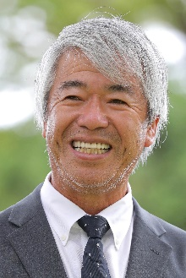 | Fujisawa, Kazuo | Sprint ‒ Tower Of London
Age: 69. Kazuo Fujisawa is the most successful Japanese trainer in modern era, having been crowned JRA’s Champion Trainer for a record-equalling 12 times between 1993 and 2009. He is the only active, and second ever, JRA trainer to reach the 1000 win mark (1521 wins as at 30 November) and with over 100 Group race wins. After finishing his studies at university, Fujisawa travelled to the UK to work as a groom for legendary trainer Gavin Pritchard-Gordon for four years. He returned to Japan in 1977 and obtained his JRA training license 10 years later. He has won the Tenno Sho Autumn six times (1996 Bubble Gum Fellow, 2002 & 2003 Symboli Kris S, 2004 Zenno Rob Roy, 2014 Spielberg, 2017 Rey de Oro), the Arima Kinen three times (2002 & 2003 Symboli Kris S, 2004 Zenno Rob Roy) and the Yasuda Kinen three times (1997 Taiki Blizzard, 1998 Taiki Shuttle, 2020 Gran Alegria) among his 32 G1/JPN G1 wins in his career. Three Japanese Horses of the Year, namely Taiki Shuttle (1998), Symboli Kris S (2002 & 2003) and Zenno Rob Roy (2004), were also under his tutelage. Hong Kong wins
(as of 29 November) : 0

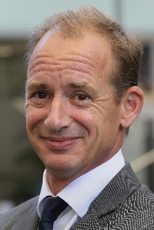 | Gibson, Richard | Sprint ‒ Rattan
 | Age: 51. Englishman Richard Gibson established himself as a Group 1 trainer in France before he arrived in Hong Kong ahead of the 2011/12 season. He gained a solid grounding in the art and science of training racehorses with Frenchmen Pascal Bary and Henri-Alex Pantall, as well as Americans Bill Mott and Gary Jones. He took out his first licence at Chantilly in 1996 and struck gold as early as 1999 when Lady Of Chad won the G1 Prix Marcel Boussac en route to becoming European Champion Juvenile Filly. He has trained the winners of eight G1s altogether, the highlights being Akeed Mofeed's and Doctor Dino's exploits in Hong Kong and the USA. His other high-class trainees prior to moving to Hong Kong include Marotta, Lune D'Or, Cut Quartz, Mores Wells, Swedish Shave, and for a short spell Dunaden. He won the Hong Kong Derby with Akeed Mofeed and saddled the top-class galloper Gold-Fun to run a close second in the 2016 G1 Diamond Jubilee Stakes at Royal Ascot. HKIR wins (3): Hong Kong Vase (2007 & 2008 Doctor Dino), Hong Kong Cup (2013 Akeed Mofeed). Hong Kong Wins (as of 29 November): 243

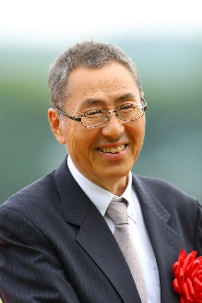 | Hagiwara, Kiyoshi | Cup ‒ Normcore
 | Age: 61. Born in Kanagawa, Kiyoshi Hagiwara commenced his racing career as a groom in 1982, before obtaining his JRA trainer licence in 1996. Logi Universe brought him a first top-class and Japanese Classic success when taking the JPN G1 Tokyo Yushun in 2009. Other notable gallopers he has prepared include Le Vent Se Leve, JRA’s Best Dirt Horse and G1 Champions Cup winner in 2018, Obruchev (2011 Zen Nippon Nisai Yushun), and his current flagbearer Normcore (2019 Victoria Mile). He has amassed 624 JRA wins in his career including 18 this term (as of 30 November). Hong Kong wins (as of 29 November): 0

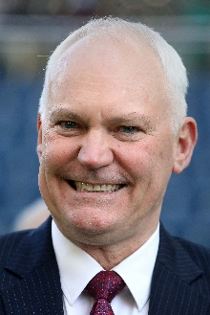 | Hall, David | Vase ‒ Ho Ho Khan
 | Age: 57. David Hall was born in Adelaide, the son of trainer Joe Hall. He began training at Morphettville in 1988 and moved to Melbourne five years later. Best known at home for winning the Melbourne Cup in 2003 with the brilliant Makybe Diva, he also trained Silent Witness before the champion sprinter switched to Hong Kong. Hall began his training career in Hong Kong in 2004/05. Absolute Champion's victory in the G1 Hong Kong Sprint is his Hong Kong highlight to date. In the 2018/19 season he saddled two G3 winners, Ho Ho Khan (Queen Mother Memorial Cup) and Little Giant (Sha Tin Vase). HKIR wins (1): Hong Kong Sprint (2006 Absolute Champion). Hong Kong Wins (as of 29 November): 490

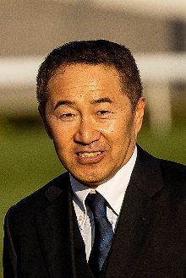 | Hatakeyama, Yoshihiro | Cup ‒ Win Bright
 | Age: 58. Yoshihiro Hatakeyama commenced his JRA career as a work rider in 1986, before obtaining his JRA training licence in 1999 and started his stable operation the following year. Meiner Dupre’s success in the G3 Kyodo News Service Hai in 2004 was Hatakeyama’s first at Group level. His top-class breakthrough came with Meiner Ho O’s victory in the 2013 NHK Mile Cup. His other top performers include top dirt fillies Grab Your Heart and Trois Bonheur, who brought the trainer a total of eight Group wins on the regional NAR circuit. He achieved a career high when three-time G2 winner Win Bright took the G1 FWD QEII Cup at Sha Tin in 2019, and the same horse completed a Spring-Autumn G1 double as he took the LONGINES Hong Kong Cup that same year. He has amassed a total of 323 JRA wins, including 16 this season (as of 30 November). HKIR win (1): Hong Kong Cup (2019 Win Bright). Hong Kong wins (as of 29 November): 2

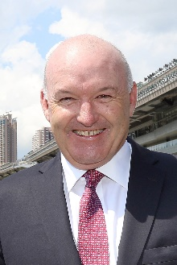 | Hayes, David | Mile ‒ Beauty Generation; Vase ‒ Chefano
 | Age: 58. David Hayes is a son of legendary Australian trainer Colin Hayes. He took out his own licence to train in 1990 and quickly established a top-class reputation across a five-year span, thanks to 31 Group 1 scores, his domination of the trainer titles in Melbourne and Adelaide, and famous victories in the Japan Cup and Melbourne Cup. He relocated to Hong Kong in 1996 and, during what proved to be his first spell in Hong Kong, Hayes was champion trainer on two occasions and established his position as a top-four trainer, notching 458 wins across ten seasons; his major wins included the G1 Hong Kong Sprint and the Hong Kong Derby. He returned to Australia in 2005 and advanced his Lindsay Park operation to greater heights of achievement; he has won majors along the way with the likes of Miss Finland, Fields Of Omagh, Redkirk Warrior, Nicconi and Criterion, and he has achieved a record six wins in the crack two-year-old race, the G1 Blue Diamond. Hayes formed a partnership with his nephew Tom Dabernig in 2014, and in 2016 that expanded to include his son, Ben Hayes. He is the first trainer in Hong Kong’s professional era to return to train in the city, having commenced his second spell in July 2020 ahead of the 2020/21 campaign. Honour: Hong Kong champion trainer (1997/98 & 1998/99); 8x Melbourne champion trainer; 9x Adelaide champion trainer; youngest inductee to the Australian Racing Hall of Fame (2008); only Australian trainer to win the Japan Cup (1990 Better Loosen Up); first Australian trainer to achieve 300 wins in a season (1994). HKIR wins (1): Hong Kong Sprint (2002 All Thrills Too). Hong Kong Wins (as of 29 November): 465

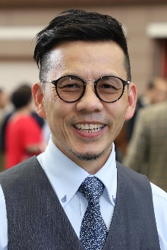 | Lor, Frankie | Mile ‒ Simply Brilliant; Sprint ‒ Big Party, Fat Turtle
 | Age: 54. Frankie Lor began his career as a rider in Hong Kong, notching 27 wins between 1981 and 1995. He became a work rider and then an assistant to a number of trainers, most notably to two of Hong Kong's greats, John Moore and John Size. Lor was granted a full licence ahead of the 2017/18 Hong Kong racing season. His first win was achieved with his first runner, Yourthewonforme, in a Class 4 contest at the season opener on 3 September, 2017. Lor ended that campaign second in the premiership behind his old master John Size. His final tally of 65 wins surpassed Hong Kong's previous best first-season total, set by Size when winning his first Hong Kong trainers’ championship in 2002. Lor landed his first G1 wins in only his second season, scooping a double at the 2018 LONGINES HKIR with Mr Stunning (Hong Kong Sprint) and Glorious Forever (Hong Kong Cup). That season also saw him sweep the 2019 Four-Year-Old Classic Series with Furore and Mission Tycoon. HKIR wins (2): Hong Kong Sprint (2018 Mr Stunning), Hong Kong Cup (2018 Glorious Forever). Hong Kong wins (as of 29 November): 194

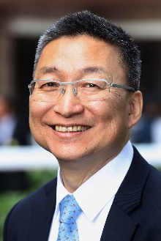 | Lui, Francis | Mile ‒ Golden Sixty, More Than This
 | Age: 61. Francis Lui graduated from the HKJC Apprentice Jockeys' School to ride 36 winners as a licensed jockey between 1975 and 1982, and later became an assistant trainer. He received his own licence to train in 1996/97. Lui enjoyed his best season in 2019/20 when he not only challenged for the trainers’ title but also won all three legs of the Four-Year-Old Classic Series with the brilliant Golden Sixty; the handler saddled the bay through ten races unbeaten since last term. Lui ended the last season with a personal best of 63 wins to place third in the championship, four behind Ricky Yiu. Hello Pretty also provided the handler with one leg of the Four-Year-Old Classic Series when he won the Hong Kong Derby Trial in 2006, while his standout stable star prior to Golden Sixty was sprinter Lucky Bubbles, who gave the trainer his first Group 1 win in 2017 when he took the Chairman's Sprint Prize. Hong Kong wins (as of 29 November): 699

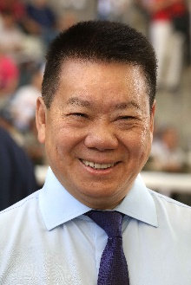 | Man, Manfred | Sprint ‒ Big Time Baby
 | Age: 63. Manfred Man was a jockey in Hong Kong between 1976 and 1983 and notched a memorable triumph in the 1979 Queen Elizabeth II Cup on Go-Getter. He then worked through the assistant trainer ranks, most notably with John Moore, and received a full trainer's licence in 2001. He achieved his best total of 43 winners in 2009/10, the season in which he won five races apiece with the griffins London China Town and Tai Sing Yeh. He won the Hong Kong International Sale Bonus with Great Achievement (2003), London China Town (2009) and Pleasure Gains (2014). Man enjoyed a first Pattern race triumph with Eagle Regiment in the HKG1 Centenary Sprint Cup in 2012 and brought the horse back from injury to win the same race in 2013. He also nursed Eagle Regiment to achieve a gallant third in the G1 Al Quoz Sprint at Meydan, Dubai, in 2013. In the 2019/20 season he improved the six-year-old Big Time Baby from a rating of 87 – winning three of seven starts and placing second in the G1 Chairman’s Sprint Prize – to end the campaign rated 120. Honours: Hong Kong Champion Apprentice Jockey (1978/79). Hong Kong wins (as of 29 November): 522

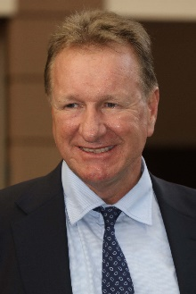 | Millard, Tony | Cup ‒ Singapore Sling
 | Age: 59. Tony Millard's father was the legendary multiple South African champion trainer Terrance Millard. Millard made an impressive start to his own training career in 1991. He was champion trainer in South Africa twice and won all of that country's majors. He trained three Horses of the Year there in Empress Club, Jet Master and Surfing Home as well as numerous other champions. He sent out 39 G1 winners in his first nine years of training before relocating to Hong Kong. The handler made an immediate impact locally, winning the 2000 Hong Kong Derby with Keen Winner in his first season. His most spectacular successes in Hong Kong have come with two-time Horse of the Year Ambitious Dragon whose 13 career wins included two G1s and five local G1s. Millard took Hong Kong's star mare Sweet Sanette to Royal Ascot in 2011 where she finished third in the G1 King's Stand Stakes, while Super Jockey was second in the 2015 G1 Dubai Golden Shaheen and won the inaugural KOR G1 Korea Sprint in 2016. Honours: South African Champion Trainer (1992, 1994 [shared with Pat Shaw]). HKIR wins (1): Hong Kong Mile (2012 Ambitious Dragon). Hong Kong Wins (as of 29 November): 652

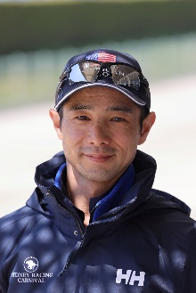 | Nakauchida, Mitsumasa | Cup ‒ Danon Premium
 | Age: 41. Mitsumasa Nakauchida has spent his entire life around horses after being born on a pre-training farm in Western Japan, and at the age of 16, he left Japan and went to Ireland, UK, France and US to learn about training horses, before returning to his homeland and work as a groom for the Mikio Matsunaga stable in 2007. He obtained his JRA trainer’s license in 2012 and has twice won the JRA Award, for the highest winning percentage, in 2017 and 2019. He has so far amassed 229 wins in his career, including 29 this year (as at 30 November). His two G1 successes to date came with Danon Premium’s win in the 2017 G1 Asahi Hai Futurity Stakes and Danon Fantasy’s win in the G1 2018 Hanshin Juvenile Fillies. Hong Kong wins : No previous runner

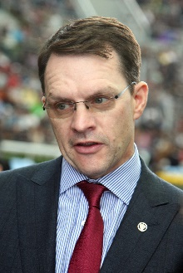 | O'Brien, Aidan | Cup ‒ Magical; Mile ‒ Order Of Australia; Vase ‒ Mogul
 | Age: 51. Aidan O’Brien has a phenomenal list of big race victories to his name and has notched an unmatched 339 G1 wins. In 2017, he eclipsed American training legend Bobby Frankel’s record for the most G1 wins in a season with 28 for the year, three more than Frankel’s mark. A champion amateur jumps jockey in Ireland, he was assistant trainer to Jim Bolger before taking out a trainers’ licence in 1993 – he has sealed Ireland’s champion trainer title for the 23rd time in 2020 (22nd consecutively). He enjoyed remarkable success with jumpers before teaming up with John Magnier’s Coolmore operation at the legendary Ballydoyle training base in 1996; a year later, he became Ireland’s youngest ever champion trainer on the flat. O’Brien has trained a host of champions including super sire Galileo, High Chaparral, Giant’s Causeway, Rock Of Gibraltar, Yeats, Cape Blanco and Minding, as well as the great hurdler Istabraq. He broke new ground in 2014 with his first winner in Australia, Adelaide, in the G1 Cox Plate, and in December 2015 Highland Reel gave him his first Hong Kong win. HKIR wins (2): Hong Kong Vase (2015 and 2017 Highland Reel). Hong Kong wins (as of 29 November): 2

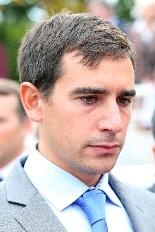 | Reynier, Jerome | Cup ‒ Skalleti; Vase ‒ Royal Julius
 | Age: 35. Jerome Reynier is a trainer based in Marseille in the south east of France. After graduating from Godolphin’s Flying Start programme, he worked as a bloodstock agent for two years before switching to training, and in April 2013, he saddled his first winner, Its All Class, which he bred himself. He quickly ascended through the French training ranks and sent out his first Listed Stakes winner when Royal Julius won the Grand Prix Anjou Bretagne at Nantes in 2017. Royal Julius also provided him with the first black type winner of his career as a Group Two victor in Italy in 2018, before claiming the 2019 Bahrain International Trophy. His current stable star is the super consistent Skalleti, who provided Reynier with a pair of G3 and G2 wins in France before snaring second in the G1 Champion Stakes at Ascot. Hong Kong Wins: No previous runner.

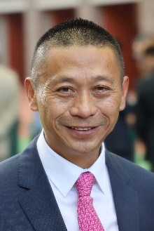 | Shum, Danny | Sprint ‒ Perfect Match; Vase ‒ Playa del Puente
 | Age: 60. Danny Shum rode 24 winners in Hong Kong between 1977 and 1983. He learnt the training ropes as assistant to former multiple Hong Kong champion trainer Ivan Allan. He was granted a Hong Kong trainer's licence ahead of the 2003/04 season and began brightly with 34 winners. The handler improved on that good debut season to rank third in the trainers’ premiership in his second term when Scintillation emerged as his standout runner. The 2011/12 season brought a first overseas success as Little Bridge went to Royal Ascot to clinch victory in the G1 King's Stand Stakes. Shum recorded a best ever season's tally of 54 wins to finish second in the 2015/16 trainers' premiership. Hong Kong wins (as of 29 November): 640

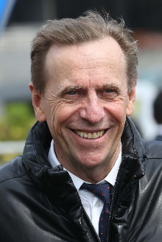 | Size, John | Mile ‒ Waikuku; Sprint ‒ Hot King Prawn
 | Age: 66. John Size was a top trainer in Sydney before his arrival in Hong Kong in 2001 with a reputation for improving and rekindling the spark in his horses. He broke the mould by winning the trainers' premiership in his very first season. Size’s ninth championship in 2016/17 saw him set a new record for most winners in a season with 94, 27 more than nearest rival John Moore. In winning his 10th title in 2017/18, Size set a new benchmark for earnings in a season, accruing total prize money of HK$176,441,240. His 11th title in 2018/19 was sealed after a tussle with rival John Moore that went to the season’s final day. He has trained the winners of two Horse of the Year titles, the multiple HKG1 scorers Electronic Unicorn and Grand Delight. In 2009/10 he trained Brave Kid to equal the then record of six wins in a season and Entrapment who finally broke that record with seven victories in just five months. Honours: Hong Kong Champion Trainer (2001/02, 2002/03, 2003/04, 2005/06, 2007/08, 2009/10, 2011/12, 2015/16, 2016/17, 2017/18, 2018/19); Australian Racing Hall of Fame inductee (2018). HKIR wins (3): Hong Kong Mile (2013 Glorious Days), Hong Kong Sprint (2017 Mr Stunning and 2019 Beat The Clock). Hong Kong Career Wins (as of 29 November): 1,275

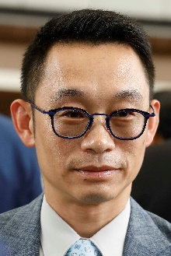 | Ting, Jimmy | Sprint – Amazing Star (Reserve)
 | Age: 48. Jimmy Ting started out in 1988 as an apprentice jockey allocated to Brian Kan and became a fully-licensed rider in 1993. He retired from race-riding in 2003 and worked as assistant trainer to David Hill for two seasons, leaving to fulfil the same duties for Michael Chang with whom he worked for a further three years. Five years as assistant to Francis Lui preceded a five-year spell with Danny Shum. He was granted a full trainers' licence for the 2018/19 season and opened his account at the first attempt when Triumphant Jewel took the season opener at Sha Tin on 2 September, 2018. He accrued 38 wins that season. Ting added 35 wins in 2019/20, including four from Amazing Star, the Most Improved Horse of the season. Ting has gained overseas experience in Australia, Ireland and England. Hong Kong Wins (as of 29 November): 79

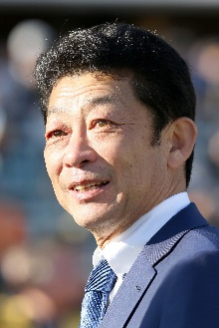 | Tomomichi, Yasuo | Mile ‒ Admire Mars
 | Age: 57. Yasuo Tomomichi was a vet student and joined the Equestrian Team shortly after his admission to university. With his Equestrian Team’s training located close to the racecourse, he took up a part-time job and worked as an assistant to horse vets during race days. Tomomichi started his own racing career as a work rider and stable assistant in 1989, and obtained his trainer’s licence in 2001. Tomomichi received his first JRA Award as the trainer with highest earnings in 2018 and he has no less than 13 G1/JPN G1 wins. Admire Jupiter helped him open his account in the 2008 Tenno Sho Spring, while Unrivaled (2009 Japanese 2000 Guineas), Makahiki (2015 Tokyo Yushun), Cheval Grand (2017 Japan Cup), Wagnerian (2018 Tokyo Yushun) and World Premiere (2019 Kikuka Sho) are his other top performers. Vivlos landed him the G1 Dubai Turf in 2017, while G1 NHK Mile Cup winner Admire Mars earned Tomomichi a first Hong Kong success in the G1 LONGINES Hong Kong Mile in 2019. He has amassed a total of 576 JRA wins in his career, including 49 this term (as of 30 November) and he currently sits second in the JRA trainers’ championship.HKIR win (1): Hong Kong Mile (2019 Admire Mars). Hong Kong win (as of 29 November): 1

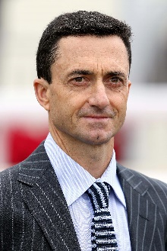 | Whyte, Douglas | Sprint ‒ Stronger (Reserve)
 | Age: 49. Douglas Whyte’s first season as a trainer in 2019/20 saw him accrue 44 wins. The former jockey was born in South Africa and earned the nickname “The Durban Demon” during his storied career in the saddle. He was Hong Kong’s champion jockey for 13 consecutive seasons, establishing an incredible legacy. Whyte retired from the saddle in February 2019 with a Hong Kong record of 1,813 wins and all-time high prize money of more than HK$1.5 billion. After a few months travelling to Europe, Dubai, South Africa and Australia to see how some of the world’s master trainers ran their operations, Whyte commenced his own training career at Sha Tin’s Olympic Stables on 15 July, 2019. An outstanding horseman, he first sat on a horse at age two and developed his skills riding in the countryside with his late father, himself a former jockey. A South African Jockey Academy graduate, in 1996 he rode weekends in Singapore and undertook a short contract in Hong Kong at the start of the 1996/97 season. He returned for the 1997/98 season and made Hong Kong his home. He was the first jockey to reach 1,000 wins in Hong Kong, and his tally of 114 wins in 2005/06 stood as a record until Joao Moreira surpassed it in 2014/15. Honours: Hong Kong Champion Jockey (13 consecutive seasons from 2000/01 to 2012/13); LONGINES IJC winner (2002, 2007, 2008); World Super Jockeys Series (Japan) winner (2004); six wins in a day as a jockey: 7 April, 2013 (a Hong Kong record-equalling feat at the time); record holder for overall career wins as a jockey in Hong Kong (1,813 wins) and most career prize money won by a jockey (over HK$1.5 billion). Hong Kong Wins as trainer (as of 29 November): 54

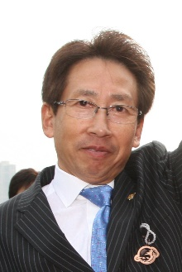 | Yasuda, Takayuki | Sprint ‒ Danon Smash
 | Age: 67. Born in Kyoto, Takayuki Yasuda had 680 wins as a jockey between 1972 and 1994. In 1991, he rode a personal best 80 wins and partnered the legendary horse Tokai Teio to take two Japanese classics, the Satsuki Sho and Tokyo Yushun. Yasuda obtained his training licence in 1994 and registered his first victory in March 1995. Yasuda notched his first JRA Champion Trainer title with 62 wins in 2019. He has saddled 843 JRA career wins, including 42 this season (as of 30 November). Of the 15 G1/JPN G1 wins he has amassed so far, two have come from brilliant mare and 2011 G1 Sprinters Stakes winner Curren Chan, but the great Lord Kanaloa remains the best horse he has ever trained. The Hall of Famer and 2013 Japanese Horse of the Year notched six G1 wins, including back-to-back successes in the G1 Sprinters Stakes and G1 LONGINES Hong Kong Sprint in 2012 & 2013. Transcend (2010 & 2011 Japan Cup Dirt), Grape Brandy (2013 February Stakes) and Fashionista (2020 JBC Ladies’ Classic) are his other top performers. HKIR wins (2): Hong Kong Sprint (2012 & 2013 Lord Kanaloa). Hong Kong wins (as of 29 November): 2

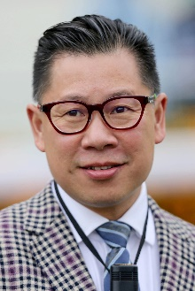 | Yip, Dennis | Sprint ‒ Wishful Thinker
 | Age: 53. HKJC Apprentice Jockeys' School graduate Dennis Yip was licensed as a jockey in Hong Kong between 1984 and 1993. He rode a total of 59 winners before moving on to learn the training game overseas and then acting as assistant to multiple champion trainer, Brian Kan. In 2002/03 he became a licensed trainer in his own right. Yip trained more than 30 winners in each of his seasons as a trainer until he fell short with 26 wins in the 2019/20 season, despite a solid back half to the campaign following a slow start. The 2011/12 season saw him reach the 50-win mark as he finished fourth in the trainers' premiership. He maintained his upward curve in 2012/13 as he sent out 69 winners to clinch his first trainers' title, sealing victory over Tony Cruz in the very last race of the season. His biggest win that term came with Go Baby Go in the HKG3 Bauhinia Sprint Trophy, while All You Wish took Champion Griffin honours and the Most Improved Horse title. Honours: Hong Kong Champion Trainer (2012/13). Hong Kong wins (as of 29 November): 751

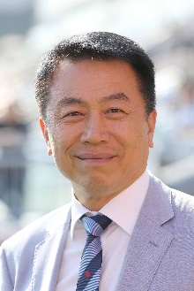 | Yiu, Ricky | Mile ‒ Mighty Giant; Sprint ‒ Jolly Banner, Voyage Warrior
 | Age: 63. Ricky Yiu rode 11 winners between 1974 and 1980 when apprenticed to Jack Goswell, and was first licensed as a trainer in 1995/96, after learning the ropes as assistant trainer to Gordon Smyth and Eddie Lo. He achieved a lifelong ambition in 2019/20 when he was crowned champion trainer, having unexpectedly led his rivals for most of the campaign; his final tally of 67 wins meant that he held off second-placed Tony Cruz by two. One of his greatest early moments came with Fairy King Prawn's success in the inaugural Hong Kong Sprint of 1999. Three-time world champion sprinter Sacred Kingdom, one of Hong Kong's all-time greats, was his outstanding stable star and the two-time G1 Hong Kong Sprint winner and 2009/10 Horse of the Year won the Hong Kong Champion Sprinter title for the fourth year in succession in 2010/11. In 2010 he also sent out Ultra Fantasy to triumph in the G1 Sprinters Stakes at Nakayama as, with Alex Lai on board, the pair became the first Hong Kong Chinese trainer-jockey partnership to triumph in an overseas G1 event. Following Sacred Kingdom's retirement in the spring of 2012, another blistering speedster, Amber Sky, provided Yiu with further elite success at home and abroad. His son, Eric Yiu, was appointed the stable's assistant trainer ahead of the 2018/19 season. Honours: Hong Kong Champion Trainer (2019/20). HKIR wins (3): Hong Kong Sprint (1999 Fairy King Prawn, 2007 & 2009 Sacred Kingdom). Hong Kong wins (as of 29 November): 823

