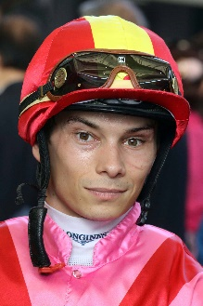 | Badel, Alexis
Age: 30.
Background: Alexis Badel hails from a traditional racing family, his mother being trainer Myriam Bollack-Badel and his father, former jockey Alain Badel. He was France's Champion Apprentice in 2007 and broke into the top 10 in the premiership in just his second year, riding with 60 winners. Badel's first Group race win came aboard Norse King in the October, 2013 Prix du Conseil de Paris. He was appointed as the second retained rider for The Aga Khan behind Christophe Soumillon at the beginning of the 2015 racing season and went on to record his most successful season to date with 104 wins. That saw him obtain seventh position in the French Championship. Badel debuted at Sha Tin on 11 December, 2016 and he ended his maiden two-month stint in Hong Kong with seven wins. He returned in the 2017/18 season, landing 14 wins. Following his second campaign in Hong Kong, Badel returned for a third short-term stint and landed 26 wins in under four months - his best haul to date. Badel currently rides on a full-season licence for the 2020/21 season. He secured a first G1 win aboard Nonza in the August, 2018 Prix Jean Romanet at Deauville. Honours: France’s Champion Apprentice (2007). Honours: France's Champion Apprentice (2007). Hong Kong wins (as of 29 November): 74

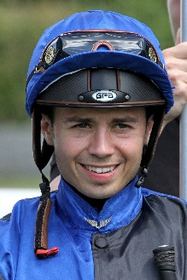 | Barzalona, Mickael
Age: 29.
Background: Mickael Barzalona was born in Avignon, France, a grandson of Corsican trainer Christian Barzalona and nephew of former Flat and Jumps jockey Armand Barzalona. He began his career with France’s standout trainer, Andre Fabre, with whom he is still associated, and is Godolphin’s number one rider in France. A precocious sensation, he enjoyed a stunning Dubai Carnival in 2011, at age 19, winning major races for the Godolphin operation, and that momentum took him to a famous English Derby win in June of that year aboard Pour Moi for Fabre and Coolmore. He then headed to Hong Kong for a short stint in 2011/12, notching one winner from 42 rides. Barzalona won the 2012 G1 Dubai World Cup aboard Monterosso and the 2017 Breeders’ Cup Turf on Talismanic. The latest of his 14 G1 wins came on Sealiway in the Prix Jean-Luc Lagardere in October. Hong Kong wins (as of 29 November): 1

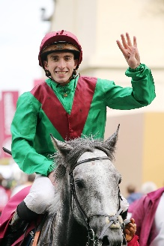 | Boudot, Pierre-Charles
Age: 27.
Background: Pierre-Charles Boudot won his second French champion jockey title - and first outright - in 2016 with a then European record of 300 wins for the season. His father, the late Marc Boudot, was a trainer in central France. He attended the jockeys’ school at Govieux before joining the inimitable Andre Fabre as an apprentice. He notched his first win in April 2009 and his maiden G1 triumph was atop Gallante in the 2014 Grand Prix de Paris. He won the 2014 G1 Prix Rothschild and the following year’s G1 Prix Jacques le Marois and G1 Sun Chariot Stakes on Esoterique. Boudot rode in Japan for two months at the end of 2014, based at Ritto with trainer Yasutoshi Ikee. He achieved a career peak in 2019 when winning the Prix de l’Arc de Triomphe on Waldgeist, one of seven G1 wins during the year. He has won 11 G1s through 2020, including two at the Breeders’ Cup, the Filly & Mare Turf on Audarya, as well as the Breeders’ Cup Mile aboard Order Of Australia. Honours: France’s champion jockey (2015 [tied with Christophe Soumillon] & 2016). Hong Kong wins (as of 29 November): 5

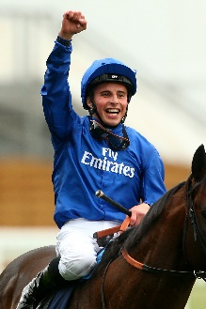 | Buick, William
Age: 32.
Background: Norwegian-born William Buick was joint champion apprentice in Britain in 2008 and rode his first G1 win on Lahaleeb in the E P Taylor Stakes the following year. He was appointed stable jockey to John Gosden in 2010 and the partnership started with a bang as he rode Dar Re Mi to win the G1 Dubai Sheema Classic. In late 2014, he began his association with Sheikh Mohammed’s Godolphin operation, primarily riding for trainer Charlie Appleby. This partnership quickly proved fruitful as he took the G1 Dubai World Cup the following March on Prince Bishop. His list of 63 G1 wins includes four on star sprinter Dream Ahead, as well as the Dubai World Cup (2015 Prince Bishop), and nine in 2018 featuring the QEII Cup on Pakistan Star, the English Derby aboard Masar and Japan’s Mile Championship on Stelvio. His recent exploits at the top-level include three G1s aboard Godolphin’s Ghaiyyath, who claimed the Coronation Cup, Eclipse Stakes and Juddmonte International Stakes. While his most recent at G1 level came aboard Wonderful Tonight in the British Champions Fillies & Mares Stakes on Champions Day at Ascot. Hong Kong wins (as of 29 November): 1

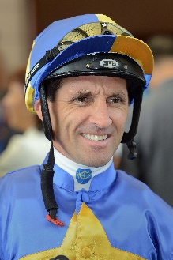 | Callan, Neil
Age: 42.
Background: Irishman Neil Callan finished runner-up in the British jockeys' championship in 2005 (151 wins) and 2007 (170 wins). After a fruitless start as an apprentice in Ireland with Kevin Prendergast he moved to Britain and forged successful partnerships with trainers Karl Burke, Kevin Ryan and Michael Jarvis. He first rode in Hong Kong on a short contract in the 2010/11 season and has since established a reputation as a tough competitor. His first full Hong Kong season, 2014/15, yielded 47 wins and fifth place in the jockeys' premiership and he equalled that tally when finishing third in 2016/17. His big race wins include the 2015 Hong Kong Classic Mile on Beauty Only and three G1s on Blazing Speed (2015 QEII Cup; 2014 & 2016 Champions & Chater Cup). Honours: British Champion Apprentice (1999). Hong Kong wins (as of 29 November): 266

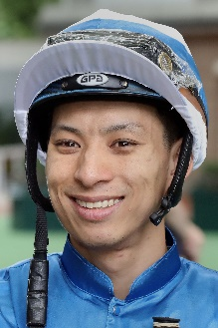 | Chadwick, Matthew
Age: 30.
Background: A graduate of Hong Kong's Apprentice Jockeys' School, Matthew Chadwick went to Australia for his apprentice training and rode a four-timer at Lismore Racecourse at age 17. Indentured to the Tony Cruz stable upon his return to Hong Kong, he was champion apprentice in 2008/09. He earned a full jockey's licence in January 2010. His first Group race winner was Egyptian Ra in the HKG3 National Day Cup (2009). Chadwick became the first homegrown rider to win a HKIR contest when clinching the G1 Hong Kong Cup on California Memory in 2011 and followed up on the same horse in the same race in 2012. He rode his first Hong Kong four-timer at Sha Tin on 22 June, 2014. Honours: Hong Kong Champion Apprentice (2008/09); Shergar Cup Silver Saddle winner (2012). LONGINES HKIR wins (2): Hong Kong Cup (2011 & 2012 California Memory). Hong Kong wins (as of 29 November): 384

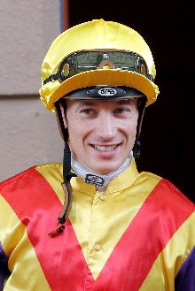 | Hamelin, Antoine
Age: 29.
Background: Frenchman Antoine Hamelin began his career as an apprentice to Jean de Roualle in Chantilly and has since ridden more than 700 winners. His first win came for Alain de Royer-Dupre aboard the Aga Khan-owned Artana at Lyon-Parilly racecourse on 11 November, 2009. Hamelin completed his apprenticeship under the tutelage of Royer-Dupre and went freelance upon earning fully-fledged jockey status, basing himself out of Chantilly. He is best known for his association with Saonois, who he partnered to classic victory in the 2012 G1 Prix du Jockey Club at Chantilly among other wins. Hamelin first rode in Hong Kong when pairing with Saonois to finish 10th in the 2012 LONGINES Hong Kong Cup at Sha Tin. Hamelin kicked off his three-month contract with a first-day double at Sha Tin, firstly aboard Best For You before Baltic Success burst clear later that day. Hamelin secured 17 wins across his first stint in Hong Kong and returns on a full-season licence for 2020/21. Hamelin has ridden in Great Britain, Ireland, Italy, Germany, USA, Spain, Dubai and Canada. In 2017 he gained a first Royal Ascot success in the Albany Stakes aboard 20/1 shot Different League. Hong Kong wins (as of 29 November): 23

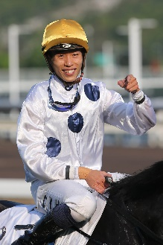 | Ho, Vincent
Age: 30.
Background: HKJC Apprentice Jockeys' School graduate Vincent Ho racked up 44 wins as a young rider in New Zealand under the tutelage of leading trainer Lance O'Sullivan. He made a good start to his Hong Kong career with 10 victories in his first season in 2009/10, including a trio of wins he achieved on only his fourth race day in Hong Kong. He sealed the 2010/11 Champion Apprentice title with 39 wins. Ho reached the graduation benchmark on 1 October, 2012 by claiming his 70th win in Hong Kong on board Castle Hero. He notched 33 wins in 2014/15 to be the season's leading homegrown rider. Ho enjoyed his best season to date in 2019/20 with not only a career-high 67 wins but a renewed partnership with the brilliant Golden Sixty saw the pair sweep the Four-Year-Old Classic Series, culminating an unbeaten term with a thrilling Hong Kong Derby victory. Ho followed those triumphs with a career-first G1, saluting with Southern Legend in 2020 Champions Mile, outlasting Beauty Generation by a short-head. Among his 67-seasonal wins, Ho took four other Pattern Races, two at G2 level and two at G3 level as well as a second consecutive Tony Cruz Award as the season’s leading homegrown rider. Ho rode a short stint in Europe during the off-season in 2018 and notched a first UK win at the first attempt, partnering the Mark Johnston-trained X Rated to success at Haydock on 9 August. He returned to Britain during the 2019 off-season and competed at the Shergar Cup at Ascot where he won the Shergar Cup Mile aboard the Marcus Tregoning-trained Power Of Darkness, helping the Rest of the World team secure the Shergar Cup. Honours: Hong Kong Champion Apprentice (2010/11); Best Freelance Jockey Award (2014/15); Tony Cruz Award (2018/19 & 2019/20). Hong Kong wins (as of 29 November): 355

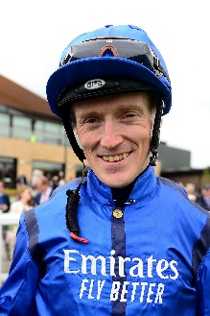 | Lee, William
Age: 34.
Background: Irishman Billy Lee rode his first winner aboard Zeno over at Sligo in 2002, quickly establishing himself as a rising star under the tutelage of trainer Tommy Stack, with whom he completed his apprenticeship. While Flat racing has been Lee’s unwavering focus throughout his career, he has tasted success over jumps with victory in the Listed Gordon Plant Memorial Newton Novices’ Hurdle aboard Wanango at Haydock Park, but his biggest win to date came with a first G1 triumph aboard Fiesolana for Willie McCreery in the Matron Stakes at Leopardstown in 2014. Lee’s Royal Ascot victories include those on Settle For Bay in the Royal Hunt Handicap in 2018, five years after partnering Joanna Morgan’s Roca Tumu to Britannia Stakes success. Lee has partnered a string of top gallopers, notably Romanised who he partnered to G1 success in France’s Prix Jacques Le Marois, Agnes Stewart, Gordon Lord Byron, Space Traveller, Downforce and Devonshire. He has also ridden abroad successfully with stints in Dubai, Australia and Qatar. Honours: Irish Racing’s ride of the year (2019). Hong Kong wins (as of 29 November): Has not ridden in Hong Kong previously.

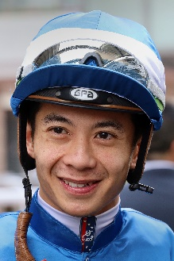 | Leung, Derek
Age: 32.
Background: Derek Leung’s career highlight is his 2017 LONGINES Hong Kong Mile victory aboard Beauty Generation. A product of Hong Kong's Apprentice Jockeys' School, he cut his teeth in New Zealand under trainer Lance O'Sullivan. He was assigned as apprentice jockey to Paul O'Sullivan's stable upon his return to Hong Kong. Leung reached the graduation benchmark after his 70th win on board Star Of Fame on 1 June, 2011. He reached a personal best total of 33 wins in the 2015/16 season and received the Tony Cruz Award in 2016/17 and 2017/18 as the leading home-grown rider. His biggest win came in the 2017 Hong Kong Mile on Beauty Generation. Honours: Asian Young Guns Challenge winner (2010); Tony Cruz Award winner (2017 & 2018). LONGINES HKIR wins (1): Hong Kong Mile (2017 Beauty Generation). Hong Kong wins (as of 29 November): 321

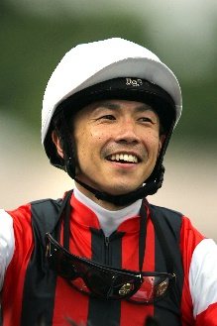 | Matsuoka, Masami
Age: 36.
Background: Matsuoka commenced his JRA jockey career in 2003 and travelled to Ireland in 2006 and worked for trainer John Oxx for three months. He earned his first top-class win the following year, atop Koiuta in the JPN G1 Victoria Mile, before adding another important win with Meiner Kitz in the 2009 G1 Tenno Sho Spring. He had to wait 10 years for his next major wins in 2019, as he guided Win Bright to victory in the G1 FWD QEII Cup, setting a 2000m Sha Tin course record in the process, before completing a Sha Tin double on that horse in the G1 LONGINES Hong Kong Cup. Matsuoka was sidelined for eight months after suffering a bone fracture in a race fall in February. He has amassed a total of 830 JRA wins, including two (as of 29 November) this year. HKIR win (1): LONGINES Hong Kong Cup (2019 Win Bright). Hong Kong wins (as of 29 November): 2

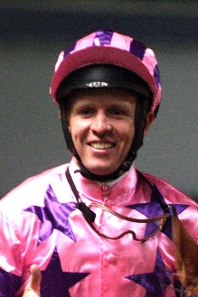 | McEvoy, Kerrin
Age: 40.
Background: Kerrin McEvoy made his name as a fresh-faced 20-year-old when he became the second-youngest jockey to win the G1 Melbourne Cup (2000 Brew) - he has won it three times in all thanks to Almandin (2016) and Godolphin’s Cross Counter (2018). Sheikh Mohammed’s Godolphin team recognised his talent and in 2004 appointed him second rider behind Frankie Dettori in Europe. During that spell he won a British Classic thanks to Rule Of Law in the G1 St Leger and notably partnered Shamardal to G1 success at Royal Ascot. Since returning to Australia in 2008 he has established himself among the elite in his homeland. He has been associated with Australian champion colt The Autumn Sun and won the first two editions of the Everest on Redzel, before landing a third this year atop Classique Legend. Honours: LONGINES IJC champion (2013). Hong Kong wins (as of 29 November): 2

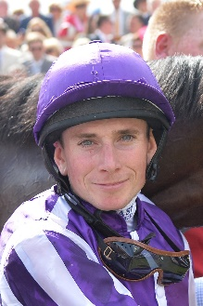 | Moore, Ryan
Age: 37.
Background: Ryan Moore is a two-time winner of the LONGINES IJC. He is the outstanding international rider of recent years and was the first recipient of the LONGINES World’s Best Jockey Award as a result of 15 G1 wins in 2014. He won that accolade again in 2016. Moore hails from a racing family. His first win came for his trainer father, Gary Moore, on Mersey Beat over hurdles at Towcester in May 2000. His first professional Flat win came on Marwell’s Kiss at Lingfield in January 2002. He notched a first G1 aboard Notnowcato in the 2006 Juddmonte International Stakes at York and has won 11 English Classics. Moore bagged 11 G1 wins in 2019, and this year’s six G1s have taken his overall tally to 138 at the elite level in 11 different countries. Moore has won some of the world’s foremost races including the LONGINES Hong Kong Cup (2016 Maurice), LONGINES Hong Kong Mile (2015 Maurice), LONGINES Hong Kong Vase (2015 & 2017 Highland Reel), Prix de l’Arc de Triomphe, English Derby, Japan Cup, Breeders’ Cup Turf and Melbourne Cup.
Honours: British Champion Jockey (2006, 2008, 2009); British Champion Apprentice (2003); LONGINES IJC winner (2009 [shared] & 2010); LONGINES World’s Best Jockey Award winner (2014 & 2016). LONGINES HKIR wins (5): Hong Kong Vase (2015 & 2017 Highland Reel), Hong Kong Cup (2010 Snow Fairy, 2016 Maurice), Hong Kong Mile (2015 Maurice). Hong Kong wins (as of 29 November): 34

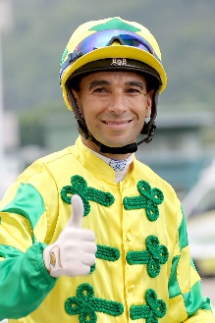 | Moreira, Joao
Age: 37.
Background: Known as “Magic Man”, Joao Moreira notched more than 1000 wins in South America before moving to Asia. He relocated to Singapore in 2009, and, after finishing third in the premiership in that first season, he proceeded to dominate the Singapore circuit for four years. He moved to Hong Kong in October 2013 and was champion jockey for three straight seasons, with record-breaking win totals (145, 168 and 170). Moreira departed for Japan at the end of the 2017/18 season but returned to Hong Kong in December 2018 to ride as stable jockey to John Size, ending that term with 90 wins. In the 2019/20 season he amassed 138 wins, five at G1 level including two aboard that season’s Champion Sprinter, Beat The Clock, to accrue total prize money of HK$206 million. He is currently leading this season’s premiership. Honours: LONGINES IJC winner (2012); Hong Kong Champion Jockey (2014/15, 2015/16, 2016/17); Singapore Champion Jockey (2010, 2011, 2012, 2013); two-time Brazilian Eclipse Award winner (2006/07, 2007/08); fastest 100 in a Hong Kong season (22 February, 2017); Hong Kong record for most wins in a season (170 in 2016/17); most wins in a Hong Kong race day (eight: 5 March, 2017); Singapore record for most wins in a season (206 in 2012); eight wins from eight rides at Kranji (6 September, 2013); eight wins in a day at Cidade Jardim (March 2006). World All-Star Series (Japan) winner (2015). LONGINES HKIR wins (6): Hong Kong Vase (2016 Satono Crown, 2019 Glory Vase), Hong Kong Cup (2014 Designs On Rome), Hong Kong Mile (2014 Able Friend), Hong Kong Sprint (2015 Peniaphobia, 2019 Beat The Clock). Hong Kong wins (as of 29 November): 990

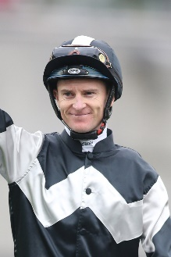 | Purton, Zac
Age: 37.
Background: Zac Purton sealed a fourth Hong Kong jockeys’ championship last season, outgunning his great rival Joao Moreira 147 – 138, notching a hat-trick of titles for the Australian. The previous season, Purton grabbed his third championship with 168 wins and a record-setting stakes money of almost HK$235 million. Having ended Douglas Whyte's 13-season dominance with his first Hong Kong jockeys' championship in 2013/14 (112 wins), in 2017/18 he halted Moreira’s own title streak at three. His second championship was a remarkable effort as he chased down Moreira to take the lead for the first time that term on June 10, 2018. Five weeks later, at season’s end, he had outpointed Moreira 136-134 with a win strike rate of 21% to the Brazilian’s 20%. Purton started his career in Brisbane and was an apprentice sensation, winning the premiership there in 2003. He then moved on to Sydney where he was twice second in the premiership. Purton moved to Hong Kong in September 2007. His many major wins include the King's Stand Stakes at Royal Ascot in 2012, a Caulfield Cup success aboard Admire Rakti in 2014. Purton’s achievements include a record-matching eight victories at the LONGINES HKIR, including triumphs in each of the four features. He is the regular partner of Hong Kong’s highest-earning horse, Beauty Generation. Honours: Hong Kong Champion Jockey (2013/14, 2017/18, 2018/19, 2019/20); Brisbane Champion Jockey (2003 - when still an apprentice); LONGINES IJC (2017); World Super Jockeys Series (Japan) winner (2012). LONGINES HKIR wins (8): Hong Kong Vase (2013 Dominant, 2018 Exultant), Hong Kong Cup (2017 Time Warp), Hong Kong Mile (2012 Ambitious Dragon, 2016 Beauty Only, 2018 Beauty Generation), Hong Kong Sprint (2014 & 2016 Aerovelocity). Hong Kong wins (as of 29 November): 1,198

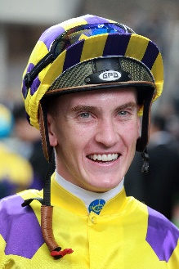 | Schofield, Chad
Age: 26.
Background: Chad Schofield spent four years (2002-2006) of his youth living in Hong Kong where his father, the South African jockey Glyn Schofield, was contracted to ride. His family relocated to Australia and Schofield commenced his own riding career in Sydney in the 2010/11 season, enjoying rapid success. He moved to Melbourne in 2012 to ride for the powerful David Hayes stable. His first Group 1 win was a major, the 2013 Cox Plate on Shamus Award. He and his father made history in 2014 as the first father and son to compete against each other in the Melbourne Cup and at Sha Tin on 14 February, 2016 they became the first in Hong Kong to ride against each other. Schofield tallied 43 wins during the 2019/20 season, five more than his previous best. Schofield spent three months during the summer of 2015 riding in England, based out of Ed Dunlop's yard, and scored two wins from 42 rides. Honours: Sydney and New South Wales Champion Apprentice (2011/12); Melbourne Champion Apprentice (2012/13). Hong Kong wins (as of 29 November): 190

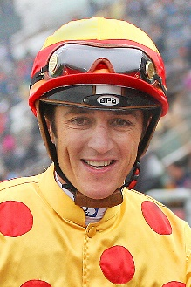 | Soumillon, Christophe
Age: 39.
Background: Belgian ace Christophe Soumillon is a son of jump jockey Jean-Marc Soumillon. He was apprenticed to Cedric Boutin at Chantilly and rode his first winner in November 1997. He was champion apprentice in 1999. His outstanding talent in the saddle has brought him 10 champion jockey titles in France (2003, 2005, 2006, 2011, 2012, 2013, 2014, 2015 (shared with Pierre-Charles Boudot), 2017 and 2018. In 2018 he set a European record of 305 wins in year. He has had two spells as the Aga Khan’s number one jockey and some of his greatest moments have been in the famous green and red silks, notably two Prix de l’Arc de Triomphe wins, on Dalakhani and the brilliant filly Zarkava. He has won G1 races across Europe, Japan, Hong Kong, Dubai, Canada and the USA. In 2016 he partnered Almanzor to wins in the Irish Champion Stakes and the Champion Stakes. He had back-to-back Dubai World Cup scores aboard the Godolphin-owned Thunder Snow in 2018 and 2019. Honours: x10 France’s champion jockey. LONGINES HKIR wins (2): Hong Kong Mile (2008 Good Ba Ba, 2019 Admire Mars). Hong Kong wins (as of 29 November): 110

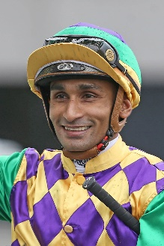 | Teetan, Karis
Age: 30.
Background: Mauritian rider Karis Teetan was well ensconced in the top 10 of the South African Jockeys' Championship when he left for Hong Kong in August 2013. He entered the South African Jockey Academy at the age of 14 and went on to be crowned South African Champion Apprentice in 2008. He graduated in 2009 with 147 wins to his credit. Teetan passed the 100-win mark in every season as a senior jockey in South Africa. His first top-level win was in his native Mauritius on 24 November, 2008, aboard Halo Hunter. Teetan represented South Africa in the 2012 International Jockeys' Invitational in Seoul, Korea and in the 2008 Macau Apprentice Jockeys Invitation Races. He notched an impressive 50 wins in his first Hong Kong season and has continued to build on that good start. He finished third in the 2017/18 premiership race with 52 wins, which included a trio of Group 3 triumphs. He topped that in 2018/19 with 84 wins as he secured his first Hong Kong G1 win aboard Mr Stunning in the Hong Kong Sprint and again went better in 2019/20 with a personal best of 93 wins, cementing third place in the premiership race. He reunited with Mr Stunning in the 2020 Chairman’s Sprint Prize, securing the Mauritian his second Hong Kong G1. Honours: South African Champion Apprentice (2008); LONGINES IJC winner (2019). LONGINES HKIR wins (1): Hong Kong Sprint (2018 Mr Stunning). Hong Kong career wins (as of 29 November): 418

