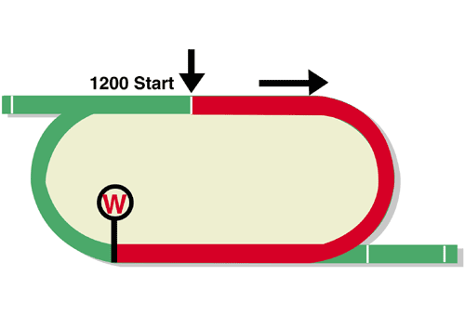
Chairman’s Sprint Prize (Group 1)
Final Leg of the Hong Kong Speed Series
Race Best Time
1.08.20 (2007)
HK$18 million (US$2.3 million)
1st HK$10,260,000, 2nd HK$3,960,000, 3rd HK$1,800,000,
4th HK$1,026,000, 5th HK$594,000, 6th HK$360,000

Performance Analysis

Horse Details |  |  |  |  |  | Horse Statistics |  |  |  |  |  |  | Probable Jockey | Trainer
Name |  | Rep | Age/  Sex | Wt. | Int’l Rtg (20/21) | Lifetime | G1 | Good | Wet | RH | 1000-1200 | Trk/Dist
Danon Smash | 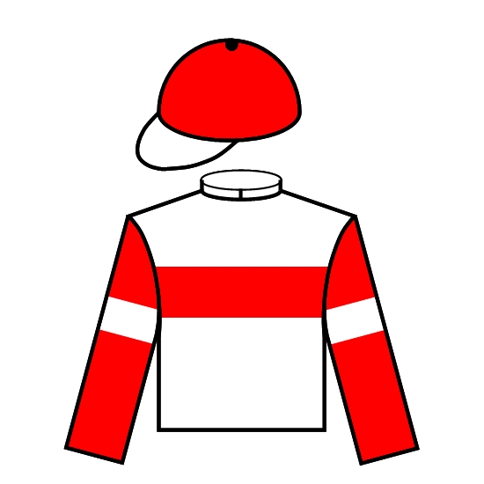 | JPN | 6h | 126 | 116 | 23 (11-3-1) | 10 (2-1-1) | 21 (10-3-1) | 2 (1-0-0) | 14 (8-2-1) | 14 (8-2-1) | 2 (1-0-0) | J Moreira | T Yasuda
Jolly Banner | 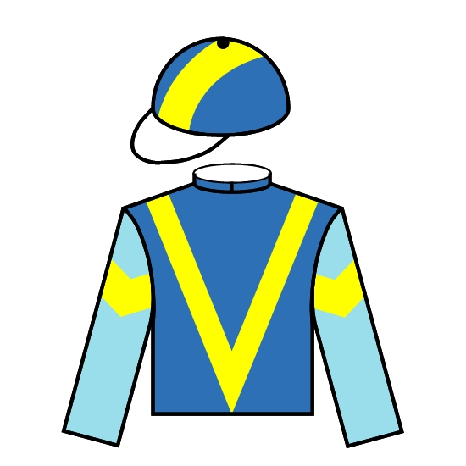 | HK | 9g | 126 | 113 | 47 (8-8-10) | 3 (0-1-0) | 42 (7-8-8) | 3 (1-0-1) | 42 (6-6-10) | 16 (2-4-4) | 9 (0-2-3) | M F Poon | P F Yiu
Wishful Thinker |  | HK | 7g | 126 | 113 | 39 (9-1-8) | 8 (0-0-0) | 36 (8-1-7) | 3 (1-0-1) | 28 (6-1-5) | 36 (9-1-8) | 23 (4-1-5) | K C Leung | C H Yip
Computer Patch | 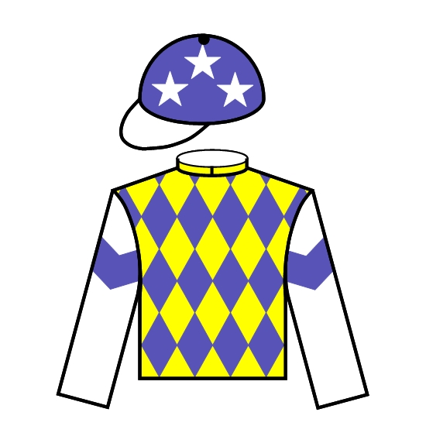 | HK | 4r | 126 | 112 | 19 (5-5-1) | 2 (0-0-0) | 19 (5-5-1) | 0 (0-0-0) | 16 (3-5-1) | 19 (5-5-1) | 13 (2-5-1) | M Chadwick | A S Cruz
Rattan |  | HK | 7g | 126 | 112 | 34 (7-7-4) | 7 (0-1-1) | 32 (6-7-4) | 2 (1-0-0) | 33 (7-7-4) | 10 (1-1-3) | 9 (1-1-3) | C Schofield | R Gibson
Wellington | 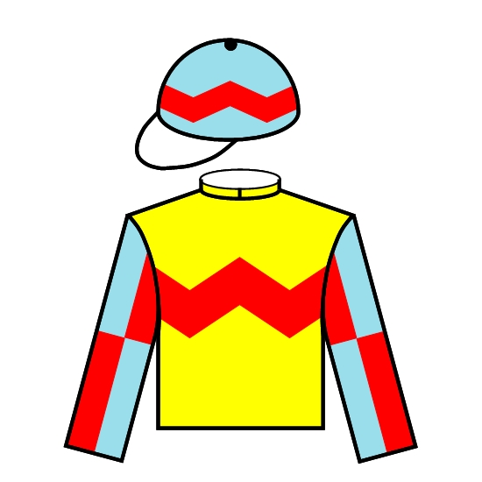 | HK | 4g | 126 | 112 | 9 (6-1-0) | 0 (0-0-0) | 9 (6-1-0) | 0 (0-0-0) | 7 (5-0-0) | 8 (6-1-0) | 6 (5-0-0) | A Badel | R Gibson
Amazing Star |  | HK | 6g | 126 | 111 | 22 (7-2-1) | 2 (0-0-0) | 20 (7-2-1) | 0 (0-0-0) | 19 (7-2-0) | 22 (7-2-1) | 8 (2-2-0) | V Borges | K H Ting
Big Party |  | HK | 5g | 126 | 111 | 21 (5-0-3) | 3 (0-0-1) | 19 (4-0-3) | 1 (0-0-0) | 17 (4-0-2) | 21 (5-0-3) | 15 (2-0-2) | K Teetan | F C Lor
Fat Turtle | 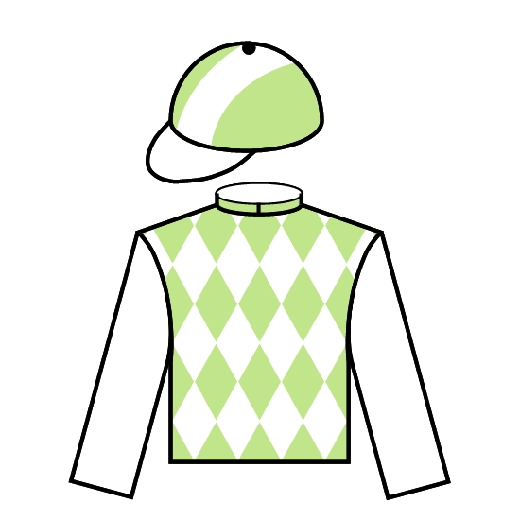 | HK | 6g | 126 | 111 | 30 (6-7-2) | 3 (0-0-0) | 28 (5-6-2) | 2 (1-1-0) | 30 (6-7-2) | 18 (5-6-1) | 11 (2-2-1) | A Hamelin | F C Lor
Stronger | 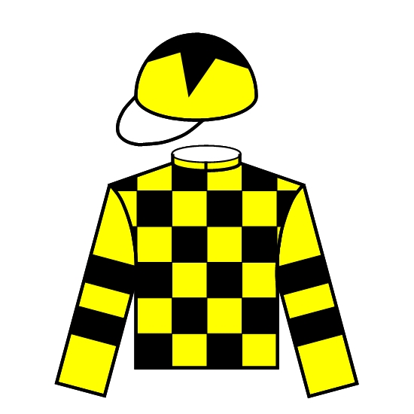 | HK | 4c | 126 | 110 | 23 (5-5-2) | 2 (0-0-0) | 18 (3-5-1) | 5 (2-0-1) | 18 (4-2-2) | 22 (4-5-2) | 6 (0-1-0) | C Y Ho | D J Whyte
Voyage Warrior | 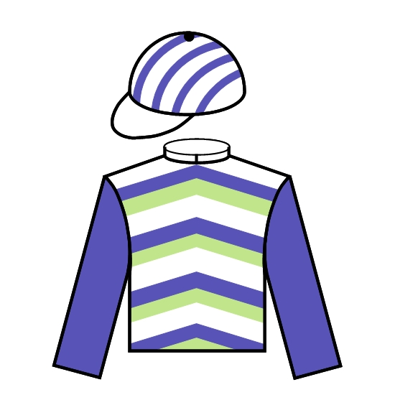 | HK | 5g | 126 | 110 | 17 (5-1-0) | 3 (0-0-0) | 16 (5-0-0) | 1 (0-1-0) | 11 (1-0-0) | 17 (5-1-0) | 11 (1-0-0) | R Maia | P F Yiu
Beauty Applause | 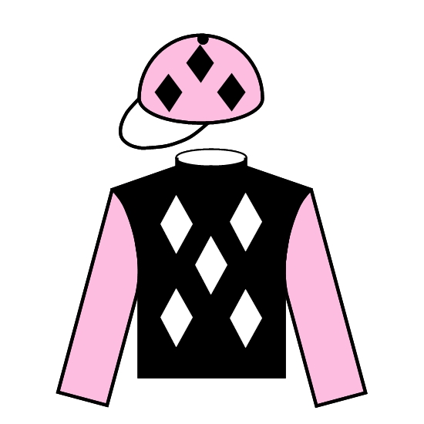 | HK | 5g | 126 | 108 | 21 (6-3-3) | 0 (0-0-0) | 21 (6-3-3) | 0 (0-0-0) | 20 (5-3-3) | 17 (6-3-2) | 14 (5-3-2) | Z Purton | J Size
Sky Field |  | HK | 4g | 126 | 103 | 11 (4-1-2) | 0 (0-0-0) | 11 (4-1-2) | 0 (0-0-0) | 11 (4-1-2) | 10 (4-1-1) | 8 (3-1-1) | B Shinn | C Fownes

Barrier Draw Statistics (Since 1992) Speed Chart

Draw 1st 2nd 3rd 4th  1 3 4 4 3  2 3 1 1 1  3 2 3 3 5  4 3 4 2 1  5 4 4 3 4  6 1 0 1 3  7 2 2 2 3  8 1 2 3 6  9 1 6 1 1  10 3 0 4 1  11 3 3 3 0  12 1 0 2 1  13 1 0 0 1  14 1 0 0 0  (Past 29 runnings) | 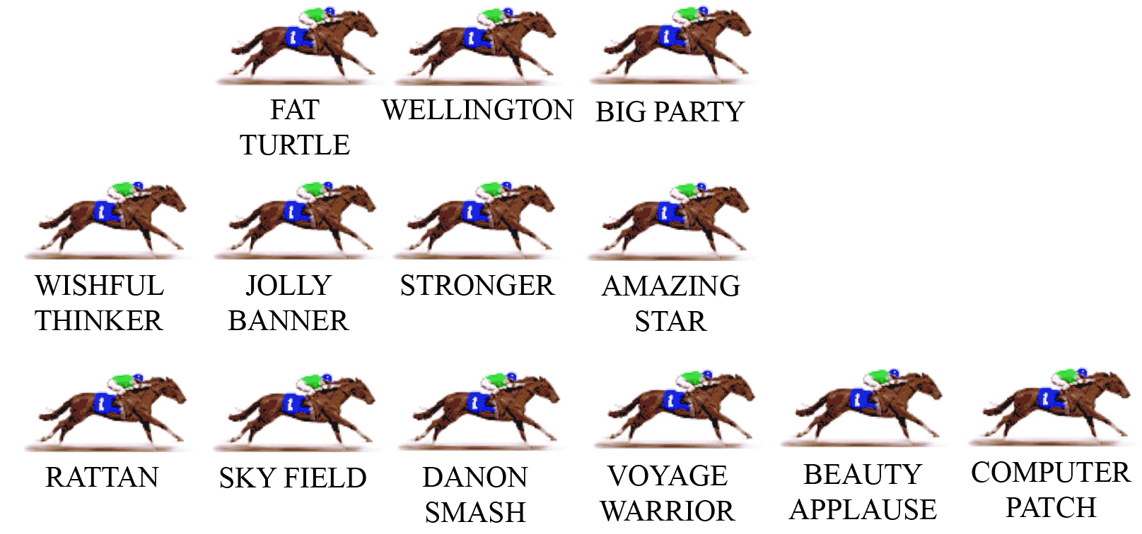  COMPUTER PATCH looks the likely leader here, from BEAUTY APPLAUSE. In the history of the race, it’s typically been on-pace runners who have won this race, with the exception of Chautauqua, who came from last with a devastating finishing sprint. VOYAGE WARRIOR, AMAZING STAR and BIG PARTY can all race prominently. At midfield, we should have the Japanese visitor DANON SMASH, together with STRONGER and the up-and-comer WELLINGTON. With COMPUTER PATCH engaged, the speed should be decent.  PACE: GOOD

