Spotlight

Danon Smash, winner of December’s G1 LONGINES Hong Kong Sprint (1200m) is aiming to add another top-level victory in Hong Kong to his growing resume when he contests the G1 Chairman’s Sprint Prize. His record, which now also features last month’s G1 Takamatsunomiya Kinen (1200m) at Chukyo Racecourse, is growing rapidly and he tops the billing for this month’s HK$18 million dash.

But there is no shortage of talent in Hong Kong bidding to stop him. Jolly Banner, who finished second to Danon Smash in last year’s G1 LONGINES Hong Kong Sprint is entered, while Wellington, who clocked an equal Class 1 record to that of the legendary Sacred Kingdom also lines up.

A trio of G2 winners also feature - Wishful Thinker, who claimed this season’s Premier Bowl (1200m) is engaged, as is Rattan, the 2019 G2 Sprint Cup (1200m) victor, while Voyage Warrior, the winner of the 2020 G2 Sprint Cup (1200m), takes his place.

Trainer Frankie Lor, who won this race last year with Mr Stunning, will be represented by a pair of talents, the G3-winning Big Party and Fat Turtle, fifth in last year’s G1 LONGINES Hong Kong Sprint.

Computer Patch, a G3 winner down the straight features, as does Sky Field and three supplementary entries, the first three across the line in the G2 Sprint Cup (1200m), Amazing Star, Stronger and Beauty Applause, respectively, rounding out the 13-runner field.

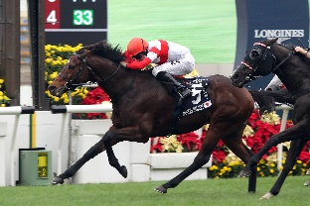 | DANON SMASH (JPN)  JAPAN  6h 116  T Yasuda | 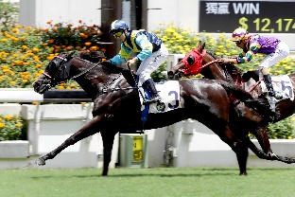 | JOLLY BANNER (AUS)  HONG KONG  9g 113  P F Yiu
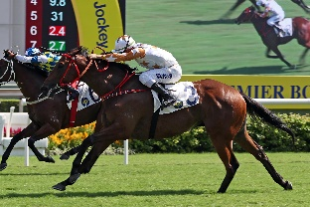 | WISHFUL THINKER (AUS)  HONG KONG  7g 113  C H Yip | 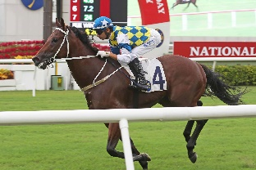 | COMPUTER PATCH (AUS)  HONG KONG  4r 112  A S Cruz
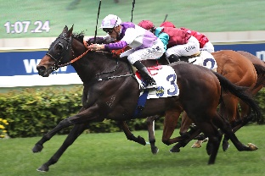 | RATTAN (NZ)  HONG KONG  7g 112  R Gibson | 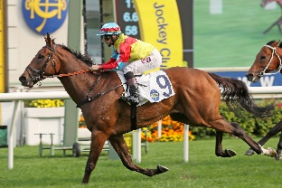 | WELLINGTON (AUS)  HONG KONG  4g 112  R Gibson
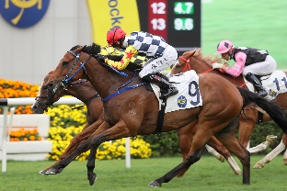 | AMAZING STAR (NZ)  HONG KONG  6g 111  K H Ting | 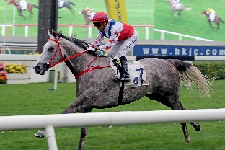 | BIG PARTY (AUS)  HONG KONG  5g 111  F C Lor
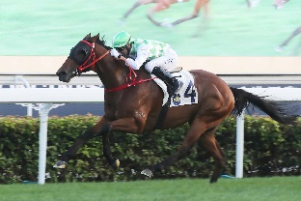 | FAT TURTLE (AUS)  HONG KONG  6g 111  F C Lor | 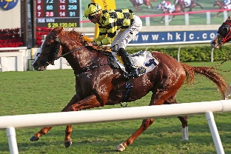 | STRONGER (AUS)  HONG KONG  4c 110  D J Whyte
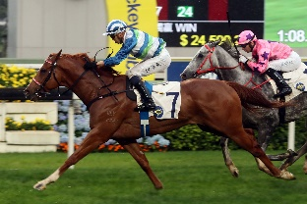 | VOYAGE WARRIOR (AUS)  HONG KONG  5g 110  P F Yiu | 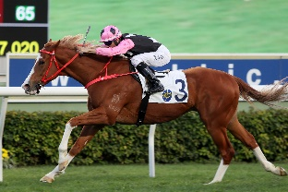 | BEAUTY APPLAUSE (AUS)  HONG KONG  5g 108  J Size
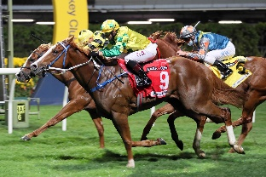 | SKY FIELD (AUS)  HONG KONG  4g 103  C Fownes

