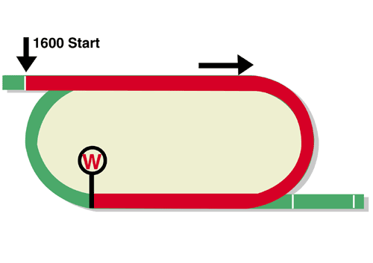
FWD Champions Mile (Group 1)
HK$20 million (US$2.6 million)
Race Best Time
1.33.13 (2020)
1st HK$11,400,000, 2nd HK$4,400,000, 3rd HK$2,000,000,
4th HK$1,140,000, 5th HK$660,000, 6th HK$400,000

Performance Analysis

Horse Details |  |  |  |  |  | Horse Statistics |  |  |  |  |  |  | Probable Jockey | Trainer
Name |  | Rep | Age/  Sex | Wt. | Int’l Rtg (20/21) | Lifetime | G1 | Good | Wet | RH | 1400-1800 | Trk/Dist
Golden Sixty | 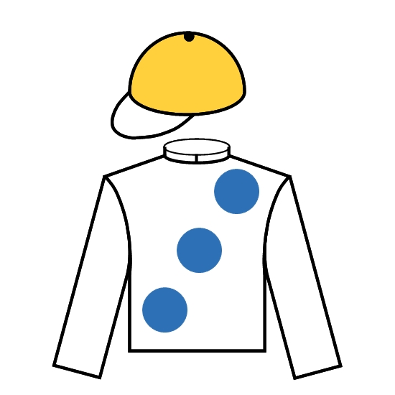 | HK | 5g | 126 | 124 | 17 (16-0-0) | 3 (3-0-0) | 17 (16-0-0) | 0 (0-0-0) | 17 (16-0-0) | 11 (10-0-0) | 5 (5-0-0) | C Y Ho | K W Lui
Southern Legend | 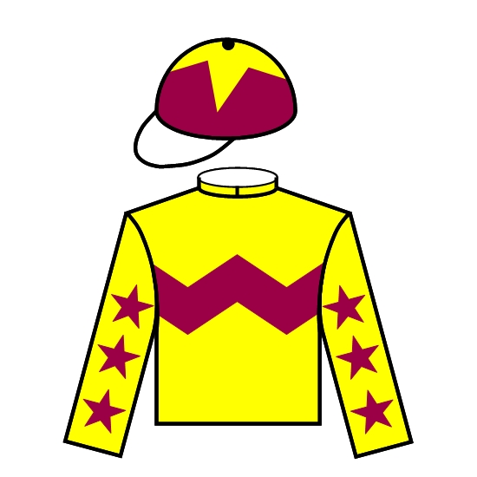 | HK | 8g | 126 | 118 | 50 (12-8-9) | 14 (1-4-3) | 46 (11-7-9) | 4 (1-1-0) | 46 (10-8-8) | 31 (6-6-6) | 16 (2-5-6) | K Teetan | C Fownes
Ka Ying Star | 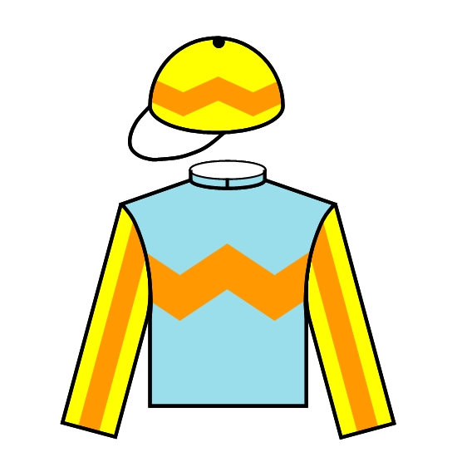 | HK | 6g | 126 | 117 | 31 (7-7-6) | 7 (0-1-2) | 30 (7-7-5) | 1 (0-0-1) | 27 (4-7-5) | 30 (7-7-6) | 18 (4-5-4) | Z Purton | A S Cruz
Mighty Giant | 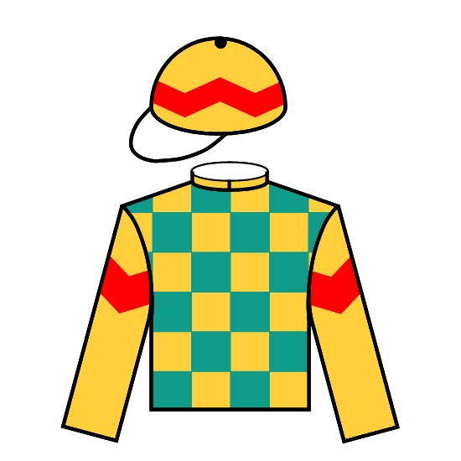 | HK | 5g | 126 | 114 | 15 (7-2-2) | 3 (0-0-1) | 15 (7-2-2) | 0 (0-0-0) | 15 (7-2-2) | 14 (7-2-2) | 4 (1-0-0) | A Hamelin | P F Yiu
More Than This |  | HK | 5g | 126 | 114 | 19 (7-2-3) | 3 (0-0-0) | 19 (7-2-3) | 0 (0-0-0) | 17 (5-2-3) | 17 (6-2-2) | 10 (3-2-1) | J Moreira | K W Lui
Healthy Happy | 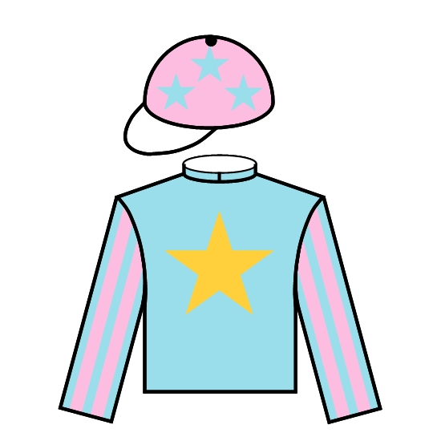 | HK | 4g | 126 | 109 | 11 (5-2-1) | 0 (0-0-0) | 9 (4-1-1) | 2 (1-1-0) | 11 (5-2-1) | 5 (3-0-0) | 1 (0-0-0) | A Badel | F C Lor

Barrier Draw Statistics (Since 2001) Speed Chart

Draw 1st 2nd 3rd 4th  1 4 3 2 1  2 4 2 3 2  3 1 1 1 3  4 1 3 4 1  5 1 1 3 1  6 1 3 1 4  7 2 2 1 0  8 3 1 1 3  9 2 1 1 1  10 0 1 1 2  11 0 0 0 1  12 1 1 1 0  13 0 0 0 0  14 0 1 1 1  (Past 20 runnings) | 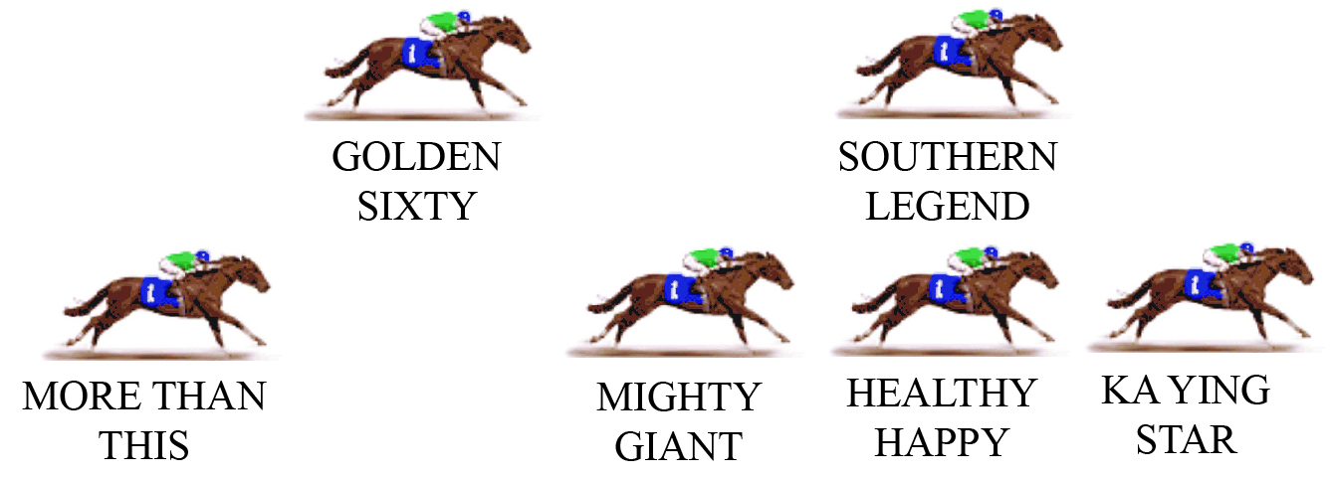  KA YING STAR looks the likely leader here, but he won’t be taking them along at any great pace. HEALTHY HAPPY is the alternative leader but he will probably defer to KA YING STAR. The 2020 winner SOUTHERN LEGEND is out to defend his crown and he will race prominently as usual, and MIGHTY GIANT will drop in behind this group. Champion GOLDEN SIXTY will balance up and get back in the field as normal. MORE THAN THIS should settle at the tail.  PACE: GOOD TO SLOW

