Spotlight

Golden Sixty was imperious when winning the 2020 G1 LONGINES Hong Kong Mile and the brilliant son of Medaglia d’Oro will step down in distance after claiming February’s G1 Citi Hong Kong Gold Cup (2000m) to contest the G1 FWD Champions Mile.

While two legs of Hong Kong’s Triple Crown are in the bag and the third, the G1 Standard Chartered Champions & Chater Cup (2400m) is set for the end of May, the new pin-up boy of Hong Kong racing will in the meantime look to extend his record to 14 consecutive wins in the FWD Champions Mile, with a view to also winning his fourth G1 race in succession.

But there is no shortage of opposition to Francis Lui’s standout charge, with six selected to run including last year’s winner of the race, Southern Legend, a consistent jetsetter who has two international successes to his name in Singapore and, was narrowly touched off by Golden Sixty three starts ago in the G1 Stewards’ Cup (1600m) by a head.

Also included in the small but select field is the four-year-old Healthy Happy, winner of the Hong Kong Classic Cup (1800m).

The home team also features Ka Ying Star, last-start G2 Chairman’s Trophy all-the-way winner Mighty Giant and More Than This.

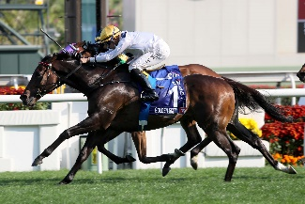 | GOLDEN SIXTY (AUS)  HONG KONG  5g 124  K W Lui | 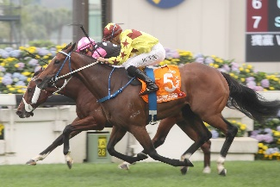 | SOUTHERN LEGEND (AUS)  HONG KONG  8g 118  C Fownes
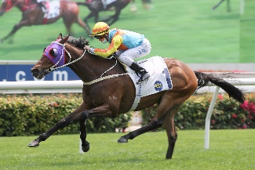 | KA YING STAR (GB)  HONG KONG  6g 117  A S Cruz | 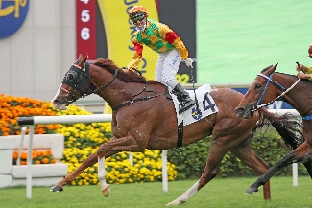 | MIGHTY GIANT (NZ)  HONG KONG  5g 114  P F Yiu
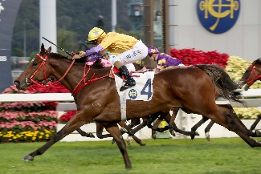 | MORE THAN THIS (GB)  HONG KONG  5g 114  K W Lui | 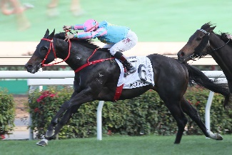 | HEALTHY HAPPY (AUS)  HONG KONG  4g 109  F C Lor

