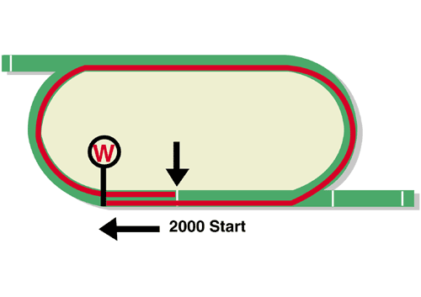
FWD QEII Cup (Group 1)
Race Best Time
1.58.81 (2019)
HK$25 million (US$3.2 million)
1st HK$14,250,000, 2nd HK$5,500,000, 3rd HK$2,500,000,
4th HK$1,425,000, 5th HK$825,000, 6th HK$500,000

Performance Analysis

Horse Details |  |  |  |  |  | Horse Statistics |  |  |  |  |  |  | Probable Jockey | Trainer
Name |  | Rep | Age/  Sex | Wt. | Int’l Rtg (20/21) | Lifetime | G1 | Good | Wet | RH | 1800-2200 | Trk/Dist
Glory Vase |  | JPN | 6h | 126 | 123 | 14 (5-3-0) | 5 (1-1-0) | 13 (5-3-0) | 1 (0-0-0) | 10 (4-2-0) | 6 (2-1-0) | 0 (0-0-0) | K Teetan | T Ozeki
Exultant |  | HK | 7g | 126 | 120 | 34 (13-11-5) | 12 (5-4-3) | 31 (11-11-4) | 3 (2-0-1) | 33 (12-11-5) | 20 (7-8-3) | 10 (4-4-2) | Z Purton | A S Cruz
Furore |  | HK | 6g | 126 | 117 | 28 (8-3-5) | 10 (0-2-2) | 26 (7-3-4) | 2 (1-0-1) | 28 (8-3-5) | 17 (5-3-3) | 9 (2-3-0) | J Moreira | A S Cruz
Glorious Dragon |  | HK | 6g | 126 | 116 | 23 (5-5-2) | 3 (0-0-0) | 22 (4-5-2) | 1 (1-0-0) | 21 (4-5-2) | 17 (4-4-2) | 10 (2-1-2) | M F Poon | K W Lui
Kiseki |  | JPN | 7h | 126 | 115 | 28 (4-6-5) | 15 (1-4-1) | 25 (3-6-5) | 3 (1-0-0) | 19 (2-5-3) | 14 (3-3-4) | 0 (0-0-0) | C Schofield | Y Tsujino
Time Warp |  | HK | 8g | 126 | 109 | 50 (12-4-5) | 14 (3-0-1) | 38 (7-3-3) | 6 (4-0-1) | 44 (9-3-4) | 26 (5-3-1) | 16 (3-1-1) | M Chadwick | A S Cruz
Daring Tact |  | JPN | 4f | 122 | 119 | 7 (5-1-1) | 4 (3-0-1) | 5 (4-0-1) | 2 (1-1-0) | 4 (4-0-0) | 2 (1-1-0) | 0 (0-0-0) | K Matsuyama | H Sugiyama
Loves Only You |  | JPN | 5m | 122 | 116 | 12 (5-1-3) | 6 (1-0-3) | 11 (5-1-3) | 1 (0-0-0) | 8 (4-1-2) | 7 (3-1-2) | 0 (0-0-0) | C Y Ho | Y Yahagi

Barrier Draw Statistics (Since 1997) Speed Chart

Draw 1st 2nd 3rd 4th  1 4 3 1 2  2 1 2 5 1  3 2 2 3 4  4 0 1 3 0  5 4 4 0 2  6 2 2 2 3  7 2 0 1 4  8 5 3 1 3  9 1 1 1 1  10 1 2 2 0  11 0 2 1 4  12 2 1 2 0  13 0 1 2 0  14 0 0 0 0  (Past 24 runnings) | 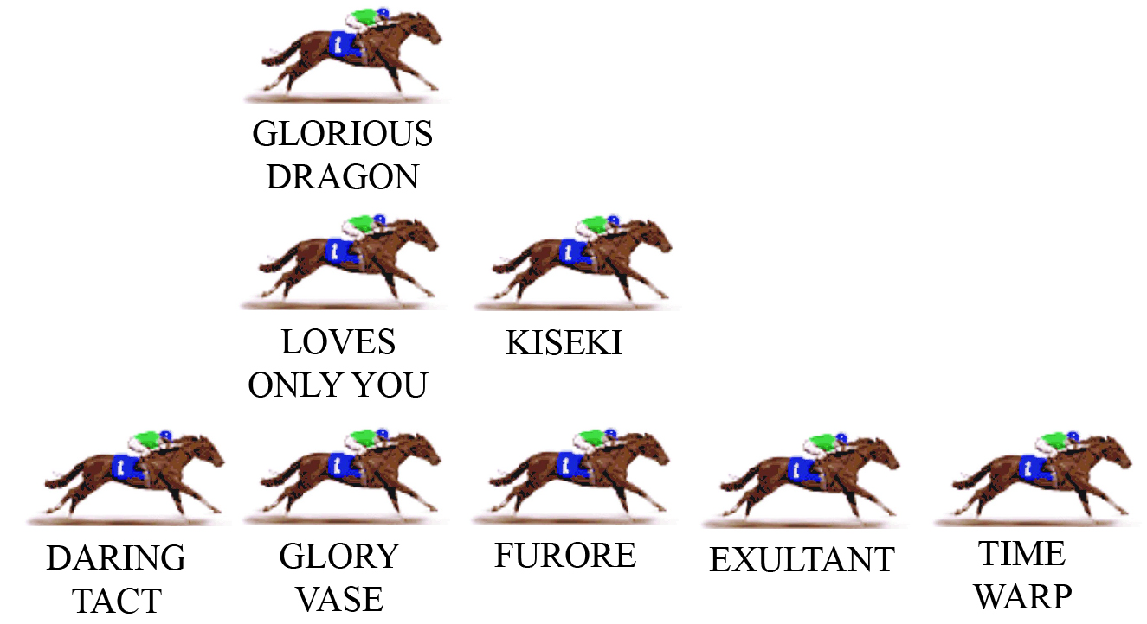  TIME WARP is a ready-made leader here and it’s hard to find anything that might challenge him early. EXULTANT will drop in behind TIME WARP but is unlikely to be adding any pace pressure in the early stages. FURORE can be next, in company with the Japanese visitor KISEKI. Another Japanese visitor GLORY VASE can follow, in company with compatriot LOVES ONLY YOU and Hong Kong’s GLORIOUS DRAGON. The fourth of the Japanese runners, DARING TACT, is likely to settle at the tail of the field.  PACE: GOOD TO SLOW

