Spotlight

Reigning Horse of the Year Exultant will meet Japan’s Daring Tact in a clash of old and young over the famed 2000m at Sha Tin in the G1 FWD QEII Cup. A seven-year-old now, the Irish-bred son of Teofilo, Exultant, will aim to capture his sixth win at the top-level and second FWD QEII Cup in succession. Against him, Japan’s sixth Fillies’ Triple Crown victor Daring Tact, who in turn bids to become the sixth Japanese winner of the FWD QEII Cup as she steps out onto international soil for the first time as a brilliant winner over 1600m, 2000m and 2400m in her home country.

Not least, she also finished third to super mare Almond Eye in the 2020 Japan Cup (2400m) and, fifth out of that race, Glory Vase, the 2019 G1 LONGINES Hong Kong Vase (2400m) hero will also feature, as well as Japanese Classic winner Loves Only You and the enigmatic Kiseki – a brazen son of 2012 QEII Cup winner Rulership.

Trainer Tony Cruz’s game veteran Exultant is one of eight selected for the 2000m feature, which includes six G1 winners in total and his presence is bolstered by the inclusion of stablemates Time Warp and Furore, the former is a two-time G1 Citi Hong Kong Gold Cup (2000m) winner while the latter reigned supreme in the 2019 BMW Hong Kong Derby (2000m).

The improving Glorious Dragon, winner of the G3 Centenary Vase Handicap (1800m) and last-start course and distance winner, also lines up.

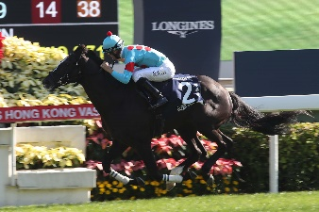 | GLORY VASE (JPN)  JAPAN  6h 123  T Ozeki | 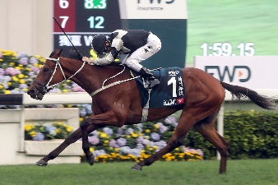 | EXULTANT (IRE)  HONG KONG  7g 120  A S Cruz
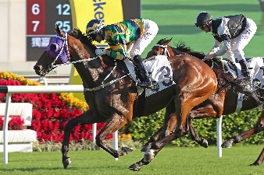 | FURORE (NZ)  HONG KONG  6g 117  A S Cruz | 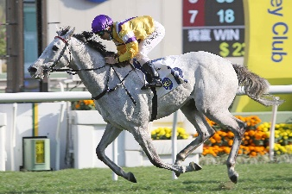 | GLORIOUS DRAGON (IRE)  HONG KONG  6g 116  K W Lui
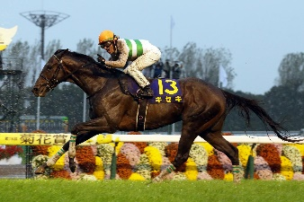 | KISEKI (JPN)  JAPAN  7h 115  Y Tsujino | 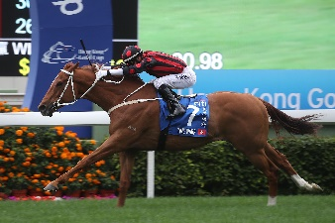 | TIME WARP (GB)  HONG KONG  8g 109  A S Cruz
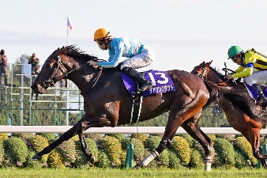 | DARING TACT (JPN)  JAPAN  4f 119  H Sugiyama | 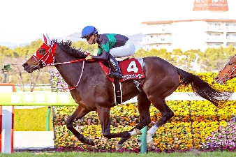 | LOVES ONLY YOU (JPN)  JAPAN  5m 116  Y Yahagi

