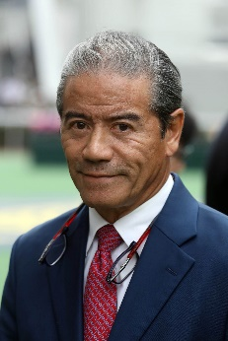 | Cruz, Tony | FWDQEII ‒ Exultant, Furore, Time Warp; FWDCM ‒ Ka Ying Star;  CSP ‒ Computer Patch
 | Age: 64. Tony Cruz is a son of Johnny Cruz, a renowned rider from Hong Kong's amateur era. He was among the first intake of apprentices to the HKJC Apprentice Jockeys’ School when that facility opened in 1972. Cruz started his riding career in the 1973/74 season. He went on to be Hong Kong's champion jockey six times and rode 946 winners. Cruz also made his name at G1 level in Europe and notably partnered the great race mare Triptych. He was granted a Hong Kong trainer's licence in 1996 and first landed the trainers' title in 1999/2000. He regained the crown in 2005, setting a then record for a season's winners (91) and earnings (HK$113m) in the process. He trained the great Hong Kong champion Silent Witness to win 17 consecutive races. Honours: Hong Kong Champion Jockey (1978/79, 1980/81, 1982/83, 1983/84, 1985/86, 1994/95); Hong Kong Champion Trainer (1999/00, 2004/05). FWD Champions Day race wins (7): FWD Champions Mile (2005 & 2006 Bullish Luck), FWD QEII Cup (2015 Blazing Speed, 2018 Pakistan Star, 2020 Exultant), Chairman's Sprint Prize (2004 & 2005 Silent Witness). Hong Kong wins (as of 11 April): 1,334.

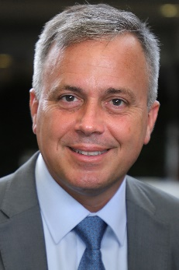 | Fownes, Caspar | FWDCM ‒ Southern Legend; CSP ‒ Sky Field
 | Age: 53. Caspar Fownes assisted his late father Lawrie for several seasons before gaining his licence in 2003/04. He eclipsed his father's best season stats in his rookie year with 44 wins. In 2006/07 he won his first premiership and has since added two more. His third championship came in 2013/14 when his strong late charge brought three wins on the closing day to tie with John Size on 62 wins, and with one more second place than his rival he sealed the title on count-back. Fownes is particularly known for his fine record at Happy Valley where he has notched 514 career wins (as at 5 April), a tally second only to Hong Kong's longest-serving trainer John Moore. He has enjoyed overseas success in Singapore’s G1 KrisFlyer International Sprint three times, firstly with Green Birdie in 2010, before Lucky Nine snared two in succession (2013 and 2014). Fownes’ most recent exploits abroad have reaped consecutive SIN G1 Kranji Mile’s with Southern Legend. Honours: Hong Kong Champion Trainer (2006/07, 2008/09, 2013/14). FWD Champions Day race wins (3): FWD Champions Mile (2020 Southern Legend), Chairman's Sprint Prize (2013 & 2014 Lucky Nine). Hong Kong wins (as of 11 April): 942.

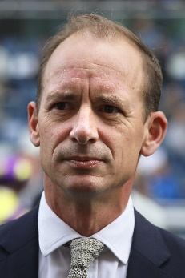 | Gibson, Richard | CSP ‒ Rattan, Wellington
 | Age: 51. Englishman Richard Gibson established himself as a Group 1 trainer in France before he arrived in Hong Kong ahead of the 2011/12 season. He gained a solid grounding in the art and science of training racehorses with Frenchmen Pascal Bary and Henri-Alex Pantall, as well as Americans Bill Mott and Gary Jones. He took out his first licence at Chantilly in 1996 and struck gold as early as 1999 when Lady Of Chad won the G1 Prix Marcel Boussac en route to becoming European Champion Juvenile Filly. He has trained the winners of eight G1s altogether, the highlights being Akeed Mofeed's and Doctor Dino's exploits in Hong Kong and the USA. His other high-class trainees prior to moving to Hong Kong include Marotta, Lune D'Or, Cut Quartz, Mores Wells, Swedish Shave, and for a short spell Dunaden. He also won the Hong Kong Derby with Akeed Mofeed. FWD Champions Day race wins (1): Chairman’s Sprint Prize (2015 Gold-Fun). Hong Kong wins (as of 11 April): 252.

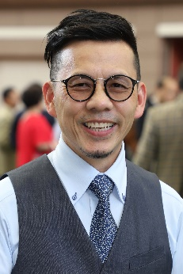 | Lor, Frankie F C | FWDCM ‒ Healthy Happy; CSP ‒ Big Party, Fat Turtle
 | Age: 54. Frankie Lor began his career as a rider in Hong Kong, notching 27 wins between 1981 and 1995. He became a work rider and then an assistant to a number of trainers, most notably to two of Hong Kong's greats, John Moore and John Size. Lor was granted a full licence ahead of the 2017/18 Hong Kong racing season. His first win was achieved with his first runner, Yourthewonforme, in a Class 4 contest at the season opener on 3 September, 2017. Lor ended that campaign second in the premiership behind his old master John Size. His final tally of 65 wins surpassed Hong Kong's previous best first-season total, set by Size when winning his first Hong Kong trainers’ championship in 2002. Lor landed his first G1 wins in only his second season, scooping a double at the 2018 LONGINES HKIR with Mr Stunning (Hong Kong Sprint) and Glorious Forever (Hong Kong Cup). That season also saw him sweep the 2019 Four-Year-Old Classic Series with Furore and Mission Tycoon. FWD Champions Day race wins (1): Chairman’s Sprint Prize (2020 Mr Stunning). Hong Kong wins (as of 11 April): 223.

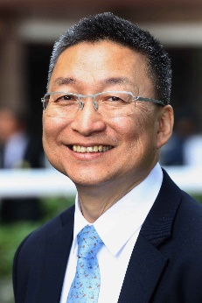 | Lui, Francis K W | FWDQEII ‒ Glorious Dragon; FWDCM ‒ Golden Sixty, More Than This
 | Age: 62. Francis Lui graduated from the HKJC Apprentice Jockeys' School to ride 36 winners as a licensed jockey between 1975 and 1982, and later became an assistant trainer. He received his own licence to train in 1996/97. Lui enjoyed his best season in 2019/20 when he not only challenged for the trainers’ title but also won all three legs of the Four-Year-Old Classic Series with the brilliant Golden Sixty; the handler saddled the bay through 13 races unbeaten since last term. Lui ended the last season with a personal best of 63 wins to place third in the championship, four behind Ricky Yiu. Hello Pretty also provided the handler with one leg of the Four-Year-Old Classic Series when he won the Hong Kong Derby Trial in 2006, while his standout stable star prior to Golden Sixty was sprinter Lucky Bubbles, who gave the trainer his first Group 1 win in 2017 when he took the Chairman's Sprint Prize. FWD Champions Day race win (1): Chairman’s Sprint Prize (2017 Lucky Bubbles). Hong Kong wins (as of 11 April): 729.

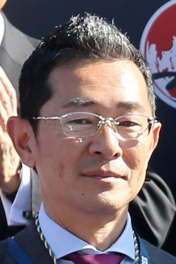 | Ozeki, Tomohito | FWDQEII ‒ Glory Vase
 | Age: 49. After graduating from his vet studies at university, Ozeki joined the JRA and started out as a groom in 1999. He obtained his JRA trainer licence in 2008 and established his own stable the following year. He has notched 298 JRA wins so far in his career, including six this term (as of 1 April). Red Falx gave him his first G1 success in the 2016 Sprinters Stakes before that same horse won the race for a second time the following year. Glory Vase brought Ozeki a first overseas success in the G1 2019 LONGINES Hong Kong Vase at Sha Tin. Sakura Gospel, winner of the 2015 G2 Keio Hai Spring Cup, is another notable horses he has trained. Hong Kong wins (as of 11 April): 1.

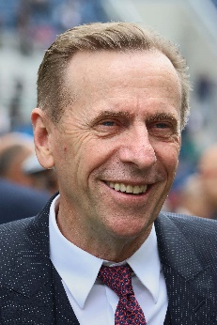 | Size, John | CSP – Beauty Applause
 | Age: 66. John Size was a top trainer in Sydney before his arrival in Hong Kong in 2001 with a reputation for improving and rekindling the spark in his horses. He broke the mould by winning the trainers' premiership in his very first season. Size’s ninth championship in 2016/17 saw him set a new record for most winners in a season with 94, 27 more than nearest rival John Moore. In winning his 10th title in 2017/18, Size set a new benchmark for earnings in a season, accruing total prize money of HK$176,441,240. His 11th title in 2018/19 was sealed after a tussle with rival John Moore that went to the season’s final day. He has trained the winners of two Horse of the Year titles, the multiple HKG1 scorers Electronic Unicorn and Grand Delight. In 2009/10 he trained Brave Kid to equal the then record of six wins in a season and Entrapment who finally broke that record with seven victories in just five months. Honours: Hong Kong Champion Trainer (2001/02, 2002/03, 2003/04, 2005/06, 2007/08, 2009/10, 2011/12, 2015/16, 2016/17, 2017/18, 2018/19); Australian Racing Hall of Fame inductee (2018). FWD Champions Day race wins (7): FWD QEII Cup (2004 River Dancer), FWD Champions Mile (2003 Electronic Unicorn, 2009 Sight Winner, 2017 Contentment), Chairman’s Sprint Prize (2003 Grand Delight, 2018 Ivictory, 2019 Beat The Clock). Hong Kong wins (as of 11 April): 1313.

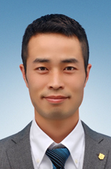 | Sugiyama, Haruki | FWDQEII – Daring Tact
 | Age: 39. Born in Kawasaki, Sugiyama joined the JRA as a groom in 2004. He obtained his JRA trainers’ license in 2016 and notched his first major success as K T Brave took the JPN G1 JBC Classic in 2018. He enjoyed a monumental year in 2020 as Daring Tact, his current flagbearer, became the sixth in history, and the first ever unbeaten, Japanese Fillies’ Triple Crown winner after sweeping the Oka Sho, Yushun Himba and Shuka Sho. Sugiyama has so far amassed 120 JRA wins, including eight (as at 11 April) this season. Hong Kong wins: Debut

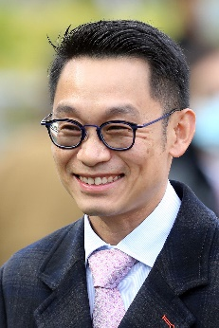 | Ting, Jimmy K H | CSP ‒ Amazing Star
 | Age: 48. Jimmy Ting started out in 1988 as an apprentice jockey allocated to Brian Kan and became a fully-licensed rider in 1993. He retired from race-riding in 2003 and worked as assistant trainer to David Hill for two seasons, leaving to fulfil the same duties for Michael Chang with whom he worked for a further three years. Five years as assistant to Francis Lui preceded a five-year spell with Danny Shum. He was granted a full trainers' licence for the 2018/19 season and opened his account at the first attempt when Triumphant Jewel took the season opener at Sha Tin on 2 September, 2018. He accrued 38 wins that season. Ting added 35 wins in 2019/20, including four from Amazing Star, the Most Improved Horse of the season. Ting has gained overseas experience in Australia, Ireland and England. Hong Kong wins (as of 11 April): 95.

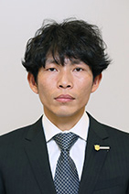 | Tsujino, Yasuyuki | FWDQEII – Kiseki
 | Age: 39. Born in Osaka, Tsujino is part of a new crop of trainers having been licenced for the first time this year. He worked as a rider at a stud farm in Hokkaido before joining the JRA as a groom in 2005. Having worked in the Katsuhiko Sumii stable since 2006, Tsujino obtained his trainer licence in 2020 following Sumii’s retirement, and commenced his stable operation at Ritto Training Centre in March, having inherited multiple horses including G1 Kikuka Sho winner Kiseki and JPN G1 Kashiwa Kinen winner Wide Pharaoh after Sumii’s retirement. Tsujino notched his first win as a trainer with his second ever starter at Nakayama on 7 March, and has amassed 3 JRA wins to date (as at 1 April). Hong Kong wins: Debut

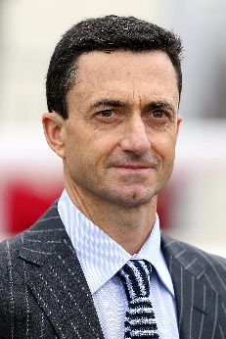 | Whyte, Douglas | CSP ‒ Stronger
 | Age: 49. Douglas Whyte’s first season as a trainer in 2019/20 saw him accrue 44 wins. The former jockey was born in South Africa and earned the nickname “The Durban Demon” during his storied career in the saddle. He was Hong Kong’s champion jockey for 13 consecutive seasons, establishing an incredible legacy. Whyte retired from the saddle in February 2019 with a Hong Kong record of 1,813 wins and all-time high prize money of more than HK$1.5 billion. After a few months travelling to Europe, Dubai, South Africa and Australia to see how some of the world’s master trainers ran their operations, Whyte commenced his own training career at Sha Tin’s Olympic Stables on 15 July, 2019. An outstanding horseman, he first sat on a horse at age two and developed his skills riding in the countryside with his late father, himself a former jockey. A South African Jockey Academy graduate, in 1996 he rode weekends in Singapore and undertook a short contract in Hong Kong at the start of the 1996/97 season. He returned for the 1997/98 season and made Hong Kong his home. He was the first jockey to reach 1,000 wins in Hong Kong, and his tally of 114 wins in 2005/06 stood as a record until Joao Moreira surpassed it in 2014/15. Honours: Hong Kong Champion Jockey (13 consecutive seasons from 2000/01 to 2012/13); LONGINES IJC winner (2002, 2007, 2008); World Super Jockeys Series (Japan) winner (2004); six wins in a day as a jockey: 7 April, 2013 (a Hong Kong record-equalling feat at the time); record holder for overall career wins as a jockey in Hong Kong (1,813 wins) and most career prize money won by a jockey (over HK$1.5 billion). Hong Kong wins as trainer (as of 11 April): 63

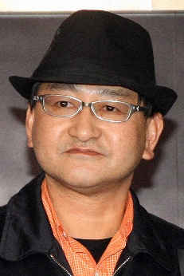 | Yahagi, Yoshito | FWDQEII ‒ Loves Only You
 | Age: 60. Yoshito Yahagi grew up at the vicinity of Oi Racecourse in Tokyo, as his father Kazuto is a former trainer and jockey in the regional NAR circuit. Yahagi travelled to Australia to learn the skills of training at Randwick, Flemington and Toowoomba, before coming back to Japan to start his career as a stable assistant in 1984. In 1990, he spent three months working with trainer Geoff Wragg in the UK. Yahagi received his JRA training licence in 2004 and has since become one of the top JRA trainers, having won the JRA Award four times, as the Best Trainer with most races won in 2014, 2016 and 2020. He has sent out 695 JRA winners (as of 1 April) including 16 this season which places him to an early lead in the 2021 JRA trainer’s standings. Grand Prix Boss gave Yahagi the first of his 17 career G1/JPN G1 wins in the 2010 Asahi Hai Futurity Stakes. His other notable winners included Deep Brillante (2012 Tokyo Yushun), Real Steel (2016 Dubai Turf), Mozu Ascot (2018 Yasuda Kinen), 2020 Japanese Triple Crown winner Contrail, and 2019 G1 Cox Plate winner and JRA Horse of the Year Lys Gracieux. Hong Kong wins (as of 11 April): 0

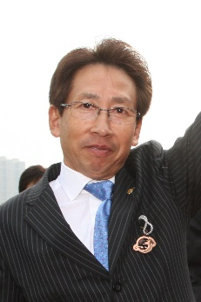 | Yasuda, Takayuki | CSP ‒ Danon Smash
 | Age: 68. Born in Kyoto, Yasuda had 680 wins as a jockey between 1972 and 1994. In 1991, he rode a personal best 80 wins and partnered the legendary horse Tokai Teio to take two Japanese classics, the Satsuki Sho and Tokyo Yushun. Yasuda obtained his training licence in 1994 and registered his first victory in March 1995. Yasuda notched his first JRA Champion Trainer title with 62 wins in 2019. He has saddled 861 JRA career wins, including 14 this season (as of 1 April). Of the 18 G1/JPN G1 wins he has amassed so far, the great Lord Kanaloa remains the best horse he has ever trained. The Hall of Famer and 2013 Japanese Horse of the Year notched six G1 wins, including back-to-back successes in the G1 Sprinters Stakes and G1 LONGINES Hong Kong Sprint in 2012 & 2013. Lord Kanaloa’s son Danon Smash brought Yasuda a third G1 win in Hong Kong with success in the 2020 Hong Kong Sprint. Curren Chan (2011 Sprinters Stakes), Transcend (2010 & 2011 Japan Cup Dirt), Grape Brandy (2013 February Stakes), Danon The Kid (2020 Hopeful Stakes) and Fashionista (2020 JBC Ladies’ Classic) are his other top performers. Hong Kong wins (as of 11 April): 3

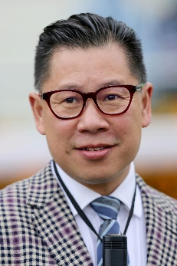 | Yip, Dennis C H | CSP ‒ Wishful Thinker
 | Age: 53. HKJC Apprentice Jockeys' School graduate Dennis Yip was licensed as a jockey in Hong Kong between 1984 and 1993. He rode a total of 59 winners before moving on to learn the training game overseas and then acting as assistant to multiple champion trainer, Brian Kan. In 2002/03 he became a licensed trainer in his own right. Yip trained more than 30 winners in each of his seasons as a trainer until he fell short with 26 wins in the 2019/20 season, despite a solid back half to the campaign following a slow start. The 2011/12 season saw him reach the 50-win mark as he finished fourth in the trainers' premiership. He maintained his upward curve in 2012/13 as he sent out 69 winners to clinch his first trainers' title, sealing victory over Tony Cruz in the very last race of the season. His biggest win that term came with Go Baby Go in the HKG3 Bauhinia Sprint Trophy, while All You Wish took Champion Griffin honours and the Most Improved Horse title. Honours: Hong Kong Champion Trainer (2012/13). Hong Kong wins (as of 11 April): 768

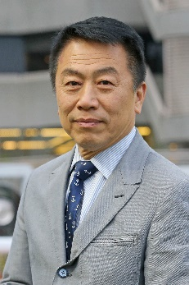 | Yiu, Ricky P F | FWDCM ‒ Mighty Giant; CSP ‒ Jolly Banner, Voyage Warrior
 | Age: 63. Ricky Yiu rode 11 winners between 1974 and 1980 when apprenticed to Jack Goswell, and was first licensed as a trainer in 1995/96, after learning the ropes as assistant trainer to Gordon Smyth and Eddie Lo. He achieved a lifelong ambition in 2019/20 when he was crowned champion trainer, having unexpectedly led his rivals for most of the campaign; his final tally of 67 wins meant that he held off second-placed Tony Cruz by two. One of his greatest early moments came with Fairy King Prawn's success in the inaugural Hong Kong Sprint of 1999. Three-time world champion sprinter Sacred Kingdom, one of Hong Kong's all-time greats, was his outstanding stable star and the two-time G1 Hong Kong Sprint winner and 2009/10 Horse of the Year won the Hong Kong Champion Sprinter title for the fourth year in succession in 2010/11. In 2010 he also sent out Ultra Fantasy to triumph in the G1 Sprinters Stakes at Nakayama as, with Alex Lai on board, the pair became the first Hong Kong Chinese trainer-jockey partnership to triumph in an overseas G1 event. Following Sacred Kingdom's retirement in the spring of 2012, another blistering speedster, Amber Sky, provided Yiu with further elite success at home and abroad. His son, Eric Yiu, was appointed the stable's assistant trainer ahead of the 2018/19 season. Honours: Hong Kong Champion Trainer (2019/20). FWD Champions Day race wins (3): Chairman’s Sprint Prize (1999 Fairy King Prawn, 2008 and 2010 Sacred Kingdom). Hong Kong wins (as of 11 April): 838

