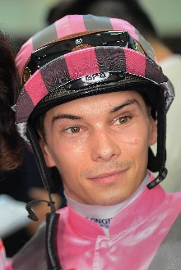 | Badel, Alexis
 | Age: 31. Alexis Badel hails from a racing tradition, his mother being trainer Myriam Bollack-Badel and his father, former jockey Alain Badel. He was France's Champion Apprentice in 2007 and broke into the top 10 in the premiership in just his second year riding with 60 winners. Badel's first Group race win came aboard Norse King in the October, 2013 Prix du Conseil de Paris. He was appointed as the second retained rider for The Aga Khan behind Christophe Soumillon at the beginning of the 2015 racing season and went on to record his most successful season to date with 104 wins. That saw him obtain seventh position in the French Championship. He debuted at Sha Tin with two mounts on 11 December, 2016. His first Hong Kong winner was Supreme Profit on 27 December, 2016 and he ended that maiden two-month stint with seven wins. He returned in the 2017/18 season, landing 14 wins. Following his second campaign in Hong Kong, Badel returned for a third short-term stint and landed 26 wins in under four months - his best haul to date. Badel returns on a full-season licence for the 2020/21 season. He secured a first G1 win aboard Nonza in the August, 2018 Prix Jean Romanet at Deauville. Honours: France's Champion Apprentice (2007). Hong Kong wins: 103 (as of 11 April, 2021).

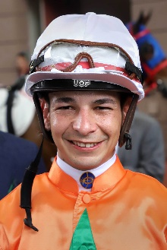 | Borges, Vagner
 | Age: 28. Vagner Borges is one of South American horse racing’s brightest stars. A four-time champion jockey in his native Brazil, he partnered that country’s 12th Triple Crown winner, Bal A Bali, to his famous classic successes in the 2014 season. Borges was a phenomenon as an apprentice upon commencing his career in the 2009/10 season at Gavea Racecourse in Rio de Janeiro. In December 2011 he collected his 374th success to set a new Brazilian record for the most wins by an apprentice, two months before he graduated to the fully-licensed ranks. He took his first jockeys’ championship in 2011/12 with a career-high 244 wins at a win strike rate of 20.75%. Borges maintained a win strike rate above 20% in each of his further three championship seasons, notching 212, 218 wins and 186 wins. He has accrued no less than 14 career G1 wins, his first being Sutil in the March 2013 Grande Premio Diana. The lightweight rider has more than 1600 career wins on the board and, he scored his first Hong Kong Pattern race victory aboard Amazing Star in the G2 Sprint Cup. Honours: Four-time champion jockey in Brazil (2011/12, 2013/14, 2014/15, 2017/18); Brazil’s champion apprentice. Hong Kong wins: 35 (as of 11 April, 2021).

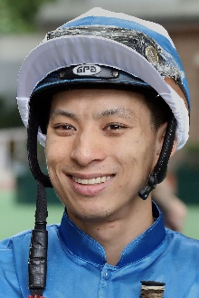 | Chadwick, Matthew
 | Age: 30. A graduate of the Hong Kong Jockey Club Apprentice Jockeys' School, Matthew Chadwick went to Australia for his apprentice training and rode a four-timer at Lismore Racecourse at age 17. Indentured to the Tony Cruz stable upon his return to Hong Kong, he was champion apprentice in 2008/09. He earned a full jockey's licence in January, 2010. His first Group race winner was Egyptian Ra in the HKG3 National Day Cup (2009). He is most famous for his partnership with California Memory and became the first homegrown rider to win a Hong Kong International Races contest when clinching the G1 Hong Kong Cup on the grey in December, 2011. Chadwick notched his 250th win in Hong Kong with Majestic Anthem on 26 December, 2013 and rode his first Hong Kong four-timer at Sha Tin on 22 June, 2014. Honours: Hong Kong Champion Apprentice (2008/09); Shergar Cup Silver Saddle winner (2012). Hong Kong wins: 398 (as of 11 April, 2021).

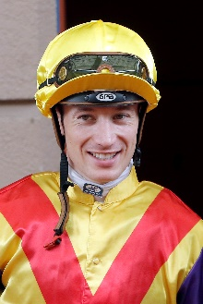 | Hamelin, Antoine
 | Age: 29. Frenchman Antoine Hamelin began his career as an apprentice to Jean de Roualle in Chantilly and has since ridden more than 700 winners. His first win came for Alain de Royer-Dupre aboard the Aga Khan-owned Artana at Lyon-Parilly racecourse on 11 November, 2009. Hamelin completed his apprenticeship under the tutelage of Royer-Dupre and went freelance upon earning fully-fledged jockey status, basing himself out of Chantilly. He is best known for his association with Saonois, who he partnered to classic victory in the 2012 G1 Prix du Jockey Club at Chantilly among other wins. Hamelin first rode in Hong Kong when pairing with Saonois to finish 10th in the 2012 LONGINES Hong Kong Cup at Sha Tin. Hamelin kicked off his three month contract with a first-day double at Sha Tin, firstly aboard Best For You before Baltic Success burst clear later that day. Hamelin secured 17 wins across his first stint in Hong Kong and returns on a full-season licence for 2020/21. Hamelin has ridden in Great Britain, Ireland, Italy, Germany, USA, Spain, Dubai and Canada. In 2017 he gained a first Royal Ascot success in the Albany Stakes aboard 20/1 shot Different League. Hong Kong wins: 37 (as of 11 April, 2021).

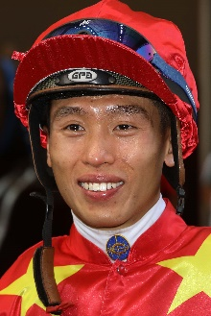 | Ho, Vincent C Y
 | Age: 30. HKJC Apprentice Jockeys' School graduate Vincent Ho racked up 44 wins as a young rider in New Zealand under the tutelage of leading trainer Lance O'Sullivan. He made a good start to his Hong Kong career with 10 victories in his first season in 2009/10, including a trio of wins he achieved on only his fourth race day in Hong Kong. He sealed the 2010/11 Champion Apprentice title with 39 wins. Ho reached the graduation benchmark on 1 October, 2012 by claiming his 70th win in Hong Kong on board Castle Hero. He notched 33 wins in 2014/15 to be the season's leading homegrown rider. Ho enjoyed his best season to date in 2019/20 with not only a career-high 67 wins but a renewed partnership with the brilliant Golden Sixty saw the pair sweep the Four-Year-Old Classic Series, while also unbeaten in seven runs that term, which culminated in a thrilling Hong Kong Derby victory. Ho followed those triumphs with a career-first G1, saluting with Southern Legend in 2020 Champions Mile, outlasting Beauty Generation by a short-head in the process. So far this season, he has added a further three G1s to his haul aboard Golden Sixty. Honours: Hong Kong Champion Apprentice (2010/11); Best Freelance Jockey Award (2014/15); Tony Cruz Award (2018/19 & 2019/20). FWD Champions Day wins (1): FWD Champions Mile (2020 Southern Legend). Hong Kong wins: 378 (as of 11 April, 2021).

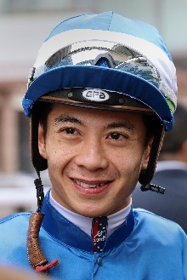 | Leung, Derek K C
 | Age: 32. A product of the Hong Kong Jockey Club Apprentice Jockeys' School, Derek Leung cut his teeth as a young rider in New Zealand under the tutelage of trainer Lance O'Sullivan. He was assigned as apprentice jockey to Paul O'Sullivan's stable upon his return to Hong Kong and reached the graduation benchmark after claiming his 70th win aboard Star Of Fame on 1 June, 2011. Leung reached a personal best total of 37 wins in the 2017/18 season, enough to earn a second consecutive Tony Cruz Award as the leading home-grown rider. That season also saw Leung notch a first career Group 1 aboard subsequent Horse of the Year Beauty Generation. The rider was also in the plate for Group 3 and Group 2 wins on the gelding. Honours: Asian Young Guns Challenge winner (2010); Tony Cruz Award winner (2017 & 2018). Hong Kong wins: 343 (as of 11 April, 2021).

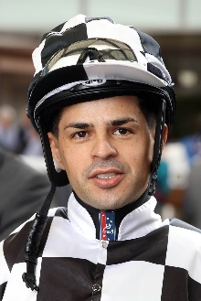 | Maia, Ruan
 | Age: 32. Ruan Maia began his riding career in 2006 as an apprentice in Sao Paulo, Brazil. Maia was a leading jockey in his home country before setting his sights on an international career and in 2016 he made the move to Macau. Maia was crowned champion jockey in both of his only two full seasons he completed in Macau, finishing with 60 and 71 wins respectively, he also scored two major victories at MAC G1 level, claiming the Macau Gold Cup and Chairman’s Challenge Cup. In April 2018, Maia made his first visit to Singapore and tasted instant success aboard former Hong Kong-based galloper Circuit Land in the SIN G2 Chairman’s Trophy at Kranji Racecourse. In May that same year he rode for the first time in Hong Kong at the 2018 Hong Kong Macau Trophy race day, and his best result from six rides on the card was a second atop the Tony Cruz-trained California Joy. At the start of 2020, Maia took the opportunity to shift base to Singapore and in his first full season he finished second in the Singapore jockeys’ championship to now four-time champion Vlad Duric by three wins, ending his first and only campaign in the Lion City with 62 wins at a win strike rate of 17.7%. Honours: Macau Champion Jockey (2017/18, 2018/19). Hong Kong wins: 4 (as of 11 April, 2021).

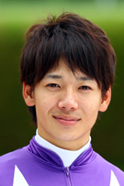 | Matsuyama, Kohei
 | Age: 31. Born in Kobe, Japan, Matsuyama developed an interest in racing as he regularly attended races with his father and grandfather at Hanshin Racecourse. In 2006, he enrolled to the JRA Riding School jockey training programme and started riding in races in March, 2009, where he scored two wins at his riding debut at Kokura Racecourse. He was crowned the JRA Champion Rookie with 36 wins in that same year. Matsuyama notched his first Pattern win with Smart Gear in the G3 Chunichi Shimbun Hai in 2012, his first top-class success with Corin Berry in the 2015 JPN G1 JBC Sprint, and his first Classic win aboard Al Ain in the 2017 G1 Satsuki Sho. Matsuyama reached new heights in his career in 2020 as he partnered Daring Tact to become the sixth ever, and the first to do so unbeaten, Fillies’ Triple Crown winner in Japan. He has so far amassed 806 JRA wins and currently sits second behind Christophe Lemaire in this year’s JRA Jockey’s Championship. Hong Kong wins: Debut

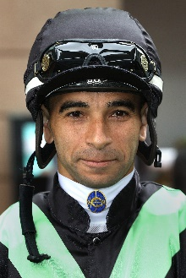 | Moreira, Joao
 | Age: 37. Brazilian sensation Joao Moreira, known as ''Magic Man'', notched more than 1,000 wins in South America. He relocated to Singapore in 2009 and was a dominant four-time champion jockey. He moved to Hong Kong in October 2013 and was runner-up in the title race that term with 97 wins before clinching a first championship in a record smashing 2014/15 campaign that yielded an all-time high 145 wins - he demolished that record in 2015/16 with 168 wins, and improved again in 2016/17 with 170 wins. In December, 2020, Moreira notched his 1000th Hong Kong win. Honours: Hong Kong Champion Jockey (2014/15, 2015/16, 2016/17); LONGINES IJC winner (2012); Japan's World All-Star Jockeys winner (2015); Singapore Champion Jockey (2010, 2011, 2012, 2013); Brazilian Eclipse Award winner (2006/07, 2007/08); fastest 100 in a Hong Kong season (22 February, 2017); Hong Kong record for most wins in a season (170 in 2016/17); most wins in a Hong Kong race day (eight: 5 March, 2017); Singapore record for most wins in a season (206 in 2012); eight wins from eight rides at Kranji (6 September, 2013); eight wins in a day at Cidade Jardim (March, 2006). FWD Champions Day wins (4): FWD QEII Cup (2017 Neorealism), FWD Champions Mile (2015 Able Friend, 2016 Maurice), Chairman’s Sprint Prize (2019 Beat The Clock). Hong Kong wins: 1055 (as of 11 April, 2021).

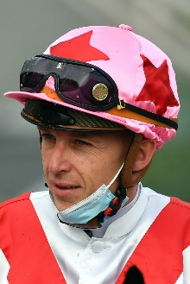 | Piccone, Tony
 | Age: 33. Tony Piccone was inspired to become a jockey when, as a child, he would watch his jockey father, Jean-Marc Piccone, competing in races. His own career began at age 14 when he was accepted to the apprentice jockeys’ school in Marseille. At age 17 he was apprenticed to Chantilly trainer Cedric Boutin and rode out his claim in 2008. He has since made his name as a prominent freelance jockey and has accrued no less than 760 wins including five at Group 1 level. His initial Group 1 victory was aboard Robin Of Navan in the 2015 Criterium de Saint-Cloud. Piccone secured his first Hong Kong win with his fourth ride at his first race meeting, driving home Charity Go at Sha Tin on Wednesday, 1 January, 2020. He closed out his first term in Hong Kong with eight wins, including two doubles. Hong Kong wins: 14 (as of 11 April, 2021).

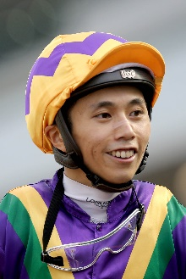 | Poon, Matthew M F
 | Age: 27. Matthew Poon joined Hong Kong's race-riding ranks in March 2017. He landed a win on his first race-day but also suffered an injury that side-lined him for three weeks. Upon returning he raced to 20 wins and a reduction to his 10lb claim within 14 fixtures and 112 rides. His second Hong Kong season yielded 35 victories. The HKJC Apprentice Jockeys' School student undertook his overseas training in South Australia, embarking in June 2015, and was based with leading trainer Richard Jolly. His first race ride, a winner, came in October of that year. At the end of his first season, in July, 2016, he was crowned South Australia's Champion Apprentice Jockey with 51 wins. His second season in Adelaide saw him ride 65 winners and at the time of his departure for Hong Kong in March 2017, he was sitting second in the South Australian jockeys championship. Poon commenced his Hong Kong career with an overall record of 117 wins from 862 rides at a rate of 13.57%. His first pattern victory came aboard Faaltless in the SIN G3 Garden City Trophy in Singapore in August, 2017 and he notched a second win in that grade when taking the Jumbo Jet Trophy at Kranji during the Hong Kong off-season in 2018. Honours: South Australia Champion Apprentice (2015/16). Hong Kong wins: 146 (as of 11 April, 2021).

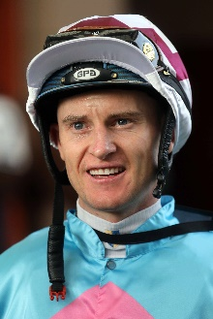 | Purton, Zac
 | Age: 38. Zac Purton ended Douglas Whyte's 13-season dominance with his first Hong Kong jockeys' championship in 2013/14 (112 wins) and in earning his second title in 2017/18 he halted Joao Moreira's title streak at three. During his first championship season, the Australian ace raced to what was then the fastest 50 in Hong Kong history and became the second rider, after Whyte, to notch 100 wins in a season. Purton lost his title when second to Moreira in 2014/15 with 95 wins, a position he filled for the next two terms, including when notching his second century in 2016/17. His second championship was a remarkable effort as he chased down Moreira to take the lead for the first time that term on June 10, 2018. Five weeks later, at season's end, he had outpointed Moreira 136-134 with a win strike rate of 21% to the Brazilian's 20%. Purton tallied a career-high 168 wins in 2018/19, a season in which he also became the second jockey in Hong Kong history to ride 1000 winners, and in which he set a new single season prizemoney record of HK$234,989,515. The Australian ace took a third consecutive championship in 2019/20 with 147 wins and three Group 1’s, his triumph aboard Exultant in the 2020 QEII Cup meant he became the only rider in history to have won every Group 1 race on the Hong Kong calendar. Honours: Hong Kong Champion Jockey (2013/14, 2017/18, 2018/19 & 2019/20); Brisbane Champion Jockey (2003 - when still an apprentice); LONGINES IJC winner (2017); World Super Jockeys Series (Japan) winner (2012); Hong Kong single season prize money record (HK$234,989,515). FWD Champions Day wins (4): FWD QEII Cup (2020 Exultant), Chairman’s Sprint Prize (2018 Ivictory), FWD Champions Mile (2018 & 2019 Beauty Generation) Hong Kong wins: 1262 (as of 11 April, 2021).

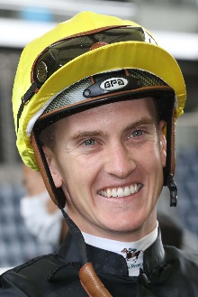 | Schofield, Chad
 | Age: 27. Chad Schofield spent four years (2002-2006) of his youth living in Hong Kong where his father, the South African jockey Glyn Schofield, was contracted to ride. His family relocated to Australia and Schofield commenced his own riding career in Sydney in the 2010/11 season, enjoying rapid success. He moved to Melbourne in 2012 to ride for the powerful David Hayes stable. His first Group 1 win was a major, the 2013 Cox Plate on Shamus Award. He and his father made history in 2014 as the first father and son to compete against each other in the Melbourne Cup and at Sha Tin on 14 February, 2016 they became the first in Hong Kong to ride against each other. Schofield tallied 43 wins during the 2019/20 season, five more than his previous best. Schofield spent three months during the summer of 2015 riding in England, based out of Ed Dunlop's yard, and scored two wins from 42 rides. Honours: Sydney and New South Wales Champion Apprentice (2011/12); Melbourne Champion Apprentice (2012/13). Hong Kong wins: 197 (as of 11 April, 2021).

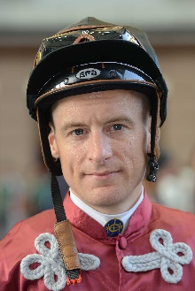 | Shinn, Blake
 | Age: 33. Blake Shinn’s father is the late Gerald Shinn, a one-time champion apprentice jockey in Australia. He began his career in Victoria and his first win came at Kilmore in 2003 aboard Clearly Unique. He showed brilliant precocity, winning his first G1, the 2005 Adelaide Cup aboard Demerger, at just 17 years of age when still an apprentice. He made history in the 2004/05 season, becoming the first apprentice to win the Scobie Breasley Medal for excellence in race riding on the Melbourne circuit. Shinn made the move to Sydney to become stable jockey to Gai Waterhouse and in his first year he won the 2007/08 Sydney premiership. He also has the distinction of being one of the youngest Melbourne Cup-winning jockeys, being just 20 when he partnered the Bart Cummings-trained Viewed in 2008. He finished runner-up in the 2017/18 Sydney Jockeys’ premiership with 136 wins. Honours: Sydney Jockeys’ Premiership (2007/08); Victorian champion apprentice (2005/06); Scobie Breasley Medal (2005); Nathan Berry Medal (2018). Hong Kong wins: 30 (as of 11 April, 2021).

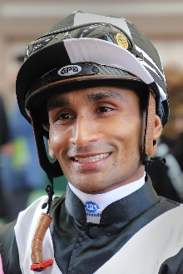 | Teetan, Karis
 | Age: 30. Mauritian rider Karis Teetan was well ensconced in the top 10 of the South African Jockeys' Championship when he left for Hong Kong in August, 2013. He entered the South African Jockey Academy at the age of 14 and went on to be crowned South African Champion Apprentice in 2008. He graduated in 2009 with 147 wins to his credit. Teetan passed the 100-win mark in every season as a senior jockey in South Africa. His first top level win was in his native Mauritius on 24 November, 2008, aboard Halo Hunter. Teetan represented South Africa in the 2012 International Jockeys' Invitational in Seoul, Korea and in the 2008 Macau Apprentice Jockeys Invitation Races. He notched an impressive 50 wins in his first Hong Kong season and has continued to build on that good start. He finished third in the 2017/18 premiership race with 52 wins, which included a trio of Group 3 triumphs. He topped that in 2018/19 with 84 wins as he secured his first Hong Kong G1 win aboard Mr Stunning in the Hong Kong Sprint and again went better in 2019/20 with a personal best 93 wins, cementing third place in the premiership race. FWD Champions Day wins: Chairman’s Sprint Prize (2020 Mr Stunning). Honours: South African Champion Apprentice (2008). LONGINES IJC winner (2019). Hong Kong wins: 447 (as of 11 April, 2021).

