Spotlight

Aidan O’Brien is the most prolific trainer in the history of the LONGINES Hong Kong Vase and he will be represented by last year’s winner, Mogul.

Glory Vase, Silk Racing’s 2019 winner of the race, returns to re-claim his crown and he is joined by Stay Foolish, Yoshito Yahagi’s consistent stayer who boasts placings behind Loves Only You, Chrono Genesis, Blast Onepiece, Mer de Glace and Win Bright.

Pyledriver has had Hong Kong on his radar for a while now. The son of Harbour Watch defied Al Aasy in a gripping G1 Coronation Cup (2405m) at Epsom Downs Racecourse in June and before that boasts form around Addeybb as well as a solid third-placing in the G1 St Leger Stakes (2905m) to Galileo Chrome.

Runner-up in the 2021 G1 Standard Chartered Champions & Chater Cup (2400m), Columbus County heads the Hong Kong team along with Butterfield, a dual G1 winner in Brazil, as well as Reliable Team, who recently made all in the G2 BOCHK Jockey Club Cup (2000m).

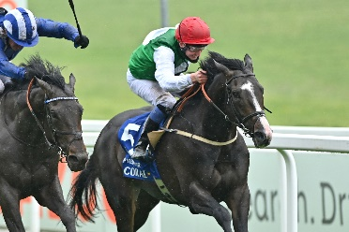 | PYLEDRIVER (GB)  GREAT BRITAIN 4c 121  Won G1 Coronation Cup (2405m) at Epsom Downs; solid stayer who finished third in G1 St Leger Stakes at Doncaster last year; last out won at Lingfield on the All-Weather course over 2000m carrying a hefty weight. | 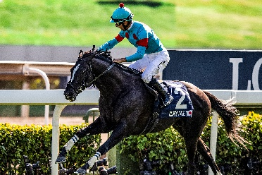 | GLORY VASE (JPN)  JAPAN 6h 120  G1 LONGINES Hong Kong Vase champ in 2019, since then second to Loves Only You in 2021 FWD QEII Cup (2000m).
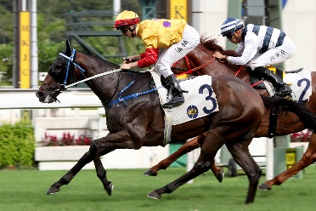 | COLUMBUS COUNTY (NZ)  HONG KONG 6g 115  Second in 2021 G1 Champions & Chater Cup (2400m) to Panfield by a half a length; last out returned fourth in G2 Jockey Club Cup (2000m). | 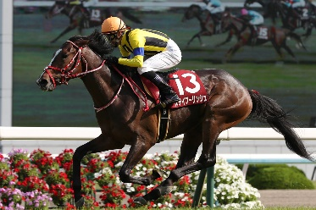 | STAY FOOLISH (JPN)  JAPAN 6h 112  Solid performer who boasts placings behind Loves Only You, Chrono Genesis, Blast Onepiece, Mer de Glace and Win Bright.
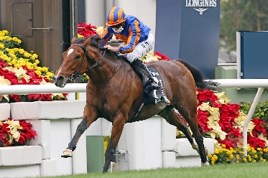 | MOGUL (GB)  IRELAND 4c 111  Last year’s G1 LONGINES Hong Kong Vase (2400m) winner returning for another crack; mixed his form since that run but did place a well-beaten third at G1 level at Longchamp three runs ago. | 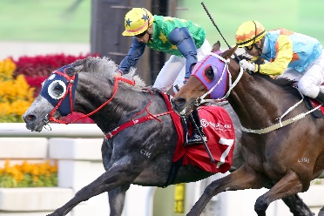 | RELIABLE TEAM (NZ)  HONG KONG 6g 111  Three times placed at G3 level, missing by under half a length each time; last out captured the G2 Jockey Club Cup (2000m).
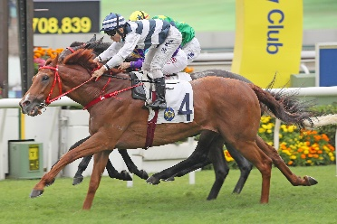 | BUTTERFIELD (BRZ)  HONG KONG 6g 110  2021 G3 Queen Mother Memorial Cup (2400m) winner; prior to arriving in Hong Kong was a two-time G1 winner in Brazil, including the Derby Paulista (2400m). | 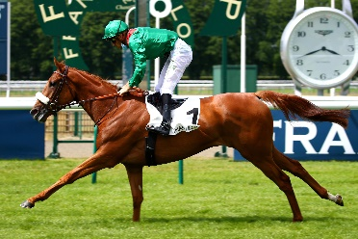 | EBAIYRA (USA)  FRANCE 4f 112  Dual G3 and G2 winner; finished second to Broome in 2021 Grand Prix de Saint-Cloud (2400m).

