 |  |  | 致勝一擊  PYLEDRIVER (GB) 4 b c  Harbour Watch (IRE) - La Pyle (FR) (Le Havre (IRE))  Owner(s): La Pyle Partnership |  | 莫爾 (英國)  W Muir (GB) | 戴馬田  M Dwyer | 126 lb  (121)

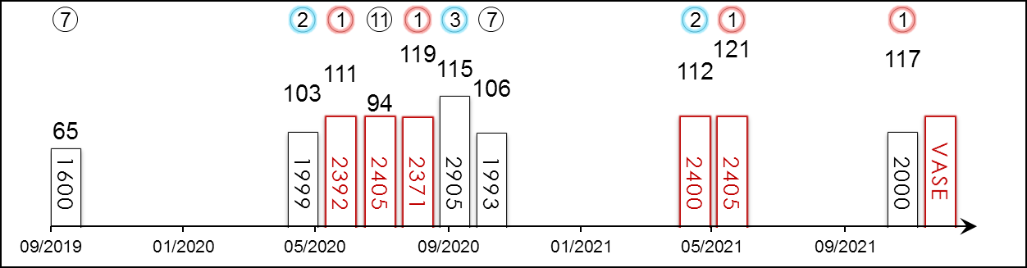 | HK Starts : - Right-handed : 4 (1-2-0-0-1) Jockey : 12 (5-2-1-1-3)  Pre Import : - Sha Tin-Turf : - GF+ : 2 (1-1-0-0-0)  Lifetime : 13 (6-2-1-1-3) Non-Turf : 2 (1-1-0-0-0) Good : 4 (1-0-1-0-2)  2021 : 3 (2-1-0-0-0) Distance : 5 (3-1-0-0-1) Yielding : -  G1 : 4 (1-0-1-0-2) Course & Dist : - Soft/Hvy : 5 (3-0-0-1-1)  First Up : 4 (2-2-0-0-0) 2200-2800 : 5 (3-1-0-0-1) HK$ : 4,226,120  G1 win : 2021 Coronation Cup 2405m

Pos | Index | Date | Perf  Rating | Race Category & Name |  | Track | Dist/Course/Going |  | Wt | Jockey | Draw | Race Sectional Time |  |  |  | Race  Time | Horse  Final | Position & Margin in Running |  |  |  |  |  | Finish |  | Odds | Winner/Second
7/7 | - | 28/9/19 | 65 | G2 | Royal Lodge S. - 2yo | NEW, GB | 1600 St | G | 126 | M Dwyer | 1 |  | - | - | - | 1.35.¹³ | - | - |  | - |  | - |  | 7 | 21 | 8/1 | Royal Dornoch
2/9 | - | 3/6/20 | 103 | G3 | Classic Trial S. - 3yo | KEM, GB | 1999 RH | Poly | 127 | M Dwyer | 11 |  | - | - | - | 2.06.⁷⁰ | - | - |  | - |  | - |  | 2 | 1.3 | 40/1 | Berlin Tango
1/6 | - | 16/6/20 | 111 | G2 | King Edward VII S. - 3yo | ASC, GB | 2392 RH | GS | 126 | M Dwyer | 1 |  | - | - | - | 2.32.²¹ | - | - |  | - |  | - |  | 1 | 2 | 18/1 | Arthur's Kingdom
11/16 | - | 4/7/20 | 94 | G1 | Derby S. - 3yo | EPS, GB | 2405 LH | G | 126 | M Dwyer | 3 |  | - | - | - | 2.34.⁴³ | - | - |  | - |  | - |  | 11 | 14.5 | 16/1 | Serpentine
1/8 | - | 19/8/20 | 119 | G2 | Great Voltigeur S. - 3yo | YOR, GB | 2371 LH | G | 129 | M Dwyer | 3 |  | - | - | - | 2.30.⁵⁷ | - | - |  | - |  | - |  | 1 | 3.5 | 10/1 | Highland Chief
3/11 | - | 12/9/20 | 115 | G1 | St. Leger S. - 3yo | DON, GB | 2905 LH | G | 127 | M Dwyer | 4 |  | - | - | - | 3.01.⁹⁴ | - | - |  | - |  | - |  | 3 | 1.3 | 9/2 | Galileo Chrome
7/10 | - | 17/10/20 | 106 | G1 | Champion S. | ASC, GB | 1993 RH | S | 127 | M Dwyer | 4 |  | - | - | - | 2.12.²⁹ | - | - |  | - |  | - |  | 7 | 11 | 16/1 | Addeybb
2/5 | - | 1/5/21 | 112 | G2 | Jockey Club S. | NEW, GB | 2400 RH | GF | 127 | M Dwyer | 2 |  | - | - | - | 2.32.⁵⁴ | - | - |  | - |  | - |  | 2 | 2.3 | 15/8JF | Sir Ron Priestley
1/6 | - | 4/6/21 | 121 | G1 | Coronation Cup | EPS, GB | 2405 LH | GS | 126 | M Dwyer | 3 |  | - | - | - | 2.42.²³ | - | - |  | - |  | - |  | 1 | Nk | 8/1 | Al Aasy
1/10 | - | 13/11/21 | 117 | L | Churchill S. | LIN, GB | 2000 LH | Poly | 135 | M Dwyer | 3 |  | - | - | - | 2.04.⁷⁴ | - | - |  | - |  | - |  | 1 | 0.5 | 6/4F | Harrovian
 |  | 12/12/21 |  | G1 | LONGINES Hong Kong Vase | ST, HK | 2400 RH |  | 126 | M Dwyer
Six-time winner from 13 starts, including G1 Coronation Cup (2405m) at Epsom Downs in June this year. Solid stayer who finished third in G1 St Leger Stakes at Doncaster. Last out won at Lingfield on the All-Weather course over 2000m after a break with a hefty impost. Showed early promise as a two-year-old when winning Listed race in Haydock. Versatile. No ground concerns.

 |  |  | 耀滿瓶  GLORY VASE (JPN) 6 db h  Deep Impact (JPN) - Mejiro Tsubone (JPN) (Swept Overboard (USA))  Owner(s): Silk Racing Co Ltd |  | 尾關知人 (日本)  T Ozeki (JPN) | 莫雷拉  J Moreira  Win 17.6% Place 40.1% | 126 lb  (120)

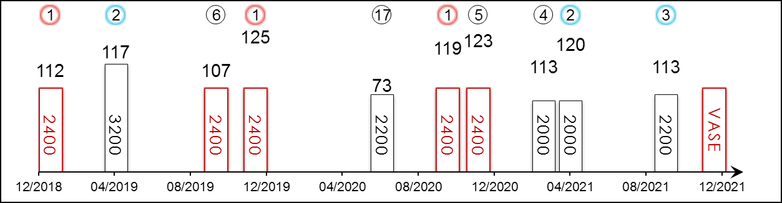 | HK Starts : 2 (1-1-0-0-0) Right-handed : 12 (4-3-1-1-3) Jockey : 1 (1-0-0-0-0)  Pre Import : - Sha Tin-Turf : 2 (1-1-0-0-0) GF+ : 11 (3-3-1-1-3)  Lifetime : 16 (5-4-1-2-4) Non-Turf : - Good : 4 (2-1-0-0-1)  2021 : 3 (0-1-1-1-0) Distance : 5 (3-0-0-0-2) Yielding : 1 (0-0-0-1-0)  G1 : 6 (1-2-0-0-3) Course & Dist : 1 (1-0-0-0-0) Soft/Hvy : -  First Up : 13 (5-2-1-2-3) 2200-2800 : 8 (3-0-1-1-3) HK$ : 38,900,700  G1 win : 2019 LONGINES Hong Kong Vase 2400m

Pos | Index | Date | Perf  Rating | Race Category & Name |  | Track | Dist/Course/Going |  | Wt | Jockey | Draw | Race Sectional Time |  |  |  | Race  Time | Horse  Final | Position & Margin in Running |  |  |  |  |  | Finish |  | Odds | Winner/Second
1/16 | - | 13/1/19 | 112 | G2 | Nikkei Shinshun Hai - hcp | KYO, JPN | 2400 RH | F | 121 | M Demuro | 2 |  | 25.⁷⁰ | 24.¹⁰ | 25.⁵⁰ | 2.26.²⁰ | 36.⁸⁰ | 9 | - | 10 | - | 6 | - | 1 | 0.5 | 2.7F | Look Twice
2/13 | - | 28/4/19 | 117 | G1 | Tenno Sho Spring | KYO, JPN | 3200 RH | F | 128 | K Tosaki | 7 |  | 24.⁸⁰ | 23.³⁰ | 22.⁹⁰ | 3.15.⁰⁰ | 34.⁴⁰ | 8 | - | 7 | - | 2 | - | 2 | Nk | 11.3 | Fierement
6/17 | - | 6/10/19 | 107 | G2 | Kyoto Daishoten | KYO, JPN | 2400 RH | F | 126 | M Demuro | 16 |  | 24.⁷⁰ | 23.³⁰ | 23.⁶⁰ | 2.23.⁵⁰ | 35.⁷⁰ | 3 | - | 5 | - | 6 | - | 6 | 5 | 2F | Dreadnoughtus
1/14 | **230 | 8/12/19 | 125 | G1 | LONGINES Hong Kong Vase | ST, HK | 2400 RH | G | 126 | J Moreira | 7 |  | 24.⁶⁸ | 24.⁰⁴ | 23.⁰³ | 2.24.⁷⁷ | 22.⁶³ | 7 | 4.3 | 7 | 3.5 | 7 | 2.5 | 1 | 3.5 | 8.2 | Lucky Lilac
17/18 | - | 28/6/20 | 73 | G1 | Takarazuka Kinen | HSN, JPN | 2200 RH | G | 128 | D Lane | 3 |  | 24.⁸⁰ | 24.³⁰ | 24.⁴⁰ | 2.13.⁵⁰ | 41.²⁰ | 13 | - | 14 | - | 8 | - | 17 | 32.5 | 10.7 | Chrono Genesis
1/17 | - | 11/10/20 | 119 | G2 | Kyoto Daishoten | KYO, JPN | 2400 RH | G | 128 | Y Kawada | 13 |  | 25.⁵⁰ | 23.⁸⁰ | 23.⁴⁰ | 2.25.⁶⁰ | 34.⁵⁰ | 5 | - | 5 | - | 5 | - | 1 | 0.8 | 6.2 | Kiseki
5/15 | - | 29/11/20 | 123 | G1 | Japan Cup | TOK, JPN | 2400 LH | F | 126 | Y Kawada | 15 |  | 23.⁷⁰ | 24.⁴⁰ | 25.⁵⁰ | 2.23.⁰⁰ | 35.²⁰ | 4 | - | 2 | - | 2 | - | 5 | 1.8 | 17.2 | Almond Eye
4/10 | - | 14/3/21 | 113 | G2 | Kinko Sho | CYO, JPN | 2000 LH | Y | 126 | Y Kawada | 4 |  | 23.⁶⁰ | 24.⁰⁰ | 24.⁷⁰ | 2.01.⁸⁰ | 36.⁴⁰ | 3 | - | 4 | - | 3 | - | 4 | 0.8 | 4.5 | Gibeon
2/7 | *620 | 25/4/21 | 120 | G1 | FWD QEII Cup | ST, HK | 2000 RH | G | 126 | K Teetan | 7 |  | 23.⁵³ | 22.⁷⁶ | 23.⁰¹ | 2.01.²² | 22.⁷⁵ | 6 | 4.3 | 6 | 4.5 | 5 | 2.5 | 2 | 0.8 | 4.7 | Loves Only You
3/16 | - | 26/9/21 | 113 | G2 | Sankei Sho All Comers | NAK, JPN | 2200 RH | GF | 126 | M Demuro | 11 |  | 24.¹⁰ | 23.³⁰ | 23.⁸⁰ | 2.11.⁹⁰ | 35.²⁰ | 15 | - | 4 | - | 3 | - | 3 | 1.8 | 6.2 | Win Marilyn
 |  | 12/12/21 |  | G1 | LONGINES Hong Kong Vase | ST, HK | 2400 RH |  | 126 | J Moreira
G1 LONGINES Hong Kong Vase (2400m) champ in 2019, since then finished fifth in the 2020 G1 Japan Cup (2400m) behind Almond Eye and second to Loves Only You in the 2021 G1 FWD QEII Cup (2000m) on FWD Champions Day. Also proven over further when 2nd to Fierement in the G1 Tenno Sho Spring (3200m) in early 2019. Last out third at G2 level at Nakayama. Hold up runner. Won on good and firm.

 |  |  | 時時有餘 C465  COLUMBUS COUNTY (NZ) ex Sword In Stone 6 b g  Redwood (GB) - Spirit Of Sandford (NZ) (Kilimanjaro (GB))  Owner(s): Mr & Mrs Hamen Fan Shi Hoo, Alex Fan Chen Yen and Christina Fan Chen Mun |  | 方嘉柏 (香港)  C Fownes (HK)  Win 4.5% Place 23.4% | 田泰安  K Teetan  Win 8.1% Place 33.5% | 126 lb  (115)

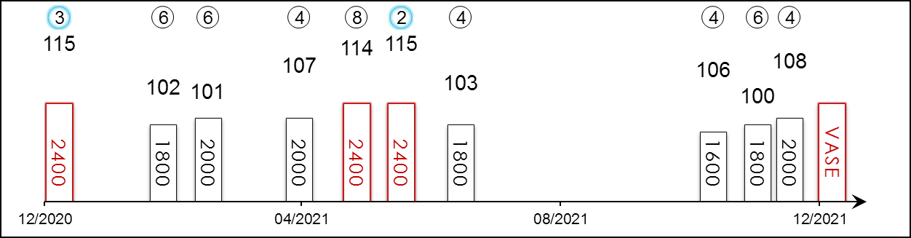 | HK Career : 19 (2-4-2-6-5) Right-handed : 20 (3-4-2-6-5) Jockey : 1 (0-0-0-1-0)  Pre Import : 3 (1-1-1-0-0) Sha Tin-Turf : 17 (1-4-2-5-5) GF+ : 6 (1-1-1-2-1)  Lifetime : 22 (3-5-3-6-5) Non-Turf : - Good : 16 (2-4-2-4-4)  2021/22 : 3 (0-0-0-2-1) Distance : 3 (0-1-1-0-1) Yielding : -  G1 : 3 (0-1-1-0-1) Course & Dist : 3 (0-1-1-0-1) Soft/Hvy : -  First Up : 6 (1-2-0-3-0) 2200-2800 : 3 (0-1-1-0-1) HK$ : 11,546,710  G1 win : Nil

Pos | Index | Date | Perf  Rating | Race Category & Name |  | Track | Dist/Course/Going |  | Wt | Jockey | Draw | Race Sectional Time |  |  |  | Race  Time | Horse  Final | Position & Margin in Running |  |  |  |  |  | Finish |  | Odds | Winner/Second
3/7 | *261 | 13/12/20 | 115 | G1 | LONGINES Hong Kong Vase | ST, HK | 2400 RH | G | 126 | J Moreira | 1 |  | 24.⁰⁴ | 24.⁰¹ | 23.⁴³ | 2.27.²¹ | 23.⁵¹ | 6 | 4¾ | 6 | 4¼ | 6 | 3 | 3 | 3½ | 7.5 | Mogul
6/10 | *389 | 31/1/21 | 102 | G3 | Centenary Vase - hcp | ST, HK | 1800 RH | G | 120 | C Soumillon | 9 |  | 22.⁷⁸ | 22.⁵⁹ | 23.⁰¹ | 1.46.⁰¹ | 22.⁸⁴ | 8 | 5 | 8 | 7½ | 7 | 5¼ | 6 | 4¼ | 5.6 | Glorious Dragon
6/7 | *447 | 21/2/21 | 101 | G1 | Citi Hong Kong Gold Cup | ST, HK | 2000 RH | G | 126 | B Shinn | 5 |  | 23.²⁰ | 22.⁵⁷ | 22.⁵⁹ | 2.00.²⁵ | 23.⁹⁴ | 4 | 2¼ | 2 | 1½ | 3 | 1 | 6 | 9½ | 43 | Golden Sixty
4/9 | *556 | 5/4/21 | 107 | - | Cl.1 hcp | ST, HK | 2000 RH | G | 128 | K Teetan | 9 |  | 24.²³ | 23.²⁰ | 23.¹³ | 2.01.⁹² | 22.⁷³ | 9 | 6½ | 9 | 6 | 8 | 4¾ | 4 | 2¼ | 8.4 | Glorious Dragon
8/12 | *638 | 2/5/21 | 114 | G3 | Queen Mother Memorial Cup - hcp | ST, HK | 2400 RH | G | 133 | Z Purton | 9 |  | 24.³⁸ | 22.⁹³ | 23.¹³ | 2.28.¹⁴ | 22.⁹⁶ | 9 | 4¾ | 7 | 2¾ | 11 | 4¼ | 8 | 3¼ | 15 | Butterfield
2/8 | *696 | 23/5/21 | 115 | G1 | Standard Chartered Champions & Chater Cup | ST, HK | 2400 RH | GF | 126 | J Moreira | 5 |  | 24.⁵¹ | 23.⁵⁶ | 22.⁶⁴ | 2.25.²⁵ | 22.⁴⁷ | 5 | 4 | 5 | 3½ | 4 | 1½ | 2 | 1/2 | 3.2 | Panfield
4/10 | *762 | 20/6/21 | 103 | G3 | Premier Plate - hcp | ST, HK | 1800 RH | GF | 122 | J Moreira | 5 |  | 23.⁷³ | 22.⁵⁹ | 23.²⁶ | 1.46.³⁰ | 22.⁵⁷ | 7 | 6 | 8 | 7¼ | 7 | 6 | 4 | 1¾ | 2.9F | Southern Legend
4/12 | 101 | 17/10/21 | 106 | G2 | Oriental Watch Sha Tin Trophy - hcp | ST, HK | 1600 RH | G | 120 | C Y Ho | 10 |  | 23.⁴¹ | 23.⁰⁰ | 22.⁷⁷ | 1.34.⁴⁰ | 22.⁴⁸ | 8 | 3¼ | 7 | 3 | 8 | 2¾ | 4 | 3/4 | 20 | Panfield
6/8 | 155 | 7/11/21 | 100 | G3 | Sa Sa Ladies' Purse - hcp | ST, HK | 1800 RH | G | 121 | J Moreira | 6 |  | 23.⁸³ | 23.¹² | 23.¹³ | 1.46.⁰² | 23.²⁸ | 7 | 4¾ | 7 | 5 | 5 | 2½ | 6 | 3½ | 5.3 | Tourbillon Diamond
4/7 | 194 | 21/11/21 | 108 | G2 | BOCHK Jockey Club Cup | ST, HK | 2000 RH | G | 123 | J Moreira | 5 |  | 25.²² | 22.⁸⁸ | 21.⁸¹ | 2.03.⁸⁶ | 21.⁷¹ | 6 | 4¾ | 5 | 3½ | 5 | 2 | 4 | 1½ | 11 | Reliable Team
 |  | 12/12/21 |  | G1 | LONGINES Hong Kong Vase | ST, HK | 2400 RH |  | 126 | K Teetan
Finished 3rd in the G2 Waikato Guineas (2000m) in New Zealand pre-import. Achieved career-high when 3rd in the 2020 G1 LONGINES Hong Kong Vase (2400m). Fine effort in three starts through his six-year-old campaign this term, running fourth in his seasonal debut in the G2 Oriental Watch 60th Anniversary Sha Tin Trophy Handicap (1600m). Ran 4th in the G2 BOCHK Jockey Club Cup (2000m) latest. Hold up runner, best on good and good to firm ground.

 |  |  | 愚者眼界  STAY FOOLISH (JPN) 6 b h  Stay Gold (JPN) - Kauai Lane (JPN) (King Kamehameha (JPN))  Owner(s): Shadai Race Horse Co Ltd |  | 矢作芳人 (日本)  Y Yahagi (JPN) | 何澤堯  C Y Ho  Win 11.4% Place 28.5% | 126 lb  (112)

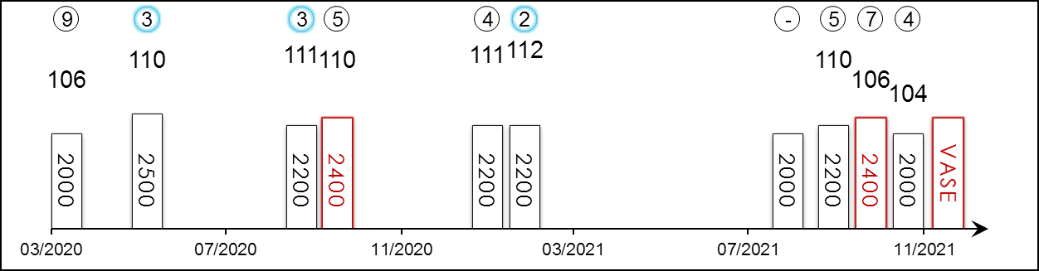 | HK Starts : - Right-handed : 24 (1-5-6-2-10) Jockey : -  Pre Import : - Sha Tin-Turf : - GF+ : 23 (2-4-5-1-11)  Lifetime : 28 (2-5-7-2-12) Non-Turf : - Good : 3 (0-1-1-0-1)  2021 : 6 (0-1-0-2-3) Distance : 4 (0-0-0-0-4) Yielding : 1 (0-0-1-0-0)  G1 : 5 (0-0-1-0-4) Course & Dist : - Soft/Hvy : 1 (0-0-0-1-0)  First Up : 8 (2-1-2-1-2) 2200-2800 : 13 (1-3-3-1-5) HK$ : 21,952,070  G1 win : Nil

Pos | Index | Date | Perf  Rating | Race Category & Name |  | Track | Dist/Course/Going |  | Wt | Jockey | Draw | Race Sectional Time |  |  |  | Race  Time | Horse  Final | Position & Margin in Running |  |  |  |  |  | Finish |  | Odds | Winner/Second
9/12 | - | 5/4/20 | 106 | G1 | Osaka Hai | HSN, JPN | 2000 RH | F | 126 | Y Iwata | 7 |  | 23.⁷⁰ | 23.⁰⁰ | 22.⁹⁰ | 1.58.⁴⁰ | 34.⁹⁰ | 5 | - | 5 | - | 5 | - | 9 | 6 | 49.1 | Lucky Lilac
3/18 | - | 31/5/20 | 110 | G2 | Meguro Kinen - hcp | TOK, JPN | 2500 LH | F | 127 | R Sakai | 11 |  | 24.⁰⁰ | 24.⁰⁰ | 23.⁹⁰ | 2.29.⁶⁰ | 35.⁷⁰ | 5 | - | 5 | - | 5 | - | 3 | 1 | 13.8 | King Of Koji
3/9 | - | 27/9/20 | 111 | G2 | Sankei Sho All Comers | NAK, JPN | 2200 RH | G | 123 | H Tanabe | 7 |  | 24.¹⁰ | 23.⁴⁰ | 23.⁷⁰ | 2.15.⁵⁰ | 35.²⁰ | 2 | - | 3 | - | 3 | - | 3 | 1.3 | 4.9 | Centelleo
5/17 | - | 11/10/20 | 110 | G2 | Kyoto Daishoten | KYO, JPN | 2400 RH | G | 123 | Y Fujioka | 6 |  | 25.⁵⁰ | 23.⁸⁰ | 23.⁴⁰ | 2.25.⁶⁰ | 35.²⁰ | 4 | - | 3 | - | 2 | - | 5 | 2.5 | 7.3 | Glory Vase
4/17 | - | 24/1/21 | 111 | G2 | American Jockey Club Cup | NAK, JPN | 2200 RH | S | 123 | S Ishibashi | 12 |  | 24.⁷⁰ | 24.⁴⁰ | 25.⁵⁰ | 2.17.⁹⁰ | 38.¹⁰ | 4 | - | 3 | - | 4 | - | 4 | 2.3 | 9.5 | Aristoteles
2/11 | - | 14/2/21 | 112 | G2 | Kyoto Kinen | HSN, JPN | 2200 RH | GF | 123 | R Wada | 2 |  | 23.⁹⁰ | 23.⁵⁰ | 23.⁷⁰ | 2.10.⁴⁰ | 35.²⁰ | 2 | - | 2 | - | 1 | - | 2 | 1.3 | 7 | Loves Only You
-/13 | (DNF) | 22/8/21 | - | G2 | Sapporo Kinen | SAP, JPN | 2000 RH | GF | 126 | R Sakai | 1 |  | 24.⁹⁰ | 23.⁶⁰ | 23.⁶⁰ | 1.59.⁵⁰ | - | 3 | - | 10 | - | 12 | - | - | DNF | 14.7 | Sodashi
5/16 | - | 26/9/21 | 110 | G2 | Sankei Sho All Comers | NAK, JPN | 2200 RH | GF | 123 | K Yokoyama | 16 |  | 24.¹⁰ | 23.³⁰ | 23.⁸⁰ | 2.11.⁹⁰ | 35.⁴⁰ | 4 | - | 4 | - | 5 | - | 5 | 2 | 20.3 | Win Marilyn
7/14 | - | 10/10/21 | 106 | G2 | Kyoto Daishoten | HSN, JPN | 2400 RH | GF | 123 | H Kawasu | 3 |  | 23.³⁰ | 23.³⁰ | 24.⁸⁰ | 2.24.⁵⁰ | 36.⁷⁰ | 4 | - | 4 | - | 4 | - | 7 | 3 | 8.4 | Makahiki
4/16 | - | 14/11/21 | 104 | G3 | Fukushima Kinen - hcp | FKS, JPN | 2000 RH | GF | 127 | R Sakai | 9 |  | 23.⁷⁰ | 24.⁸⁰ | 25.²⁰ | 1.59.²⁰ | 37.⁰⁰ | 4 | - | 4 | - | 4 | - | 4 | 4.8 | 6.7 | Panthalassa
 |  | 12/12/21 |  | G1 | LONGINES Hong Kong Vase | ST, HK | 2400 RH |  | 126 | C Y Ho
Solid performer but not a prolific winner; however, boasts placings behind Loves Only You, Chrono Genesis, Blast Onepiece, Mer de Glace and Win Bright. Finished 3rd in the G1 Hopeful Stakes (2000m) as a two-year-old and won G2 Kyoto Shimbun Hai (2200m) in his three-year-old campaign. Has struggled to notch another win since then. Fourth in the G3 Fukushima Kinen (2000m) latest. Versatile. Both career wins were on firm ground.

 |  |  | 業界巨頭  MOGUL (GB) 4 b c  Galileo (IRE) - Shastye (IRE) (Danehill (USA))  Owner(s): Michael Tabor, Derrick Smith & Mrs John Magnier |  | 岳伯仁 (愛爾蘭)  A P O'Brien (IRE) | 莫雅  R Moore | 126 lb  (111)

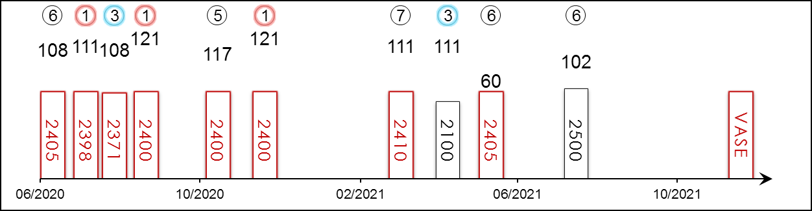 | HK Starts : 1 (1-0-0-0-0) Right-handed : 8 (4-1-1-1-1) Jockey : 8 (4-0-1-1-2)  Pre Import : - Sha Tin-Turf : 1 (1-0-0-0-0) GF+ : 1 (0-0-0-0-1)  Lifetime : 15 (5-1-2-2-5) Non-Turf : 1 (0-0-0-1-0) Good : 7 (4-0-1-0-2)  2021 : 4 (0-0-1-0-3) Distance : 9 (3-0-1-1-4) Yielding : 1 (1-0-0-0-0)  G1 : 8 (2-0-1-1-4) Course & Dist : 1 (1-0-0-0-0) Soft/Hvy : 5 (0-1-1-1-2)  First Up : 4 (0-1-0-1-2) 2200-2800 : 10 (3-0-1-1-5) HK$ : 16,474,740  G1 win : 2020 LONGINES Hong Kong Vase 2400m, 2020 GP de Paris 2400m

Pos | Index | Date | Perf  Rating | Race Category & Name |  | Track | Dist/Course/Going |  | Wt | Jockey | Draw | Race Sectional Time |  |  |  | Race  Time | Horse  Final | Position & Margin in Running |  |  |  |  |  | Finish |  | Odds | Winner/Second
6/16 | - | 4/7/20 | 108 | G1 | Derby S. - 3yo | EPS, GB | 2405 LH | G | 126 | R Moore | 2 |  | - | - | - | 2.34.⁴³ | - | - |  | - |  | - |  | 6 | 7 | 7/1 | Serpentine
1/6 | - | 30/7/20 | 111 | G3 | Gordon S. - 3yo | GOO, GB | 2398 RH | G | 127 | R Moore | 5 |  | - | - | - | 2.34.⁸⁹ | - | - |  | - |  | - |  | 1 | 0.8 | 9/2 | Highland Chief
3/8 | - | 19/8/20 | 108 | G2 | Great Voltigeur S. - 3yo | YOR, GB | 2371 LH | G | 126 | R Moore | 5 |  | - | - | - | 2.30.⁵⁷ | - | - |  | - |  | - |  | 3 | 4 | 85/40F | Pyledriver
1/10 | - | 13/9/20 | 121 | G1 | GP de Paris - 3yo | LCH, FR | 2400 RH | G | 129 | P-C Boudot | 10 |  | - | - | - | 2.24.⁷⁶ | - | - |  | - |  | - |  | 1 | 2.5 | 8.6 | In Swoop
5/10 | - | 7/11/20 | 117 | G1 | Breeders' Cup Turf | KEE, USA | 2400 LH | F | 122 | P-C Boudot | 10 |  | 24.⁵³ | 23.⁹³ | 23.⁵⁷ | 2.28.⁰² | - | 8 | 3.8 | 6 | 3.3 | 6 | 3.8 | 5 | 3 | 5 | Tarnawa
1/7 | *261 | 13/12/20 | 121 | G1 | LONGINES Hong Kong Vase | ST, HK | 2400 RH | G | 121 | R Moore | 4 |  | 24.⁰⁴ | 24.⁰¹ | 23.⁴³ | 2.27.²¹ | 23.²³ | 4 | 3 | 4 | 2.8 | 3 | 1.3 | 1 | 3 | 2.6 | Exultant
7/9 | - | 27/3/21 | 111 | G1 | Dubai Sheema Classic | MEY, UAE | 2410 LH | G | 125 | R Moore | 1 |  | - | - | - | 2.26.⁶⁵ | - | - |  | - |  | - |  | 7 | 6.5 | 7/4F | Mishriff
3/7 | - | 2/5/21 | 111 | G1 | P. Ganay | LCH, FR | 2100 RH | GS | 128 | C Soumillon | 2 |  | - | - | - | 2.11.⁶² | - | - |  | - |  | - |  | 3 | 3.5 | 2.7F | Mare Australis
6/6 | - | 4/6/21 | 60 | G1 | Coronation Cup | EPS, GB | 2405 LH | GS | 126 | J Heffernan | 5 |  | - | - | - | 2.42.²³ | - | - |  | - |  | - |  | 6 | 40 | 13/2 | Pyledriver
6/10 | - | 8/8/21 | 102 | G3 | P. de Reux | DEA, FR | 2500 RH | S | 131 | I Mendizabal | 7 |  | - | - | - | 2.48.⁶⁴ | - | - |  | - |  | - |  | 6 | 3.8 | 3.8F | Glycon
 |  | 12/12/21 |  | G1 | LONGINES Hong Kong Vase | ST, HK | 2400 RH |  | 126 | R Moore
Dual G1 winner. Last year’s G1 LONGINES Hong Kong Vase (2400m) winner returning for another crack. Struggled for form since that run but has placed at G1 level at Longchamp since. Also last year’s G1 Grand Prix de Paris (2400m) victor, followed by fifth in the 2020 G1 Breeder’s Cup Turf (2400m) in Keeneland. Tough stayer. Versatile. Relishes good ground.

 |  |  | 精神威 C345  RELIABLE TEAM (NZ) 6 gr g  Reliable Man (GB) - Stella Doro (NZ) (Faltaat (USA))  Owner(s): Nova Stella Syndicate |  | 羅富全 (香港)  F C Lor (HK)  Win 16.6% Place 41.4% | 梁家俊  K C Leung  Win 7.2% Place 17.0% | 126 lb  (111)

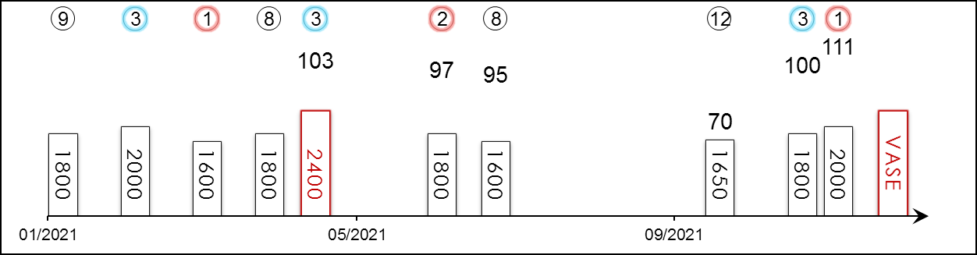 | HK Career : 28 (7-3-5-0-13) Right-handed : 28 (7-3-5-0-13) Jockey : 8 (2-0-3-0-3)  Pre Import : - Sha Tin-Turf : 16 (3-2-4-0-7) GF+ : 8 (1-1-1-0-5)  Lifetime : 28 (7-3-5-0-13) Non-Turf : - Good : 20 (6-2-4-0-8)  2021/22 : 3 (1-0-1-0-1) Distance : 1 (0-0-1-0-0) Yielding : -  G1 : - Course & Dist : 1 (0-0-1-0-0) Soft/Hvy : -  First Up : 4 (1-0-0-0-3) 2200-2800 : 1 (0-0-1-0-0) HK$ : 12,765,800  G1 win : Nil

Pos | Index | Date | Perf  Rating | Race Category & Name |  | Track | Dist/Course/Going |  | Wt | Jockey | Draw | Race Sectional Time |  |  |  | Race  Time | Horse  Final | Position & Margin in Running |  |  |  |  |  | Finish |  | Odds | Winner/Second
9/14 | *372 | 24/1/21 | - | - | Cl.2 hcp | ST, HK | 1800 RH | G | 127 | Z Purton | 6 |  | 24.⁹⁶ | 23.¹⁵ | 23.³⁰ | 1.47.⁷⁰ | 23.⁶⁹ | 1 | 1½ | 1 | 3/4 | 1 | 1/2 | 9 | 2½ | 11 | Assimilate
3/9 | *442 | 21/2/21 | - | - | Cl.2 hcp | ST, HK | 2000 RH | G | 127 | K Teetan | 6 |  | 25.¹⁶ | 23.²⁰ | 22.⁹³ | 2.01.⁵⁵ | 23.³⁵ | 1 | 3/4 | 1 | 1/2 | 1 | N | 3 | 2½ | 15 | Panfield
1/14 | *526 | 21/3/21 | - | - | Cl.2 hcp | ST, HK | 1600 RH | G | 126 | K C Leung | 12 |  | 23.³¹ | 23.⁴² | 22.⁹⁷ | 1.34.⁴⁹ | 22.⁹⁷ | 1 | SH | 1 | 1/2 | 1 | SH | 1 | N | 49 | Beauty Smile
8/12 | *593 | 14/4/21 | - | - | Cl.2 hcp | HV, HK | 1800 RH | GF | 133 | K Teetan | 11 |  | 25.⁵⁷ | 23.³¹ | 23.⁵⁶ | 1.49.⁴² | 23.⁹⁰ | 1 | 2 | 1 | 1/2 | 1 | N | 8 | 2¼ | 22 | Charity Fun
3/12 | *638 | 2/5/21 | 103 | G3 | Queen Mother Memorial Cup - hcp | ST, HK | 2400 RH | G | 117 | K C Leung | 8 |  | 24.³⁸ | 22.⁹³ | 23.¹³ | 2.28.¹⁴ | 23.¹⁹ | 1 | 1¼ | 1 | SH | 1 | N | 3 | N | 35 | Butterfield
2/10 | *762 | 20/6/21 | 97 | G3 | Premier Plate - hcp | ST, HK | 1800 RH | GF | 113 | H W Lai | 4 |  | 23.⁷³ | 22.⁵⁹ | 23.²⁶ | 1.46.³⁰ | 23.³⁶ | 2 | 1¾ | 2 | 3/4 | 1 | 1¼ | 2 | 1/2 | 25 | Southern Legend
8/11 | *823 | 11/7/21 | 95 | - | Sha Tin Mile Trophy - hcp | ST, HK | 1600 RH | GF | 124 | K C Leung | 10 |  | 22.²⁸ | 22.⁵⁰ | 23.⁵¹ | 1.32.²⁴ | 23.⁸⁸ | 2 | 1 | 2 | 1 | 2 | 1¾ | 8 | 4 | 14 | Preciousship
12/12 | 83 | 6/10/21 | 70 | - | Cl.2 hcp | HV, HK | 1650 RH | G | 133 | K C Leung | 10 |  | 23.⁹⁸ | 23.⁰² | 24.⁴² | 1.38.⁷³ | 26.⁶⁹ | 6 | 3¼ | 7 | 2¼ | 8 | 5 | 12 | 19¼ | 24 | Telecom Fighters
3/8 | 155 | 7/11/21 | 100 | G3 | Sa Sa Ladies' Purse - hcp | ST, HK | 1800 RH | G | 115 | K C Leung | 2 |  | 23.⁸³ | 23.¹² | 23.¹³ | 1.46.⁰² | 23.¹⁸ | 1 | N | 1 | 1 | 1 | 1 | 3 | N | 8.2 | Tourbillon Diamond
1/7 | 194 | 21/11/21 | 111 | G2 | BOCHK Jockey Club Cup | ST, HK | 2000 RH | G | 123 | K C Leung | 2 |  | 25.²² | 22.⁸⁸ | 21.⁸¹ | 2.03.⁸⁶ | 21.⁸¹ | 1 | 3/4 | 1 | 1/2 | 1 | 1/2 | 1 | N | 17 | Ka Ying Star
 |  | 12/12/21 |  | G1 | LONGINES Hong Kong Vase | ST, HK | 2400 RH |  | 126 | K C Leung
Seven-time winner in Hong Kong and three times placed at G3 level, missing by under half a length each time. Bold front-runner whose catch-me-if-you-can tactics resulted in a G2 BOCHK Jockey Club Cup (2000m) triumph at his most recent start. Before that finished a gallant third behind Tourbillon Diamond and Ka Ying Star in the G3 Sa Sa Ladies’ Purse Handicap (1800m). Won on good and good to firm ground.

 |  |  | 勇猛神駒 C462  BUTTERFIELD (BRZ) ex Halston 6 ch g  Setembro Chove (BRZ) - Londrinita (ARG) (Fahim (GB))  Owner(s): Yue Yun Hing |  | 沈集成 (香港)  C S Shum (HK)  Win 11.7% Place 37.5% | 潘頓  Z Purton  Win 23.1% Place 52.7% | 126 lb  (110)

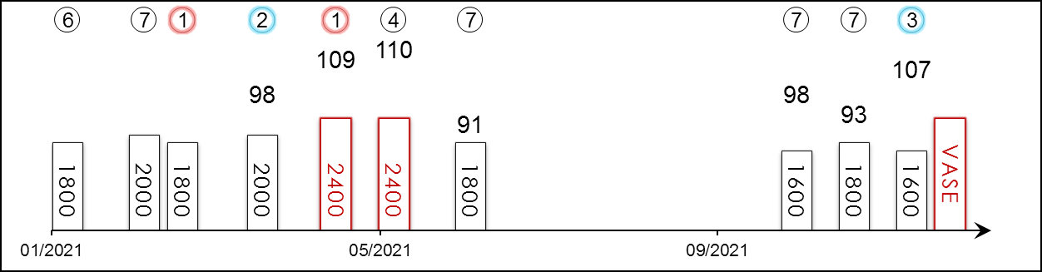 | HK Career : 27 (3-4-1-4-15) Right-handed : 27 (3-4-1-4-15) Jockey : 4 (1-0-0-1-2)  Pre Import : 6 (4-0-1-0-1) Sha Tin-Turf : 22 (3-3-1-2-13) GF+ : 8 (0-1-0-2-5)  Lifetime : 33 (7-4-2-4-16) Non-Turf : - Good : 22 (5-3-2-2-10)  2021/22 : 3 (0-0-1-0-2) Distance : 3 (2-0-0-1-0) Yielding : -  G1 : 4 (2-0-0-1-1) Course & Dist : 2 (1-0-0-1-0) Soft/Hvy : 3 (2-0-0-0-1)  First Up : 6 (2-0-0-0-4) 2200-2800 : 3 (2-0-0-1-0) HK$ : 9,732,240  G1 win : 2018 Derby Paulista 2400m, 2018 Ipiranga 1600m

Pos | Index | Date | Perf  Rating | Race Category & Name |  | Track | Dist/Course/Going |  | Wt | Jockey | Draw | Race Sectional Time |  |  |  | Race  Time | Horse  Final | Position & Margin in Running |  |  |  |  |  | Finish |  | Odds | Winner/Second
6/14 | *372 | 24/1/21 | - | - | Cl.2 hcp | ST, HK | 1800 RH | G | 130 | K Teetan | 11 |  | 24.⁹⁶ | 23.¹⁵ | 23.³⁰ | 1.47.⁷⁰ | 23.²⁷ | 6 | 4¼ | 5 | 2¼ | 6 | 1½ | 6 | 1¼ | 11 | Assimilate
7/9 | *442 | 21/2/21 | - | - | Cl.2 hcp | ST, HK | 2000 RH | G | 125 | C L Chau⁻⁷ | 8 |  | 25.¹⁶ | 23.²⁰ | 22.⁹³ | 2.01.⁵⁵ | 23.⁹⁵ | 2 | 3/4 | 2 | 1/2 | 2 | N | 7 | 6½ | 10 | Panfield
1/14 | *488 | 7/3/21 | - | - | Cl.2 hcp | ST, HK | 1800 RH | G | 122 | Z Purton | 2 |  | 23.⁹³ | 22.⁷⁸ | 23.⁶² | 1.47.¹⁸ | 23.²² | 5 | 3¼ | 6 | 4 | 4 | 2½ | 1 | 1¾ | 5.8 | Charity Go
2/9 | *556 | 5/4/21 | 98 | - | Cl.1 hcp | ST, HK | 2000 RH | G | 116 | A Badel | 4 |  | 24.²³ | 23.²⁰ | 23.¹³ | 2.01.⁹² | 23.⁰⁴ | 4 | 3 | 4 | 2½ | 3 | 1½ | 2 | 1 | 3.3 | Glorious Dragon
1/12 | *638 | 2/5/21 | 109 | G3 | Queen Mother Memorial Cup - hcp | ST, HK | 2400 RH | G | 122 | M F Poon | 5 |  | 24.³⁸ | 22.⁹³ | 23.¹³ | 2.28.¹⁴ | 22.⁸⁵ | 3 | 2 | 5 | 1½ | 5 | 1¾ | 1 | SH | 28 | Charity Fun
4/8 | *696 | 23/5/21 | 110 | G1 | Standard Chartered Champions & Chater Cup | ST, HK | 2400 RH | GF | 126 | M F Poon | 2 |  | 24.⁵¹ | 23.⁵⁶ | 22.⁶⁴ | 2.25.²⁵ | 22.⁷¹ | 6 | 4¼ | 6 | 3¾ | 6 | 3¼ | 4 | 3¾ | 13 | Panfield
7/10 | *762 | 20/6/21 | 91 | G3 | Premier Plate - hcp | ST, HK | 1800 RH | GF | 115 | M F Poon | 6 |  | 23.⁷³ | 22.⁵⁹ | 23.²⁶ | 1.46.³⁰ | 23.³⁶ | 3 | 3 | 3 | 2½ | 4 | 3¾ | 7 | 4½ | 8.8 | Southern Legend
7/12 | 101 | 17/10/21 | 98 | G2 | Oriental Watch Sha Tin Trophy - hcp | ST, HK | 1600 RH | G | 113 | M F Poon | 7 |  | 23.⁴¹ | 23.⁰⁰ | 22.⁷⁷ | 1.34.⁴⁰ | 22.⁵² | 9 | 3¾ | 8 | 3¼ | 10 | 2¾ | 7 | 1¼ | 45 | Panfield
7/8 | 155 | 7/11/21 | 93 | G3 | Sa Sa Ladies' Purse - hcp | ST, HK | 1800 RH | G | 114 | M F Poon | 5 |  | 23.⁸³ | 23.¹² | 23.¹³ | 1.46.⁰² | 23.²² | 5 | 3½ | 6 | 3¾ | 7 | 3 | 7 | 3½ | 12 | Tourbillon Diamond
3/12 | 211 | 28/11/21 | 107 | - | Chevalier Cup - hcp | ST, HK | 1600 RH | G | 130 | B Shinn | 8 |  | 23.⁰⁹ | 23.⁵² | 22.⁸⁷ | 1.33.⁷¹ | 22.⁵³ | 10 | 7¼ | 9 | 6¼ | 7 | 3¼ | 3 | 1¼ | 46 | Silver Express
 |  | 12/12/21 |  | G1 | LONGINES Hong Kong Vase | ST, HK | 2400 RH |  | 126 | Z Purton
2021 G3 Queen Mother Memorial Cup Handicap (2400m) winner; prior to arriving in Hong Kong was a two-time G1 winner in Brazil, including the Derby Paulista (2400m) at Cidade Jardim. Ran a creditable fourth in the G1 Standard Chartered Champions & Chater Cup (2400m) last season. Midfield in his first two runs this term, including seventh in the G3 Sa Sa Ladies’ Purse Handicap (1800m) two starts back. Ran third in the Class 1 Chevalier Cup Handicap (1600m) latest. Versatile. Won on good ground in Hong Kong but also triumphed on soft ground pre-import in Brazil.

 |  |  | 倚蓬萊  EBAIYRA (USA) 4 ch f  Distorted Humor (USA) - Ebiyza (IRE) (Rock Of Gibraltar (IRE))  Owner(s): H H Aga Khan |  | 羅迪普 (法國)  A de Royer Dupre (FR) | 蘇銘倫  C Soumillon | 122 lb  (112)

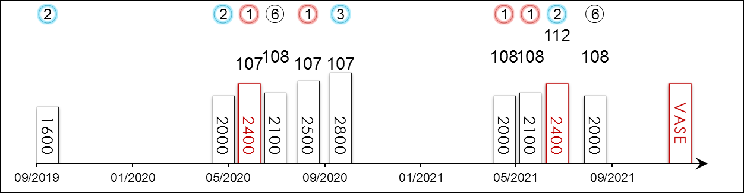 | HK Starts : - Right-handed : 7 (3-1-1-0-2) Jockey : 9 (4-3-1-0-1)  Pre Import : - Sha Tin-Turf : - GF+ : -  Lifetime : 10 (4-3-1-0-2) Non-Turf : - Good : -  2021 : 4 (2-1-0-0-1) Distance : 2 (1-1-0-0-0) Yielding : -  G1 : 4 (0-1-1-0-2) Course & Dist : - Soft/Hvy : 10 (4-3-1-0-2)  First Up : 3 (1-2-0-0-0) 2200-2800 : 4 (2-1-1-0-0) HK$ : 3,029,280  G1 win : Nil

Pos | Index | Date | Perf  Rating | Race Category & Name |  | Track | Dist/Course/Going |  | Wt | Jockey | Draw | Race Sectional Time |  |  |  | Race  Time | Horse  Final | Position & Margin in Running |  |  |  |  |  | Finish |  | Odds | Winner/Second
2/11 | - | 27/9/19 | - | - | 2yo fillies mdn | STC, FR | 1600 LH | VS | 123 | C Soumillon | 9 |  | - | - | - | 1.47.⁴³ | - | - |  | - |  | - |  | 2 | 1.5 | 4.7F | Black Fever
2/15 | - | 18/5/20 | - | - | 3yo fillies mdn | CHY, FR | 2000 RH | GS | 128 | C Soumillon | 11 |  | - | - | - | 2.02.³⁹ | - | - |  | - |  | - |  | 2 | 3 | 3.6F | Solsticia
1/9 | - | 10/6/20 | 107 | G3 | P. de Royaumont - 3yo fillies | CHY, FR | 2400 RH | GS | 126 | C Soumillon | 2 |  | - | - | - | 2.29.⁸⁶ | - | - |  | - |  | - |  | 1 | 2.5 | 2.7F | American Apples
6/11 | - | 5/7/20 | 108 | G1 | P. de Diane - 3yo fillies | CHY, FR | 2100 RH | GS | 126 | V Cheminaud | 5 |  | - | - | - | 2.05.⁴⁶ | - | - |  | - |  | - |  | 6 | 3.5 | 18 | Fancy Blue
1/8 | - | 23/8/20 | 107 | G2 | P. de Pomone - f&m | DEA, FR | 2500 RH | S | 121 | C Soumillon | 6 |  | - | - | - | 2.51.²⁴ | - | - |  | - |  | - |  | 1 | 0.8 | 4.2 | Spirit of Appin
3/12 | - | 3/10/20 | 107 | G1 | P. de Royallieu - f&m | LCH, FR | 2800 RH | H | 122 | C Soumillon | 1 |  | - | - | - | 3.11.²² | - | - |  | - |  | - |  | 3 | 6.3 | 6.2 | Wonderful Tonight
1/6 | - | 2/5/21 | 108 | G3 | P. Allez France - f&m | LCH, FR | 2000 RH | GS | 123 | C Soumillon | 4 |  | - | - | - | 2.10.⁴³ | - | - |  | - |  | - |  | 1 | Nk | 5.8 | Raabihah
1/6 | - | 26/5/21 | 108 | G2 | P. Corrida - f&m | STC, FR | 2100 LH | H | 126 | C Soumillon | 5 |  | - | - | - | 2.24.⁰⁴ | - | - |  | - |  | - |  | 1 | 1.5 | 2.6 | Raabihah
2/8 | - | 4/7/21 | 112 | G1 | GP de Saint-Cloud | STC, FR | 2400 LH | S | 125 | C Soumillon | 1 |  | - | - | - | 2.29.¹¹ | - | - |  | - |  | - |  | 2 | 1 | 5.8 | Broome
6/8 | - | 22/8/21 | 108 | G1 | P. Jean Romanet - f&m | DEA, FR | 2000 RH | GS | 126 | C Soumillon | 1 |  | - | - | - | 2.06.⁹⁹ | - | - |  | - |  | - |  | 6 | 4.3 | 2.9F | Grand Glory
 |  | 12/12/21 |  | G1 | LONGINES Hong Kong Vase | ST, HK | 2400 RH |  | 122 | C Soumillon
Four-year-old filly for H H Aga Khan, dual G3 and G2 winner and finished second in the 2021 G1 Grand Prix de Saint-Cloud (2400m). Last out sixth in the G1 Prix Jean Romanet (2000m) at Deauville. Tends to race prominently and those tactics have seen her score at G3 and G2 level this season. Best form on rain-affected ground.

