Spotlight

Danon Smash returns to defend his LONGINES Hong Kong Sprint crown, just like his sire, Lord Kanaloa did in 2013. He will also bid to give trainer Takayuki Yasuda a record-setting fourth win in the race; joining him from Japan is first and second place-getters out of the G1 Sprinters Stakes - Pixie Knight and Resistencia.

Spearheading the home team’s brigade is Wellington, winner of G1 Chairman’s Sprint Prize (1200m) last April, while veteran grey Hot King Prawn bolsters him at the top of the charts for Hong Kong as does Computer Patch, Amazing Star, Stronger and dual G2-winner Lucky Patch.

A host of young adversaries join their more experienced counterparts – Courier Wonder and Naboo Attack have shown glimpses of G1 quality and they will each look to take the next step in this race.

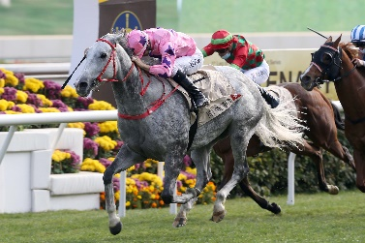 | HOT KING PRAWN (AUS)  HONG KONG 7g 117  Incredibly consistent performer with 12 wins from 25 starts; biggest win in 2021 G1 Centenary Sprint Cup (1200m); second by a neck in 2019 LONGINES Hong Kong Sprint (1200m). | 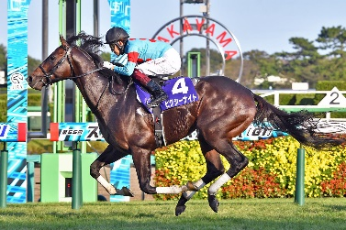 | PIXIE KNIGHT (JPN)  JAPAN 3c 117  Winner of 2021 G1 Sprinters Stakes (1200m) at Nakayama last out, defying Resistencia.
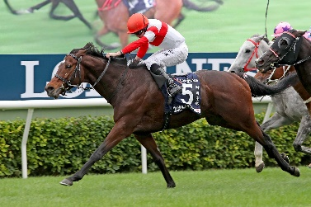 | DANON SMASH (JPN)  JAPAN 6h 116  Looking to win back-to-back LONGINES Hong Kong Sprints (1200m); three starts ago won the G1 Takamatsunomiya Kinen (1200m) at Chukyo; last out placed sixth to Pixie Knight in the G1 Sprinters Stakes (1200m). | 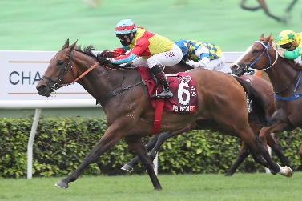 | WELLINGTON (AUS)  HONG KONG 5g 116  Prolific winner with seven wins from 11 starts; claimed G1 Chairman’s Sprint Prize (1200m) last term.
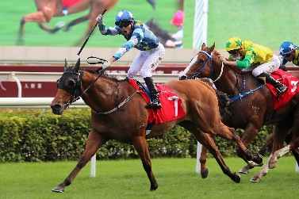 | LUCKY PATCH (NZ)  HONG KONG 5g 115  Dual G2 winner this season at his most recent two runs, winning the 2021 Premier Bowl (1200m) and Jockey Club Sprint (1200m). | 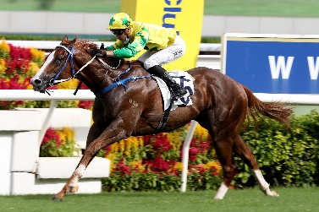 | SKY FIELD (AUS)  HONG KONG 5g 115  Five wins from 17 starts; biggest win to date in 2021 G3 Premier Cup (1400m); last out finished third in G2 Jockey Club Sprint (1200m).
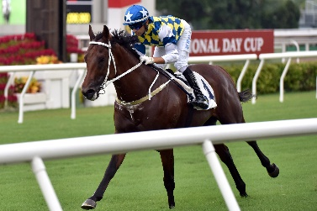 | COMPUTER PATCH (AUS)  HONG KONG 5g 112  G3 winner who has placed at G1 level, finishing second to Wellington in April’s G1 Chairman’s Sprint Prize (1200m). | 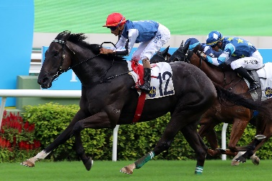 | NABOO ATTACK (AUS)  HONG KONG 5g 112  Two-time winner from five starts in Hong Kong; hulking horse who won first-up this season at Class 1 level; last out finished second in G2 Jockey Club Sprint (1200m).
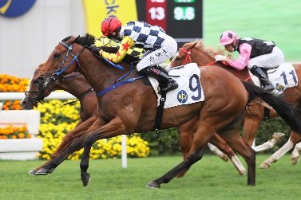 | AMAZING STAR (NZ)  HONG KONG 7g 110  Seven-time winner in Hong Kong including at G2 level in 2021 Sprint Cup (1200m) when surprising at 178/1. | 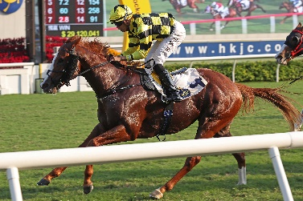 | STRONGER (AUS)  HONG KONG 5h 110  Solid contender who is twice G2 placed; last out finished sixth in G2 Jockey Club Sprint (1200m) to Lucky Patch.
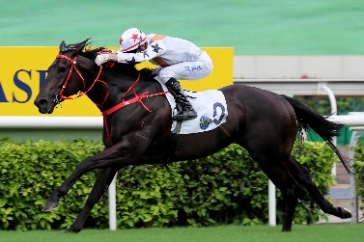 | COURIER WONDER (NZ)  HONG KONG 4g 108  Prodigious talent who won his first five starts to remain undefeated through his first Hong Kong season; claimed G3 Sha Tin Vase (1200m) at his final run last season; last out finished fifth in G2 Jockey Club Sprint (1200m). | 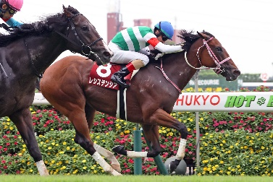 | RESISTENCIA (JPN)  JAPAN 4f 111  Runner-up in October’s G1 Sprinters Stakes (1200m) at Nakayama to Pixie Knight; G2 winner the start before, defeating Pixie Knight at Chukyo.

