Previous Winners

Horse /  Owner |  | Trainer /  Jockey | Rep. | Win.  Margin | Draw | Odds | Going | Race Time | Pre-race  Rating | Last Start Performance | Best Performance Last  12 months (Runs since)
2020
Danon Smash (JPN) 5h | 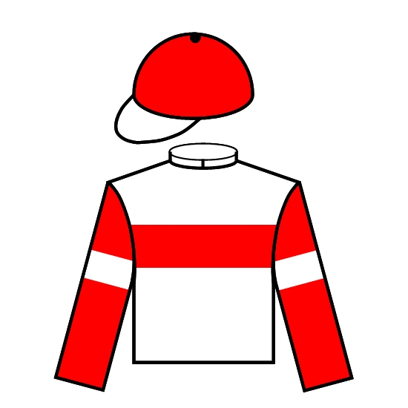 | T Yasuda | JPN | 1/2 | 14 | 22 | G | 1.08.45 | 114 | 2nd Sprinters S. 1200 G1 | 2nd Sprinters S. 1200 G1 (0)
Danox Co. Ltd. |  | R Moore
2019
Beat The Clock (AUS) 6g | 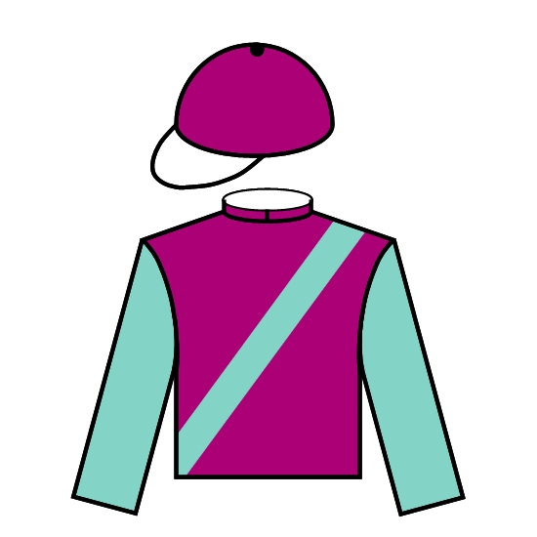 | J Size | HK | N | 3 | 6.5 | G | 1.08.12 | 120 | 3rd Jockey Club Sprint 1200 G2 | Won Chairman’s Sprint Prize 1200 G1 (1)
Merrick Chung Wai Lik |  | J Moreira
2018
Mr Stunning (AUS) 6g | 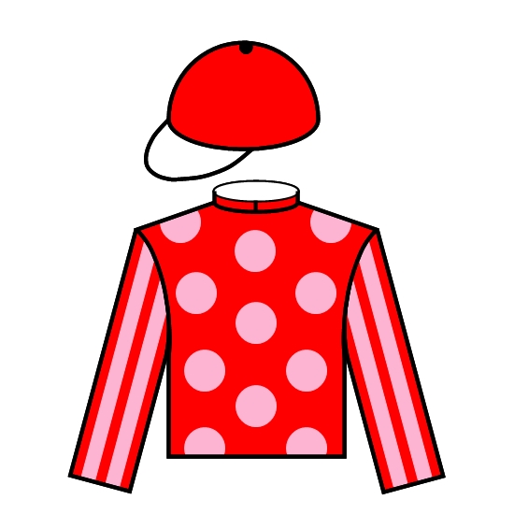 | F C Lor | HK | 3/4 | 9 | 3.6 | G | 1.08.85 | 121 | 2nd BOCHK Wealth Management JC Sprint 1200 G2 | 2nd Chairman’s Sprint Prize 1200 G1 (2)
Maurice Koo Win Chong |  | K Teetan
2017
Mr Stunning (AUS) 5g |  | J Size | HK | N | 4 | 1.9F | G | 1.08.40 | 121 | Won BOCHK Wealth Management JC Sprint 1200 G2 | Won BOCHK Wealth Management JC Sprint 1200 G2 (0)
Maurice Koo Win Chong |  | N Rawiller
2016
Aerovelocity (NZ) 8g | 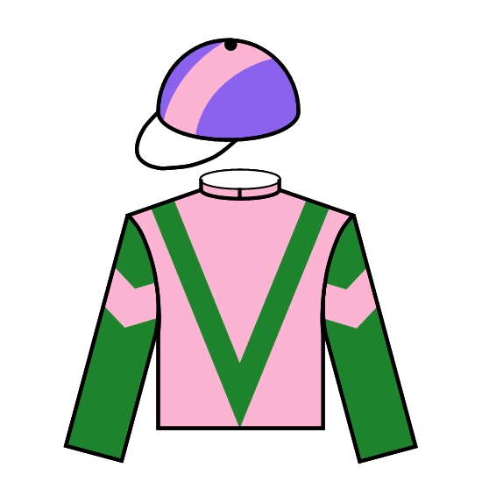 | P O’Sullivan | HK | SH | 2 | 7.5 | G | 1.08.80 | 119 | 3rd BOCHK Wealth Management JC Sprint 1200 G2 | 3rd BOCHK Wealth Management JC Sprint 1200 G2 (0)
Daniel Yeung Ngai |  | Z Purton
2015
Peniaphobia (IRE) 4g |  | A S Cruz | HK | 1/2 | 14 | 4.4 | G | 1.08.74 | 116 | 2nd BOCHK Wealth Management JC Sprint 1200 G2 | 2nd BOCHK Wealth Management JC Sprint 1200 G2 (0)
Huang Kai Wen |  | J Moreira
2014
Aerovelocity (NZ) 6g | 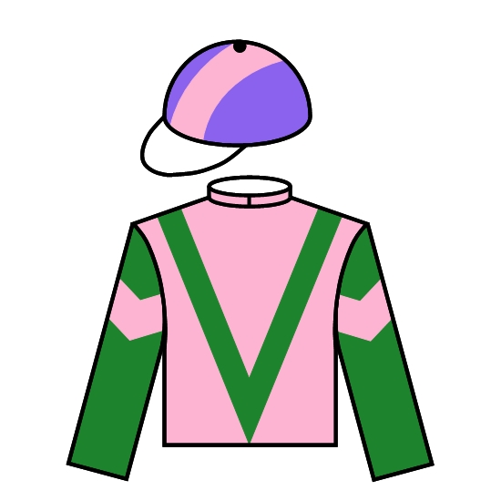 | P O’Sullivan | HK | N | 7 | 3.9 | GF | 1.08.57 | 112 | 14th BOCHK Wealth Management JC Sprint 1200 G2 | Won Premier Bowl 1200 (G2) (1)
Daniel Yeung Ngai |  | Z Purton
2013
Lord Kanaloa (JPN) 5h | 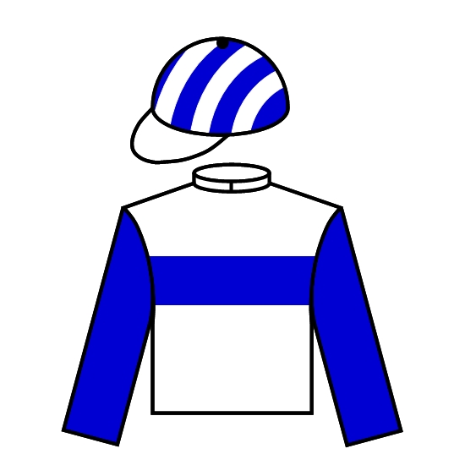 | T Yasuda | JPN | 5 | 12 | 1.8F | GF | 1.08.25 | 120 | Won Sprinters S. 1200 G1 | Won Yasuda Kinen 1600 G1 (2)
Lord Horse Club |  | Y Iwata
2012
Lord Kanaloa (JPN) 4c |  | T Yasuda | JPN | 2-1/2 | 6 | 4 | G | 1.08.50 | 117 | Won Sprinters Stakes 1200 G1 | Won Sprinters Stakes 1200 G1 (0)
Lord Horse Club |  | Y Iwata
2011
Lucky Nine (IRE) 4g | 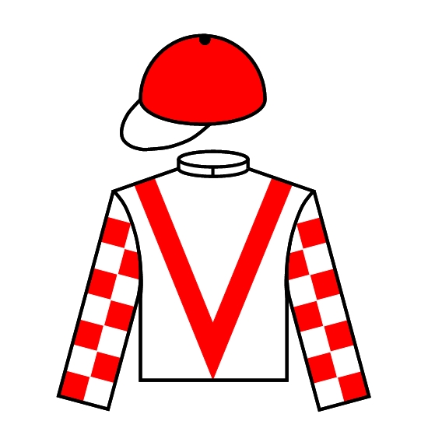 | C Fownes | HK | HD | 6 | 4.3 | GF | 1.08.98 | 117 | 5th Sprinters Stakes 1200 G1 | 2nd BMW Champions Mile 1600 G1 (2)
Dr. Chang Fuk To & Maria Chang Lee Ming Shum |  | B Prebble

