 |  |  | 旺蝦王 A299  HOT KING PRAWN (AUS) 7 gr g  Denman (AUS) - De Chorus (AUS) (Unbridled's Song (USA))  Owner(s): Lau Sak Hong |  | 蔡約翰 (香港)  J Size (HK)  Win 9.7% Place 25.8% | 莫雅  R Moore | 126 lb  (117)

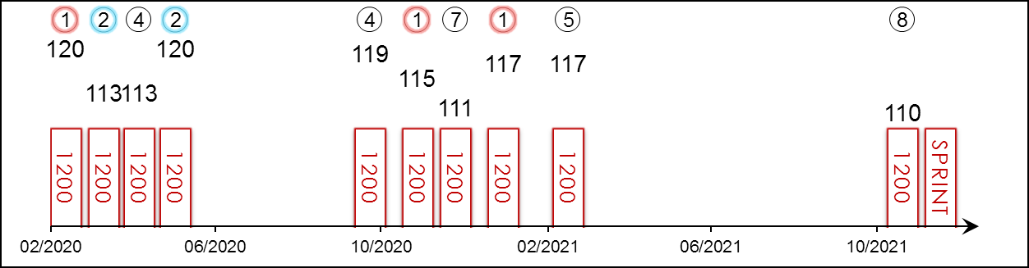 | HK Career : 25 (12-5-2-2-4) Right-handed : 19 (6-5-2-2-4) Jockey : -  Pre Import : - Sha Tin-Turf : 24 (11-5-2-2-4) GF+ : 5 (3-1-0-1-0)  Lifetime : 25 (12-5-2-2-4) Non-Turf : - Good : 19 (8-4-2-1-4)  2021/22 : 1 (0-0-0-0-1) Distance : 18 (6-5-1-2-4) Yielding : 1 (1-0-0-0-0)  G1 : 7 (1-1-2-1-2) Course & Dist : 17 (5-5-1-2-4) Soft/Hvy : -  First Up : 7 (3-2-0-1-1) 1000-1200 : 24 (12-5-1-2-4) HK$ : 34,192,300  G1 win : 2021 Centenary Sprint Cup 1200m

Pos | Index | Date | Perf  Rating | Race Category & Name |  | Track | Dist/Course/Going |  | Wt | Jockey | Draw | Race Sectional Time |  |  |  | Race  Time | Horse  Final | Position & Margin in Running |  |  |  |  |  | Finish |  | Odds | Winner/Second
1/7 | **475 | 8/3/20 | 120 | - | Cl.1 hcp | ST, HK | 1200 RH | G | 133 | J Moreira | 2 |  | 23.⁷⁹ | 22.⁶⁸ | 22.²⁵ | 1.08.⁷² | 22.⁰¹ | - |  | 3 | 1¼ | 3 | 1½ | 1 | 1/2 | 3.5 | Thanks Forever
2/8 | **551 | 5/4/20 | 113 | G2 | Sprint Cup | ST, HK | 1200 RH | G | 123 | J Moreira | 1 |  | 24.²⁷ | 22.²⁹ | 22.⁹² | 1.09.⁴⁸ | 22.⁹⁰ | - |  | 3 | 1¼ | 3 | 1 | 2 | 3/4 | 2.6 | Voyage Warrior
4/11 | **606 | 26/4/20 | 113 | G1 | Chairman's Sprint Prize | ST, HK | 1200 RH | G | 126 | J Moreira | 1 |  | 23.²³ | 22.²¹ | 22.⁹⁶ | 1.08.⁴⁰ | 22.⁹⁹ | - |  | 4 | 1¾ | 4 | 1¼ | 4 | 1½ | 3 | Mr Stunning
2/8 | **682 | 24/5/20 | 120 | G3 | Sha Tin Vase - hcp | ST, HK | 1200 RH | G | 133 | J Moreira | 4 |  | 24.⁷⁹ | 21.⁹⁷ | 22.²⁰ | 1.08.⁹⁶ | 22.²⁵ | - |  | 1 | 1/2 | 1 | 3/4 | 2 | N | 4 | Thanks Forever
4/7 | *113 | 18/10/20 | 119 | G2 | Premier Bowl - hcp | ST, HK | 1200 RH | GF | 133 | J Moreira | 6 |  | 23.⁵¹ | 21.⁶⁷ | 22.⁷¹ | 1.07.⁸⁹ | 22.⁸² | - |  | 5 | 2¾ | 5 | 1¾ | 4 | 2½ | 5.3 | Wishful Thinker
1/10 | *207 | 22/11/20 | 115 | G2 | Jockey Club Sprint | ST, HK | 1200 RH | GF | 123 | J Moreira | 5 |  | 23.¹⁸ | 21.⁹³ | 22.⁸⁹ | 1.08.⁰⁰ | 22.⁶⁹ | - |  | 4 | 2¼ | 4 | 1¼ | 1 | 3/4 | 3.9 | Computer Patch
7/14 | *262 | 13/12/20 | 111 | G1 | LONGINES Hong Kong Sprint | ST, HK | 1200 RH | G | 126 | J Moreira | 5 |  | 23.⁰⁹ | 22.⁴⁶ | 22.⁹⁰ | 1.08.⁴⁵ | 22.⁹⁵ | - |  | 5 | 2¼ | 4 | 1¼ | 7 | 1½ | 2.1F | Danon Smash
1/11 | *368 | 24/1/21 | 117 | G1 | Centenary Sprint Cup | ST, HK | 1200 RH | G | 126 | J Moreira | 2 |  | 23.⁴⁹ | 21.⁹² | 22.⁶⁰ | 1.08.⁰¹ | 22.³⁶ | - |  | 3 | 1¾ | 3 | 1½ | 1 | 1¾ | 2.1F | Regency Legend
5/9 | *504 | 13/3/21 | 117 | - | Cl.1 hcp | ST, HK | 1200 RH | G | 133 | J Moreira | 5 |  | 23.⁹⁵ | 21.⁸³ | 22.⁰² | 1.07.⁸⁰ | 22.³³ | - |  | 4 | 2¼ | 4 | 2 | 5 | 4 | 3.7F | Wellington
8/10 | 192 | 21/11/21 | 110 | G2 | BOCHK Private Banking JC Sprint | ST, HK | 1200 RH | G | 128 | V Borges | 3 |  | 23.⁴¹ | 22.¹¹ | 22.⁴⁶ | 1.07.⁹⁸ | 22.⁷⁹ | - |  | 3 | 2 | 4 | 1½ | 8 | 3½ | 31 | Lucky Patch
 |  | 12/12/21 |  | G1 | LONGINES Hong Kong Sprint | ST, HK | 1200 RH |  | 126 | R Moore
Incredibly consistent performer with 12 wins from 25 starts in Hong Kong; biggest win in the 2021 G1 Centenary Sprint Cup (1200m). Second by a neck in 2019 G1 LONGINES Hong Kong Sprint (1200m). Returned first-up this season to finish eighth in the G2 BOCHK Private Banking Jockey Club Sprint (1200m) after an eight-month break. Often leads or sits prominently. No ground issues.

 |  |  | 妙發靈機  PIXIE KNIGHT (JPN) 3 b c  Maurice (JPN) - Pixie Hollow (JPN) (King Halo (JPN))  Owner(s): Silk Racing Co Ltd |  | 音無秀孝 (日本)  H Otonashi (JPN) | 福永祐一  Y Fukunaga | 126 lb  (117)

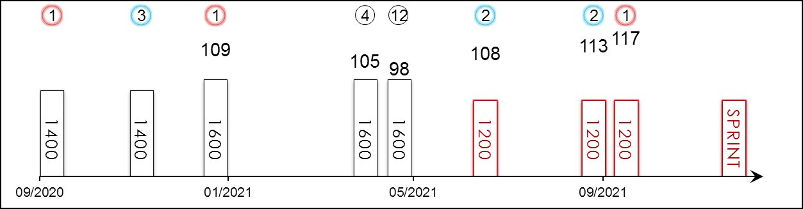 | HK Starts : - Right-handed : 4 (1-1-1-1-0) Jockey : 8 (3-2-1-1-1)  Pre Import : - Sha Tin-Turf : - GF+ : 7 (3-2-1-0-1)  Lifetime : 8 (3-2-1-1-1) Non-Turf : - Good : -  2021 : 6 (2-2-0-1-1) Distance : 3 (1-2-0-0-0) Yielding : 1 (0-0-0-1-0)  G1 : 2 (1-0-0-0-1) Course & Dist : - Soft/Hvy : -  First Up : 3 (1-1-0-1-0) 1000-1200 : 3 (1-2-0-0-0) HK$ : 16,640,640  G1 win : 2021 Sprinters S. 1200m

Pos | Index | Date | Perf  Rating | Race Category & Name |  | Track | Dist/Course/Going |  | Wt | Jockey | Draw | Race Sectional Time |  |  |  | Race  Time | Horse  Final | Position & Margin in Running |  |  |  |  |  | Finish |  | Odds | Winner/Second
1/11 | - | 26/9/20 | - | - | 2yo newcomer | CYO, JPN | 1400 LH | F | 119 | Y Fukunaga | 8 |  | 23.⁶⁰ | 24.¹⁰ | 23.¹⁰ | 1.23.⁴⁰ | 34.⁶⁰ | - |  | 5 | - | 5 | - | 1 | 0.5 | 1.7F | Air Shrub
3/11 | - | 23/11/20 | - | - | 2yo 1 Win | HSN, JPN | 1400 RH | F | 121 | Y Fukunaga | 3 |  | 21.⁶⁰ | 23.³⁰ | 24.²⁰ | 1.21.³⁰ | 35.⁸⁰ | - |  | 10 | - | 9 | - | 3 | 2.3 | 2.7F | Blue Spirit
1/15 | - | 10/1/21 | 109 | G3 | Shinzan Kinen - 3yo | CYO, JPN | 1600 LH | GF | 123 | Y Fukunaga | 12 |  | 22.⁹⁰ | 23.⁴⁰ | 23.⁶⁰ | 1.33.³⁰ | 35.²⁰ | 1 | - | 1 | - | 1 | - | 1 | 1.3 | 13 | Rooks Nest
4/18 | - | 17/4/21 | 105 | G3 | Arlington Cup - 3yo | HSN, JPN | 1600 RH | Y | 123 | Y Fukunaga | 8 |  | 23.⁸⁰ | 23.⁷⁰ | 23.⁵⁰ | 1.34.²⁰ | 35.⁴⁰ | - |  | 1 | - | 1 | - | 4 | 2.5 | 4.3 | Ho O Amazon
12/18 | - | 9/5/21 | 98 | G1 | NHK Mile Cup - 3yo | TOK, JPN | 1600 LH | GF | 126 | Y Fukunaga | 18 |  | 22.⁹⁰ | 23.⁰⁰ | 23.³⁰ | 1.31.⁶⁰ | 36.⁰⁰ | - |  | 1 | - | 1 | - | 12 | 8 | 15.1 | Schnell Meister
2/13 | - | 4/7/21 | 108 | G3 | CBC Sho - hcp | KOK, JPN | 1200 RH | GF | 117 | Y Fukunaga | 11 |  | 21.⁶⁰ | 21.⁶⁰ | 22.⁸⁰ | 1.06.⁰⁰ | 33.³⁰ | - |  | 7 | - | 6 | - | 2 | 0.5 | 4.4 | First Force
2/17 | - | 12/9/21 | 113 | G2 | Centaur S. | CYO, JPN | 1200 LH | GF | 119 | Y Fukunaga | 15 |  | 22.²⁰ | 21.⁶⁰ | 23.⁴⁰ | 1.07.²⁰ | 33.³⁰ | - |  | 6 | - | 6 | - | 2 | Nk | 4.6 | Resistencia
1/16 | - | 3/10/21 | 117 | G1 | Sprinters S. | NAK, JPN | 1200 RH | GF | 121 | Y Fukunaga | 4 |  | 22.³⁰ | 22.¹⁰ | 22.⁷⁰ | 1.07.¹⁰ | 33.⁴⁰ | - |  | 3 | - | 2 | - | 1 | 2 | 5.3 | Resistencia
 |  | 12/12/21 |  | G1 | LONGINES Hong Kong Sprint | ST, HK | 1200 RH |  | 126 | Y Fukunaga
His sire Maurice was a three-time winner in Hong Kong. Winner of the 2021 G1 Sprinters Stakes (1200m) at Nakayama last out, defying Resistencia. Finished second twice at G2 and G3 (both at 1200m) level prior to that. Stepped up to the mile for the G1 NHK Mile Cup (1600m) this year in May but faded to 12th; first overseas test. Sits handy with strong late acceleration. Best on firm track.

 |  |  | 野田重擊  DANON SMASH (JPN) 6 b h  Lord Kanaloa (JPN) - Spinning Wildcat (USA) (Hard Spun (USA))  Owner(s): Danox Co Ltd |  | 安田隆行 (日本)  T Yasuda (JPN) | 川田將雅  Y Kawada | 126 lb  (116)

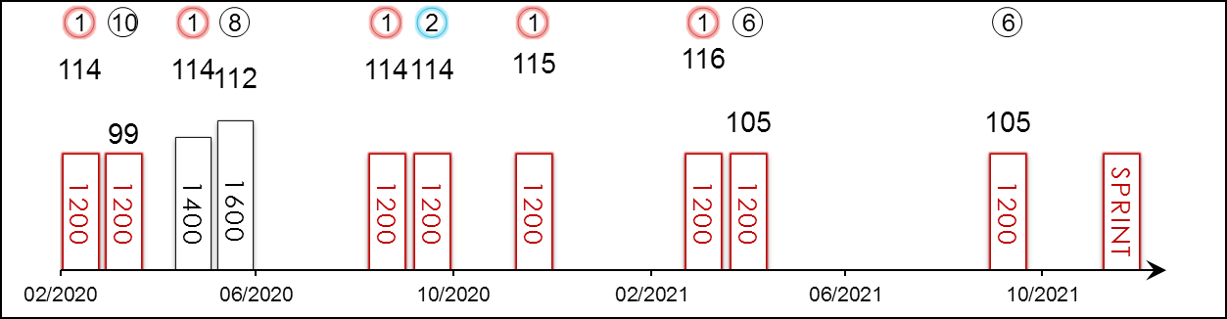 | HK Starts : 3 (1-0-0-0-2) Right-handed : 16 (8-2-1-0-5) Jockey : 7 (3-1-1-0-2)  Pre Import : - Sha Tin-Turf : 3 (1-0-0-0-2) GF+ : 15 (6-2-1-1-5)  Lifetime : 25 (11-3-1-1-9) Non-Turf : - Good : 8 (4-1-0-0-3)  2021 : 3 (1-0-0-0-2) Distance : 16 (8-2-1-1-4) Yielding : 2 (1-0-0-0-1)  G1 : 12 (2-1-1-1-7) Course & Dist : 3 (1-0-0-0-2) Soft/Hvy : -  First Up : 13 (8-1-0-0-4) 1000-1200 : 16 (8-2-1-1-4) HK$ : 54,654,560  G1 win : 2021 Takamatsunomiya Kinen 1200m, 2020 LONGINES Hong Kong Sprint 1200m

Pos | Index | Date | Perf  Rating | Race Category & Name |  | Track | Dist/Course/Going |  | Wt | Jockey | Draw | Race Sectional Time |  |  |  | Race  Time | Horse  Final | Position & Margin in Running |  |  |  |  |  | Finish |  | Odds | Winner/Second
1/16 | - | 7/3/20 | 114 | G3 | Ocean S. | NAK, JPN | 1200 RH | F | 123 | Y Kawada | 2 |  | 22.³⁰ | 22.²⁰ | 22.⁹⁰ | 1.07.⁴⁰ | 34.⁰⁰ | - |  | 4 | - | 4 | - | 1 | 1.5 | 2.0F | Nac Venus
10/18 | - | 29/3/20 | 99 | G1 | Takamatsunomiya Kinen | CYO, JPN | 1200 LH | Y | 126 | Y Kawada | 6 |  | 22.⁹⁰ | 22.⁷⁰ | 23.¹⁰ | 1.08.⁷⁰ | 34.⁷⁰ | - |  | 7 | - | 4 | - | 10 | 6 | 4.1 | Mozu Superflare
1/13 | - | 16/5/20 | 114 | G2 | Keio Hai Spring Cup | TOK, JPN | 1400 LH | G | 123 | D Lane | 13 |  | 22.⁸⁰ | 22.⁴⁰ | 22.²⁰ | 1.19.⁸⁰ | 33.¹⁰ | - |  | 1 | - | 1 | - | 1 | 1.3 | 4.9 | Stelvio
8/14 | - | 7/6/20 | 112 | G1 | Yasuda Kinen | TOK, JPN | 1600 LH | G | 128 | K Miura | 14 |  | 22.⁷⁰ | 23.⁰⁰ | 22.⁹⁰ | 1.31.⁶⁰ | 35.¹⁰ | - |  | 1 | - | 1 | - | 8 | 5.5 | 73.6 | Gran Alegria
1/17 | - | 13/9/20 | 114 | G2 | Centaur S. | CYO, JPN | 1200 LH | F | 126 | K Miura | 16 |  | 22.¹⁰ | 22.³⁰ | 23.⁵⁰ | 1.07.⁹⁰ | 34.¹⁰ | - |  | 4 | - | 4 | - | 1 | 1 | 3.0F | Meisho Glocke
2/16 | - | 4/10/20 | 114 | G1 | Sprinters S. | NAK, JPN | 1200 RH | F | 126 | Y Kawada | 3 |  | 22.⁰⁰ | 22.³⁰ | 24.⁰⁰ | 1.08.³⁰ | 35.⁰⁰ | - |  | 4 | - | 4 | - | 2 | 2 | 5.1 | Gran Alegria
1/14 | *262 | 13/12/20 | 115 | G1 | LONGINES Hong Kong Sprint | ST, HK | 1200 RH | G | 126 | R Moore | 14 |  | 23.⁰⁹ | 22.⁴⁶ | 22.⁹⁰ | 1.08.⁴⁵ | 22.⁵⁴ | - |  | 8 | 3.8 | 7 | 2.3 | 1 | 0.5 | 22 | Jolly Banner
1/18 | - | 28/3/21 | 116 | G1 | Takamatsunomiya Kinen | CYO, JPN | 1200 LH | Y | 126 | Y Kawada | 14 |  | 22.⁹⁰ | 22.⁷⁰ | 23.⁶⁰ | 1.09.²⁰ | 34.³⁰ | - |  | 10 | - | 9 | - | 1 | Nk | 6 | Resistencia
6/13 | *617 | 25/4/21 | 105 | G1 | Chairman's Sprint Prize | ST, HK | 1200 RH | G | 126 | J Moreira | 5 |  | 24.²³ | 22.²³ | 22.¹⁸ | 1.08.⁶⁴ | 22.⁰⁹ | - |  | 7 | 3.3 | 8 | 4.5 | 6 | 4 | 2.2F | Wellington
6/16 | - | 3/10/21 | 105 | G1 | Sprinters S. | NAK, JPN | 1200 RH | GF | 126 | Y Kawada | 14 |  | 22.³⁰ | 22.¹⁰ | 22.⁷⁰ | 1.07.¹⁰ | 33.⁸⁰ | - |  | 5 | - | 6 | - | 6 | 4.8 | 2.6F | Pixie Knight
 |  | 12/12/21 |  | G1 | LONGINES Hong Kong Sprint | ST, HK | 1200 RH |  | 126 | Y Kawada
6YO with 11 wins over 1200m and 1400m from 25 career starts. Consistent performer who is looking to win back-to-back G1 LONGINES Hong Kong Sprint (1200m). Three starts ago made an encouraging seasonal reappearance when winning the G1 Takamatsunomiya Kinen (1200m) at Chukyo. Then ran sixth in the G1 Chairman’s Sprint Prize (1200m) at Sha Tin. Last out placed sixth to Pixie Knight in the G1 Sprinters Stakes (1200m). Tactically versatile. No ground worries.

 |  |  | 福逸 D176  WELLINGTON (AUS) 5 b g  All Too Hard (AUS) - Mihiri (AUS) (More Than Ready (USA))  Owner(s): Mr & Mrs Michael Cheng Wing On and Jeffrey Cheng Man Cheong |  | 高伯新 (香港)  R Gibson (HK)  Win 4.2% Place 13.9% | 巴度  A Badel  Win 12.0% Place 29.1% | 126 lb  (116)

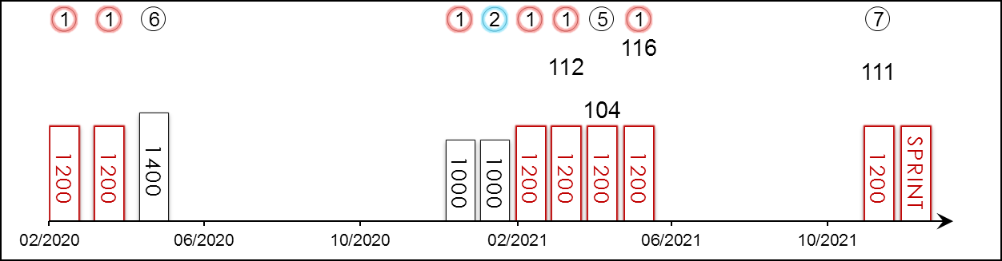 | HK Career : 11 (7-1-0-0-3) Right-handed : 9 (6-0-0-0-3) Jockey : 6 (4-0-0-0-2)  Pre Import : - Sha Tin-Turf : 11 (7-1-0-0-3) GF+ : 1 (1-0-0-0-0)  Lifetime : 11 (7-1-0-0-3) Non-Turf : - Good : 10 (6-1-0-0-3)  2021/22 : 1 (0-0-0-0-1) Distance : 8 (6-0-0-0-2) Yielding : -  G1 : 1 (1-0-0-0-0) Course & Dist : 8 (6-0-0-0-2) Soft/Hvy : -  First Up : 3 (2-0-0-0-1) 1000-1200 : 10 (7-1-0-0-2) HK$ : 18,424,690  G1 win : 2021 Chairman's Sprint Prize 1200m

Pos | Index | Date | Perf  Rating | Race Category & Name |  | Track | Dist/Course/Going |  | Wt | Jockey | Draw | Race Sectional Time |  |  |  | Race  Time | Horse  Final | Position & Margin in Running |  |  |  |  |  | Finish |  | Odds | Winner/Second
1/14 | **425 | 16/2/20 | - | - | Cl.3 hcp | ST, HK | 1200 RH | G | 116 | A Badel | 13 |  | 23.³⁷ | 22.⁴⁶ | 23.⁹⁴ | 1.09.⁷⁷ | 22.⁸² | - |  | 10 | 7¾ | 10 | 7 | 1 | N | 1.6F | Ballistic King
1/12 | **515 | 22/3/20 | - | - | Cl.3 hcp | ST, HK | 1200 RH | GF | 123 | Z Purton | 12 |  | 23.⁴⁸ | 22.⁵⁹ | 22.⁴⁸ | 1.08.⁵⁵ | 22.⁰⁴ | - |  | 7 | 5¼ | 7 | 2¾ | 1 | 1 | 1.7F | Larson
6/14 | **607 | 26/4/20 | - | - | Cl.3 hcp | ST, HK | 1400 RH | G | 133 | Z Purton | 3 |  | 21.⁶¹ | 23.¹⁵ | 23.¹⁸ | 1.21.⁵¹ | 23.⁴⁶ | 2 | SH | 3 | 1½ | 3 | 1½ | 6 | 3¼ | 1.5F | Fantastic Show
1/14 | *304 | 26/12/20 | - | - | Cl.3 hcp | ST, HK | 1000 St | G | 133 | Z Purton | 8 |  | 13.¹² | 20.⁸³ | 22.⁵⁶ | 0.56.⁵¹ | 22.⁵⁶ | - |  | 4 | 3/4 | 1 | N | 1 | 2¼ | 1.9F | Ping Hai Bravo
2/14 | *353 | 17/1/21 | - | - | Cl.2 hcp | ST, HK | 1000 St | G | 125 | Z Purton | 10 |  | 13.¹² | 20.⁶¹ | 23.⁰¹ | 0.56.⁷⁴ | 22.⁸⁵ | - |  | 5 | 1 | 3 | 1½ | 2 | 1/2 | 1.7F | Beauty Applause
1/11 | *429 | 14/2/21 | - | - | Cl.2 hcp | ST, HK | 1200 RH | G | 127 | Z Purton | 6 |  | 23.⁶⁰ | 22.⁵⁴ | 22.⁴² | 1.08.⁵⁶ | 22.³⁸ | - |  | 3 | 1½ | 2 | N | 1 | SH | 3 | Duke Wai
1/9 | *504 | 13/3/21 | 112 | - | Cl.1 hcp | ST, HK | 1200 RH | G | 113 | A Badel | 4 |  | 23.⁹⁵ | 21.⁸³ | 22.⁰² | 1.07.⁸⁰ | 21.⁶² | - |  | 5 | 3¼ | 5 | 2½ | 1 | 1¼ | 4.2 | Computer Patch
5/13 | *563 | 5/4/21 | 104 | G2 | Sprint Cup | ST, HK | 1200 RH | G | 123 | A Badel | 12 |  | 23.²⁹ | 21.⁸⁷ | 23.⁰⁸ | 1.08.²⁴ | 22.⁹⁰ | - |  | 6 | 3½ | 7 | 3¾ | 5 | 2½ | 2.8F | Amazing Star
1/13 | *617 | 25/4/21 | 116 | G1 | Chairman's Sprint Prize | ST, HK | 1200 RH | G | 126 | A Badel | 3 |  | 24.²³ | 22.²³ | 22.¹⁸ | 1.08.⁶⁴ | 21.⁶⁶ | - |  | 6 | 3 | 6 | 3¼ | 1 | 1½ | 3.9 | Computer Patch
7/10 | 192 | 21/11/21 | 111 | G2 | BOCHK Private Banking JC Sprint | ST, HK | 1200 RH | G | 128 | A Badel | 7 |  | 23.⁴¹ | 22.¹¹ | 22.⁴⁶ | 1.07.⁹⁸ | 22.⁴² | - |  | 8 | 7 | 8 | 3¼ | 7 | 3 | 7.1 | Lucky Patch
 |  | 12/12/21 |  | G1 | LONGINES Hong Kong Sprint | ST, HK | 1200 RH |  | 126 | A Badel
Talented sprinter who made an immediate impact by scoring a hat-trick of wins in his rookie season. Prolific winner with seven wins from 11 starts. Achieved his career-best performance in claiming the G1 Chairman’s Sprint Prize (1200m) two starts back after a fair fifth in the G2 Sprint Cup (1200m) in early April. First-up finished seventh in the G2 BOCHK Private Banking Jockey Club Sprint (1200m) latest. Should improve for the run. Usually races handily. Likes good and good to firm going.

 |  |  | 錶之未來 D422  LUCKY PATCH (NZ) ex Paleontologist 5 b g  El Roca (AUS) - Gould (AUS) (Danehill Dancer (IRE))  Owner(s): Patch Syndicate |  | 呂健威 (香港)  K W Lui (HK)  Win 11.4% Place 30.2% | 潘頓  Z Purton  Win 23.1% Place 52.7% | 126 lb  (115)

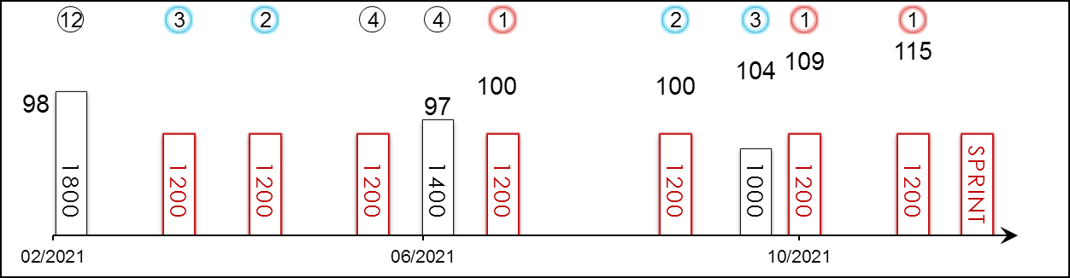 | HK Career : 15 (5-3-3-3-1) Right-handed : 16 (7-3-2-3-1) Jockey : 3 (1-1-0-1-0)  Pre Import : 2 (2-0-0-0-0) Sha Tin-Turf : 14 (4-3-3-3-1) GF+ : 5 (1-0-2-2-0)  Lifetime : 17 (7-3-3-3-1) Non-Turf : 1 (1-0-0-0-0) Good : 9 (3-3-1-1-1)  2021/22 : 4 (2-1-1-0-0) Distance : 9 (5-2-1-1-0) Yielding : -  G1 : - Course & Dist : 7 (3-2-1-1-0) Soft/Hvy : 2 (2-0-0-0-0)  First Up : 2 (2-0-0-0-0) 1000-1200 : 11 (6-2-2-1-0) HK$ : 14,106,540  G1 win : Nil

Pos | Index | Date | Perf  Rating | Race Category & Name |  | Track | Dist/Course/Going |  | Wt | Jockey | Draw | Race Sectional Time |  |  |  | Race  Time | Horse  Final | Position & Margin in Running |  |  |  |  |  | Finish |  | Odds | Winner/Second
12/14 | *449 | 21/2/21 | 98 | - | Hong Kong Classic Cup | ST, HK | 1800 RH | G | 126 | M F Poon | 7 |  | 24.⁴⁶ | 24.⁰⁴ | 22.⁷⁷ | 1.47.²¹ | 23.⁴⁷ | 2 | 1 | 3 | 1¾ | 2 | 3/4 | 12 | 5¼ | 9.2 | Healthy Happy
3/14 | *545 | 28/3/21 | - | - | Cl.2 hcp | ST, HK | 1200 RH | GF | 127 | M F Poon⁻² | 4 |  | 23.⁷³ | 21.⁸² | 22.⁷³ | 1.08.²⁸ | 22.⁸¹ | - |  | 2 | N | 2 | N | 3 | 3/4 | 3F | Duke Wai
2/14 | *622 | 25/4/21 | - | - | Cl.2 hcp | ST, HK | 1200 RH | G | 125 | Z Purton | 12 |  | 23.⁷⁰ | 21.⁷⁶ | 22.⁷⁸ | 1.08.²⁴ | 23.⁰¹ | - |  | 2 | 1/2 | 2 | 1/2 | 2 | 2 | 5.4 | Courier Wonder
4/14 | *718 | 30/5/21 | - | - | Cl.2 hcp | ST, HK | 1200 RH | GF | 133 | Z Purton | 5 |  | 23.³⁷ | 21.⁸⁴ | 22.⁷¹ | 1.07.⁹² | 22.⁸⁹ | - |  | 2 | 3/4 | 2 | SH | 4 | 1¼ | 3.4 | Naboo Attack
4/11 | *764 | 20/6/21 | 97 | G3 | Premier Cup - hcp | ST, HK | 1400 RH | GF | 113 | M F Poon | 11 |  | 22.¹² | 22.⁶⁷ | 22.³⁶ | 1.20.⁵⁵ | 22.⁷⁶ | 4 | 1¼ | 2 | N | 1 | N | 4 | 2½ | 4.9 | Sky Field
1/13 | *825 | 11/7/21 | 100 | - | Cl.1 hcp | ST, HK | 1200 RH | GF | 115 | C L Chau⁻⁵ | 1 |  | 23.⁰⁴ | 21.⁸³ | 22.⁷⁴ | 1.07.⁶¹ | 22.⁴⁶ | - |  | 3 | 1½ | 4 | 1¾ | 1 | 2¼ | 2.6F | Stronger
2/13 | 4 | 5/9/21 | 100 | - | HKSAR CE Cup - hcp | ST, HK | 1200 RH | G | 123 | C L Chau⁻⁵ | 10 |  | 23.⁹¹ | 21.⁷⁶ | 22.⁴⁴ | 1.08.¹¹ | 22.⁵² | - |  | 2 | SH | 2 | 1/2 | 2 | 1 | 4.1 | Naboo Attack
3/14 | 72 | 1/10/21 | 104 | G3 | National Day Cup - hcp | ST, HK | 1000 St | G | 124 | C L Chau | 14 |  | 13.⁰⁵ | 20.⁰⁹ | 21.⁸² | 0.54.⁹⁶ | 21.⁷⁴ | - |  | 6 | 1 | 7 | 1¾ | 3 | 1¼ | 3.3F | Super Wealthy
1/12 | 99 | 17/10/21 | 109 | G2 | Premier Bowl - hcp | ST, HK | 1200 RH | G | 122 | Z Purton | 12 |  | 23.²⁵ | 21.⁶⁶ | 23.⁰⁴ | 1.07.⁹⁵ | 22.⁵² | - |  | 7 | 3¼ | 8 | 3¼ | 1 | N | 9.3 | Super Wealthy
1/10 | 192 | 21/11/21 | 115 | G2 | BOCHK Private Banking JC Sprint | ST, HK | 1200 RH | G | 123 | C L Chau | 10 |  | 23.⁴¹ | 22.¹¹ | 22.⁴⁶ | 1.07.⁹⁸ | 22.¹⁴ | - |  | 6 | 5 | 5 | 2 | 1 | 3/4 | 5.5 | Naboo Attack
 |  | 12/12/21 |  | G1 | LONGINES Hong Kong Sprint | ST, HK | 1200 RH |  | 126 | Z Purton
Ultra consistent performer with five wins, three seconds and three thirds from 15 Hong Kong starts and only finished out of money once. Further improvement shown this term, winning the G2 Premier Bowl Handicap (1200m) after two other placings since early September. Scored another G2 win in the BOCHK Private Banking Jockey Club Sprint (1200m) latest. Sits handy but stayed in midfield in recent two starts. Won on good and good to firm ground.

 |  |  | 顯心星 D216  SKY FIELD (AUS) 5 ch g  Deep Field (AUS) - Laravissante (NZ) (O'Reilly (NZ))  Owner(s): Kwan Shiu Man, Jessica Kwan Mun Hang & Jeffrey Kwan Chun Ming |  | 方嘉柏 (香港)  C Fownes (HK)  Win 4.5% Place 23.4% | 薛恩  B Shinn  Win 7.3% Place 27.1% | 126 lb  (115)

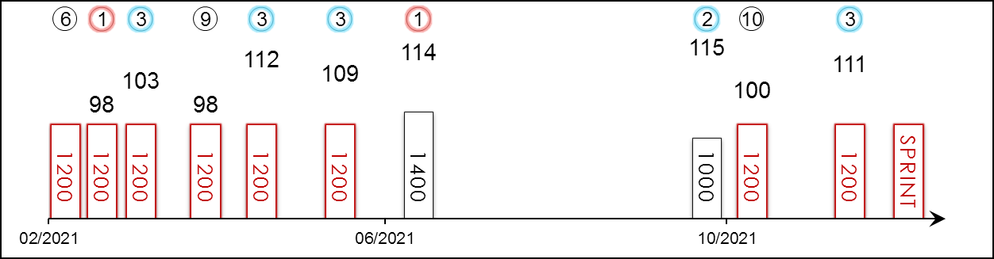 | HK Career : 17 (5-2-5-1-4) Right-handed : 16 (5-1-5-1-4) Jockey : 6 (1-1-3-0-1)  Pre Import : - Sha Tin-Turf : 15 (4-2-5-0-4) GF+ : 5 (3-1-1-0-0)  Lifetime : 17 (5-2-5-1-4) Non-Turf : - Good : 12 (2-1-4-1-4)  2021/22 : 3 (0-1-1-0-1) Distance : 13 (4-1-4-0-4) Yielding : -  G1 : 1 (0-0-1-0-0) Course & Dist : 12 (3-1-4-0-4) Soft/Hvy : -  First Up : 5 (1-2-0-1-1) 1000-1200 : 15 (4-2-4-1-4) HK$ : 11,897,700  G1 win : Nil

Pos | Index | Date | Perf  Rating | Race Category & Name |  | Track | Dist/Course/Going |  | Wt | Jockey | Draw | Race Sectional Time |  |  |  | Race  Time | Horse  Final | Position & Margin in Running |  |  |  |  |  | Finish |  | Odds | Winner/Second
6/11 | *429 | 14/2/21 | - | - | Cl.2 hcp | ST, HK | 1200 RH | G | 128 | C Soumillon | 11 |  | 23.⁶⁰ | 22.⁵⁴ | 22.⁴² | 1.08.⁵⁶ | 22.³⁴ | - |  | 10 | 6¾ | 8 | 3¼ | 6 | 2¾ | 8.2 | Wellington
1/8 | *456 | 24/2/21 | 98 | - | Cl.1 hcp | HV, HK | 1200 RH | GF | 118 | A Badel | 1 |  | 24.²¹ | 22.⁴² | 22.²¹ | 1.08.⁸⁴ | 21.⁷³ | - |  | 6 | 3 | 6 | 3 | 1 | HD | 3.1 | Stronger
3/9 | *504 | 13/3/21 | 103 | - | Cl.1 hcp | ST, HK | 1200 RH | G | 113 | M L Yeung | 1 |  | 23.⁹⁵ | 21.⁸³ | 22.⁰² | 1.07.⁸⁰ | 21.⁶⁶ | - |  | 7 | 4¾ | 7 | 4 | 3 | 1¾ | 7.6 | Wellington
9/13 | *563 | 5/4/21 | 98 | G2 | Sprint Cup | ST, HK | 1200 RH | G | 123 | Z Purton | 10 |  | 23.²⁹ | 21.⁸⁷ | 23.⁰⁸ | 1.08.²⁴ | 23.¹⁵ | - |  | 9 | 4¾ | 9 | 4½ | 9 | 5 | 4.7 | Amazing Star
3/13 | *617 | 25/4/21 | 112 | G1 | Chairman's Sprint Prize | ST, HK | 1200 RH | G | 126 | B Shinn | 1 |  | 24.²³ | 22.²³ | 22.¹⁸ | 1.08.⁶⁴ | 22.⁰⁶ | - |  | 5 | 2½ | 4 | 2¼ | 3 | 1½ | 12 | Wellington
3/9 | *692 | 23/5/21 | 109 | G3 | Sha Tin Vase - hcp | ST, HK | 1200 RH | GF | 130 | B Shinn | 5 |  | 23.⁹² | 21.⁸⁶ | 22.³⁸ | 1.08.¹⁶ | 22.¹³ | - |  | 7 | 5 | 6 | 2¾ | 3 | 1¼ | 19 | Courier Wonder
1/11 | *764 | 20/6/21 | 114 | G3 | Premier Cup - hcp | ST, HK | 1400 RH | GF | 125 | B Shinn | 7 |  | 22.¹² | 22.⁶⁷ | 22.³⁶ | 1.20.⁵⁵ | 22.⁰⁸ | 10 | 3½ | 8 | 3½ | 5 | 1¾ | 1 | 1¾ | 9.4 | Sky Darci
2/14 | 72 | 1/10/21 | 115 | G3 | National Day Cup - hcp | ST, HK | 1000 St | G | 133 | B Shinn | 12 |  | 13.⁰⁵ | 20.⁰⁹ | 21.⁸² | 0.54.⁹⁶ | 21.³⁷ | - |  | 14 | 3 | 10 | 3½ | 2 | 3/4 | 11 | Super Wealthy
10/12 | 99 | 17/10/21 | 100 | G2 | Premier Bowl - hcp | ST, HK | 1200 RH | G | 133 | B Shinn | 2 |  | 23.²⁵ | 21.⁶⁶ | 23.⁰⁴ | 1.07.⁹⁵ | 23.⁹⁹ | - |  | 4 | 2 | 3 | 1½ | 10 | 7½ | 14 | Lucky Patch
3/10 | 192 | 21/11/21 | 111 | G2 | BOCHK Private Banking JC Sprint | ST, HK | 1200 RH | G | 123 | B Shinn | 1 |  | 23.⁴¹ | 22.¹¹ | 22.⁴⁶ | 1.07.⁹⁸ | 22.¹² | - |  | 9 | 8 | 9 | 3¼ | 3 | 1¼ | 6.8 | Lucky Patch
 |  | 12/12/21 |  | G1 | LONGINES Hong Kong Sprint | ST, HK | 1200 RH |  | 126 | B Shinn
Progressive sprinter who opened his Hong Kong account in style with a four-length victory in July 2020. Steady five-year-old with five wins from 17 starts in Hong Kong to his name. Biggest win to date in the G3 Premier Cup Handicap (1400m). Ran a creditable third in the Chairman’s Sprint Prize (1200m) in his first time and only asking of at G1 level. Last out finished 3rd in the G2 BOCHK Private Banking Jockey Club Sprint (1200m). Hold up runner. Raced only on good or good to firm.

 |  |  | 錶之智能 D139  COMPUTER PATCH (AUS) ex Sun Patch 5 b g  Exceed And Excel (AUS) - Girl Hussler (AUS) (Hussonet (USA))  Owner(s): Yeung Kin Man |  | 告東尼 (香港)  A S Cruz (HK)  Win 12.2% Place 30.6% | 連達文  D Lane | 126 lb  (112)

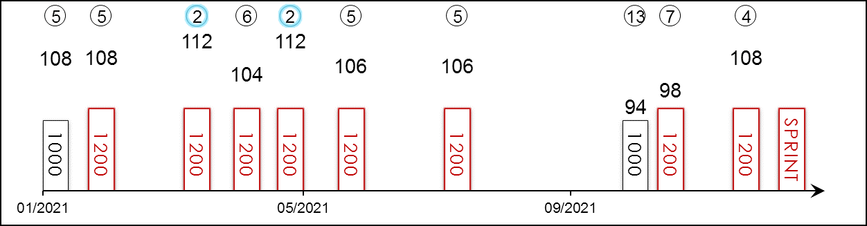 | HK Career : 22 (4-6-1-2-9) Right-handed : 21 (3-6-1-2-9) Jockey : -  Pre Import : 3 (1-0-0-0-2) Sha Tin-Turf : 22 (4-6-1-2-9) GF+ : 4 (0-2-0-0-2)  Lifetime : 25 (5-6-1-2-11) Non-Turf : - Good : 21 (5-4-1-2-9)  2021/22 : 3 (0-0-0-1-2) Distance : 19 (2-6-1-2-8) Yielding : -  G1 : 3 (0-1-0-0-2) Course & Dist : 18 (2-6-1-2-7) Soft/Hvy : -  First Up : 5 (1-1-0-1-2) 1000-1200 : 25 (5-6-1-2-11) HK$ : 16,235,560  G1 win : Nil

Pos | Index | Date | Perf  Rating | Race Category & Name |  | Track | Dist/Course/Going |  | Wt | Jockey | Draw | Race Sectional Time |  |  |  | Race  Time | Horse  Final | Position & Margin in Running |  |  |  |  |  | Finish |  | Odds | Winner/Second
5/5 | *308 | 1/1/21 | 108 | G3 | Bauhinia Sprint Trophy - hcp | ST, HK | 1000 St | G | 133 | J Moreira | 5 |  | 13.⁴⁰ | 20.⁸⁶ | 22.⁴⁰ | 0.56.⁶⁶ | 22.⁸⁶ | - |  | 2 | SH | 1 | SH | 5 | 2¾ | 1.6F | Explosive Witness
5/11 | *368 | 24/1/21 | 108 | G1 | Centenary Sprint Cup | ST, HK | 1200 RH | G | 126 | M Chadwick | 9 |  | 23.⁴⁹ | 21.⁹² | 22.⁶⁰ | 1.08.⁰¹ | 22.⁹⁰ | - |  | 2 | 1/2 | 2 | 3/4 | 5 | 2¾ | 12 | Hot King Prawn
2/9 | *504 | 13/3/21 | 112 | - | Cl.1 hcp | ST, HK | 1200 RH | G | 121 | N Callan | 7 |  | 23.⁹⁵ | 21.⁸³ | 22.⁰² | 1.07.⁸⁰ | 22.²⁴ | - |  | 1 | 3/4 | 1 | 1¼ | 2 | 1¼ | 11 | Wellington
6/13 | *563 | 5/4/21 | 104 | G2 | Sprint Cup | ST, HK | 1200 RH | G | 123 | N Callan | 9 |  | 23.²⁹ | 21.⁸⁷ | 23.⁰⁸ | 1.08.²⁴ | 23.⁵¹ | - |  | 1 | 1 | 1 | 1/2 | 6 | 2¾ | 8.8 | Amazing Star
2/13 | *617 | 25/4/21 | 112 | G1 | Chairman's Sprint Prize | ST, HK | 1200 RH | G | 126 | M Chadwick | 7 |  | 24.²³ | 22.²³ | 22.¹⁸ | 1.08.⁶⁴ | 22.⁴¹ | - |  | 1 | 1¼ | 1 | 1 | 2 | 1½ | 19 | Wellington
5/9 | *692 | 23/5/21 | 106 | G3 | Sha Tin Vase - hcp | ST, HK | 1200 RH | GF | 132 | M Chadwick | 4 |  | 23.⁹² | 21.⁸⁶ | 22.³⁸ | 1.08.¹⁶ | 22.⁸⁶ | - |  | 1 | 1/2 | 1 | N | 5 | 3 | 15 | Courier Wonder
5/13 | *825 | 11/7/21 | 106 | - | Cl.1 hcp | ST, HK | 1200 RH | GF | 133 | N Callan | 11 |  | 23.⁰⁴ | 21.⁸³ | 22.⁷⁴ | 1.07.⁶¹ | 23.³⁴ | - |  | 2 | N | 2 | 1/2 | 5 | 4¼ | 8.7 | Lucky Patch
13/14 | 72 | 1/10/21 | 94 | G3 | National Day Cup - hcp | ST, HK | 1000 St | G | 127 | K Teetan | 6 |  | 13.⁰⁵ | 20.⁰⁹ | 21.⁸² | 0.54.⁹⁶ | 22.⁸⁰ | - |  | 2 | SH | 3 | 1 | 13 | 7 | 10 | Super Wealthy
7/12 | 99 | 17/10/21 | 98 | G2 | Premier Bowl - hcp | ST, HK | 1200 RH | G | 123 | K Teetan | 11 |  | 23.²⁵ | 21.⁶⁶ | 23.⁰⁴ | 1.07.⁹⁵ | 23.⁴² | - |  | 5 | 2½ | 6 | 2¼ | 7 | 4¾ | 48 | Lucky Patch
4/10 | 192 | 21/11/21 | 108 | G2 | BOCHK Private Banking JC Sprint | ST, HK | 1200 RH | G | 123 | K Teetan | 8 |  | 23.⁴¹ | 22.¹¹ | 22.⁴⁶ | 1.07.⁹⁸ | 22.⁸¹ | - |  | 1 | 1 | 1 | N | 4 | 2¼ | 34 | Lucky Patch
 |  | 12/12/21 |  | G1 | LONGINES Hong Kong Sprint | ST, HK | 1200 RH |  | 126 | D Lane
Steady performer with four wins, six seconds and one third from 22 Hong Kong starts. G3 winner who has placed at G1 level, finishing second to Wellington in April’s G1 Chairman’s Sprint Prize (1200m). Returned for first three runs this term for no first three placings. Tried to make all in the G2 BOCHK Private Banking Jockey Club Sprint (1200m) latest but weakened in the final stages to finish fourth behind the race victor Lucky Patch. Best when handy. Raced only on good or good to firm.

 |  |  | 肥仔叻叻 E354  NABOO ATTACK (AUS) ex Command'N'Conquer 5 bl g  Warhead (AUS) - Commanding Queen (AUS) (Commands (AUS))  Owner(s): Cheung Yeuk Lee |  | 大衛希斯 (香港)  D A Hayes (HK)  Win 11.0% Place 30.9% | 田泰安  K Teetan  Win 8.1% Place 33.5% | 126 lb  (112)

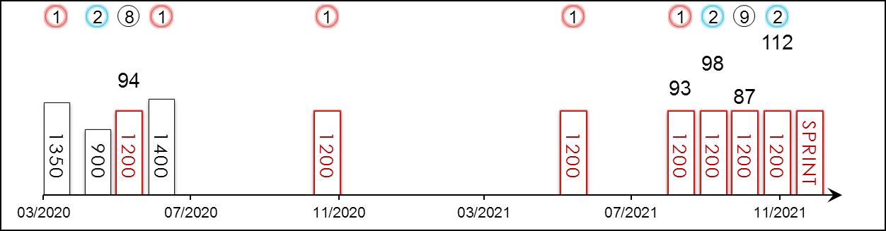 | HK Career : 5 (2-2-0-0-1) Right-handed : 12 (7-3-0-0-2) Jockey : 1 (1-0-0-0-0)  Pre Import : 7 (5-1-0-0-1) Sha Tin-Turf : 5 (2-2-0-0-1) GF+ : 2 (1-1-0-0-0)  Lifetime : 12 (7-3-0-0-2) Non-Turf : - Good : 10 (6-2-0-0-2)  2021/22 : 4 (1-2-0-0-1) Distance : 7 (3-2-0-0-2) Yielding : -  G1 : - Course & Dist : 5 (2-2-0-0-1) Soft/Hvy : -  First Up : 4 (4-0-0-0-0) 1000-1200 : 8 (4-2-0-0-2) HK$ : 6,804,830  G1 win : Nil

Pos | Index | Date | Perf  Rating | Race Category & Name |  | Track | Dist/Course/Going |  | Wt | Jockey | Draw | Race Sectional Time |  |  |  | Race  Time | Horse  Final | Position & Margin in Running |  |  |  |  |  | Finish |  | Odds | Winner/Second
1/12 | - | 28/3/20 | - | - | 3yo hcp | DOOM, AUS | 1350 RH | G | 121 | J Orman | 6 |  | - | - | 34.⁰⁵ | 1.20.¹⁰ | - | - |  | - |  | - |  | 1 | 1 | 1.9F | Vanna Girl
2/8 | - | 8/5/20 | - | - | BM 78 hcp | GCST, AUS | 900 RH | G | 126 | J Orman | 3 |  | - | - | 32.⁷⁸ | 0.50.⁶⁸ | - | - |  | - |  | - |  | 2 | 1 | 1.5F | Archer's Paradox
8/14 | - | 16/5/20 | 94 | G3 | Gold Coast Guineas - 3yo | GCST, AUS | 1200 RH | G | 126 | J Orman | 9 |  | - | - | 33.⁷⁸ | 1.08.⁷¹ | - | - |  | - |  | - |  | 8 | 3.3 | 6 | Hightail
1/10 | - | 29/5/20 | - | - | 3yo hcp | GCST, AUS | 1400 RH | G | 130 | J Orman | 8 |  | - | - | 34.³⁹ | 1.23.³⁶ | - | - |  | - |  | - |  | 1 | 0.8 | 1.75F | Maozi
1/12 | - | 7/11/20 | - | - | BM 80 hcp | DOOM, AUS | 1200 RH | G | 129 | J Orman | 6 |  | - | - | 34.¹² | 1.09.⁴⁰ | - | - |  | - |  | - |  | 1 | 0.5 | 1.85F | Gee Tee Tee
1/14 | *718 | 30/5/21 | - | - | Cl.2 hcp | ST, HK | 1200 RH | GF | 117 | C Y Ho | 7 |  | 23.³⁷ | 21.⁸⁴ | 22.⁷¹ | 1.07.⁹² | 22.⁰³ | - |  | 8 | 5½ | 7 | 4¼ | 1 | 1¼ | 17 | Mr Croissant
1/13 | 4 | 5/9/21 | 93 | - | HKSAR CE Cup - hcp | ST, HK | 1200 RH | G | 113 | K Teetan | 6 |  | 23.⁹¹ | 21.⁷⁶ | 22.⁴⁴ | 1.08.¹¹ | 21.⁹² | - |  | 7 | 2¾ | 8 | 3¼ | 1 | 1 | 2.7F | Lucky Patch
2/12 | 64 | 26/9/21 | 98 | - | Cl.2 hcp | ST, HK | 1200 RH | GF | 133 | Z Purton | 9 |  | 23.⁷⁰ | 21.⁹² | 22.⁶⁰ | 1.08.²² | 21.⁹⁷ | - |  | 10 | 5 | 10 | 5¼ | 2 | 1¼ | 3.3 | Trillion Win
9/12 | 99 | 17/10/21 | 87 | G2 | Premier Bowl - hcp | ST, HK | 1200 RH | G | 114 | A Badel | 3 |  | 23.²⁵ | 21.⁶⁶ | 23.⁰⁴ | 1.07.⁹⁵ | 23.²⁰ | - |  | 9 | 4½ | 9 | 4¼ | 9 | 5¼ | 3.2 | Lucky Patch
2/10 | 192 | 21/11/21 | 112 | G2 | BOCHK Private Banking JC Sprint | ST, HK | 1200 RH | G | 123 | Z Purton | 9 |  | 23.⁴¹ | 22.¹¹ | 22.⁴⁶ | 1.07.⁹⁸ | 21.⁸³ | - |  | 10 | 8¼ | 10 | 4¾ | 2 | 3/4 | 8.1 | Lucky Patch
 |  | 12/12/21 |  | G1 | LONGINES Hong Kong Sprint | ST, HK | 1200 RH |  | 126 | K Teetan
Five-time winner in Australia pre-import. Big, strong gelding. Two-time winner from five starts in Hong Kong. Won first-up this season at Class 1 level, followed by two luckless runs at Class 2 and G2 level. Showed strong acceleration again last out when 2nd in the G2 BOCHK Private Banking Jockey Club Sprint (1200m). Hold up runner. Best on good and good to firm ground.

 |  |  | 君達星 B019  AMAZING STAR (NZ) 7 b g  Darci Brahma (NZ) - Bright Abyss (USA) (Royal Academy (USA))  Owner(s): Grinders' Racing Club Syndicate |  | 丁冠豪 (香港)  K H Ting (HK)  Win 15.0% Place 25.2% | 希威森  L Hewitson | 126 lb  (110)

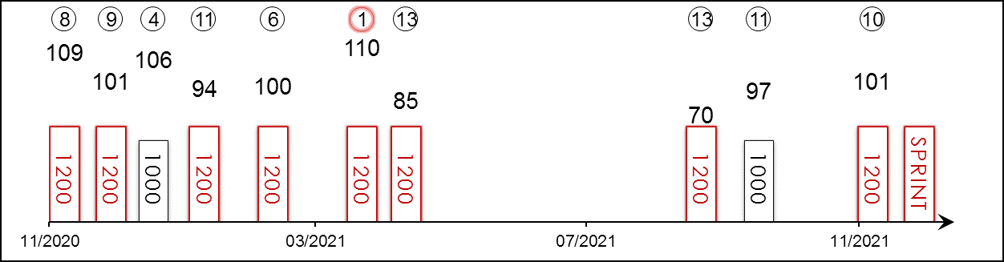 | HK Career : 26 (7-2-1-2-14) Right-handed : 22 (7-2-0-1-12) Jockey : -  Pre Import : - Sha Tin-Turf : 15 (2-2-1-1-9) GF+ : 8 (4-0-0-0-4)  Lifetime : 26 (7-2-1-2-14) Non-Turf : 2 (0-0-0-1-1) Good : 16 (3-2-1-1-9)  2021/22 : 3 (0-0-0-0-3) Distance : 22 (7-2-0-1-12) Yielding : -  G1 : 3 (0-0-0-0-3) Course & Dist : 11 (2-2-0-0-7) Soft/Hvy : -  First Up : 8 (1-0-1-1-5) 1000-1200 : 26 (7-2-1-2-14) HK$ : 9,062,690  G1 win : Nil

Pos | Index | Date | Perf  Rating | Race Category & Name |  | Track | Dist/Course/Going |  | Wt | Jockey | Draw | Race Sectional Time |  |  |  | Race  Time | Horse  Final | Position & Margin in Running |  |  |  |  |  | Finish |  | Odds | Winner/Second
8/10 | *207 | 22/11/20 | 109 | G2 | Jockey Club Sprint | ST, HK | 1200 RH | GF | 123 | T Piccone | 8 |  | 23.¹⁸ | 21.⁹³ | 22.⁸⁹ | 1.08.⁰⁰ | 22.⁸² | - |  | 7 | 4¼ | 7 | 2¼ | 8 | 1¾ | 10 | Hot King Prawn
9/14 | *262 | 13/12/20 | 101 | G1 | LONGINES Hong Kong Sprint | ST, HK | 1200 RH | G | 126 | Z Purton | 2 |  | 23.⁰⁹ | 22.⁴⁶ | 22.⁹⁰ | 1.08.⁴⁵ | 23.²⁹ | - |  | 7 | 3½ | 8 | 2½ | 9 | 5 | 11 | Danon Smash
4/5 | *308 | 1/1/21 | 106 | G3 | Bauhinia Sprint Trophy - hcp | ST, HK | 1000 St | G | 125 | T Piccone | 1 |  | 13.⁴⁰ | 20.⁸⁶ | 22.⁴⁰ | 0.56.⁶⁶ | 22.⁵⁰ | - |  | 1 | SH | 2 | SH | 4 | 1/2 | 13 | Explosive Witness
11/11 | *368 | 24/1/21 | 94 | G1 | Centenary Sprint Cup | ST, HK | 1200 RH | G | 126 | C Y Ho | 4 |  | 23.⁴⁹ | 21.⁹² | 22.⁶⁰ | 1.08.⁰¹ | 23.⁴² | - |  | 4 | 1¾ | 4 | 2¾ | 11 | 7¾ | 43 | Hot King Prawn
6/8 | *456 | 24/2/21 | 100 | - | Cl.1 hcp | HV, HK | 1200 RH | GF | 133 | A Hamelin | 8 |  | 24.²¹ | 22.⁴² | 22.²¹ | 1.08.⁸⁴ | 22.⁸⁷ | - |  | 2 | N | 2 | 3/4 | 6 | 5 | 15 | Sky Field
1/13 | *563 | 5/4/21 | 110 | G2 | Sprint Cup | ST, HK | 1200 RH | G | 123 | V Borges | 2 |  | 23.²⁹ | 21.⁸⁷ | 23.⁰⁸ | 1.08.²⁴ | 22.⁷² | - |  | 7 | 3¾ | 5 | 2¼ | 1 | SH | 99 | Stronger
13/13 | *617 | 25/4/21 | 85 | G1 | Chairman's Sprint Prize | ST, HK | 1200 RH | G | 126 | V Borges | 4 |  | 24.²³ | 22.²³ | 22.¹⁸ | 1.08.⁶⁴ | 23.⁸¹ | - |  | 3 | 1¼ | 3 | 1½ | 13 | 11¾ | 48 | Wellington
13/13 | 4 | 5/9/21 | 70 | - | HKSAR CE Cup - hcp | ST, HK | 1200 RH | G | 133 | V Borges | 5 |  | 23.⁹¹ | 21.⁷⁶ | 22.⁴⁴ | 1.08.¹¹ | 25.¹¹ | - |  | 1 | SH | 1 | 1/2 | 13 | 16¾ | 51 | Naboo Attack
11/14 | 72 | 1/10/21 | 97 | G3 | National Day Cup - hcp | ST, HK | 1000 St | G | 128 | L Ferraris | 4 |  | 13.⁰⁵ | 20.⁰⁹ | 21.⁸² | 0.54.⁹⁶ | 22.²⁰ | - |  | 10 | 1½ | 11 | 3½ | 11 | 5¾ | 87 | Super Wealthy
10/10 | 192 | 21/11/21 | 101 | G2 | BOCHK Private Banking JC Sprint | ST, HK | 1200 RH | G | 123 | M Chadwick | 4 |  | 23.⁴¹ | 22.¹¹ | 22.⁴⁶ | 1.07.⁹⁸ | 22.⁸⁹ | - |  | 5 | 4½ | 6 | 2½ | 10 | 5¼ | 69 | Lucky Patch
 |  | 12/12/21 |  | G1 | LONGINES Hong Kong Sprint | ST, HK | 1200 RH |  | 126 | L Hewitson
Hong Kong’s Most Improved Horse of the 2019/2020 season with four wins from six starts. Seven-time winner now including at G2 level in the 2021 Sprint Cup (1200m) when surprising at 178/1. That was his career-best performance and also a three-time winner at Class 2 level. Finished last of ten in the G2 BOCHK Private Banking Jockey Club Sprint (1200m) latest. Best when handy, relishes good and good to firm ground.

 |  |  | 當家猴王 D142  STRONGER (AUS) 5 ch h  Not A Single Doubt (AUS) - Star Pupil (AUS) (Starcraft (NZ))  Owner(s): Cheung Hon Kit, Joanna Cheung Wai Sze & Jonathan Cheung Yu Shing |  | 韋達 (香港)  D J Whyte (HK)  Win 7.0% Place 29.5% | 何澤堯  C Y Ho  Win 11.4% Place 28.5% | 126 lb  (110)

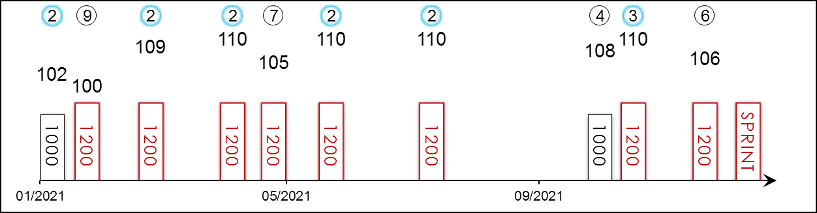 | HK Career : 22 (2-7-1-2-10) Right-handed : 23 (4-4-3-2-10) Jockey : 9 (1-4-1-1-2)  Pre Import : 7 (3-0-2-1-1) Sha Tin-Turf : 17 (1-6-1-2-7) GF+ : 9 (2-4-0-0-3)  Lifetime : 29 (5-7-3-3-11) Non-Turf : - Good : 15 (1-3-2-2-7)  2021/22 : 3 (0-0-1-1-1) Distance : 15 (1-4-2-1-7) Yielding : -  G1 : 3 (0-0-0-0-3) Course & Dist : 11 (0-3-1-1-6) Soft/Hvy : 5 (2-0-1-1-1)  First Up : 5 (3-1-0-1-0) 1000-1200 : 28 (4-7-3-3-11) HK$ : 9,649,510  G1 win : Nil

Pos | Index | Date | Perf  Rating | Race Category & Name |  | Track | Dist/Course/Going |  | Wt | Jockey | Draw | Race Sectional Time |  |  |  | Race  Time | Horse  Final | Position & Margin in Running |  |  |  |  |  | Finish |  | Odds | Winner/Second
2/5 | *308 | 1/1/21 | 102 | G3 | Bauhinia Sprint Trophy - hcp | ST, HK | 1000 St | G | 120 | C Soumillon | 3 |  | 13.⁴⁰ | 20.⁸⁶ | 22.⁴⁰ | 0.56.⁶⁶ | 22.³⁴ | - |  | 5 | 1½ | 3 | 3/4 | 2 | N | 3.3 | Explosive Witness
9/11 | *368 | 24/1/21 | 100 | G1 | Centenary Sprint Cup | ST, HK | 1200 RH | G | 126 | T Piccone | 10 |  | 23.⁴⁹ | 21.⁹² | 22.⁶⁰ | 1.08.⁰¹ | 22.⁶² | - |  | 8 | 6¼ | 9 | 5¾ | 9 | 5¾ | 39 | Hot King Prawn
2/8 | *456 | 24/2/21 | 109 | - | Cl.1 hcp | HV, HK | 1200 RH | GF | 130 | C Y Ho | 2 |  | 24.²¹ | 22.⁴² | 22.²¹ | 1.08.⁸⁴ | 21.⁹⁹ | - |  | 3 | 1¼ | 3 | 1½ | 2 | HD | 10 | Sky Field
2/13 | *563 | 5/4/21 | 110 | G2 | Sprint Cup | ST, HK | 1200 RH | G | 123 | C Y Ho | 8 |  | 23.²⁹ | 21.⁸⁷ | 23.⁰⁸ | 1.08.²⁴ | 22.³⁴ | - |  | 11 | 5 | 10 | 4¾ | 2 | SH | 24 | Amazing Star
7/13 | *617 | 25/4/21 | 105 | G1 | Chairman's Sprint Prize | ST, HK | 1200 RH | G | 126 | C Y Ho | 8 |  | 24.²³ | 22.²³ | 22.¹⁸ | 1.08.⁶⁴ | 21.⁹⁹ | - |  | 9 | 4½ | 10 | 5¼ | 7 | 4 | 6.7 | Wellington
2/9 | *692 | 23/5/21 | 110 | G3 | Sha Tin Vase - hcp | ST, HK | 1200 RH | GF | 130 | C Y Ho | 8 |  | 23.⁹² | 21.⁸⁶ | 22.³⁸ | 1.08.¹⁶ | 21.⁹⁵ | - |  | 6 | 4 | 7 | 3½ | 2 | 3/4 | 25 | Courier Wonder
2/13 | *825 | 11/7/21 | 110 | - | Cl.1 hcp | ST, HK | 1200 RH | GF | 132 | C Y Ho | 3 |  | 23.⁰⁴ | 21.⁸³ | 22.⁷⁴ | 1.07.⁶¹ | 22.⁶⁴ | - |  | 8 | 3½ | 6 | 3 | 2 | 2¼ | 4.1 | Lucky Patch
4/14 | 72 | 1/10/21 | 108 | G3 | National Day Cup - hcp | ST, HK | 1000 St | G | 128 | C Y Ho | 13 |  | 13.⁰⁵ | 20.⁰⁹ | 21.⁸² | 0.54.⁹⁶ | 21.⁶⁶ | - |  | 7 | 1 | 9 | 2¼ | 4 | 1¼ | 5.1 | Super Wealthy
3/12 | 99 | 17/10/21 | 110 | G2 | Premier Bowl - hcp | ST, HK | 1200 RH | G | 126 | C Y Ho | 7 |  | 23.²⁵ | 21.⁶⁶ | 23.⁰⁴ | 1.07.⁹⁵ | 22.⁵² | - |  | 10 | 4¾ | 10 | 4¼ | 3 | 1 | 16 | Lucky Patch
6/10 | 192 | 21/11/21 | 106 | G2 | BOCHK Private Banking JC Sprint | ST, HK | 1200 RH | G | 123 | C Y Ho | 2 |  | 23.⁴¹ | 22.¹¹ | 22.⁴⁶ | 1.07.⁹⁸ | 22.⁴⁵ | - |  | 7 | 6¼ | 7 | 3 | 6 | 3 | 8.6 | Lucky Patch
 |  | 12/12/21 |  | G1 | LONGINES Hong Kong Sprint | ST, HK | 1200 RH |  | 126 | C Y Ho
G3 winner on heavy ground and also placed in a 1200m G3 contest in Australia pre-import. Dual 1000m victor in Hong Kong. Solid contender who is twice G2 placed; struggles to get his nose in front but rarely beaten too far. Last out finished sixth in the G2 BOCHK Private Banking Jockey Club Sprint (1200m). Versatile and no ground issue.

 |  |  | 速遞奇兵 D449  COURIER WONDER (NZ) 4 br g  Sacred Falls (NZ) - Fabulist (NZ) (Savabeel (AUS))  Owner(s): Mr & Mrs Chadwick Mok Cham Hung |  | 蔡約翰 (香港)  J Size (HK)  Win 9.7% Place 25.8% | 莫雷拉  J Moreira  Win 17.6% Place 40.1% | 126 lb  (108)

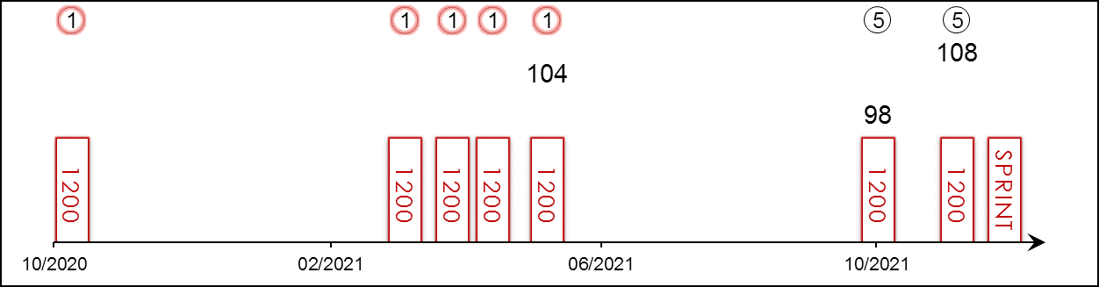 | HK Career : 7 (5-0-0-0-2) Right-handed : 7 (5-0-0-0-2) Jockey : 7 (5-0-0-0-2)  Pre Import : - Sha Tin-Turf : 7 (5-0-0-0-2) GF+ : 1 (1-0-0-0-0)  Lifetime : 7 (5-0-0-0-2) Non-Turf : - Good : 6 (4-0-0-0-2)  2021/22 : 2 (0-0-0-0-2) Distance : 7 (5-0-0-0-2) Yielding : -  G1 : - Course & Dist : 7 (5-0-0-0-2) Soft/Hvy : -  First Up : 3 (2-0-0-0-1) 1000-1200 : 7 (5-0-0-0-2) HK$ : 7,361,500  G1 win : Nil

Pos | Index | Date | Perf  Rating | Race Category & Name |  | Track | Dist/Course/Going |  | Wt | Jockey | Draw | Race Sectional Time |  |  |  | Race  Time | Horse  Final | Position & Margin in Running |  |  |  |  |  | Finish |  | Odds | Winner/Second
1/12 | *132 | 24/10/20 | - | - | Cl.4 hcp | ST, HK | 1200 RH | G | 126 | J Moreira | 3 |  | 23.⁸⁷ | 22.⁶⁷ | 22.³¹ | 1.08.⁸⁵ | 22.³¹ | - |  | 1 | 3/4 | 1 | 1 | 1 | 5¼ | 6.7 | Everyone's Delight
1/13 | *523 | 21/3/21 | - | - | Cl.3 hcp | ST, HK | 1200 RH | G | 121 | J Moreira | 1 |  | 23.⁸⁷ | 22.⁸¹ | 22.²⁴ | 1.08.⁹² | 22.²⁴ | - |  | 1 | 1 | 1 | 1 | 1 | 3½ | 1.1F | Regency Bo Bo
1/10 | *581 | 11/4/21 | - | - | Cl.3 hcp | ST, HK | 1200 RH | G | 133 | J Moreira | 8 |  | 23.⁶⁰ | 22.⁰⁴ | 22.⁹⁵ | 1.08.⁵⁹ | 22.⁹⁵ | - |  | 1 | 1/2 | 1 | 3/4 | 1 | 1/2 | 1.2F | Trillion Win
1/14 | *622 | 25/4/21 | - | - | Cl.2 hcp | ST, HK | 1200 RH | G | 117 | J Moreira | 8 |  | 23.⁷⁰ | 21.⁷⁶ | 22.⁷⁸ | 1.08.²⁴ | 22.⁶² | - |  | 3 | 1 | 3 | 1 | 1 | 2 | 1.7F | Lucky Patch
1/9 | *692 | 23/5/21 | 104 | G3 | Sha Tin Vase - hcp | ST, HK | 1200 RH | GF | 118 | J Moreira | 6 |  | 23.⁹² | 21.⁸⁶ | 22.³⁸ | 1.08.¹⁶ | 22.¹⁸ | - |  | 3 | 1¼ | 3 | 1¼ | 1 | 3/4 | 1.1F | Stronger
5/12 | 99 | 17/10/21 | 98 | G2 | Premier Bowl - hcp | ST, HK | 1200 RH | G | 120 | J Moreira | 9 |  | 23.²⁵ | 21.⁶⁶ | 23.⁰⁴ | 1.07.⁹⁵ | 23.⁰⁹ | - |  | 8 | 3½ | 7 | 3 | 5 | 3¼ | 2.3F | Lucky Patch
5/10 | 192 | 21/11/21 | 108 | G2 | BOCHK Private Banking JC Sprint | ST, HK | 1200 RH | G | 123 | J Moreira | 6 |  | 23.⁴¹ | 22.¹¹ | 22.⁴⁶ | 1.07.⁹⁸ | 22.⁷⁸ | - |  | 2 | 1 | 2 | N | 5 | 2¼ | 2.7F | Lucky Patch
 |  | 12/12/21 |  | G1 | LONGINES Hong Kong Sprint | ST, HK | 1200 RH |  | 126 | J Moreira
Prodigious talent who won his first five starts to remain undefeated in his maiden Hong Kong season, earning him the Most Improved Horse of the 2020/21 season, and claimed the G3 Sha Tin Vase Handicap (1200m) three starts back before a luckless fifth in the G2 Premier Bowl Handicap (1200m) on his penultimate start. Last out finished fifth in the G2 BOCHK Private Banking Jockey Club Sprint (1200m). Can lead but can also sit handy. Won on good and good to firm grounds.

 |  |  | 拉丁城市  RESISTENCIA (JPN) 4 b f  Daiwa Major (JPN) - Malacostumbrada (ARG) (Lizard Island (USA))  Owner(s): Carrot Farm Co Ltd |  | 松下武士 (日本)  T Matsushita (JPN) | 蘇銘倫  C Soumillon | 122 lb  (111)

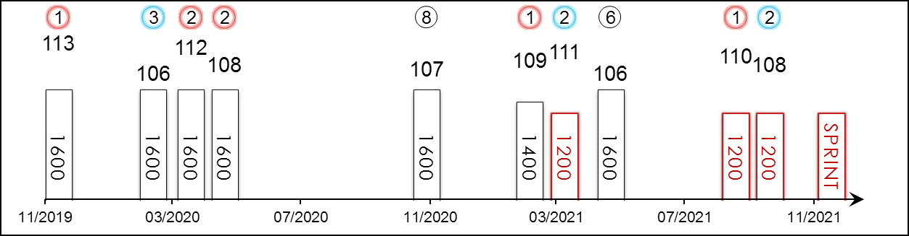 | HK Starts : - Right-handed : 8 (4-2-1-0-1) Jockey : -  Pre Import : - Sha Tin-Turf : - GF+ : 9 (4-2-1-0-2)  Lifetime : 12 (5-4-1-0-2) Non-Turf : - Good : 1 (1-0-0-0-0)  2021 : 5 (2-2-0-0-1) Distance : 3 (1-2-0-0-0) Yielding : 2 (0-2-0-0-0)  G1 : 7 (1-4-0-0-2) Course & Dist : - Soft/Hvy : -  First Up : 5 (3-0-1-0-1) 1000-1200 : 3 (1-2-0-0-0) HK$ : 30,408,790  G1 win : 2019 Hanshin Juvenile Fillies 1600m

Pos | Index | Date | Perf  Rating | Race Category & Name |  | Track | Dist/Course/Going |  | Wt | Jockey | Draw | Race Sectional Time |  |  |  | Race  Time | Horse  Final | Position & Margin in Running |  |  |  |  |  | Finish |  | Odds | Winner/Second
1/16 | - | 8/12/19 | 113 | G1 | Hanshin Juvenile Fillies - 2yo | HSN, JPN | 1600 RH | F | 119 | Y Kitamura | 4 |  | 22.⁸⁰ | 23.²⁰ | 24.⁰⁰ | 1.32.⁷⁰ | 35.²⁰ | - |  | 1 | - | 1 | - | 1 | 5 | 11.2 | Maltese Diosa
3/14 | - | 7/3/20 | 106 | G2 | Tulip Sho - 3yo fillies | HSN, JPN | 1600 RH | F | 119 | Y Kitamura | 4 |  | 23.⁷⁰ | 23.⁵⁰ | 22.⁷⁰ | 1.33.³⁰ | 34.²⁰ | - |  | 1 | - | 1 | - | 3 | 1.3 | 1.4F | Maltese Diosa
2/18 | - | 12/4/20 | 112 | G1 | Oka Sho (Japanese 1000 Guineas) - 3yo fillies | HSN, JPN | 1600 RH | Y | 121 | Y Take | 17 |  | 22.⁹⁰ | 23.²⁰ | 26.⁴⁰ | 1.36.¹⁰ | 38.²⁰ | - |  | 2 | - | 2 | - | 2 | 1.5 | 3.7F | Daring Tact
2/18 | - | 10/5/20 | 108 | G1 | NHK Mile Cup - 3yo | TOK, JPN | 1600 LH | F | 121 | C Lemaire | 3 |  | 23.³⁰ | 23.³⁰ | 23.²⁰ | 1.32.⁵⁰ | 34.⁷⁰ | - |  | 1 | - | 1 | - | 2 | 1.5 | 3F | Lauda Sion
8/17 | - | 22/11/20 | 107 | G1 | Mile Championship | HSN, JPN | 1600 RH | F | 119 | Y Kitamura | 2 |  | 23.⁴⁰ | 22.⁶⁰ | 22.⁵⁰ | 1.32.⁰⁰ | 34.³⁰ | - |  | 1 | - | 1 | - | 8 | 4.5 | 9.9 | Gran Alegria
1/17 | - | 28/2/21 | 109 | G3 | Hankyu Hai | HSN, JPN | 1400 RH | GF | 119 | Y Kitamura | 8 |  | 21.⁸⁰ | 22.⁶⁰ | 22.⁶⁰ | 1.19.²⁰ | 33.⁸⁰ | - |  | 1 | - | 1 | - | 1 | 2 | 2.4F | Mikki Brillante
2/18 | - | 28/3/21 | 111 | G1 | Takamatsunomiya Kinen | CYO, JPN | 1200 LH | Y | 121 | S Hamanaka | 16 |  | 22.⁹⁰ | 22.⁷⁰ | 23.⁶⁰ | 1.09.²⁰ | 34.⁵⁰ | - |  | 6 | - | 7 | - | 2 | Nk | 2.9F | Danon Smash
6/18 | - | 16/5/21 | 106 | G1 | Victoria Mile - f&m | TOK, JPN | 1600 LH | GF | 121 | Y Take | 18 |  | 23.³⁰ | 22.⁸⁰ | 22.²⁰ | 1.31.⁰⁰ | 34.¹⁰ | - |  | 3 | - | 2 | - | 6 | 5 | 7.1 | Gran Alegria
1/17 | - | 12/9/21 | 110 | G2 | Centaur S. | CYO, JPN | 1200 LH | GF | 119 | C Lemaire | 8 |  | 22.²⁰ | 21.⁶⁰ | 23.⁴⁰ | 1.07.²⁰ | 34.⁰⁰ | - |  | 2 | - | 2 | - | 1 | Nk | 1.9F | Pixie Knight
2/16 | - | 3/10/21 | 108 | G1 | Sprinters S. | NAK, JPN | 1200 RH | GF | 121 | C Lemaire | 12 |  | 22.³⁰ | 22.¹⁰ | 22.⁷⁰ | 1.07.¹⁰ | 33.⁵⁰ | - |  | 4 | - | 4 | - | 2 | 2 | 3.4 | Pixie Knight
 |  | 12/12/21 |  | G1 | LONGINES Hong Kong Sprint | ST, HK | 1200 RH |  | 122 | C Soumillon
JRA’s champion 2YO filly in 2019 after winning the G1 Hanshin Juvenile Fillies (1600m) at her third career start. Runner-up in October’s G1 Sprinters Stakes (1200m) at Nakayama to Pixie Knight; G2 winner the start before, defeating Pixie Knight that time at Chukyo. Two solid performances in G1 company last year when second in both the Oka Sho (1600m) and NHK Mile Cup (1600m). Races best when leading but can sit handy. Handles firm and yielding ground.

