Spotlight

Hong Kong Horse of the Year, Golden Sixty, extended his extraordinary unbeaten record to 15 in the G2 BOCHK Private Wealth Jockey Club Mile (1600m) and the brilliant son of Medaglia d’Oro will attempt to defend his crown in the LONGINES Hong Kong Mile.

Aidan O’Brien is the most prolific trainer in the history of the LONGINES Hong Kong Vase and he will look to add a LONGINES Hong Kong Mile crown to his haul with Mother Earth, his brilliant dual G1-winning three-year-old.

Danon Kingly, the G1 Yasuda Kinen (1600m) victor embarking on his first overseas foray, is joined by G1-winning miler Salios, Vin de Garde and Indy Champ, the latter returning for his second crack at Hong Kong glory after returning a luckless seventh in the 2019 LONGINES Hong Kong Mile.

G1-winning miler Waikuku leads a solid field of home team entrants including 2021 BMW Hong Kong Derby (2000m) winner Sky Darci, Excellent Proposal, the 2021 Hong Kong Classic Mile winner, as well as Lucky Express, More Than This and Healthy Happy, who led throughout to claim the 2021 Hong Kong Classic Cup (1800m).

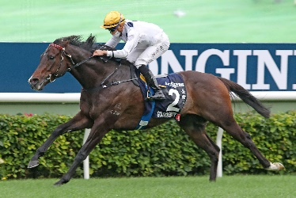 | GOLDEN SIXTY (AUS)  HONG KONG 6g 120  Exceptional talent and Hong Kong’s reigning Horse of the Year with four G1 wins among his record; last out scored comfortably in G2 Jockey Club Mile going from last-to-first as he usually does. | 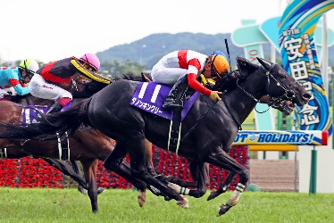 | DANON KINGLY (JPN)  JAPAN 5h 118  2021 G1 Yasuda Kinen (1600m) winner, defeating Gran Alegria over the mile at Tokyo.
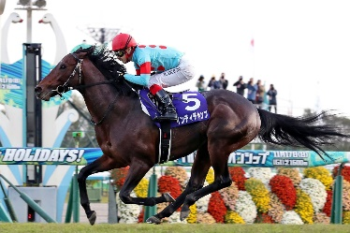 | INDY CHAMP (JPN)  JAPAN 6h 118  Returns for his second crack at Hong Kong glory; boasts a win in 2019 G1 Mile Championship among his haul. | 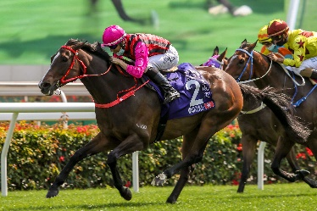 | WAIKUKU (IRE)  HONG KONG 6g 118  Two-time G1 winner scoring over 1400m and the mile at the top-level in Hong Kong, one-time over Beauty Generation.
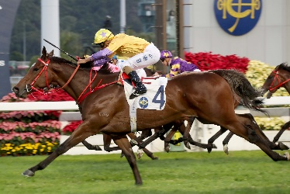 | MORE THAN THIS (GB)  HONG KONG 5g 117  Pushed Golden Sixty to within a head in 2021 Champions Mile at Sha Tin earlier this year; placed in each of the three legs of last season’s Four-Year-Old Classic Series. | 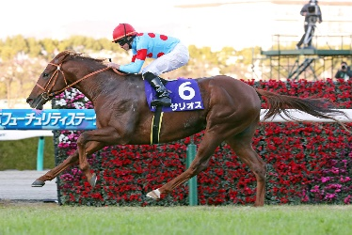 | SALIOS (JPN)  JAPAN 4c 115  Bridesmaid as a three-year-old with two seconds to the Japanese Triple Crown-winning Contrail at G1 level; since then scored a G2 win at Tokyo over 1800m.
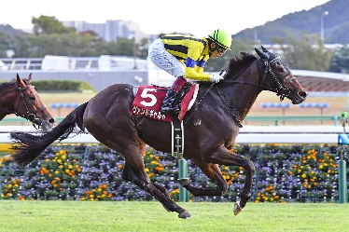 | VIN DE GARDE (JPN)  JAPAN 5h 113  G1-placed in 2021 Dubai Turf (1800m) at Meydan; before this, winner of a G2 contest at Tokyo. | 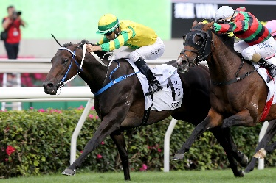 | SKY DARCI (NZ)  HONG KONG 5g 112  2021 Hong Kong Derby (2000m) hero who is a prolific winner with seven wins from 17 starts on his record, ranging from 1200m to 2000m.
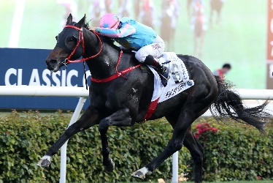 | HEALTHY HAPPY (AUS)  HONG KONG 5g 110  Three time winner from nine starts in Hong Kong, claimed 2021 Hong Kong Classic Cup (1800m) last season, also finished close-up second to Sky Darci in 2021 G3 Lion Rock Trophy (1600m). | 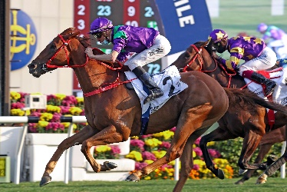 | EXCELLENT PROPOSAL (AUS)  HONG KONG 5g 107  2021 Hong Kong Classic Mile winner who scored four times throughout his four-year-old season.
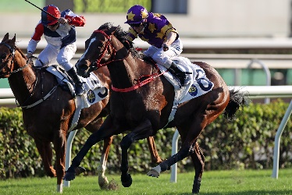 | LUCKY EXPRESS (AUS)  HONG KONG 5g 105  First-up winner this campaign clinging on to a close-up victory at Class 1 level over 1400m, also finished runner-up to stablemate Excellent Proposal in 2021 Hong Kong Classic Mile. | 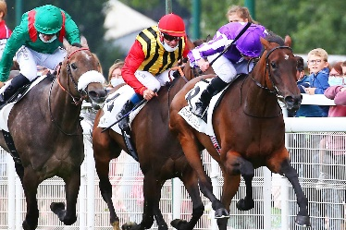 | MOTHER EARTH (IRE)  IRELAND 3f 114  Ultra-consistent performer with two G1 wins among her haul, striking in the 2021 1000 Guineas and Prix Rothschild just three months after; placed in seven other G1 contests.

