Previous Winners

Horse /  Owner |  | Trainer /  Jockey | Rep. | Win.  Margin | Draw | Odds | Going | Race Time | Pre-race  Rating | Last Start Performance | Best Performance Last  12 months (Runs since)
2020
Golden Sixty (AUS) 5g | 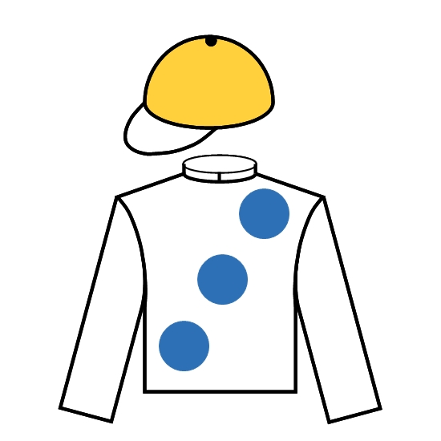 | K W Lui | HK | 2 | 7 | 1.3F | G | 1.33.45 | 119 | Won Jockey Club Mile 1600 G2 | Won Jockey Club Mile 1600 G2 (0)
Stanley Chan Ka Leung |  | C Y Ho
2019
Admire Mars (JPN) 3c | 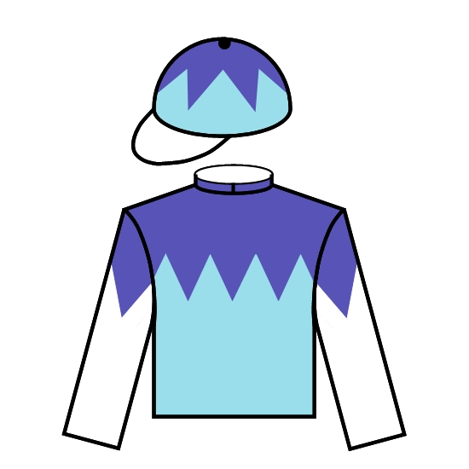 | Y Tomomichi | JPN | 1/2 | 4 | 27 | G | 1.33.25 | 116 | 9th Fuji S. 1600 G3 | Won NHK Mile Cup 1600 G1 (1)
Riichi Kondo |  | C Soumillon
2018
Beauty Generation (NZ) 6g |  | J Moore | HK | 3 | 12 | 1.5F | G | 1.33.52 | 126 | Won BOCHK Wealth Management JC Mile 1600 G2 | Won Champions Mile 1600 G1 (3)
Patrick Kwok Ho Chuen |  | Z Purton
2017
Beauty Generation (NZ) 5g |  | J Moore | HK | 1 | 9 | 8.4 | G | 1.33.72 | 112 | 3rd BOCHK Wealth Management JC Mile 1600 G2 | Won Oriental Watch Sha Tin Trophy 1600 G2 (1)
Patrick Kwok Ho Chuen |  | K C Leung
2016
Beauty Only (IRE) 5g | 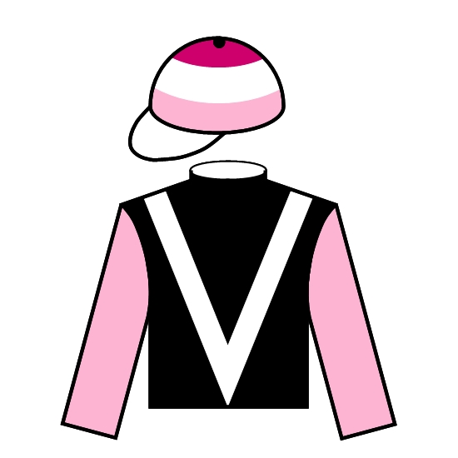 | A S Cruz | HK | 1/2 | 13 | 6 | G | 1.33.48 | 117 | Won BOCHK Wealth Management JC Mile 1600 G2 | Won BOCHK Wealth Management JC Mile 1600 G2 (0)
Eleanor Kwok Law Kwai Chun & Patrick Kwok Ho Chuen |  | Z Purton
2015
Maurice (JPN) 4c | 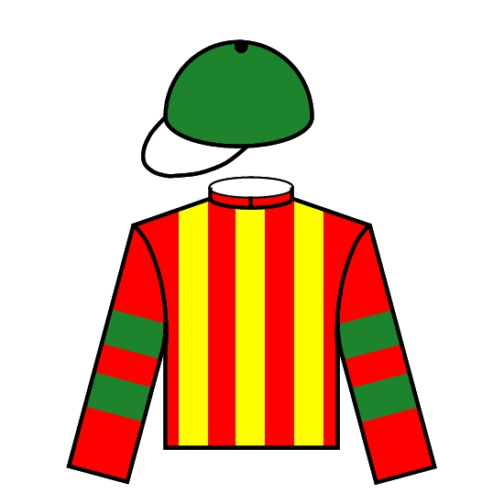 | N Hori | JPN | 3/4 | 11 | 4.1 | G | 1.33.92 | 119 | Won Mile Championship 1600 G1 | Won Mile Championship 1600 G1 (0)
Kazumi Yoshida |  | R Moore
2014
Able Friend (AUS) 5g | 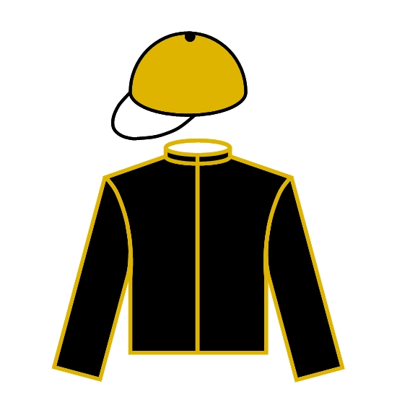 | J Moore | HK | 4-1/4 | 10 | 1.3F | GF | 1.33.49 | 122 | Won BOCHK Wealth Management JC Mile 1600 G2 | 2nd Champions Mile 1600 G1 (2)
Dr & Mrs Cornel Li Fook Kwan |  | J Moreira
2013
Glorious Days (AUS) 6g | 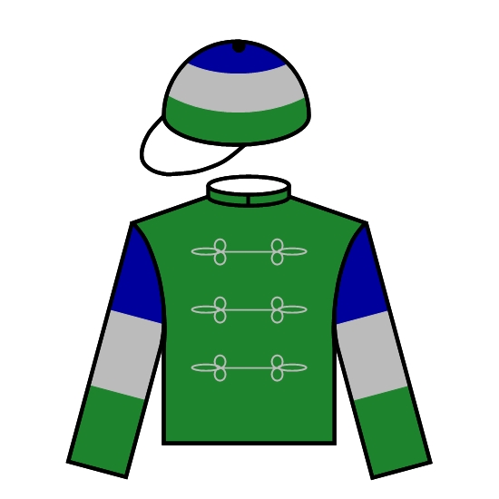 | J Size | HK | 3/4 | 13 | 8.7 | GF | 1.33.60 | 120 | 11th Yasuda Kinen 1600 G1 | Won Stewards' Cup 1600 (G1) (3)
Tom Brown's Syndicate |  | D Whyte
2012
Ambitious Dragon (NZ) 6g | 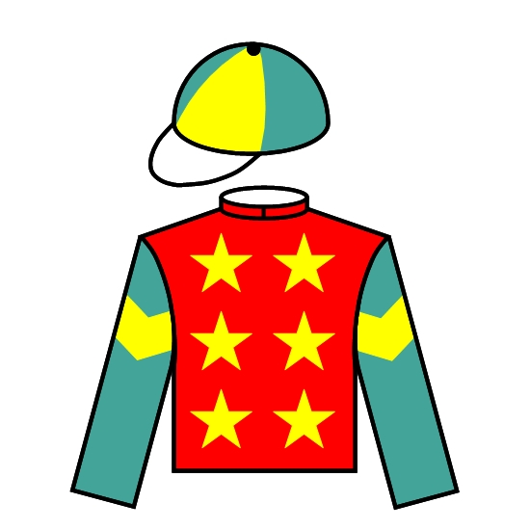 | A T Millard | HK | 3/4 | 11 | 4.1 | G | 1.34.12 | 124 | 2nd Jockey Club Mile 1600 G2 | Won Oriental Watch Shatin Trophy hcp 1600 (G2) (1)
Johnson Lam Pui Hung & Anderson Lam Hin Yue |  | Z Purton
2011
Able One (NZ) 9g |  | J Moore | HK | Nk | 7 | 66 | GF | 1.33.98 | 117 | 8th Jockey Club Mile 1600 G2 | 4th Shatin Trophy hcp 1600 (G2) (1)
Dr & Mrs Cornel Li Fook Kwan |  | J Lloyd

