 |  |  | 金鎗六十 C238  GOLDEN SIXTY (AUS) 6 br g  Medaglia d'Oro (USA) - Gaudeamus (USA) (Distorted Humor (USA))  Owner(s): Stanley Chan Ka Leung |  | 呂健威 (香港)  K W Lui (HK)  Win 11.4% Place 30.2% | 何澤堯  C Y Ho  Win 11.4% Place 28.5% | 126 lb  (120)

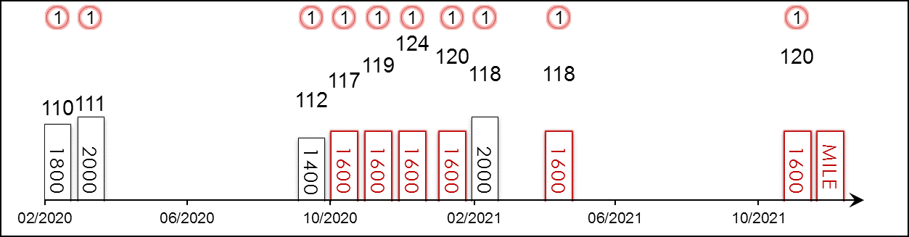 | HK Career : 19 (18-0-0-0-1) Right-handed : 19 (18-0-0-0-1) Jockey : 19 (18-0-0-0-1)  Pre Import : - Sha Tin-Turf : 19 (18-0-0-0-1) GF+ : 7 (6-0-0-0-1)  Lifetime : 19 (18-0-0-0-1) Non-Turf : - Good : 12 (12-0-0-0-0)  2021/22 : 1 (1-0-0-0-0) Distance : 7 (7-0-0-0-0) Yielding : -  G1 : 4 (4-0-0-0-0) Course & Dist : 7 (7-0-0-0-0) Soft/Hvy : -  First Up : 4 (4-0-0-0-0) 1400-1800 : 13 (12-0-0-0-1) HK$ : 80,633,100  G1 win : 2021 FWD Champions Mile 1600m, 2021 Citi Hong Kong Gold Cup 2000m, 2021 Stewards' Cup 1600m, 2020 LONGINES Hong Kong Mile 1600m

Pos | Index | Date | Perf  Rating | Race Category & Name |  | Track | Dist/Course/Going |  | Wt | Jockey | Draw | Race Sectional Time |  |  |  | Race  Time | Horse  Final | Position & Margin in Running |  |  |  |  |  | Finish |  | Odds | Winner/Second
1/10 | **441 | 23/2/20 | 110 | - | Hong Kong Classic Cup | ST, HK | 1800 RH | G | 126 | C Y Ho | 7 |  | 23.⁴⁰ | 23.³² | 22.⁷⁸ | 1.45.⁸⁸ | 22.³⁸ | 8 | 4¾ | 8 | 5¾ | 8 | 2½ | 1 | 1/2 | 2.2F | Champion's Way
1/14 | **516 | 22/3/20 | 111 | - | BMW Hong Kong Derby | ST, HK | 2000 RH | GF | 126 | C Y Ho | 9 |  | 25.²³ | 23.³¹ | 22.⁶³ | 2.00.¹⁵ | 21.⁸³ | 12 | 7 | 13 | 5¾ | 11 | 5 | 1 | N | 1.7F | Playa del Puente
1/11 | *62 | 27/9/20 | 112 | G3 | Celebration Cup - hcp | ST, HK | 1400 RH | G | 116 | C Y Ho | 2 |  | 22.⁰¹ | 22.⁷⁰ | 22.⁴³ | 1.20.⁵⁴ | 22.¹⁹ | 7 | 2¾ | 8 | 4 | 4 | 1½ | 1 | 1¾ | 1.8F | Beauty Generation/  Champion's Way
1/12 | *117 | 18/10/20 | 117 | G2 | Oriental Watch Sha Tin Trophy - hcp | ST, HK | 1600 RH | GF | 123 | C Y Ho | 6 |  | 23.¹⁷ | 22.⁷⁸ | 22.⁰⁵ | 1.33.³⁷ | 21.⁸¹ | 5 | 2 | 5 | 3¼ | 5 | 1½ | 1 | 1/2 | 1.3F | Ka Ying Star
1/7 | *205 | 22/11/20 | 119 | G2 | Jockey Club Mile | ST, HK | 1600 RH | GF | 123 | C Y Ho | 1 |  | 23.²¹ | 22.⁷⁶ | 22.²⁹ | 1.32.⁹¹ | 21.⁸⁹ | 4 | 3¼ | 6 | 3¼ | 4 | 2½ | 1 | 1½ | 1.1F | Ka Ying Star
1/10 | *264 | 13/12/20 | 124 | G1 | LONGINES Hong Kong Mile | ST, HK | 1600 RH | G | 126 | C Y Ho | 7 |  | 22.⁷⁶ | 23.¹⁰ | 22.⁴¹ | 1.33.⁴⁵ | 22.⁰⁵ | 8 | 8 | 8 | 6 | 6 | 2¼ | 1 | 2 | 1.3F | Southern Legend
1/8 | *370 | 24/1/21 | 120 | G1 | Stewards' Cup | ST, HK | 1600 RH | G | 126 | C Y Ho | 6 |  | 23.²¹ | 22.⁵⁴ | 22.²⁰ | 1.33.³⁵ | 21.⁸⁰ | 7 | 4¾ | 6 | 3½ | 5 | 2½ | 1 | HD | 1.2F | Southern Legend
1/7 | *447 | 21/2/21 | 118 | G1 | Citi Hong Kong Gold Cup | ST, HK | 2000 RH | G | 126 | C Y Ho | 4 |  | 23.²⁰ | 22.⁵⁷ | 22.⁵⁹ | 2.00.²⁵ | 22.³⁵ | 5 | 2¾ | 6 | 4¼ | 5 | 1½ | 1 | SH | 1.3F | Furore
1/6 | *619 | 25/4/21 | 118 | G1 | FWD Champions Mile | ST, HK | 1600 RH | G | 126 | C Y Ho | 5 |  | 23.⁰⁷ | 23.²⁴ | 22.⁵² | 1.33.⁴⁵ | 22.⁵² | 5 | 3½ | 6 | 3¼ | 2 | SH | 1 | HD | 1.2F | More Than This
1/7 | 193 | 21/11/21 | 120 | G2 | BOCHK Private Wealth JC Mile | ST, HK | 1600 RH | G | 128 | C Y Ho | 7 |  | 24.¹⁶ | 22.¹⁷ | 22.⁰³ | 1.34.⁵⁵ | 21.⁵¹ | 7 | 5½ | 7 | 6¼ | 6 | 3¼ | 1 | 1 | 1.1F | Waikuku
 |  | 12/12/21 |  | G1 | LONGINES Hong Kong Mile | ST, HK | 1600 RH |  | 126 | C Y Ho
Winner of 18 of his 19 career starts from 1200m to 2000m, including 9 at Pattern level. Dazzled home to notch his maiden G1 title in the LONGINES Hong Kong Mile in December 2020, earning him an international rating of 124. Only the second horse to sweep all three legs of the 4YO Classic Series. Looking to extend his unbeaten record to 16 with his successful defence of his G1 LONGINES Hong Kong Mile crown; exceptional talent and Hong Kong’s reigning Horse of the Year with four G1 wins among his record; last out scored a comfortable win in the G2 BOCHK Private Wealth Jockey Club Mile (1600m). Versatile, won on good and good to firm ground.

 |  |  | 野田賢君  DANON KINGLY (JPN) 5 db h  Deep Impact (JPN) - My Goodness (USA) (Storm Cat (USA))  Owner(s): Danox Co Ltd |  | 萩原清 (日本)  K Hagiwara (JPN) | 川田將雅  Y Kawada | 126 lb  (118)

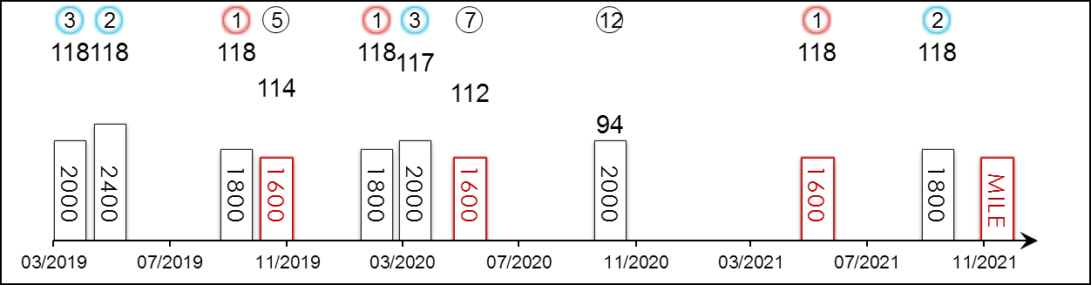 | HK Starts : - Right-handed : 5 (2-0-2-0-1) Jockey : 2 (1-1-0-0-0)  Pre Import : - Sha Tin-Turf : - GF+ : 12 (6-2-2-0-2)  Lifetime : 13 (6-2-2-0-3) Non-Turf : - Good : 1 (0-0-0-0-1)  2021 : 2 (1-1-0-0-0) Distance : 5 (3-0-0-0-2) Yielding : -  G1 : 7 (1-1-2-0-3) Course & Dist : - Soft/Hvy : -  First Up : 9 (5-1-1-0-2) 1400-1800 : 9 (6-1-0-0-2) HK$ : 37,650,580  G1 win : 2021 Yasuda Kinen 1600m

Pos | Index | Date | Perf  Rating | Race Category & Name |  | Track | Dist/Course/Going |  | Wt | Jockey | Draw | Race Sectional Time |  |  |  | Race  Time | Horse  Final | Position & Margin in Running |  |  |  |  |  | Finish |  | Odds | Winner/Second
3/18 | - | 14/4/19 | 118 | G1 | Satsuki Sho (Japanese 2000 Guineas) - 3yo | NAK, JPN | 2000 RH | F | 126 | K Tosaki | 4 |  | 24.⁶⁰ | 23.⁹⁰ | 23.⁰⁰ | 1.58.¹⁰ | 34.⁵⁰ | 3 | - | 4 | - | 5 | - | 3 | Hd | 5.8 | Saturnalia
2/18 | - | 26/5/19 | 118 | G1 | Tokyo Yushun (Japanese Derby) - 3yo | TOK, JPN | 2400 LH | F | 126 | K Tosaki | 7 |  | 24.⁷⁰ | 24.²⁰ | 23.⁹⁰ | 2.22.⁶⁰ | 34.⁵⁰ | 5 | - | 5 | - | 3 | - | 2 | Nk | 4.7 | Roger Barows
1/10 | - | 6/10/19 | 118 | G2 | Mainichi Okan | TOK, JPN | 1800 LH | F | 119 | K Tosaki | 9 |  | 23.⁰⁰ | 22.⁸⁰ | 23.¹⁰ | 1.44.⁴⁰ | 33.⁴⁰ | 10 | - | 10 | - | 9 | - | 1 | 1.3 | 1.6F | Aerolithe
5/17 | - | 17/11/19 | 114 | G1 | Mile Championship | KYO, JPN | 1600 RH | F | 123 | N Yokoyama | 1 |  | 23.⁵⁰ | 23.¹⁰ | 22.⁷⁰ | 1.33.⁰⁰ | 34.¹⁰ | - |  | 6 | - | 7 | - | 5 | 2.5 | 3.9 | Indy Champ
1/9 | - | 1/3/20 | 118 | G2 | Nakayama Kinen | NAK, JPN | 1800 RH | F | 123 | N Yokoyama | 3 |  | 23.³⁰ | 23.⁶⁰ | 23.⁴⁰ | 1.46.³⁰ | 34.²⁰ | 3 | - | 3 | - | 3 | - | 1 | 1.8 | 2.5F | Lucky Lilac
3/12 | - | 5/4/20 | 117 | G1 | Osaka Hai | HSN, JPN | 2000 RH | F | 126 | N Yokoyama | 8 |  | 23.⁷⁰ | 23.⁰⁰ | 22.⁹⁰ | 1.58.⁴⁰ | 34.³⁰ | 1 | - | 1 | - | 1 | - | 3 | 0.5 | 3.8F | Lucky Lilac
7/14 | - | 7/6/20 | 112 | G1 | Yasuda Kinen | TOK, JPN | 1600 LH | G | 128 | K Tosaki | 2 |  | 22.⁷⁰ | 23.⁰⁰ | 22.⁹⁰ | 1.31.⁶⁰ | 34.⁶⁰ | - |  | 6 | - | 5 | - | 7 | 5.5 | 12.9 | Gran Alegria
12/12 | - | 1/11/20 | 94 | G1 | Tenno Sho Autumn | TOK, JPN | 2000 LH | F | 128 | K Tosaki | 4 |  | 23.⁹⁰ | 22.⁶⁰ | 22.⁷⁰ | 1.57.⁸⁰ | 35.⁸⁰ | 5 | - | 6 | - | 6 | - | 12 | 17.5 | 13.3 | Almond Eye
1/14 | - | 6/6/21 | 118 | G1 | Yasuda Kinen | TOK, JPN | 1600 LH | GF | 128 | Y Kawada | 11 |  | 23.¹⁰ | 22.⁶⁰ | 22.⁷⁰ | 1.31.⁷⁰ | 33.¹⁰ | - |  | 8 | - | 8 | - | 1 | Hd | 47.6 | Gran Alegria
2/13 | - | 10/10/21 | 118 | G2 | Mainichi Okan | TOK, JPN | 1800 LH | GF | 128 | Y Kawada | 7 |  | 23.⁷⁰ | 23.⁰⁰ | 23.³⁰ | 1.44.⁸⁰ | 33.⁷⁰ | 12 | - | 5 | - | 5 | - | 2 | Hd | 2.7 | Schnell Meister
 |  | 12/12/21 |  | G1 | LONGINES Hong Kong Mile | ST, HK | 1600 RH |  | 126 | Y Kawada
Ran 3rd and 2nd in 2019 G1 Satsuki Sho (2000m) and G1 Japanese Derby (2400m) respectively. Won the G2 Nakayama Kinen (1800m) in his first start as a four-year-old and then ran 3rd in the G1 Osaka Hai (2000m). 2021 G1 Yasuda Kinen (1600m) winner, defeating Gran Alegria over the mile at Tokyo; prior to that, placed at G1 level in the Osaka Hai (2000m); last out finished second to G1 winner Schnell Meister over 1800m at Tokyo. Versatile. Best on firm ground.

 |  |  | 冠軍車手  INDY CHAMP (JPN) 6 b h  Stay Gold (JPN) - Will Power (JPN) (King Kamehameha (JPN))  Owner(s): Silk Racing Co Ltd |  | 音無秀孝 (日本)  H Otonashi (JPN) | 福永祐一  Y Fukunaga | 126 lb  (118)

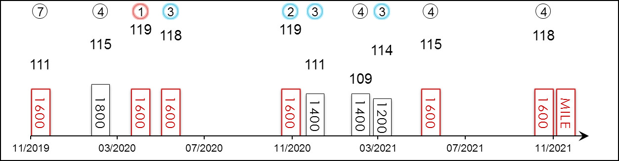 | HK Starts : 1 (0-0-0-0-1) Right-handed : 15 (5-2-2-5-1) Jockey : 16 (5-2-4-5-0)  Pre Import : - Sha Tin-Turf : 1 (0-0-0-0-1) GF+ : 18 (7-2-3-6-0)  Lifetime : 22 (8-2-5-6-1) Non-Turf : - Good : 3 (1-0-1-0-1)  2021 : 4 (0-0-1-3-0) Distance : 15 (7-2-1-4-1) Yielding : 1 (0-0-1-0-0)  G1 : 8 (2-1-2-2-1) Course & Dist : 1 (0-0-0-0-1) Soft/Hvy : -  First Up : 11 (2-2-2-5-0) 1400-1800 : 21 (8-2-4-6-1) HK$ : 44,018,760  G1 win : 2019 Mile Championship 1600m, 2019 Yasuda Kinen 1600m

Pos | Index | Date | Perf  Rating | Race Category & Name |  | Track | Dist/Course/Going |  | Wt | Jockey | Draw | Race Sectional Time |  |  |  | Race  Time | Horse  Final | Position & Margin in Running |  |  |  |  |  | Finish |  | Odds | Winner/Second
7/10 | **233 | 8/12/19 | 111 | G1 | LONGINES Hong Kong Mile | ST, HK | 1600 RH | G | 126 | D Lane | 3 |  | 22.⁸⁷ | 22.⁷⁹ | 22.⁴⁶ | 1.33.²⁵ | 22.⁵¹ | 7 | 3 | 7 | 3.3 | 9 | 3 | 7 | 3.3 | 2.9 | Admire Mars
4/9 | - | 1/3/20 | 115 | G2 | Nakayama Kinen | NAK, JPN | 1800 RH | F | 128 | Y Fukunaga | 1 |  | 23.³⁰ | 23.⁶⁰ | 23.⁴⁰ | 1.46.³⁰ | 34.¹⁰ | 5 | - | 5 | - | 6 | - | 4 | 2.5 | 5.4 | Danon Kingly
1/11 | - | 26/4/20 | 119 | G2 | Yomiuri Milers Cup | KYO, JPN | 1600 RH | F | 128 | Y Fukunaga | 1 |  | 23.⁶⁰ | 22.⁷⁰ | 22.⁵⁰ | 1.32.⁴⁰ | 33.⁰⁰ | - |  | 4 | - | 3 | - | 1 | 2 | 1.6F | Besten Dank
3/14 | - | 7/6/20 | 118 | G1 | Yasuda Kinen | TOK, JPN | 1600 LH | G | 128 | Y Fukunaga | 6 |  | 22.⁷⁰ | 23.⁰⁰ | 22.⁹⁰ | 1.31.⁶⁰ | 34.¹⁰ | - |  | 9 | - | 7 | - | 3 | 3 | 7 | Gran Alegria
2/17 | - | 22/11/20 | 119 | G1 | Mile Championship | HSN, JPN | 1600 RH | F | 126 | Y Fukunaga | 8 |  | 23.⁴⁰ | 22.⁶⁰ | 22.⁵⁰ | 1.32.⁰⁰ | 33.²⁰ | - |  | 7 | - | 5 | - | 2 | 0.8 | 8.8 | Gran Alegria
3/16 | - | 26/12/20 | 111 | G2 | Hanshin Cup | HSN, JPN | 1400 RH | F | 126 | Y Fukunaga | 12 |  | 21.⁹⁰ | 22.⁷⁰ | 23.⁰⁰ | 1.19.⁷⁰ | 34.⁰⁰ | - |  | 11 | - | 11 | - | 3 | 2 | 1.5F | Danon Fantasy
4/17 | - | 28/2/21 | 109 | G3 | Hankyu Hai | HSN, JPN | 1400 RH | GF | 126 | Y Fukunaga | 10 |  | 21.⁸⁰ | 22.⁶⁰ | 22.⁶⁰ | 1.19.²⁰ | 33.⁸⁰ | - |  | 9 | - | 7 | - | 4 | 2.5 | 3.5 | Resistencia
3/18 | - | 28/3/21 | 114 | G1 | Takamatsunomiya Kinen | CYO, JPN | 1200 LH | Y | 126 | Y Fukunaga | 9 |  | 22.⁹⁰ | 22.⁷⁰ | 23.⁶⁰ | 1.09.²⁰ | 34.⁵⁰ | - |  | 11 | - | 9 | - | 3 | 0.5 | 6.3 | Danon Smash
4/14 | - | 6/6/21 | 115 | G1 | Yasuda Kinen | TOK, JPN | 1600 LH | GF | 128 | Y Fukunaga | 8 |  | 23.¹⁰ | 22.⁶⁰ | 22.⁷⁰ | 1.31.⁷⁰ | 33.⁵⁰ | - |  | 5 | - | 5 | - | 4 | 0.8 | 7 | Danon Kingly
4/16 | - | 21/11/21 | 118 | G1 | Mile Championship | HSN, JPN | 1600 RH | GF | 126 | Y Fukunaga | 7 |  | 23.⁹⁰ | 22.⁸⁰ | 22.²⁰ | 1.32.⁶⁰ | 33.²⁰ | - |  | 5 | - | 5 | - | 4 | 1.3 | 16.7 | Gran Alegria
 |  | 12/12/21 |  | G1 | LONGINES Hong Kong Mile | ST, HK | 1600 RH |  | 126 | Y Fukunaga
Returns for his second crack at Hong Kong glory following a luckless seventh in the 2019 edition of this race; boasts a win in the 2019 G1 Mile Championship (1600m) among his haul. Consistent over a mile. Stepped back to 1200m for the first time when solid 3rd in the G1 Takamatsunomiya Kinen three starts back. Weakened in the final stages for 4th finish in the G1 Yasuda Kinen (1600m) on his penultimate start. Finished fourth in the G1 Mile Championship (1600m) latest. Can sit handy but recently raced from deep. No track worries.

 |  |  | 夏威夷 C150  WAIKUKU (IRE) 6 b g  Harbour Watch (IRE) - London Plane (IRE) (Danehill Dancer (IRE))  Owner(s): Jocelyn Siu Yang Hin Ting |  | 蔡約翰 (香港)  J Size (HK)  Win 9.7% Place 25.8% | 潘頓  Z Purton  Win 23.1% Place 52.7% | 126 lb  (118)

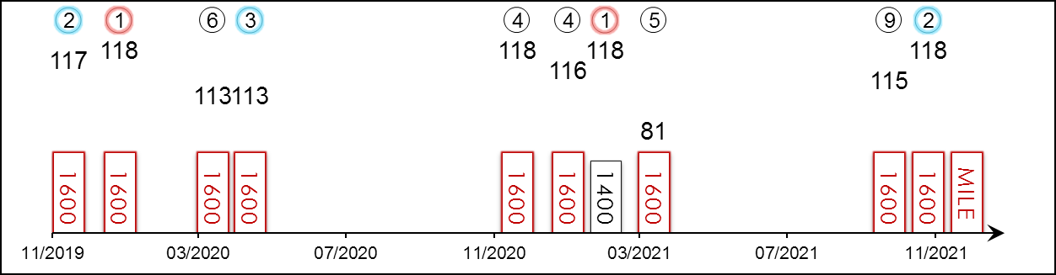 | HK Career : 21 (7-5-2-2-5) Right-handed : 21 (7-5-2-2-5) Jockey : 2 (0-1-0-0-1)  Pre Import : 2 (1-0-0-0-1) Sha Tin-Turf : 21 (7-5-2-2-5) GF+ : 6 (3-1-1-0-1)  Lifetime : 23 (8-5-2-2-6) Non-Turf : - Good : 15 (5-3-1-2-4)  2021/22 : 2 (0-1-0-0-1) Distance : 11 (2-3-1-2-3) Yielding : 1 (0-1-0-0-0)  G1 : 7 (2-1-1-2-1) Course & Dist : 11 (2-3-1-2-3) Soft/Hvy : 1 (0-0-0-0-1)  First Up : 7 (1-1-1-1-3) 1400-1800 : 19 (8-3-2-2-4) HK$ : 37,046,180  G1 win : 2021 Queen's Silver Jubilee Cup 1400m, 2020 Stewards' Cup 1600m

Pos | Index | Date | Perf  Rating | Race Category & Name |  | Track | Dist/Course/Going |  | Wt | Jockey | Draw | Race Sectional Time |  |  |  | Race  Time | Horse  Final | Position & Margin in Running |  |  |  |  |  | Finish |  | Odds | Winner/Second
2/10 | **233 | 8/12/19 | 117 | G1 | LONGINES Hong Kong Mile | ST, HK | 1600 RH | G | 126 | J Moreira | 10 |  | 22.⁸⁷ | 22.⁷⁹ | 22.⁴⁶ | 1.33.²⁵ | 22.⁰⁹ | 9 | 4¼ | 9 | 4¾ | 8 | 2¾ | 2 | 1/2 | 3.9 | Admire Mars
1/7 | **346 | 19/1/20 | 118 | G1 | Stewards' Cup | ST, HK | 1600 RH | G | 126 | J Moreira | 7 |  | 22.⁶⁵ | 23.¹² | 22.⁷⁸ | 1.33.⁰⁴ | 22.³⁸ | 7 | 4¾ | 7 | 5 | 6 | 2½ | 1 | N | 1.5F | Beauty Generation
6/7 | **547 | 5/4/20 | 113 | G2 | Chairman's Trophy | ST, HK | 1600 RH | G | 128 | J Moreira | 1 |  | 23.⁰⁰ | 22.⁶⁸ | 22.⁷⁴ | 1.33.⁴⁹ | 23.⁰² | 4 | 1½ | 3 | 2½ | 4 | 3 | 6 | 4¾ | 1.7F | Beauty Generation
3/8 | **608 | 26/4/20 | 113 | G1 | FWD Champions Mile | ST, HK | 1600 RH | G | 126 | J Moreira | 8 |  | 23.¹⁴ | 23.³² | 22.¹¹ | 1.33.¹³ | 22.¹⁴ | 8 | 6 | 6 | 4 | 6 | 2½ | 3 | 2¾ | 4.7 | Southern Legend
4/10 | *264 | 13/12/20 | 118 | G1 | LONGINES Hong Kong Mile | ST, HK | 1600 RH | G | 126 | J Moreira | 5 |  | 22.⁷⁶ | 23.¹⁰ | 22.⁴¹ | 1.33.⁴⁵ | 22.⁵⁶ | 5 | 4½ | 5 | 3¼ | 5 | 1½ | 4 | 2½ | 16 | Golden Sixty
4/8 | *370 | 24/1/21 | 116 | G1 | Stewards' Cup | ST, HK | 1600 RH | G | 126 | J Moreira | 8 |  | 23.²¹ | 22.⁵⁴ | 22.²⁰ | 1.33.³⁵ | 21.⁹⁵ | 6 | 4¼ | 7 | 4½ | 7 | 3 | 4 | 1½ | 11 | Golden Sixty
1/9 | *443 | 21/2/21 | 118 | G1 | Queen's Silver Jubilee Cup | ST, HK | 1400 RH | G | 126 | J Moreira | 6 |  | 22.⁰⁰ | 22.⁹⁰ | 22.²⁰ | 1.20.⁷⁸ | 21.⁸⁴ | 4 | 2½ | 5 | 4¼ | 4 | 2¼ | 1 | 1¼ | 2.1F | Southern Legend
5/5 | *557 | 5/4/21 | 81 | G2 | Chairman's Trophy | ST, HK | 1600 RH | G | 128 | J Moreira | 3 |  | 23.⁸² | 22.⁹³ | 22.⁴⁶ | 1.35.⁰⁶ | 24.⁹¹ | 3 | 2¼ | 4 | 2½ | 4 | 3¼ | 5 | 18½ | 1.6F | Mighty Giant
9/12 | 101 | 17/10/21 | 115 | G2 | Oriental Watch Sha Tin Trophy - hcp | ST, HK | 1600 RH | G | 131 | Z Purton | 5 |  | 23.⁴¹ | 23.⁰⁰ | 22.⁷⁷ | 1.34.⁴⁰ | 22.⁸⁰ | 3 | 1 | 4 | 1¼ | 6 | 1¾ | 9 | 2 | 9.9 | Panfield
2/7 | 193 | 21/11/21 | 118 | G2 | BOCHK Private Wealth JC Mile | ST, HK | 1600 RH | G | 128 | Z Purton | 4 |  | 24.¹⁶ | 22.¹⁷ | 22.⁰³ | 1.34.⁵⁵ | 22.⁰² | 2 | 1 | 2 | 1¼ | 2 | 1 | 2 | 1 | 15 | Golden Sixty
 |  | 12/12/21 |  | G1 | LONGINES Hong Kong Mile | ST, HK | 1600 RH |  | 126 | Z Purton
Seven-time winner from 21 starts in Hong Kong, including four consecutive victories through his debut Hong Kong season. Finished runner-up in the 2019 BMW Hong Kong Derby (2000m); since then has become a two-time G1 winner, scoring over 1400m and the mile at the top-level in Hong Kong. Below par when finished 9th in the G2 Oriental Watch 60th Anniversary Sha Tin Trophy Handicap (1600m) in October this year, followed by running 2nd in the G2 BOCHK Private Wealth Jockey Club Mile (1600m) latest. No ground concerns, versatile in the run.

 |  |  | 幸福笑容 C199  MORE THAN THIS (GB) 5 b g  Dutch Art (GB) - Striving (IRE) (Danehill Dancer (IRE))  Owner(s): Huang Kai Wen |  | 沈集成 (香港)  C S Shum (HK)  Win 11.7% Place 37.5% | 梁家俊  K C Leung  Win 7.2% Place 17.0% | 126 lb  (117)

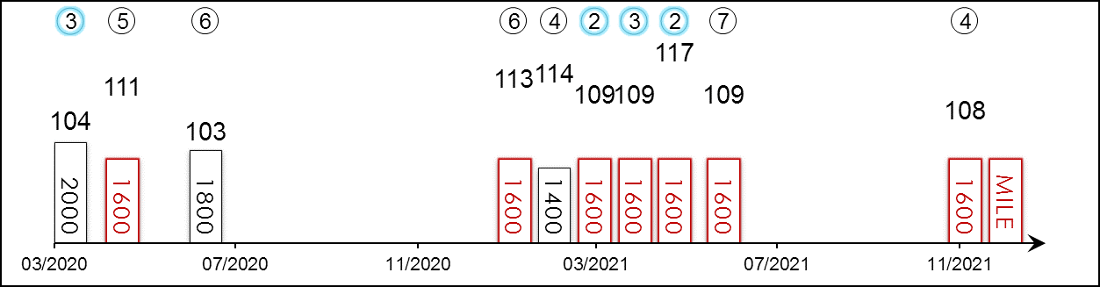 | HK Career : 19 (4-3-3-2-7) Right-handed : 20 (5-3-3-2-7) Jockey : 3 (0-0-1-1-1)  Pre Import : 3 (3-0-0-0-0) Sha Tin-Turf : 19 (4-3-3-2-7) GF+ : 10 (5-0-1-0-4)  Lifetime : 22 (7-3-3-2-7) Non-Turf : - Good : 12 (2-3-2-2-3)  2021/22 : 1 (0-0-0-1-0) Distance : 13 (3-3-1-1-5) Yielding : -  G1 : 4 (0-1-0-1-2) Course & Dist : 13 (3-3-1-1-5) Soft/Hvy : -  First Up : 5 (2-0-0-1-2) 1400-1800 : 20 (6-3-2-2-7) HK$ : 18,088,520  G1 win : Nil

Pos | Index | Date | Perf  Rating | Race Category & Name |  | Track | Dist/Course/Going |  | Wt | Jockey | Draw | Race Sectional Time |  |  |  | Race  Time | Horse  Final | Position & Margin in Running |  |  |  |  |  | Finish |  | Odds | Winner/Second
3/14 | **516 | 22/3/20 | 104 | - | BMW Hong Kong Derby | ST, HK | 2000 RH | GF | 126 | Z Purton | 1 |  | 25.²³ | 23.³¹ | 22.⁶³ | 2.00.¹⁵ | 22.⁵⁷ | 5 | 3¼ | 5 | 2¾ | 3 | 3¼ | 3 | 3 | 3.3 | Golden Sixty
5/8 | **608 | 26/4/20 | 111 | G1 | FWD Champions Mile | ST, HK | 1600 RH | G | 126 | K Teetan | 7 |  | 23.¹⁴ | 23.³² | 22.¹¹ | 1.33.¹³ | 21.⁹⁴ | 7 | 5¼ | 8 | 6½ | 8 | 4½ | 5 | 3½ | 6.2 | Southern Legend
6/8 | **756 | 21/6/20 | 103 | G3 | Premier Plate - hcp | ST, HK | 1800 RH | GF | 120 | Z Purton | 7 |  | 23.⁶⁷ | 23.¹⁴ | 22.¹⁰ | 1.45.⁸⁴ | 23.¹⁸ | 1 | 1/2 | 1 | 1½ | 1 | SH | 6 | 6¾ | 2.9F | Dances With Dragon
6/8 | *370 | 24/1/21 | 113 | G1 | Stewards' Cup | ST, HK | 1600 RH | G | 126 | K C Leung | 4 |  | 23.²¹ | 22.⁵⁴ | 22.²⁰ | 1.33.³⁵ | 22.³⁶ | 5 | 2¾ | 4 | 2¼ | 4 | 1¾ | 6 | 2¾ | 31 | Golden Sixty
4/9 | *443 | 21/2/21 | 114 | G1 | Queen's Silver Jubilee Cup | ST, HK | 1400 RH | G | 126 | K C Leung | 5 |  | 22.⁰⁰ | 22.⁹⁰ | 22.²⁰ | 1.20.⁷⁸ | 21.⁷³ | 8 | 4¾ | 8 | 7¼ | 8 | 4¾ | 4 | 1¾ | 13 | Waikuku
2/7 | *499 | 13/3/21 | 109 | - | Cl.1 hcp | ST, HK | 1600 RH | G | 126 | A Badel | 1 |  | 23.⁴⁵ | 23.⁰³ | 22.³⁶ | 1.33.⁶³ | 21.⁹⁸ | 7 | 6½ | 7 | 6¾ | 7 | 2¾ | 2 | N | 2.3F | Ka Ying Star
3/5 | *557 | 5/4/21 | 109 | G2 | Chairman's Trophy | ST, HK | 1600 RH | G | 123 | K C Leung | 5 |  | 23.⁸² | 22.⁹³ | 22.⁴⁶ | 1.35.⁰⁶ | 22.¹² | 5 | 3¾ | 5 | 3½ | 5 | 4½ | 3 | 2¼ | 5.8 | Mighty Giant
2/6 | *619 | 25/4/21 | 117 | G1 | FWD Champions Mile | ST, HK | 1600 RH | G | 126 | J Moreira | 3 |  | 23.⁰⁷ | 23.²⁴ | 22.⁵² | 1.33.⁴⁵ | 22.²⁴ | 6 | 4 | 5 | 2¾ | 6 | 2 | 2 | HD | 9.1 | Golden Sixty
7/7 | *711 | 30/5/21 | 109 | G3 | Lion Rock Trophy - hcp | ST, HK | 1600 RH | GF | 130 | K Teetan | 6 |  | 23.⁴⁰ | 22.⁹⁰ | 22.⁰⁰ | 1.33.⁴⁵ | 22.⁶⁵ | 6 | 5¼ | 6 | 4½ | 7 | 2½ | 7 | 6½ | 2.9 | Sky Darci
4/7 | 193 | 21/11/21 | 108 | G2 | BOCHK Private Wealth JC Mile | ST, HK | 1600 RH | G | 123 | M F Poon | 3 |  | 24.¹⁶ | 22.¹⁷ | 22.⁰³ | 1.34.⁵⁵ | 22.⁰⁴ | 5 | 3¾ | 5 | 4 | 7 | 3½ | 4 | 3½ | 22 | Golden Sixty
 |  | 12/12/21 |  | G1 | LONGINES Hong Kong Mile | ST, HK | 1600 RH |  | 126 | K C Leung
Three wins from three starts as a two-year-old in the UK. Won four races in a row in Hong Kong from July 2019 to December 2019. Pushed Golden Sixty to within a head in the 2021 FWD Champions Mile (1600m) at Sha Tin earlier this year; placed in each of the three legs of 2020 Four-Year-Old Classic Series, returned first-up this term to finish 4th in the G2 BOCHK Private Wealth Jockey Club Mile (1600m). Hold up runner but can also sit handily. Won on good and good to firm ground.

 |  |  | 戰舞者  SALIOS (JPN) 4 ch c  Heart's Cry (JPN) - Salomina (GER) (Lomitas (GB))  Owner(s): Silk Racing Co Ltd |  | 堀宣行 (日本)  N Hori (JPN) | 連達文  D Lane | 126 lb  (115)

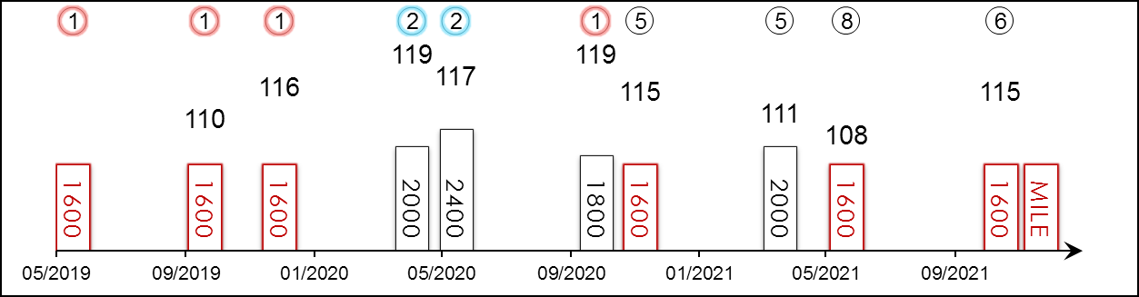 | HK Starts : - Right-handed : 5 (1-1-0-0-3) Jockey : 3 (1-2-0-0-0)  Pre Import : - Sha Tin-Turf : - GF+ : 7 (3-1-0-0-3)  Lifetime : 10 (4-2-0-0-4) Non-Turf : - Good : 2 (1-1-0-0-0)  2021 : 3 (0-0-0-0-3) Distance : 6 (3-0-0-0-3) Yielding : 1 (0-0-0-0-1)  G1 : 7 (1-2-0-0-4) Course & Dist : - Soft/Hvy : -  First Up : 8 (4-1-0-0-3) 1400-1800 : 7 (4-0-0-0-3) HK$ : 25,174,560  G1 win : 2019 Asahi Hai Futurity S. 1600m

Pos | Index | Date | Perf  Rating | Race Category & Name |  | Track | Dist/Course/Going |  | Wt | Jockey | Draw | Race Sectional Time |  |  |  | Race  Time | Horse  Final | Position & Margin in Running |  |  |  |  |  | Finish |  | Odds | Winner/Second
1/8 | - | 2/6/19 | - | - | 2yo Newcomer | TOK, JPN | 1600 LH | F | 119 | D Lane | 7 |  | 25.⁷⁰ | 23.⁹⁰ | 22.²⁰ | 1.37.¹⁰ | 33.¹⁰ | - |  | 5 | - | 5 | - | 1 | 2 | 3.2 | Absolutismo
1/9 | - | 5/10/19 | 110 | G3 | Saudi Arabia Royal Cup - 2yo | TOK, JPN | 1600 LH | F | 121 | S Ishibashi | 3 |  | 24.¹⁰ | 23.²⁰ | 22.³⁰ | 1.32.⁷⁰ | 33.¹⁰ | - |  | 3 | - | 3 | - | 1 | 1.3 | 1.5F | Cravache d'Or
1/16 | - | 15/12/19 | 116 | G1 | Asahi Hai Futurity S. - 2yo | HSN, JPN | 1600 RH | F | 121 | R Moore | 6 |  | 22.⁷⁰ | 23.⁶⁰ | 24.⁰⁰ | 1.33.⁰⁰ | 35.⁴⁰ | - |  | 3 | - | 3 | - | 1 | 2.5 | 2.0F | Taisei Vision
2/18 | - | 19/4/20 | 119 | G1 | Satsuki Sho (Japanese 2000 Guineas) - 3yo | NAK, JPN | 2000 RH | G | 126 | D Lane | 7 |  | 25.³⁰ | 24.¹⁰ | 23.⁹⁰ | 2.00.⁷⁰ | 35.⁴⁰ | 5 | - | 6 | - | 4 | - | 2 | 0.5 | 3.8 | Contrail
2/18 | - | 31/5/20 | 117 | G1 | Tokyo Yushun (Japanese Derby) - 3yo | TOK, JPN | 2400 LH | F | 126 | D Lane | 12 |  | 24.⁵⁰ | 23.¹⁰ | 23.⁰⁰ | 2.24.¹⁰ | 34.¹⁰ | 10 | - | 10 | - | 11 | - | 2 | 3 | 4.4 | Contrail
1/11 | - | 11/10/20 | 119 | G2 | Mainichi Okan | TOK, JPN | 1800 LH | G | 119 | C Lemaire | 9 |  | 23.⁵⁰ | 23.⁹⁰ | 23.⁶⁰ | 1.45.⁵⁰ | 34.¹⁰ | 4 | - | 4 | - | 4 | - | 1 | 3 | 1.3F | Daiwa Cagney
5/17 | - | 22/11/20 | 115 | G1 | Mile Championship | HSN, JPN | 1600 RH | F | 123 | M Demuro | 17 |  | 23.⁴⁰ | 22.⁶⁰ | 22.⁵⁰ | 1.32.⁰⁰ | 33.¹⁰ | - |  | 13 | - | 13 | - | 5 | 2.3 | 4.1 | Gran Alegria
5/13 | - | 4/4/21 | 111 | G1 | Osaka Hai | HSN, JPN | 2000 RH | Y | 126 | K Matsuyama | 2 |  | 24.⁹⁰ | 24.³⁰ | 24.⁷⁰ | 2.01.⁶⁰ | 37.⁷⁰ | 3 | - | 2 | - | 2 | - | 5 | 6.3 | 5.8 | Lei Papale
8/14 | - | 6/6/21 | 108 | G1 | Yasuda Kinen | TOK, JPN | 1600 LH | GF | 128 | K Matsuyama | 1 |  | 23.¹⁰ | 22.⁶⁰ | 22.⁷⁰ | 1.31.⁷⁰ | 33.⁷⁰ | - |  | 9 | - | 8 | - | 8 | 3.8 | 7.9 | Danon Kingly
6/16 | - | 21/11/21 | 115 | G1 | Mile Championship | HSN, JPN | 1600 RH | GF | 126 | K Matsuyama | 4 |  | 23.⁹⁰ | 22.⁸⁰ | 22.²⁰ | 1.32.⁶⁰ | 33.⁷⁰ | - |  | 3 | - | 2 | - | 6 | 2.8 | 9.5 | Gran Alegria
 |  | 12/12/21 |  | G1 | LONGINES Hong Kong Mile | ST, HK | 1600 RH |  | 126 | D Lane
Highly talented 4YO colt. Bridesmaid as three-year-old with two seconds to Contrail at G1 level, including the Japanese Derby (2400m); since then is a G2 winner at Tokyo over 1800m in the Mainichi Okan; last two starts – eighth in the G1 Yasuda Kinen (1600m) and finished sixth in the G1 Mile Championship (1600m) latest. Races close to speed but can race from behind. Won on firm and good ground.

 |  |  | 陳年美酒  VIN DE GARDE (JPN) 5 b h  Deep Impact (JPN) - Skia (FR) (Motivator (GB))  Owner(s): Shadai Race Horse Co Ltd |  | 藤原英昭 (日本)  H Fujiwara (JPN) |  | 126 lb  (113)

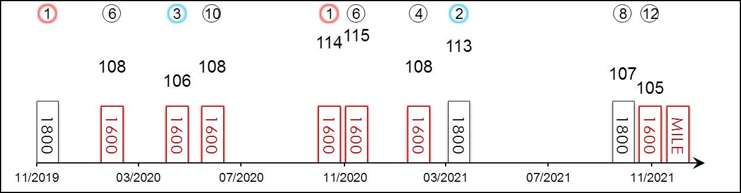 | HK Starts : - Right-handed : 9 (3-0-2-1-3) Jockey : -  Pre Import : - Sha Tin-Turf : - GF+ : 13 (2-0-3-2-6)  Lifetime : 18 (5-1-3-2-7) Non-Turf : - Good : 3 (1-1-0-0-1)  2021 : 4 (0-1-0-1-2) Distance : 11 (4-0-1-1-5) Yielding : 2 (2-0-0-0-0)  G1 : 5 (0-1-0-0-4) Course & Dist : - Soft/Hvy : -  First Up : 7 (3-0-1-1-2) 1400-1800 : 17 (5-1-3-2-6) HK$ : 17,378,920  G1 win : Nil

Pos | Index | Date | Perf  Rating | Race Category & Name |  | Track | Dist/Course/Going |  | Wt | Jockey | Draw | Race Sectional Time |  |  |  | Race  Time | Horse  Final | Position & Margin in Running |  |  |  |  |  | Finish |  | Odds | Winner/Second
1/15 | - | 24/11/19 | - | - | 3 Wins | TOK, JPN | 1800 LH | Y | 121 | M Iwata | 8 |  | 24.⁰⁰ | 24.⁶⁰ | 24.¹⁰ | 1.48.³⁰ | 35.⁷⁰ | 5 | - | 5 | - | 4 | - | 1 | 0.5 | 4.8F | Premio Tailor
6/16 | - | 9/2/20 | 108 | G3 | Tokyo Shimbun Hai | TOK, JPN | 1600 LH | F | 123 | Y Fukunaga | 2 |  | 23.⁰⁰ | 23.³⁰ | 23.⁴⁰ | 1.33.⁰⁰ | 33.⁶⁰ | - |  | 8 | - | 8 | - | 6 | 1.3 | 3.8 | Primo Scene
3/11 | - | 26/4/20 | 106 | G2 | Yomiuri Milers Cup | KYO, JPN | 1600 RH | F | 123 | M Iwata | 7 |  | 23.⁶⁰ | 22.⁷⁰ | 22.⁵⁰ | 1.32.⁴⁰ | 32.⁷⁰ | - |  | 10 | - | 10 | - | 3 | 3.5 | 3.9 | Indy Champ
10/14 | - | 7/6/20 | 108 | G1 | Yasuda Kinen | TOK, JPN | 1600 LH | G | 128 | M Iwata | 13 |  | 22.⁷⁰ | 23.⁰⁰ | 22.⁹⁰ | 1.31.⁶⁰ | 34.⁸⁰ | - |  | 6 | - | 7 | - | 10 | 7.5 | 110 | Gran Alegria
1/12 | - | 24/10/20 | 114 | G2 | Fuji S. | TOK, JPN | 1600 LH | F | 123 | Y Fukunaga | 5 |  | 22.⁴⁰ | 23.⁵⁰ | 24.⁵⁰ | 1.33.⁴⁰ | 34.⁶⁰ | - |  | 6 | - | 8 | - | 1 | 1.3 | 6.2 | Lauda Sion
6/17 | - | 22/11/20 | 115 | G1 | Mile Championship | HSN, JPN | 1600 RH | F | 126 | K Tosaki | 16 |  | 23.⁴⁰ | 22.⁶⁰ | 22.⁵⁰ | 1.32.⁰⁰ | 33.³⁰ | - |  | 11 | - | 11 | - | 6 | 2.8 | 68.6 | Gran Alegria
4/16 | - | 7/2/21 | 108 | G3 | Tokyo Shimbun Hai | TOK, JPN | 1600 LH | GF | 126 | Y Fukunaga | 13 |  | 23.¹⁰ | 22.⁷⁰ | 23.¹⁰ | 1.32.⁴⁰ | 34.²⁰ | - |  | 6 | - | 6 | - | 4 | 1.8 | 2.7F | Karate
2/12 | - | 27/3/21 | 113 | G1 | Dubai Turf | MEY, UAE | 1800 LH | G | 126 | M Barzalona | 5 |  | - | - | - | 1.46.⁴⁶ | - | - |  | - |  | - |  | 2 | 3 | 16/1 | Lord North
8/13 | - | 10/10/21 | 107 | G2 | Mainichi Okan | TOK, JPN | 1800 LH | GF | 126 | Y Fukunaga | 12 |  | 23.⁷⁰ | 23.⁰⁰ | 23.³⁰ | 1.44.⁸⁰ | 34.¹⁰ | 6 | - | 6 | - | 7 | - | 8 | 4.3 | 7.8 | Schnell Meister
12/13 | - | 6/11/21 | 105 | G1 | Breeders' Cup Mile | DMR, USA | 1600 LH | F | 126 | Y Fukunaga | 4 |  | 23.⁸⁷ | 23.⁶⁴ | 22.⁹⁹ | 1.34.⁰¹ | - | 10 | 8 | 11 | 9.5 | 12 | 10.5 | 12 | 5.8 | 39.6 | Space Blues
 |  | 12/12/21 |  | G1 | LONGINES Hong Kong Mile | ST, HK | 1600 RH |  | 126
Scoring a hat-trick of wins in his three-year-old campaign in 2019, but finished below par in the G1 Yasuda Kinen (1600m) last year. Showed excellent acceleration in the stretch to claim the G2 Fuji Stakes (1600m) at Tokyo in October 2020. G1-placed behind Lord North in the 2021 Dubai Turf (1800m) at Meydan, while last out finished 12th at Del Mar in the G1 Breeders’ Cup Mile (1600m). Races held-up. No ground issues.

 |  |  | 達心星 D088  SKY DARCI (NZ) 5 b g  Darci Brahma (NZ) - Strictly Maternal (NZ) (O'Reilly (NZ))  Owner(s): Jessica Kwan Mun Hang |  | 方嘉柏 (香港)  C Fownes (HK)  Win 4.5% Place 23.4% | 莫雷拉  J Moreira  Win 17.6% Place 40.1% | 126 lb  (112)

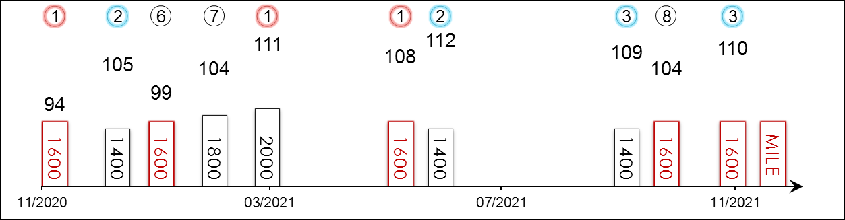 | HK Career : 17 (7-4-2-0-4) Right-handed : 17 (7-4-2-0-4) Jockey : 14 (6-3-2-0-3)  Pre Import : - Sha Tin-Turf : 13 (4-3-2-0-4) GF+ : 5 (2-2-1-0-0)  Lifetime : 17 (7-4-2-0-4) Non-Turf : - Good : 12 (5-2-1-0-4)  2021/22 : 3 (0-0-2-0-1) Distance : 5 (2-0-1-0-2) Yielding : -  G1 : - Course & Dist : 5 (2-0-1-0-2) Soft/Hvy : -  First Up : 5 (2-1-1-0-1) 1400-1800 : 10 (3-2-2-0-3) HK$ : 24,774,715  G1 win : Nil

Pos | Index | Date | Perf  Rating | Race Category & Name |  | Track | Dist/Course/Going |  | Wt | Jockey | Draw | Race Sectional Time |  |  |  | Race  Time | Horse  Final | Position & Margin in Running |  |  |  |  |  | Finish |  | Odds | Winner/Second
1/13 | *227 | 29/11/20 | 94 | - | Chevalier Cup - hcp | ST, HK | 1600 RH | G | 116 | J Moreira | 4 |  | 23.⁵⁷ | 23.⁰⁷ | 22.⁸⁴ | 1.34.¹⁰ | 22.⁶⁴ | 4 | 3½ | 4 | 3 | 4 | 1¼ | 1 | N | 2.5F | Lucky Express
2/8 | *313 | 1/1/21 | 105 | G3 | Chinese Club Challenge Cup - hcp | ST, HK | 1400 RH | G | 115 | J Moreira | 1 |  | 21.⁷⁸ | 23.⁰⁷ | 22.⁷¹ | 1.20.⁹⁹ | 22.⁴⁶ | 8 | 5½ | 7 | 4¾ | 6 | 2¾ | 2 | 1¼ | 3.1 | Champion's Way
6/13 | *371 | 24/1/21 | 99 | - | Hong Kong Classic Mile | ST, HK | 1600 RH | G | 126 | J Moreira | 7 |  | 22.²³ | 23.⁶⁵ | 23.⁹¹ | 1.33.⁸¹ | 24.¹² | 7 | 2½ | 6 | 4¼ | 5 | 2¼ | 6 | 3½ | 3.3F | Excellent Proposal
7/14 | *449 | 21/2/21 | 104 | - | Hong Kong Classic Cup | ST, HK | 1800 RH | G | 126 | J Moreira | 4 |  | 24.⁴⁶ | 24.⁰⁴ | 22.⁷⁷ | 1.47.²¹ | 22.⁷⁰ | 9 | 7½ | 9 | 7½ | 8 | 2¾ | 7 | 2¼ | 8.5 | Healthy Happy
1/14 | *524 | 21/3/21 | 111 | - | BMW Hong Kong Derby | ST, HK | 2000 RH | G | 126 | J Moreira | 2 |  | 25.³² | 23.⁷⁶ | 23.⁶¹ | 2.01.³² | 23.⁴⁹ | 6 | 10½ | 5 | 3½ | 3 | 3/4 | 1 | HD | 6.5 | Russian Emperor
1/7 | *711 | 30/5/21 | 108 | G3 | Lion Rock Trophy - hcp | ST, HK | 1600 RH | GF | 115 | J Moreira | 3 |  | 23.⁴⁰ | 22.⁹⁰ | 22.⁰⁰ | 1.33.⁴⁵ | 21.⁸⁴ | 4 | 3¾ | 4 | 3¼ | 3 | 1 | 1 | SH | 2.5F | Healthy Happy
2/11 | *764 | 20/6/21 | 112 | G3 | Premier Cup - hcp | ST, HK | 1400 RH | GF | 126 | J Moreira | 2 |  | 22.¹² | 22.⁶⁷ | 22.³⁶ | 1.20.⁵⁵ | 22.¹⁵ | 11 | 4½ | 10 | 5 | 7 | 3 | 2 | 1¾ | 3F | Sky Field
3/9 | 61 | 26/9/21 | 109 | G3 | Celebration Cup - hcp | ST, HK | 1400 RH | GF | 120 | J Moreira | 3 |  | 21.³⁶ | 22.⁵⁰ | 23.³¹ | 1.20.⁴⁸ | 22.⁹¹ | 7 | 3 | 7 | 4¼ | 6 | 4 | 3 | 1½ | 1.9F | Buddies
8/12 | 101 | 17/10/21 | 104 | G2 | Oriental Watch Sha Tin Trophy - hcp | ST, HK | 1600 RH | G | 120 | J Moreira | 11 |  | 23.⁴¹ | 23.⁰⁰ | 22.⁷⁷ | 1.34.⁴⁰ | 22.⁴⁸ | 11 | 4½ | 12 | 5¾ | 11 | 3½ | 8 | 1¾ | 2.7F | Panfield
3/7 | 193 | 21/11/21 | 110 | G2 | BOCHK Private Wealth JC Mile | ST, HK | 1600 RH | G | 123 | J Moreira | 5 |  | 24.¹⁶ | 22.¹⁷ | 22.⁰³ | 1.34.⁵⁵ | 22.²³ | 4 | 2¾ | 4 | 3 | 3 | 1¼ | 3 | 2½ | 10 | Golden Sixty
 |  | 12/12/21 |  | G1 | LONGINES Hong Kong Mile | ST, HK | 1600 RH |  | 126 | J Moreira
Champion Four-Year-Old in 2020/21. 2021 BMW Hong Kong Derby (2000m) hero who is a prolific winner with seven wins from 17 starts on his record, ranging from 1200m to 2000m; incredibly versatile winner of the G3 Lion Rock Trophy Handicap (1600m) last season also. Good efforts when 3rd behind Buddies in his seasonal return in the G3 Celebration Cup Handicap (1400m) three starts back. Finished 3rd in the G2 BOCHK Private Wealth Jockey Club Mile (1600m) latest. Versatile, won on good and good to firm ground.

 |  |  | 健康愉快 D435  HEALTHY HAPPY (AUS) ex Leviathan 5 b/br g  Zoustar (AUS) - Lady Lakshmi (AUS) (Lonhro (AUS))  Owner(s): Sin Tung Hing, Sin Yuk Lok & Sin Yuk San |  | 羅富全 (香港)  F C Lor (HK)  Win 16.6% Place 41.4% | 巴度  A Badel  Win 12.0% Place 29.1% | 126 lb  (110)

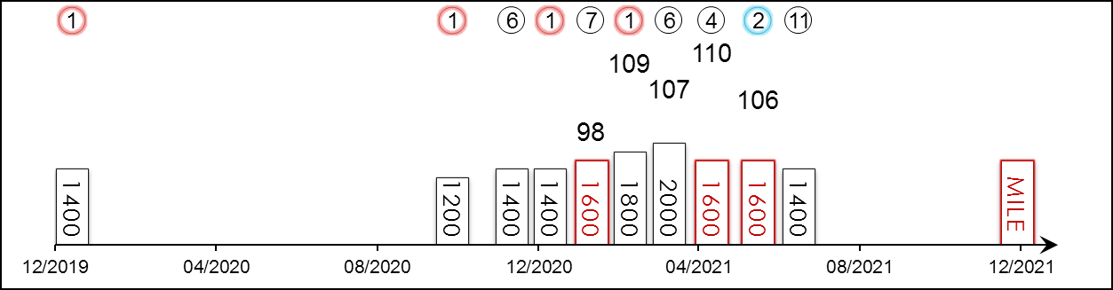 | HK Career : 9 (3-1-0-1-4) Right-handed : 14 (5-3-1-1-4) Jockey : 5 (1-1-0-1-2)  Pre Import : 5 (2-2-1-0-0) Sha Tin-Turf : 9 (3-1-0-1-4) GF+ : 2 (0-1-0-0-1)  Lifetime : 14 (5-3-1-1-4) Non-Turf : - Good : 10 (4-1-1-1-3)  2021/22 : - Distance : 3 (0-1-0-1-1) Yielding : -  G1 : 1 (0-0-0-1-0) Course & Dist : 3 (0-1-0-1-1) Soft/Hvy : 2 (1-1-0-0-0)  First Up : 3 (2-1-0-0-0) 1400-1800 : 8 (3-1-0-1-3) HK$ : 13,639,270  G1 win : Nil

Pos | Index | Date | Perf  Rating | Race Category & Name |  | Track | Dist/Course/Going |  | Wt | Jockey | Draw | Race Sectional Time |  |  |  | Race  Time | Horse  Final | Position & Margin in Running |  |  |  |  |  | Finish |  | Odds | Winner/Second
1/10 | - | 28/12/19 | - | - | BM 78 hcp | RAND, AUS | 1400 RH | G | 121 | T Berry | 3 |  | - | - | 35.⁴⁵ | 1.21.⁹⁵ | - | - |  | - |  | - |  | 1 | 1.3 | 2.6 | Bandersnatch
1/12 | *100 | 11/10/20 | - | - | Cl.3 hcp | ST, HK | 1200 RH | G | 133 | C Schofield | 2 |  | 23.⁷⁹ | 22.²⁰ | 22.⁵⁵ | 1.08.⁵⁴ | 22.³¹ | - |  | 5 | 1¾ | 3 | 1½ | 1 | 1/2 | 9.2 | Private Rocket
6/14 | *230 | 29/11/20 | - | - | Cl.2 hcp | ST, HK | 1400 RH | G | 126 | C Schofield | 8 |  | 21.⁸¹ | 22.⁵⁷ | 23.²⁵ | 1.20.⁷² | 23.²⁶ | 4 | 2¾ | 5 | 2¾ | 4 | 2¼ | 6 | 2¼ | 2.9F | Enrich Delight
1/13 | *285 | 20/12/20 | - | - | Cl.2 hcp | ST, HK | 1400 RH | G | 124 | K Teetan | 6 |  | 22.⁰³ | 23.²⁹ | 22.⁷⁷ | 1.21.⁶⁶ | 22.⁶⁹ | 3 | 3/4 | 3 | 1¾ | 2 | 1/2 | 1 | SH | 5.6 | Band Of Brothers
7/13 | *371 | 24/1/21 | 98 | - | Hong Kong Classic Mile | ST, HK | 1600 RH | G | 126 | C Y Ho | 14 |  | 22.²³ | 23.⁶⁵ | 23.⁹¹ | 1.33.⁸¹ | 24.¹³ | 8 | 2¾ | 7 | 4½ | 7 | 2¾ | 7 | 4 | 20 | Excellent Proposal
1/14 | *449 | 21/2/21 | 109 | - | Hong Kong Classic Cup | ST, HK | 1800 RH | G | 126 | A Badel | 8 |  | 24.⁴⁶ | 24.⁰⁴ | 22.⁷⁷ | 1.47.²¹ | 22.⁷⁷ | 1 | 1 | 1 | 1 | 1 | 3/4 | 1 | N | 22 | Russian Emperor
6/14 | *524 | 21/3/21 | 107 | - | BMW Hong Kong Derby | ST, HK | 2000 RH | G | 126 | A Badel | 3 |  | 25.³² | 23.⁷⁶ | 23.⁶¹ | 2.01.³² | 23.⁹⁷ | 1 | 1½ | 1 | 1 | 2 | SH | 6 | 2¼ | 10 | Sky Darci
4/6 | *619 | 25/4/21 | 110 | G1 | FWD Champions Mile | ST, HK | 1600 RH | G | 126 | A Badel | 2 |  | 23.⁰⁷ | 23.²⁴ | 22.⁵² | 1.33.⁴⁵ | 23.¹⁵ | 1 | 3/4 | 1 | 3/4 | 1 | SH | 4 | 4 | 20 | Golden Sixty
2/7 | *711 | 30/5/21 | 106 | G3 | Lion Rock Trophy - hcp | ST, HK | 1600 RH | GF | 114 | A Badel | 7 |  | 23.⁴⁰ | 22.⁹⁰ | 22.⁰⁰ | 1.33.⁴⁵ | 21.⁹⁸ | 2 | 1½ | 2 | 1¾ | 2 | N | 2 | SH | 5.8 | Sky Darci
11/11 | *764 | 20/6/21 | 5 | G3 | Premier Cup - hcp | ST, HK | 1400 RH | GF | 122 | A Badel | 5 |  | 22.¹² | 22.⁶⁷ | 22.³⁶ | 1.20.⁵⁵ | 30.⁴⁴ | 3 | 1¼ | 3 | 1 | 6 | 2½ | 11 | 53 | 6 | Sky Field
 |  | 12/12/21 |  | G1 | LONGINES Hong Kong Mile | ST, HK | 1600 RH |  | 126 | A Badel
Three time winner from nine starts, claimed 2021 Hong Kong Classic Cup (1800m) when leading all of the way last season, also finished close-up second to Sky Darci in 2021 G3 Lion Rock Trophy Handicap (1600m). Tends to find the front but has performed under a hold. Versatile but won on good.

 |  |  | 勁搏 D386  EXCELLENT PROPOSAL (AUS) 5 ch g  Exceed And Excel (AUS) - Procrastination (GB) (Pivotal (GB))  Owner(s): Kenneth Chung Kin Shu |  | 蔡約翰 (香港)  J Size (HK)  Win 9.7% Place 25.8% | 薛恩  B Shinn  Win 7.3% Place 27.1% | 126 lb  (107)

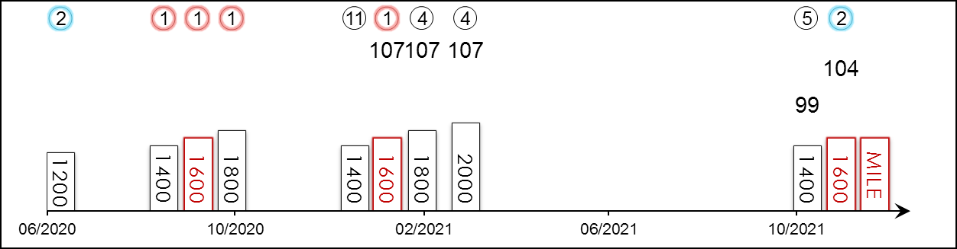 | HK Career : 10 (4-2-0-2-2) Right-handed : 14 (7-2-0-2-3) Jockey : 3 (1-0-0-2-0)  Pre Import : 4 (3-0-0-0-1) Sha Tin-Turf : 10 (4-2-0-2-2) GF+ : 2 (1-1-0-0-0)  Lifetime : 14 (7-2-0-2-3) Non-Turf : - Good : 10 (4-1-0-2-3)  2021/22 : 2 (0-1-0-0-1) Distance : 3 (2-1-0-0-0) Yielding : -  G1 : - Course & Dist : 3 (2-1-0-0-0) Soft/Hvy : 2 (2-0-0-0-0)  First Up : 6 (2-1-0-0-3) 1400-1800 : 9 (5-1-0-1-2) HK$ : 15,687,720  G1 win : Nil

Pos | Index | Date | Perf  Rating | Race Category & Name |  | Track | Dist/Course/Going |  | Wt | Jockey | Draw | Race Sectional Time |  |  |  | Race  Time | Horse  Final | Position & Margin in Running |  |  |  |  |  | Finish |  | Odds | Winner/Second
2/9 | **785 | 1/7/20 | - | - | Cl.3 hcp | ST, HK | 1200 RH | GF | 132 | J Moreira | 10 |  | 23.⁵⁹ | 21.⁸¹ | 22.⁹⁹ | 1.08.³⁹ | 22.⁶¹ | - |  | 7 | 4¾ | 6 | 2½ | 2 | SH | 4.1 | Falcon Turbo
1/14 | *9 | 6/9/20 | - | - | Cl.3 hcp | ST, HK | 1400 RH | G | 131 | J Moreira | 6 |  | 21.⁹² | 22.⁹⁶ | 23.³⁴ | 1.21.⁶⁵ | 22.⁷⁴ | 6 | 2¾ | 7 | 3¼ | 9 | 3¾ | 1 | SH | 2.4F | Star Performance
1/14 | *46 | 20/9/20 | - | - | Cl.2 hcp | ST, HK | 1600 RH | GF | 119 | J Moreira | 14 |  | 22.⁷⁸ | 23.⁷⁶ | 22.⁸⁷ | 1.33.⁶⁴ | 22.⁵⁵ | 9 | 4 | 9 | 3¼ | 6 | 2 | 1 | 1½ | 3.2F | Savvy Nine
1/14 | *84 | 4/10/20 | - | - | Cl.2 hcp | ST, HK | 1800 RH | G | 123 | J Moreira | 3 |  | 24.⁵⁶ | 23.⁹⁰ | 22.⁵⁰ | 1.48.⁰⁰ | 22.²⁶ | 6 | 3¾ | 6 | 4¼ | 6 | 1½ | 1 | 1/2 | 1.5F | Tianchi Monster
11/14 | *335 | 10/1/21 | - | - | Cl.2 hcp | ST, HK | 1400 RH | G | 132 | J Moreira | 7 |  | 21.⁸³ | 22.⁸² | 22.⁸¹ | 1.21.⁰⁶ | 23.²⁷ | 10 | 2¾ | 9 | 4 | 8 | 3½ | 11 | 6¼ | 4.4 | Not Usual Talent
1/13 | *371 | 24/1/21 | 107 | - | Hong Kong Classic Mile | ST, HK | 1600 RH | G | 126 | B Shinn | 10 |  | 22.²³ | 23.⁶⁵ | 23.⁹¹ | 1.33.⁸¹ | 23.³⁹ | 11 | 6½ | 10 | 6¾ | 9 | 3¼ | 1 | 3/4 | 23 | Lucky Express
4/14 | *449 | 21/2/21 | 107 | - | Hong Kong Classic Cup | ST, HK | 1800 RH | G | 126 | B Shinn | 5 |  | 24.⁴⁶ | 24.⁰⁴ | 22.⁷⁷ | 1.47.²¹ | 22.³³ | 11 | 9 | 11 | 8½ | 11 | 3½ | 4 | 3/4 | 4.1 | Healthy Happy
4/14 | *524 | 21/3/21 | 107 | - | BMW Hong Kong Derby | ST, HK | 2000 RH | G | 126 | B Shinn | 8 |  | 25.³² | 23.⁷⁶ | 23.⁶¹ | 2.01.³² | 23.¹¹ | 11 | 15½ | 12 | 7¾ | 11 | 5 | 4 | 1¾ | 5 | Sky Darci
5/11 | 174 | 13/11/21 | 99 | - | Panasonic Cup - hcp | ST, HK | 1400 RH | G | 125 | J Moreira | 11 |  | 21.⁶¹ | 23.⁵⁰ | 22.⁸⁴ | 1.21.²² | 22.⁶⁰ | 11 | 6¾ | 11 | 8¼ | 11 | 3½ | 5 | 2 | 8.2 | Lucky Express
2/12 | 211 | 28/11/21 | 104 | - | Chevalier Cup - hcp | ST, HK | 1600 RH | G | 125 | J Moreira | 2 |  | 23.⁰⁹ | 23.⁵² | 22.⁸⁷ | 1.33.⁷¹ | 22.⁶⁹ | 6 | 4¾ | 6 | 3¾ | 6 | 2¼ | 2 | 1¼ | 2.2F | Silver Express
 |  | 12/12/21 |  | G1 | LONGINES Hong Kong Mile | ST, HK | 1600 RH |  | 126 | B Shinn
A lightly-raced five-year-old, showed early promise when scoring a hat-trick of wins in his first three starts through his second Hong Kong season. 2021 Hong Kong Classic Mile winner who scored four times as a four-year-old season; since then, finished fifth at Class 1 level over 1400m. Finished an unlucky second in the Class 1 Chevalier Cup Handicap (1600m) latest. Hold up runner, won on good and good to firm ground.

 |  |  | 幸運快車 D026  LUCKY EXPRESS (AUS) ex Prince Of Sussex 5 b/br g  Toronado (IRE) - Il Diamante (AUS) (Testa Rossa (AUS))  Owner(s): Larry Yung Chi Kin |  | 蔡約翰 (香港)  J Size (HK)  Win 9.7% Place 25.8% | 賀銘年  A Hamelin  Win 3.4% Place 12.8% | 126 lb  (105)

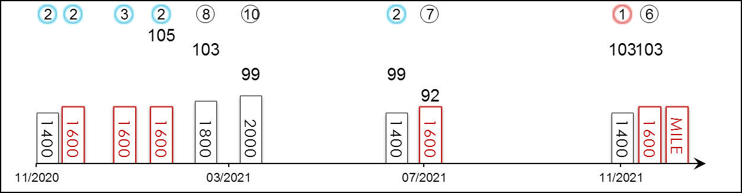 | HK Career : 15 (2-4-3-1-5) Right-handed : 15 (2-4-3-1-5) Jockey : 1 (0-0-0-0-1)  Pre Import : 3 (2-0-0-1-0) Sha Tin-Turf : 15 (2-4-3-1-5) GF+ : 4 (0-1-1-0-2)  Lifetime : 18 (4-4-3-2-5) Non-Turf : - Good : 14 (4-3-2-2-3)  2021/22 : 2 (1-0-0-0-1) Distance : 5 (0-2-1-0-2) Yielding : -  G1 : - Course & Dist : 5 (0-2-1-0-2) Soft/Hvy : -  First Up : 5 (2-1-1-1-0) 1400-1800 : 10 (1-4-1-1-3) HK$ : 13,272,440  G1 win : Nil

Pos | Index | Date | Perf  Rating | Race Category & Name |  | Track | Dist/Course/Going |  | Wt | Jockey | Draw | Race Sectional Time |  |  |  | Race  Time | Horse  Final | Position & Margin in Running |  |  |  |  |  | Finish |  | Odds | Winner/Second
2/9 | *190 | 14/11/20 | - | - | Panasonic Cup - hcp | ST, HK | 1400 RH | G | 115 | K Teetan | 3 |  | 22.⁶⁷ | 23.³¹ | 22.³³ | 1.21.⁸⁰ | 21.⁸⁵ | 7 | 3½ | 7 | 4 | 7 | 4 | 2 | 1 | 2.7F | Buddies
2/13 | *227 | 29/11/20 | - | - | Chevalier Cup - hcp | ST, HK | 1600 RH | G | 115 | V Borges | 9 |  | 23.⁵⁷ | 23.⁰⁷ | 22.⁸⁴ | 1.34.¹⁰ | 22.⁵³ | 8 | 5¾ | 8 | 5½ | 6 | 2¼ | 2 | N | 5.1 | Sky Darci
3/14 | *316 | 1/1/21 | - | - | Cl.2 hcp | ST, HK | 1600 RH | G | 130 | K Teetan | 7 |  | 23.³⁸ | 24.²⁹ | 22.³⁹ | 1.35.¹⁹ | 22.⁴⁰ | 9 | 3 | 4 | 2 | 2 | 1¾ | 3 | 1¾ | 3.5 | Circuit Three
2/13 | *371 | 24/1/21 | 105 | - | Hong Kong Classic Mile | ST, HK | 1600 RH | G | 126 | K Teetan | 9 |  | 22.²³ | 23.⁶⁵ | 23.⁹¹ | 1.33.⁸¹ | 23.⁵⁶ | 10 | 4¾ | 8 | 5¼ | 8 | 3 | 2 | 3/4 | 8.5 | Excellent Proposal
8/14 | *449 | 21/2/21 | 103 | - | Hong Kong Classic Cup | ST, HK | 1800 RH | G | 126 | K Teetan | 2 |  | 24.⁴⁶ | 24.⁰⁴ | 22.⁷⁷ | 1.47.²¹ | 22.⁸⁸ | 8 | 7¼ | 8 | 6¼ | 6 | 2 | 8 | 2¾ | 5.1 | Healthy Happy
10/14 | *524 | 21/3/21 | 99 | - | BMW Hong Kong Derby | ST, HK | 2000 RH | G | 126 | A Hamelin | 9 |  | 25.³² | 23.⁷⁶ | 23.⁶¹ | 2.01.³² | 24.¹² | 8 | 12¼ | 8 | 5¼ | 8 | 3 | 10 | 6¼ | 20 | Sky Darci
2/14 | *766 | 20/6/21 | 99 | - | Cl.2 hcp | ST, HK | 1400 RH | GF | 132 | J Moreira | 6 |  | 21.⁹⁸ | 22.²⁶ | 22.⁸⁶ | 1.20.⁸³ | 22.²⁴ | 9 | 3 | 8 | 4½ | 7 | 4 | 2 | SH | 4.6F | Hinchinlove
7/11 | *823 | 11/7/21 | 92 | - | Sha Tin Mile Trophy - hcp | ST, HK | 1600 RH | GF | 121 | J Moreira | 5 |  | 22.²⁸ | 22.⁵⁰ | 23.⁵¹ | 1.32.²⁴ | 23.²⁶ | 9 | 4½ | 9 | 6 | 8 | 5½ | 7 | 4 | 2.2F | Preciousship
1/11 | 174 | 13/11/21 | 103 | - | Panasonic Cup - hcp | ST, HK | 1400 RH | G | 124 | Z Purton | 1 |  | 21.⁶¹ | 23.⁵⁰ | 22.⁸⁴ | 1.21.²² | 22.⁶⁰ | 7 | 2¾ | 4 | 3¾ | 4 | 1½ | 1 | HD | 5.7 | Fast Most Furious
6/12 | 211 | 28/11/21 | 103 | - | Chevalier Cup - hcp | ST, HK | 1600 RH | G | 129 | Z Purton | 7 |  | 23.⁰⁹ | 23.⁵² | 22.⁸⁷ | 1.33.⁷¹ | 22.⁸⁷ | 5 | 3¾ | 5 | 3¾ | 5 | 2 | 6 | 2 | 4.9 | Silver Express
 |  | 12/12/21 |  | G1 | LONGINES Hong Kong Mile | ST, HK | 1600 RH |  | 126 | A Hamelin
Two-time winner as a two-year-old in Australia. Steady performer with two wins, four seconds and three thirds in Hong Kong. First-up winner this campaign clinging on to a close-up victory at Class 1 level over 1400m, also finished runner-up to stablemate Excellent Proposal in last season’s Hong Kong Classic Mile (1600m). Finished sixth in the Class 1 Chevalier Cup Handicap (1600m) latest. Usually sits midfield. Best on good ground.

 |  |  | 后土  MOTHER EARTH (IRE) 3 b f  Zoffany (IRE) - Many Colours (GB) (Green Desert (USA))  Owner(s): Derrick Smith, Mrs John Magnier & Michael Tabor |  | 岳伯仁 (愛爾蘭)  A P O'Brien (IRE) | 莫雅  R Moore | 121 lb  (114)

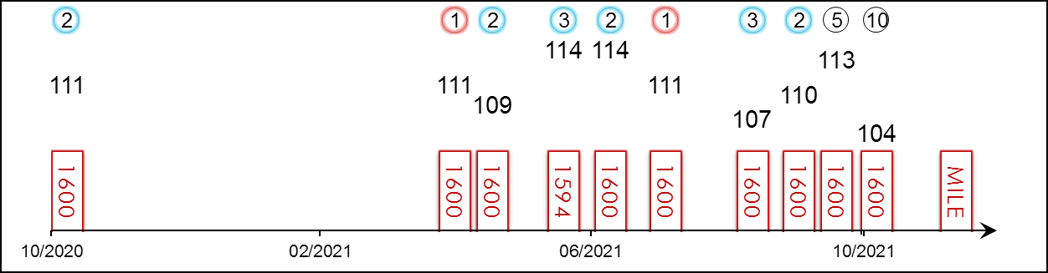 | HK Starts : - Right-handed : 3 (0-2-1-0-0) Jockey : 9 (1-3-3-0-2)  Pre Import : - Sha Tin-Turf : - GF+ : 4 (1-2-0-0-1)  Lifetime : 17 (3-5-6-0-3) Non-Turf : - Good : 4 (0-2-1-0-1)  2021 : 9 (2-3-2-0-2) Distance : 11 (2-4-3-0-2) Yielding : 1 (0-0-1-0-0)  G1 : 12 (2-4-3-0-3) Course & Dist : - Soft/Hvy : 8 (2-1-4-0-1)  First Up : 2 (1-1-0-0-0) 1400-1800 : 13 (2-4-4-0-3) HK$ : 9,437,790  G1 win : 2021 P. Rothschild 1600m, 2021 1000 Guineas 1600m

Pos | Index | Date | Perf  Rating | Race Category & Name |  | Track | Dist/Course/Going |  | Wt | Jockey | Draw | Race Sectional Time |  |  |  | Race  Time | Horse  Final | Position & Margin in Running |  |  |  |  |  | Finish |  | Odds | Winner/Second
2/14 | - | 6/11/20 | 111 | G1 | Breeders' Cup Juvenile Fillies Turf - 2yo | KEE, USA | 1600 LH | G | 122 | R Moore | 7 |  | 24.⁷⁵ | 24.⁹¹ | 23.⁵⁰ | 1.35.⁷¹ | - | 12 | 9.3 | 11 | 5.5 | 10 | 8.8 | 2 | 2.5 | 23.8 | Aunt Pearl
1/11 | - | 2/5/21 | 111 | G1 | 1000 Guineas - 3yo fillies | NEW, GB | 1600 St | GF | 126 | L Dettori | 2 |  | - | - | - | 1.36.³⁷ | - | - |  | - |  | - |  | 1 | 1 | 10/1 | Saffron Beach
2/13 | - | 16/5/21 | 109 | G1 | Poule d'Essai des Pouliches - 3yo fillies | LCH, FR | 1600 RH | VS | 126 | C Soumillon | 4 |  | - | - | - | 1.39.²⁸ | - | - |  | - |  | - |  | 2 | 1.3 | 3.2 | Coeursamba
3/11 | - | 18/6/21 | 114 | G1 | Coronation S. - 3yo fillies | ASC, GB | 1594 RH | H | 126 | R Moore | 8 |  | - | - | - | 1.43.¹³ | - | - |  | - |  | - |  | 3 | 1.8 | 9/2 | Alcohol Free
2/13 | - | 9/7/21 | 114 | G1 | Falmouth S. - f&m | NEWJ, GB | 1600 St | GF | 124 | R Moore | 8 |  | - | - | - | 1.35.⁹³ | - | - |  | - |  | - |  | 2 | 0.5 | 5/1 | Snow Lantern
1/14 | - | 3/8/21 | 111 | G1 | P. Rothschild - f&m | DEA, FR | 1600 St | S | 123 | R Moore | 3 |  | - | - | - | 1.35.⁸¹ | - | - |  | - |  | - |  | 1 | Hd | 3F | Sagamiyra
3/13 | - | 11/9/21 | 107 | G1 | Matron S. - f&m | LEO, IRE | 1600 LH | G | 128 | R Moore | 2 |  | - | - | - | 1.41.⁹⁸ | - | - |  | - |  | - |  | 3 | 1.5 | 6/5F | No Speak Alexander
2/12 | - | 2/10/21 | 110 | G1 | Sun Chariot S. - f&m | NEW, GB | 1600 St | G | 126 | R Moore | 10 |  | - | - | - | 1.40.⁵⁸ | - | - |  | - |  | - |  | 2 | 3 | 11/4F | Saffron Beach
5/10 | - | 16/10/21 | 113 | G1 | Queen Elizabeth II S. | ASC, GB | 1600 St | GS | 124 | R Moore | 9 |  | - | - | - | 1.42.⁵⁷ | - | - |  | - |  | - |  | 5 | 3.3 | 33/1 | Baaeed
10/13 | - | 6/11/21 | 104 | G1 | Breeders' Cup Mile | DMR, USA | 1600 LH | F | 120 | R Moore | 7 |  | 23.⁸⁷ | 23.⁶⁴ | 22.⁹⁹ | 1.34.⁰¹ | - | 13 | 9.8 | 13 | 10.8 | 11 | 9.5 | 10 | 4.8 | 10.2 | Space Blues
 |  | 12/12/21 |  | G1 | LONGINES Hong Kong Mile | ST, HK | 1600 RH |  | 121 | R Moore
Won a G3 over 1200m at Naas as a two-year-old and rounded off her first season with a creditable second in the G1 Breeders’ Cup Juvenile Fillies Turf (1600m) at Keeneland. Ultra-consistent performer with two G1 wins among her haul, striking in the 2021 1000 Guineas and Prix Rothschild just three months after. Fifth in the G1 Queen Elizabeth II Stakes (1600m) at Ascot after being steadied soon after start and raced freely. Never dangerous when tenth in the G1 Breeders’ Cup Mile (1600m). Hold up runner, no ground worries.

