Spotlight

World superstar Loves Only You returns to Sha Tin fresh off a brilliant success in the G1 Breeders’ Cup Filly & Mare Turf (2200m) at Del Mar Racecourse last month and G1 FWD QEII Cup (2000m) triumph at Sha Tin Racecourse in April.

Lei Papale and Hishi Iguazu join her from Japan, the former is unbeaten over 2000m and is a one-time G1 winner having claimed the Osaka Hai (2000m).

Dubai Honour, close-up second in the G1 Champion Stakes in the UK, is a two-time G2 winner who is making his first start abroad for trainer William Haggas. Third out of the British Champion Stakes, Mac Swiney, joins Dubai Honour in the contest and will bid to give legendary Irish horseman Jim Bolger a second win in this race after Alexander Goldrun reigned in 2004.

Leading Hong Kong’s defence is Glorious Dragon, along with G1 Standard Chartered Champions & Chater Cup winner Panfield as well as Russian Emperor, second place-getter in the 2021 BMW Hong Kong Derby (2000m), and Tourbillon Diamond and Ka Ying Star, who both supplemented for the race.

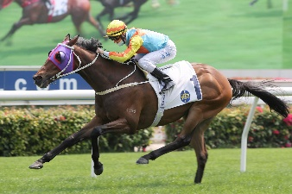 | KA YING STAR (GB)  HONG KONG 6g 117  Boasts four wins in Hong Kong and three G1 placings; best win to date in 2020 G3 Lion Rock Trophy (1600m). | 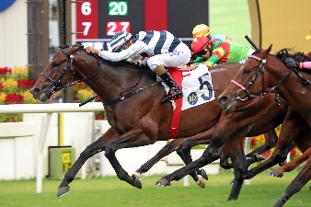 | PANFIELD (CHI)  HONG KONG 5h 116  Winner of 2021 G1 Champions & Chater Cup (2400m); in fine fettle this term to claim G2 Sha Tin Trophy (1600m); won three G1 in Chile prior to import.
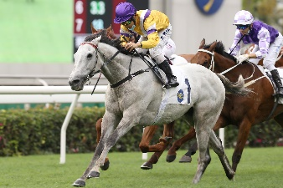 | GLORIOUS DRAGON (IRE)  HONG KONG 6g 115  Four-time winner in Hong Kong, twice last season including 2021 G3 Centenary Vase (1800m); last out third in G2 Jockey Club Cup (2000m). | 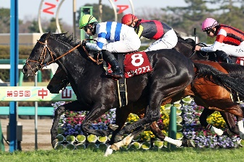 | HISHI IGUAZU (JPN)  JAPAN 5h 114  2021 G2 Nakayama Kinen winner (1800m); start prior won G3 Nakayama Kimpai (2000m); last out, fifth in G1 Tenno Sho Autumn (2000m).
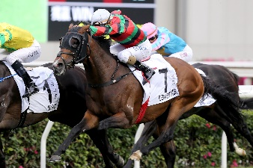 | RUSSIAN EMPEROR (IRE)  HONG KONG 4g 110  Runner-up in 2021 Hong Kong Derby (2000m); prior to import won G3 Hampton Court Stakes (1993m) at Royal Ascot. | 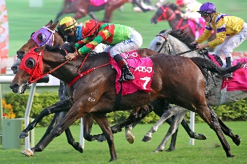 | TOURBILLON DIAMOND (AUS)  HONG KONG 5g 107  G1-placed in Australia, finishing third over 2400m in G1 Australian Derby (2400m); last out kept on stoutly to claim G3 Sa Sa Ladies’ Purse (1800m).
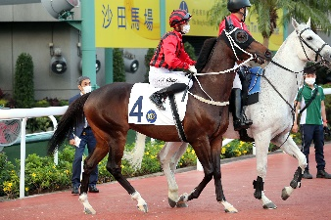 | BERLIN TANGO (GB)  HONG KONG 4g 95  G3 winner before import to Hong Kong when beating Vase contender Pyledriver in 2020 Classic Trial Stakes (1999m) at Kempton Park. | 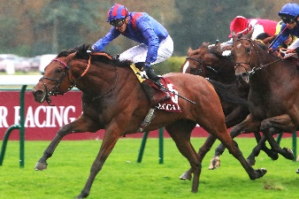 | DUBAI HONOUR (IRE)  GREAT BRITAIN 3g 121  Placed at G1 level in Champion Stakes in the UK (1993m) last start; before that, twice a winner at G2 level in France.
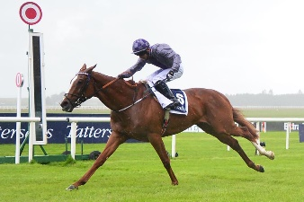 | MAC SWINEY (IRE)  IRELAND 3c 118  Two-time G1 winner over the mile at Doncaster and The Curragh; last out finished third in G1 Champion Stakes in the UK in October. | 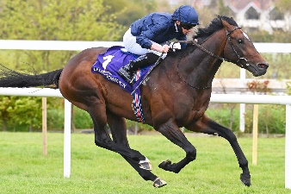 | BOLSHOI BALLET (IRE)  IRELAND 3c 115  G1 winner in the US winning the 2021 Belmont Derby Invitational Stakes over 2000m.
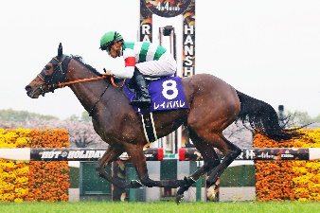 | LEI PAPALE (JPN)  JAPAN 4f 118  Winner of her first six starts including 2021 G1 Osaka Hai (2000m), since then finished third in 2021 G1 Takarazuka Kinen (2200m) to the high-class Chrono Genesis. | 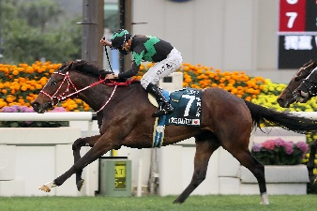 | LOVES ONLY YOU (JPN)  JAPAN 5m 118  Superb three-time G1 winning mare who boasts top-level scores in the US, Japan and Hong Kong including in 2021 G1 FWD QEII Cup and Breeders’ Cup F&M Turf.

